Lab 7

1-3. Methods and attributes
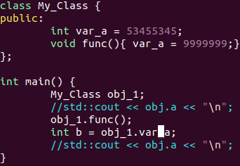
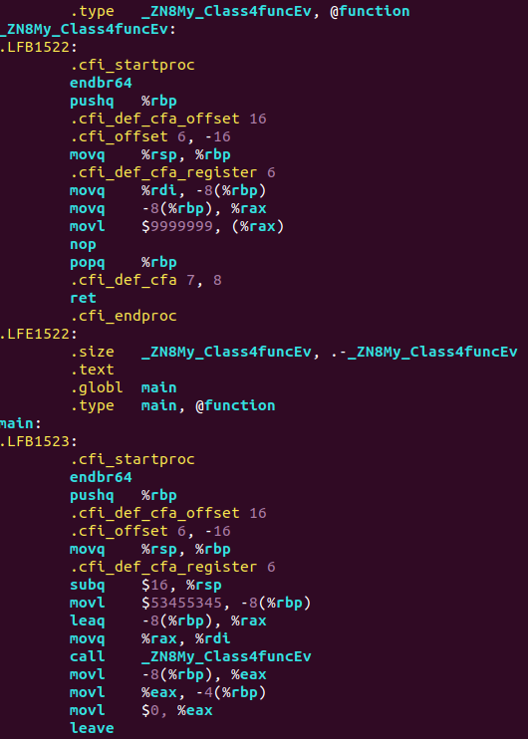
Classes are almost identical to structures – they stored exactly the same way(except when they have virtual members).
In this example class variable var_a is pushed into stack. Method func() is called as a usual function, but the name of it changes to _ZN8My_Class4funcEv to show that it belongs to a certain class.
%rdi is responsible for “this”: as we can see, the address of var_a in stack is transferred to %rdi before function call and it is used in function itself as a pointer to var_a.

5. Encapsulation
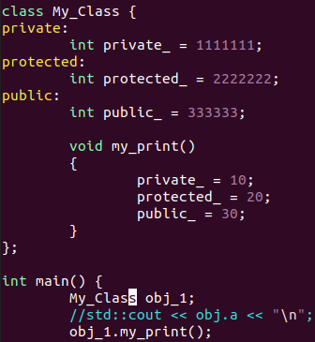
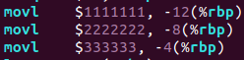

The compiler emits no code in relation to these access modifiers. It’s purely a compile-time thing, it will remember if something is private and show an error message if you try to access it from the outside, but in the compiled code there’s no concept of public or private or anything, it’s just bytes.
And, of course, at the machine code level you can always do whatever you want. The only exception is when different access modifiers cause different optimizations to apply, so e.g. some member might disappear because the compiler knows it can never be accessed from the outside and it can simply rewrite expressions so it doesn’t need it.

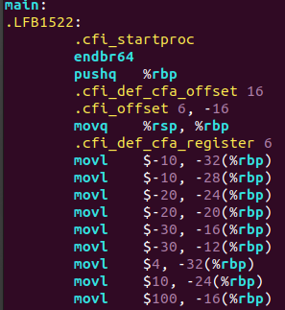
6. Inheritance
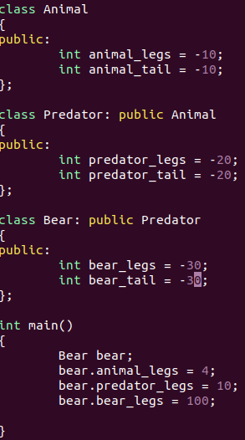

Local variables from each class are initialized(added to stack) in the same order as they are placed in code.

7. Polymorphism
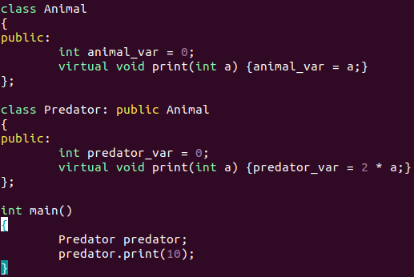

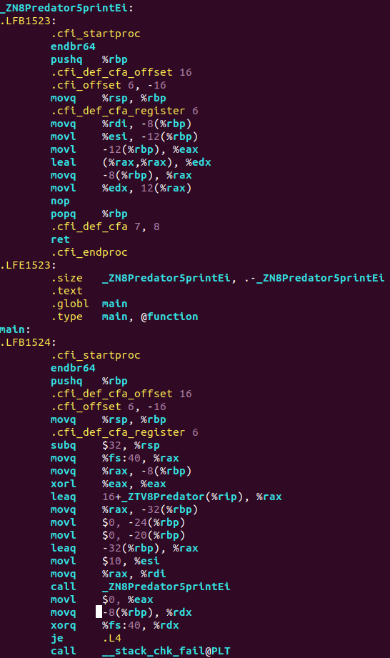
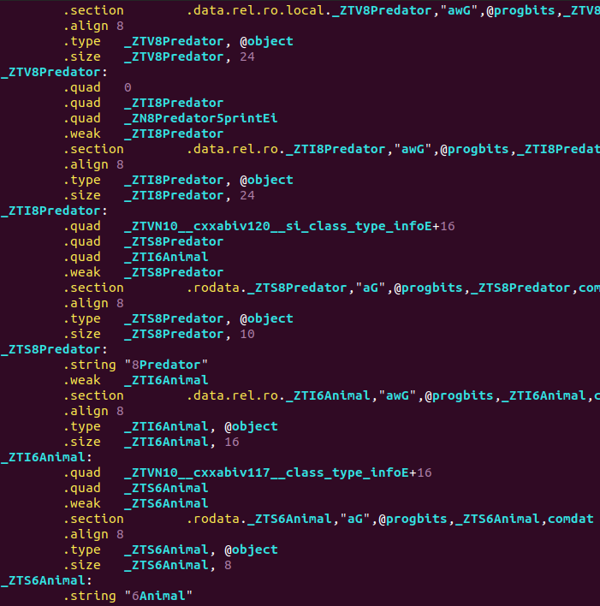
In case of using virtual functions we can notice, that class Predator is used as a global variable. Thus, besides the %rdi register(“this”), each copy of the object has to carry around an extra pointer(in this case it’s %rax, which is added to stack).

8. Static
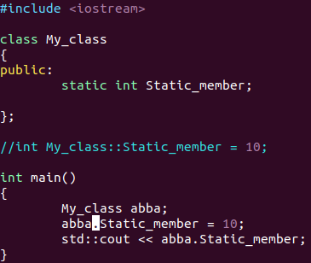
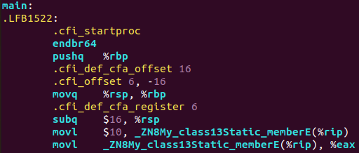
Static member is used almost as global variables, except they have their own initialization and destruction:
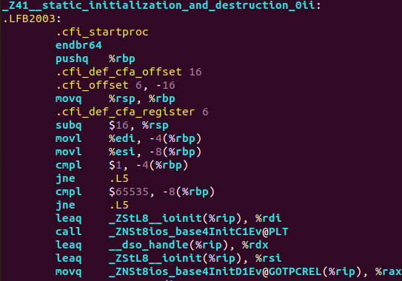
Static methods cannot access to non-static class members, because they refer to the class itself, not to the object, thus they don’t interact with “this” pointer and don’t have access to object’s non-static variables.
9. Overriding
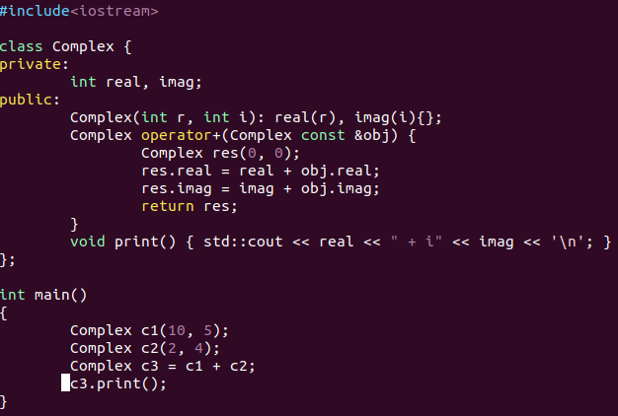
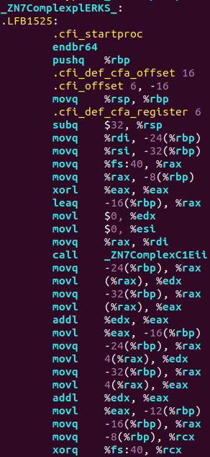
Operator overriding is represented just as a function:

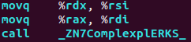

Function call in main

10. Templates
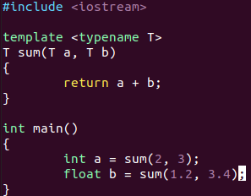
Two functions with the same realization, but with different names were created: one is referred to int , other to float.
11. Enum
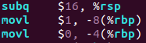
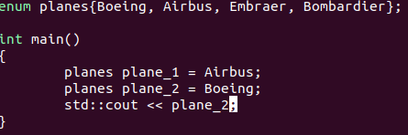
Enum is not initialized at all.

