# LTFSArchiver 1.1 Web User Interface

Summary

LTFSArchiver 1.1 Web User Interface 1

Pending jobs 4

Active jobs 5

Tape management 6

Make available manager 9

Device monitoring 10

**Scope**

This document describes in detail the LTFSArchiver Web User Interface used to manage tapes, pools and devices.

This web interface allows to monitor both automatic and manual operations, to manage tapes and tape pools and to control the stable tape mount operations (makeavailable).

The home page appears as showed in Figure 1

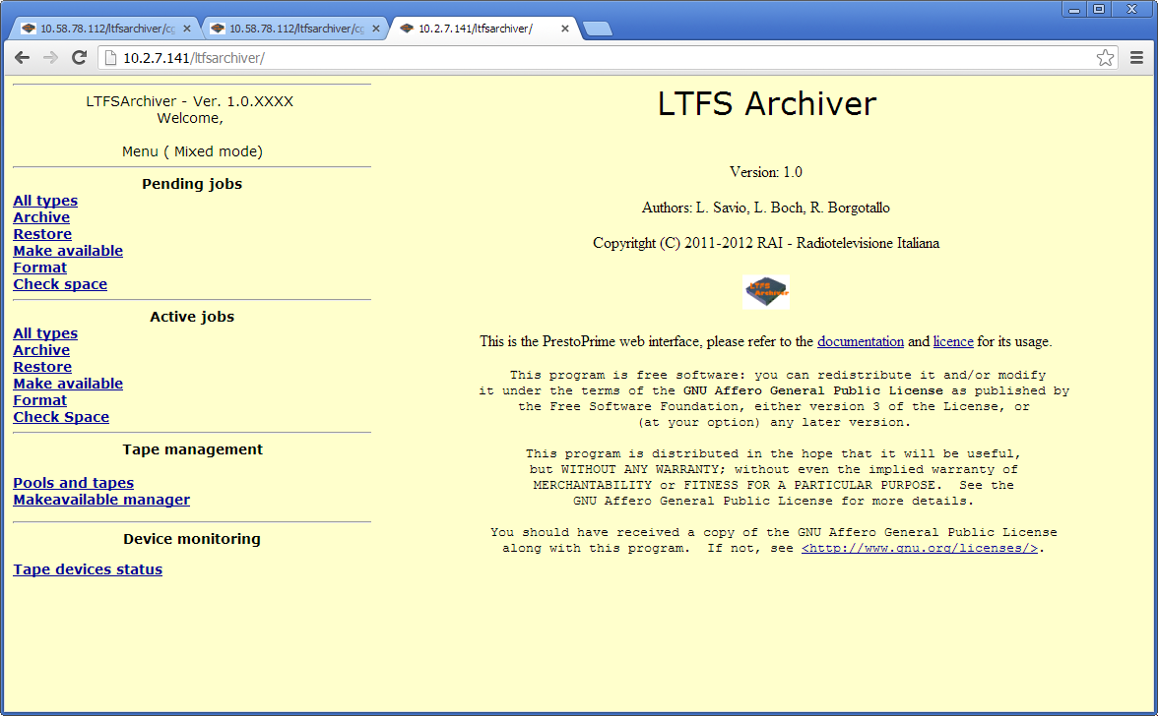

Figure 1- LTFSArchiver web interface

In the upper left corner (between brackets) is shown the operating mode which can be one of:

* “Mixed mode”: means that LTFSArchiver runs managing both external or manual (desktop model) and internal or automated (library connected) LTO drives.
* “Manual mode”: means that LTFSArchiver runs managing only external manual LTO drives.
* “Changer mode” means that LTFSArchiver runs managing only internal automated LTO drives. *Note: If mode has been set to “Changer mode”, the “Pending job” section will not be shown.*

In mixed and manual modes a human operator must be in charge for loading and unloading the tapes. The Manual mode can be suitable for very small archives not wishing to deal with a robotic library. From the client application perspective the behaviour of LTFSArchiver is exactly the same, although the operations will be unavoidably slower. Requests of manual tape displacement are asked to the operator through the web interface, and also with this interface he has to confirm when done.

In the Mixed configuration both automated and not automated LTO drives are connected to the system. In this case the service ***WriteToLTO*** tries first to use a tape located in a library with enough free space and belonging to the required pool. If this first attempt fails a “on the shelf tape” with the same requirements is asked to be used when available.

All the operations allowed through this interface are also feasible using the API described in detail in the *LTFSArchiverAPI* document. The execution of all the operations, requires that a system service daemon called *ltfarchiver* to be up and running on the server. For this reason **only if it is turned off,** an alert is shown (Figure 2) on the interface saying “ltfsarchiver daemon is DOWN !”, in this case please call the server administrator and ask him to start the service (the command to be issued as root user is “*service ltfsarchiver start”*).

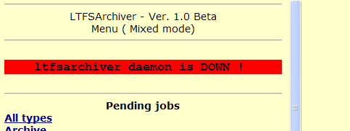

Figure 2 - System service down warning

The following chapters describe in detail all the relevant features of the interface.

### Pending jobs

This section appears in the top left part of the screen **only when the system configuration is in Manual or Mixed mode**. Here are listed pending requests that are waiting for a tape to be manually loaded. For each request, a line like that shown in Figure 3 is presented.



Figure 3 - Listing pending jobs sample

In this sample, a *Makeavailable* request was issued and the required tape is the ZZ04020B, therefore LTFSArchiver waits for that specific tape to be manually loaded into the free drive indicated in the fifth (Assigned dev.) column.

The column “Req. Action” reports what the operator is expected to do.

After having inserted the requested LTO tape in the assigned drive, the operator must click on “confirm load”, then LTFSArchiver will be able to proceed:

The following uuids have been sent to ready status:

d6f462e7-200e-45b0-9d47-cb1d13b8b794

After that the job will not be further shown in this section.

When the activity has been completed, the tape will be automatically ejected from the drive.

### Active jobs

This section lists the currently active jobs whose requests were previously accepted and actually in charge to the system.

For each job, a line looking like in Figure 4 is shown, where the column status can assume different values.



Figure 4 - Active jobs list sample

The above samples is about the status of the *Makeavailable* request discussed in the previous paragraph.The operator has loaded the tape and confirmed so the LTFSArchiver agent will be able to complete the job.

The Status and Note fields may have the following values, showed in the correct sequence they should occur:

|  |  |
| --- | --- |
| Satus | Note |
| Wait | Waiting to be dispatched |
| Dispatched, waiting for tape device |
| Dispatched, waiting for tape loading |
| Starting | Tape being loaded o positiong |
| Tape loaded and ready |
| Running | Running |

Note that the jobs that have been completed are not shown, regardless if they succeeded or failed.

### Tape management

This section has been designed to provide a web interface for the **TapeManager** and **QueryKnownTapes** services (see “LTFSArchiverAPI” document), enabling user to manage tape and pools.

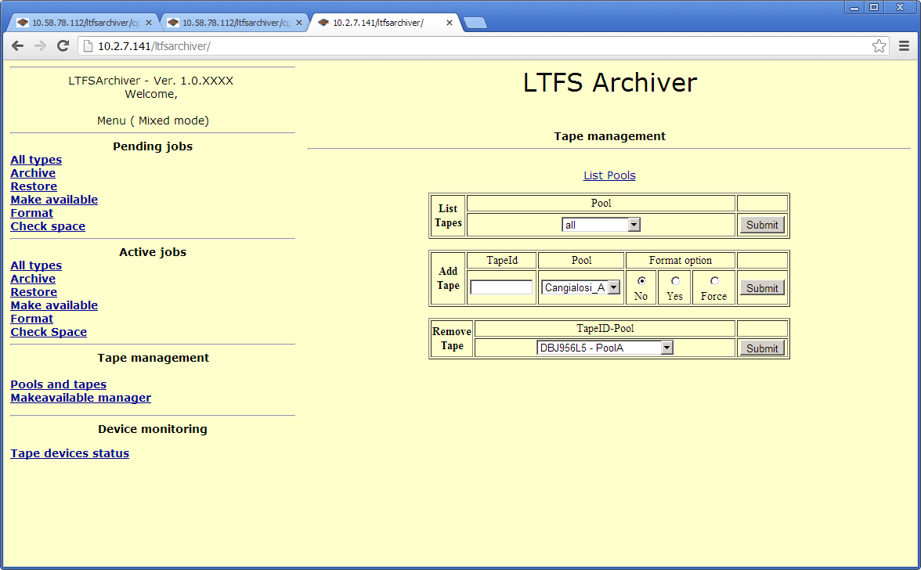

Figure 5 - Tape and Pools management

**List pools**

This function simply lists the existing configured pools in the system and the total number of tapes under each of them like shown in Figure 6.

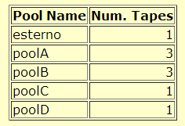

Figure 6 - List Pools output

#### List Tapes

This function lists the tapes owned by pools, a single pool or all the pools can be selected using the dropdown box (in this last case select “all”).

The output shows also the amount of free space in MB available on each tape.

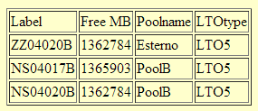

Figure 7 - List Tapes output

#### Add Tape

This function allows to add a new tape to an existing pool or to create a new pool while adding the first tape to it.

To add a new tape to an existing pool:

* fill in the “TapeID” field (according to the barcode label if present)
* select the poolname from the “Pool” combo
* choose “No”, “Yes” or “Force” with the radio button to determine the action LTFSArchiver will perform before actually add the tape to the selected pool (see notes at the end of this paragraph);
* click “Submit”

If everything works fine, a similar message will appear:

200 *uuid* LTO with label: <NEWTAPE> added to system and assigned to pool: <CHOOSENPOOL>

If at the same time the user wants to create a new pool:

* fill the “TapeID” field (according to the barcode label is present)
* click on the column heading “Pool” over the combo box, a text input field will appear in place of the combo
* fill in this textbox with the name of the new pool to be created
* choose “Yes” or “No” with the radio button to ask or not for the tape formatting (see notes at the end of this paragraph);
* click “Submit”

If everything works fine, a similar message will appear:

200 uuid LTO with label: <NEWTAPE> added to system and assigned to pool: <NEWPOOL>

In case of error (i.e. trying to add a tape already managed by LTFSArchiver), a message like the following will be returned:

400 LTO with label <NEWTAPE> was already in use by the system

Notes about Yes/No/Force formatting option.

When adding a tape that already contains a LTFS file system, choose “No”.

As soon as possible, the tape will be mounted to:

* check mechanical un-protection
* evaluate actual available space (in case it is not empty)

When adding a blank tape, choose “Yes”. As soon as possible, the tape will be mounted to:

* check mechanical un-protection
* create an LTFS file system on it according to the configuration parameter PPRIMELTO_LTFSRULE (see documentation file LTFSArchiverConfiguration)

If the tape already contains a LTFS file system and you choose “Yes”, the format will fail: as a security feature indeed, the creation of the LTFS is executed in a “non force” mode, to avoid loss of pre-existing data.

When the intention is to format a tape regardless pre-existent data on it (in LTFS or other formats) choose “Force”. As soon as possible, the tape will be mounted to:

* check mechanical un-protection
* forcedly create a LTFS file system on it according to the configuration parameter PPRIMELTO_LTFSRULE (see documentation file LTFSArchiverConfiguration)

#### Remove tape

Allows the user to remove a tape from a pool. Simply select the tape to be removed from the combo box (for each tape is shown the pool owning it) and click “Submit”.

Please note that withdrawing a tape that is currently in use or that has been booked for further use is not allowed (a error message will be returned).

### Make available manager

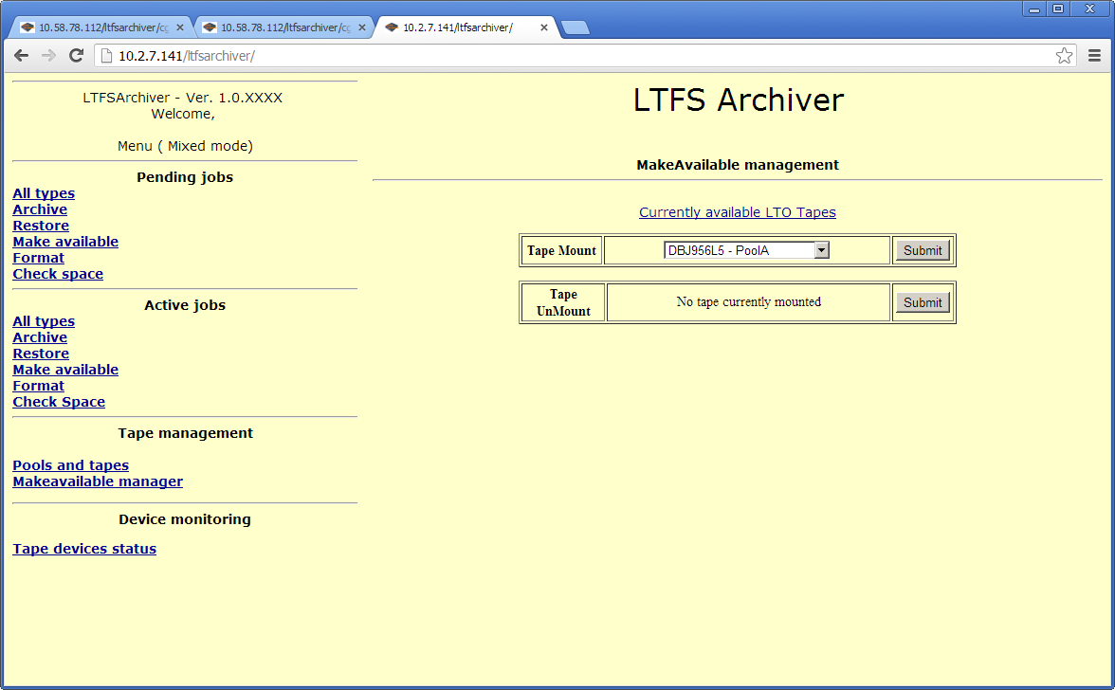

Figure 8 - Make Available manager

This section of the main menu has been designed to provide a web interface for the **MakeAvailable** API (see “LTFSArchiverAPI” document), enabling the user to manually ask for a MakeAvailable (mount or unmount) job.

#### Currently available LTO tapes

This section shows (Figure 9) which tapes are currently in the “make available” mode. As the Makeavailable access mode locks access to both tape and device in use, it is useful to check if some tape has been “forgotten” in this modality.

The column Runtime tells how long the tape has been made available through this modality.



Figure 9 - Tapes currently “made available”

#### Tape mount

This section provides a web interface for the **MakeAvailable** (mountcommand) API.

Simply select the TapeID (the owning pool is also shown near the label) from the dropdown menu and click on “Submit”. The mount process will follow the same procedure as it was submitted through the API.

#### Tape Unmount

This section provides a web interface for the **MakeAvailable** (unmountcommand) API. Simply select the TapeID (the owning pool is also shown near the label) from the dropdown menu (only mounted tapes are shown) and click on “Submit”. The unmount process will follow the same procedure as it was submitted through the API.

Note: the unmount procedure will fail (and it will be automatically re-quested) if some process is still accessing the data.

### Device monitoring

**Tape devices status command** has been designed to :

* Get a quick report about the current use of tape devices
* Enable or disable one or more tape devices

Once chosen this function, the interface shows the table of Figure 10.

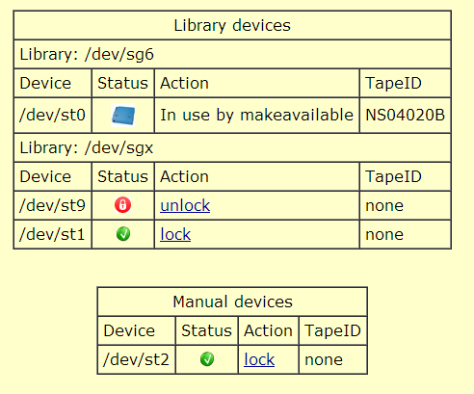

Figure 10 - Tape device status sample output

By clicking on “lock” or “unlock” links the operator can disable o enable a single tape device. A tape cannot change his status when a tape is loaded in it.

Please refer to LTFSARCHIVER_LOCK_LABEL variable in “LTFSArchiverConfiguration” for more information about locking devices.