# LTFSArchiver 1.0

## “Web User Interface” (Tapes on Shelves modality)

LTFS Archiver can be configured to work with LTO drives, without an LTO-Library. In this configuration a human operator must be in charge for loading and unloading the tapes. This modality can be suitable for very small archives not wishing to deal with a robotic library. From the client application perspective the behaviour of LTFS Archiver is exactly the same, although the operations will be unavoidably slower. LTFS Archiver provides a web-gui to the human operator having access to the LTO drives and to the LTO tapes on shelves. Requests of tape exchange are listed to the operator who will have to confirm after completion. Tape identity is verified by the LTFS Archiver service as well.

The LTFS Archiver can also work in a mixed configuration where both automated and not automated LTO drives are connected. In this case the service ***WriteToLTO*** tries first to use a tape located in a library with enough free space and belonging to the required pool. If this first attempt fails a “on the shelf tape” with the same requirements is used when available.

The home page of the user web interface appears as reported in Figure 4. In the upper left corner the operational mode which can be one of:

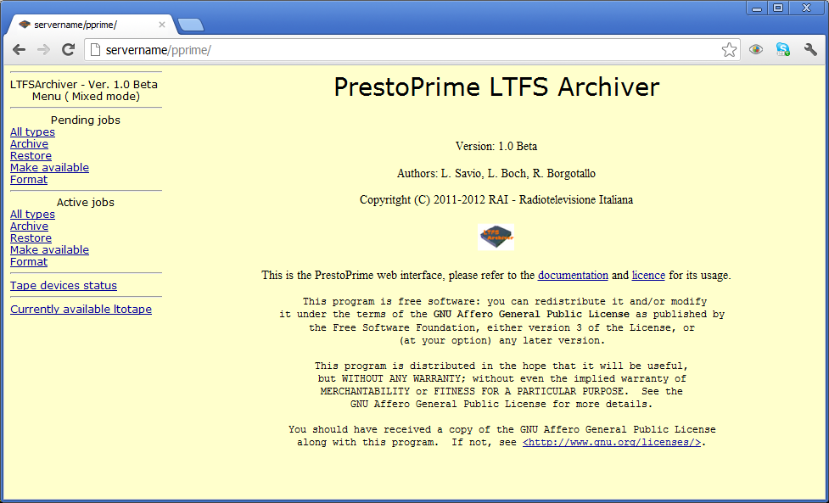

Figure - LTFSArchiver web interface

“Mixed mode” means that LTFSArchiver runs managing both external manual (desktop model) and internal automated (library connected) LTO drives.

“Manual mode” means that LTFSArchiver runs managing only external manual LTO drives.

“Changer mode” means that LTFSArchiver runs managing only internal automated LTO drives. If mode has been set to “Changer mode”, the “Pending job” section will not be shown.

### Pending jobs

Listing pending job shows the requests that are waiting for a tape to be manually loaded. For each request, a line looking like in Figure 2 is shown.



Figure - List of pending jobs

In this sample, an archive operation (as shown in the second column) was requested and the required tape was identified to be the EX000001, therefore LTFSArchiver waits for that tape to be manually loaded into a free drive.

The column “Req. Action” reports what the operator has to do. In case there are not free tape drives or the needed tape is already in use by another task, an explaining message will be shown and no link will be enabled.

Clicking on the “load tape” link, a further, simple form will be shown as represented in Figure 6.



Figure - LTFSArchiver device selection

The combo box contains a list of all the external LTO devices available to the LTFSArchiver system.

The operator first has to identify a free drive and manually load into it the specified tape, he also has to wait for the “ready” led of the tape drive to stop blinking assuring that the loading has been successful.

Finally, he has to select on the form the correspondent device tape drive (e.g. the HP drive on the table correspond to the /dev/st0 device) and press the “CONFIRM” button.

A message will state that the mount operation has been acknowledged by LTFSArchiver, now on the write request can pass to the “active” status.

### Active jobs

This section lists pending active jobs i.e. the requests that have been forwarded from the waiting status. For each request, a line looking like Figure 7 is shown where the column status can assume different values.



Figure - Web interface starting task

“Starting” means that the agent is currently mounting the LTO as a LTFS file system or positioning the tape. After a short time, the record in the table will look like in Figure 8.

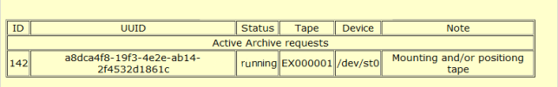

Figure - Web interface running task

“Running” means that the agent is physically writing data on the tape.

After the request has been completed, the tape is automatically ejected from the device.

If the status is “wait” status, in the Note columns a more detailed explanation is reported like in Figure 9 where the request is wainting for the confirmation that the tape has been loaded by the operator.



Figure - Web interface waiting task

### Currently available ltotape

This option will show which tape(s) has/have been put in the “make available” mode.

As the Makeavailable access mode locks access to both tape and device in use, it is useful to check if some tape has been “forgotten” in this situation.

The table of Figure 10 reports in the Runtime column how long the tape has been made available through this modality.



Figure - LTFSArchiver tapes made available