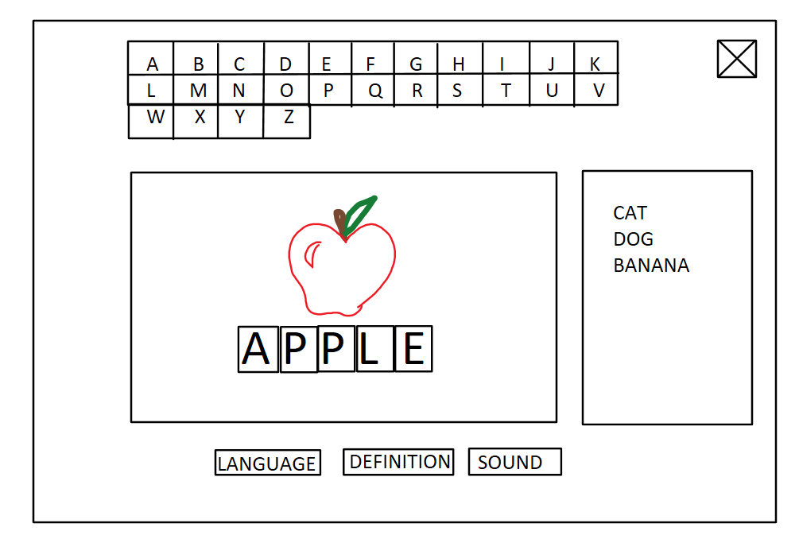

**Hmonics**

**Team:** **All Day Every Day**

Derick | Cheng | Jared | Philip