Quark
a game of matter
by
Brian Mayer

QUARK Components
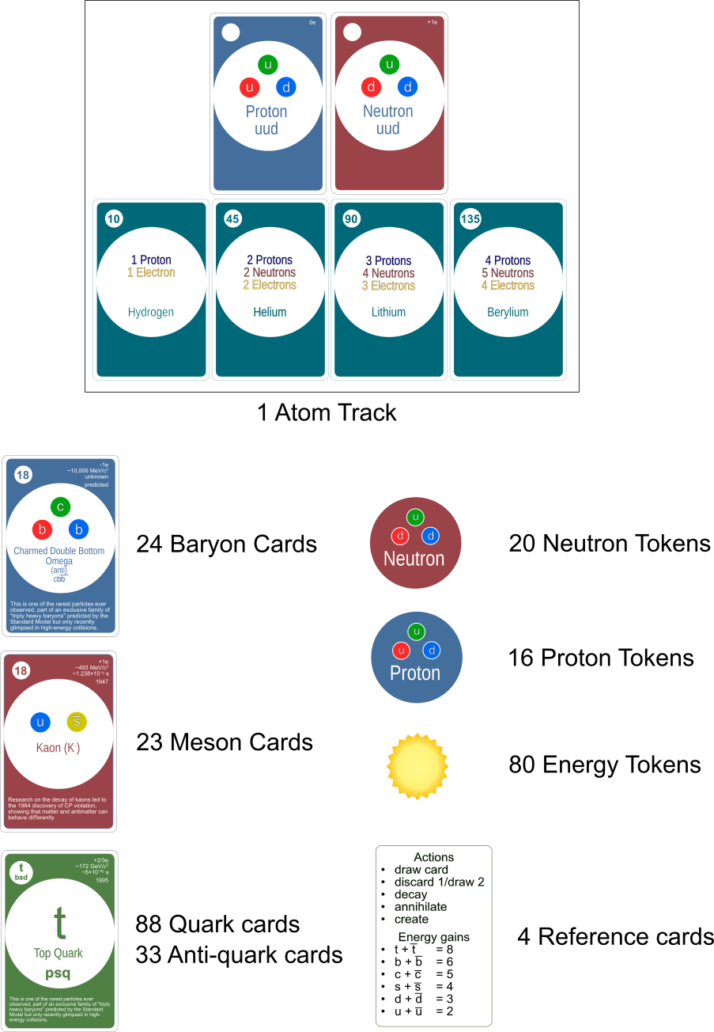

QUARK Card Anatomy
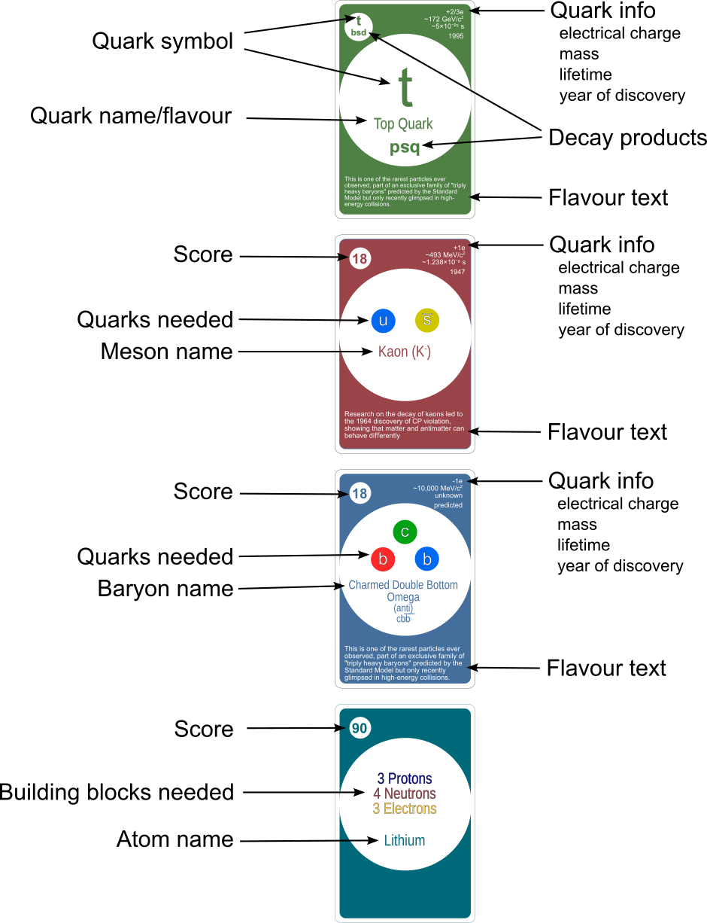

QUARK Setup

Guide the swirling mass of the smallest bits of matter back together to form sub-atomic particles (Baryons and Mesons) and race to build the biggest atom.
- Give each player two energy tokens and a double sided reference card. One side shows the actions available, the other shows the the quark rank and energy gained from annihilating quarks.
- Shuffle the Baryon deck and deal three cards face up in the center of the table. Place the rest of the cards face down next to the face-up cards.
- Shuffle the Meson deck and deal three cards face up in the center of the table. Place the rest of the cards face down next to the face-up cards.
- Shuffle all of the Quark cards (quark and anti-quark cards) together to form the quark deck. Deal five facedown cards to each player. Then deal three cards face up in the center of the table and place the rest of the quark deck face down next to the face-up cards.
- Place the two atomic building block cards in the center of the table, with the proton and neutron tokens nearby. Near these, place the four Atom Cards face up in ascending point order.
- Place the Energy TokeHeading 2ns in a nearby pile.
- Determine a start player (need a start player token)

QUARK Example 4 Player Setup
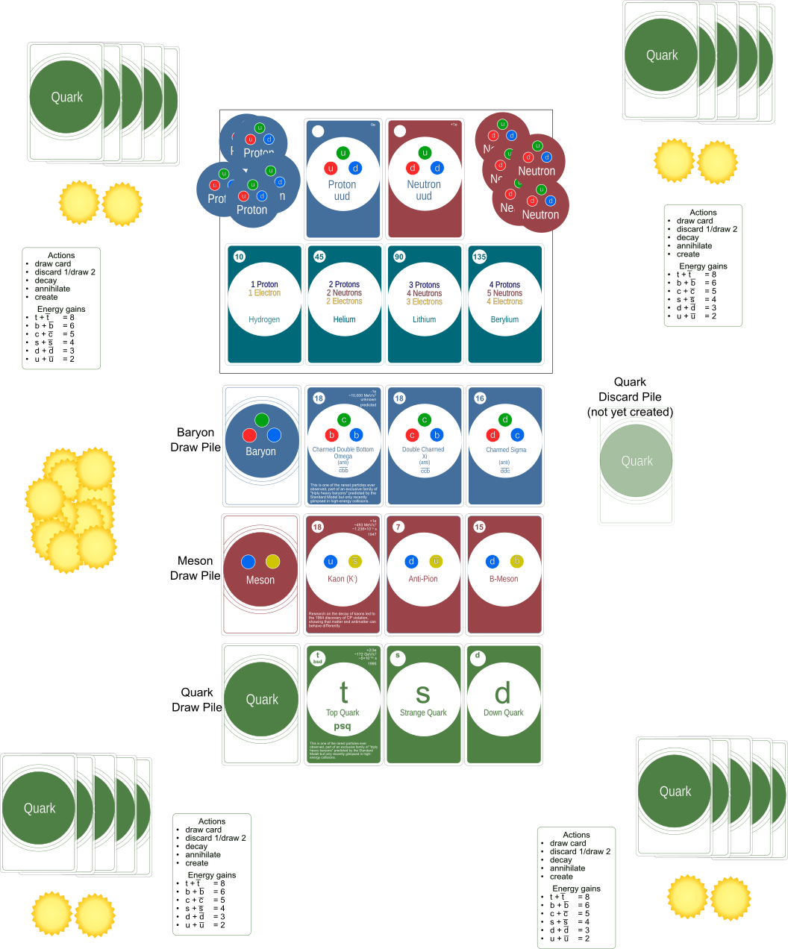

QUARK General Game Overview
In Quark, players take turns: collecting quarks, annihilating them for energy, decaying them and using them to
create subatomic particles. There are two “suits” within the quark deck:
- Quarks - which are black
- Anti-Quarks - which are red
Beginning with the starting player, each player gets two actions on their turn. Which actions they choose to do is up to them. They can take the same action twice if they have enough actions to do so. After they take their two actions, play continues to the next player clockwise. Play continues this way until the end of the game is triggered when:
- When the last card from any of the three draw decks are drawn
- A player creates Beryllium in a 2 or 3 player game, or a player creates Lithium in a 4 player game.
Play continues until all players have had an equal number of turns and then players then add up their points for the following:
- Points on created Baryons and Mesons
- Points for the highest level Atom created
- Points for left over energy
The player with the highest points wins.

QUARK Detailed Play
Play begins with the start player. On a player’s turn they have 2 actions that they can use. Players choose and execute their actions, then play passes clockwise to the next player.
Players have the following actions available on their turn:
- Draw any faceup card or blindly from the quark draw deck. A player may draw a card from the quark draw deck or from the face up quark cards in the center of the table. If the player draws a card from the face up quark cards, they immediately refill the space from the quark deck. If the first draw was from the face up cards and the player draws again with their second action, they may draw any of the cards including the new card that just replaced the card they drew.
- Discard 1, Draw 2 (1 Action). A player may discard a card from their hand to draw two cards. If there is not yet a quark discard pile, then the first player to discard places their card face up on the table to create one. When drawing, the cards may come from either the face up quark cards or the quark draw pile.
HAND SIZE: A player has a hand size limit of 7 cards at the end of their turn. During their turn, a player may have over 7 cards in their hand, but at the end of their turn they must discard.
- Decay: A player may decay an eligible quark card that is in their hand. Quarks that decay will have letters upside down on the bottom of the card. They will also have those letters written in small font below the quark letter in the upper left hand corner of the card.
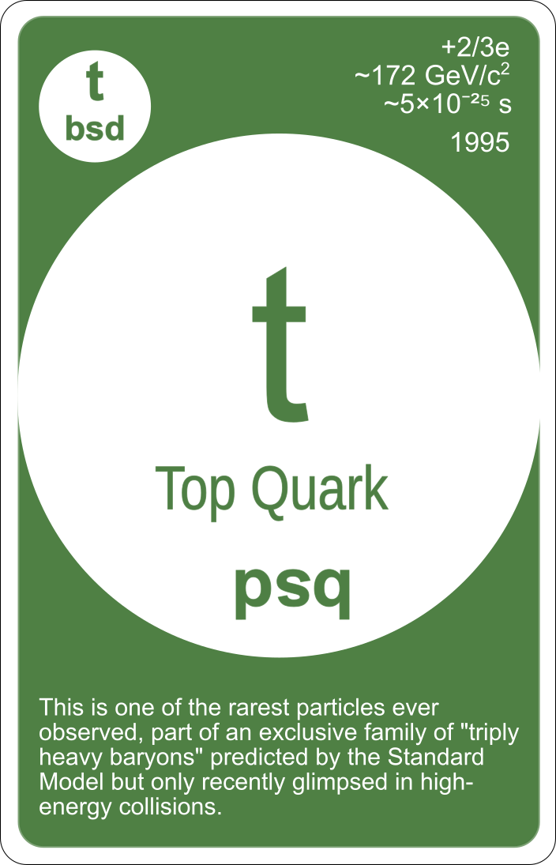Example, this TOP quark can decay. It will then be eligible to be used as a BOTTOM, STRANGE or DOWN quark.
Decaying a quark gives the player energy and creates new quarks that the player can use. To decay a quark, The player plays the quark in front of them, flipping the card upside down so the letters on the bottom of the card are face-up in front on the player. They player also takes one energy token for the energy released in the decay process.
A quark that has been decayed in front of a player can be used as any ONE of the quarks listed when the card is upside down. Additionally, when a quark has been decayed, it does NOT count towards a players hand limit.
For one action, the player places the TOP quark from their hand, upside down onto the table in front of them. They immediately take an energy token from the supply. This card is now available for the player to use as either a BOTTOM, STRANGE, or DOWN quark.
- Annihilate: A player may annihilate a quark & anti-quark pair to release and gain energy. There are two suits of quarks in the game: Quarks which are black and Anti-Quarks which are red and feature a line above the representative letter. There are also ranks of quarks across the suits. The order from the lowest rank is UP, DOWN, STRANGE, CHARMED, BOTTOM, and TOP.
Wen a player annihilates a pair of quarks, they discard a matching quark and anti-quark pair from their hands or the decayed quarks in front of them to the discard pile. They then immediately take the appropriate number of energy tokens from the supply and draw a new quark blindly from the quark draw deck. Some of the energy also spills off to the player’s left and right, with each player sitting to the left and right of the layer that initiated the annihilation receiving one energy from the bank. In a 2 player game, the other player still only receives one energy.
Annihilating a TOP and ANTI-TOP pair gains the player 8 energy. BOTTOMS = 6, CHARMED = 5, STRANGE = 4, DOWN = 3, AND UP = 2.
The energy returns are listed on one side of the player reference card.
Remember: you can use decayed quarks in front of you as part of the annihilation.
- Create: The most important part of the game is creating particles. To create particles, the player can use quark cards from their hand or from those decayed in front of them. There are three types of particles that a player can create: Mesons, Baryons, or Atomic Building Blocks. A player can create any of the faceup Meson or Baryon cards. They are also always able to build any of the two subatomic building blocks (protons & neutrons).
The process for creating any of the three particles is the same. The player discards the needed quarks from their hand and/or from quarks that have decayed in front of them. REMEMBER, a quark that is decayed in front of the player can only be used for ONE of the quarks listed at the top of the decayed card. Wherever the quarks come from, they are discarded to the quark discard pile. If one of the face up Meson or Baryons are created, the player takes the card from the faceup display and places it facedown in front of them. The card is immediately replaced with one from the draw deck. If a subatomic building block (proton or neutron) is created, they player simply takes one of the corresponding tokens from the supply.
When creating Baryons, a player can either create a quark or an anti-quark version of the baryon. this is indicated by the small anit-quark letters with lines above them in parenthesis below the quark letters on the card. Both versions score the same amount of points. For example, you could create a Lambda with uds, or you can create an anti-lambda with an anti uds.
Protons and Neutrons: When creating the atomic building blocks, Protons and Neutrons, players collect the tokens when they create them. Alone these particles are not worth anything at the end of the game. Instead the player will score points by using them to create the best Atom that they can using the particles and energy as electrons. For example, at the end of the game if a player had 3 Protons, 4 Neutrons and 3 energy they can create Lithium and score 90 points. If they have an extra Proton or Neutron, which isn’t enough to create Beryllium, those extra particles are not worth any points. Players only score points for the best atom that can be created, they can not create multiple smaller atoms, nor do they score points for each of the smaller atoms that can be created below the highest atom. Players only score for the highest scoring atom.
Missing a quark? When creating a particle, if a player doesn’t have all of the necessary quarks to create a particle they can transform ONE quark from the cards they have available in their hand or decayed in front of them. They can pay energy to transform the quark moving up the rank to meet the needed quark by paying one energy for each step they need to go up the ladder.
For example, if a player wanted to create a Proton which requires and UP, UP and DOWN they could use three UPs and pay one energy to transform one of the UPs into a DOWN. As another example, a player could pay two energy to transform a DOWN quark into a CHARMED.
Players may only transform ONE quark when creating a particle. It does not require an extra action, but it does use the card you are transforming.
Players can not transform down the ladder, only up. Additionally, quarks maintain their state, so anti- quarks remain an anti-quark during transformation and vice versa.

QUARK Game End
Play continues clockwise, with players taking turns until one of two conditions trigger the end of the
game.
- When the last card from any of the three draw decks are drawn
- A player creates Beryllium in a 2 or 3 player game, or a player creates Lithium in a 4 player game.
After the game end has been triggered, continue playing until the play returns to the start player giving each player an even number of turns.

QUARK Scoring
Players score points for the following:
- The points listed on the Particle Cards they collected during play
- For the highest level Atom they can create. Atoms consist of Protons, Neutrons and Electrons. At the end of the game players need to have collected the correct number of protons and neutrons during play. Plus they need to use one energy per electron needed. So for example, to create Lithium a player needs 3 Protons, 4 Neutrons and three energy tokens. Players only collect points for the highest atom they are able to create, not for all the atoms below it. Additionally, they can only create one atom and not multiple smaller ones.
- Any leftover energy tokens, not being used as electrons, count as 1 point each.

