**Tools used** : VS2019, .Net core 3.1 MVC, SQL Server, Entity Framework code first approach.

Since I had time over the weekend have implemented both ways of fetching data

1. **From XML (shows 4 locations)**

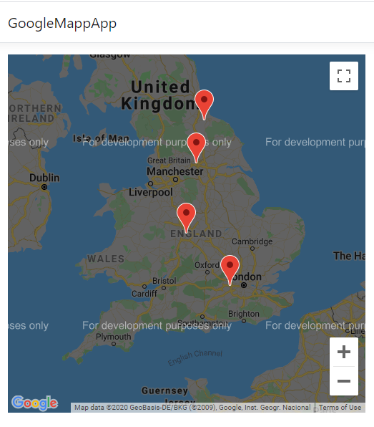

1. **From SQL Server DB (added another Manchester location)**

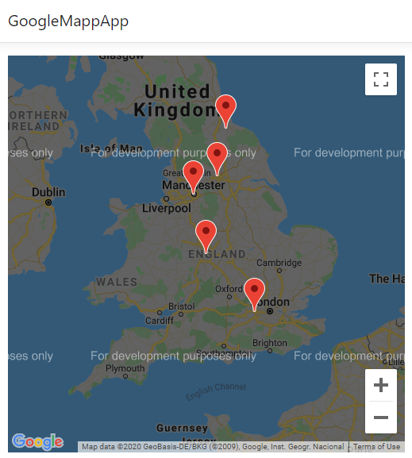

I have used a repository pattern. Single web api, calls required injected repo. One interface has two implementations as below:-



**Fetch from DB**

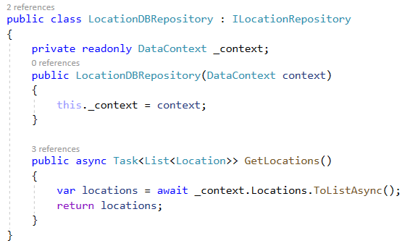

**Fetch from XML**

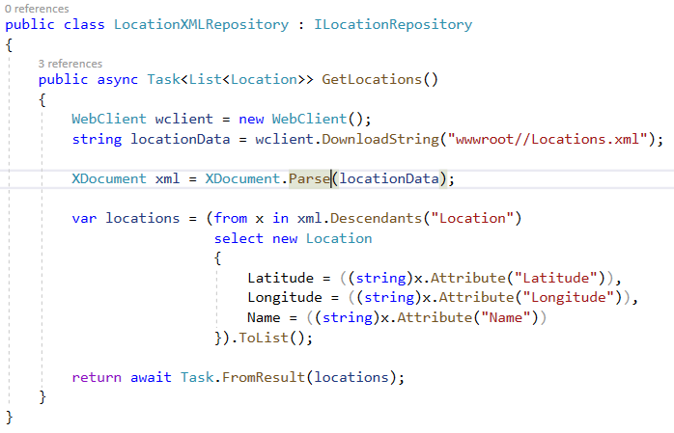

Only change should be done in StartUp file where below line needs to be commented/uncommented according to requirement. (ie either XML or DB implementation should be enabled)

Here particular repository is injected upon dependency. In this way, code is lighty coupled, maintainable and portable.

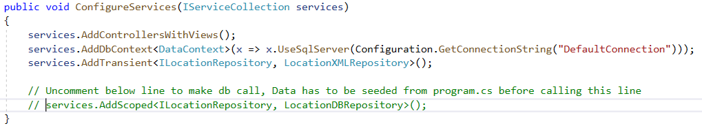

**Steps to add db call**

1. Change below to your sql server name

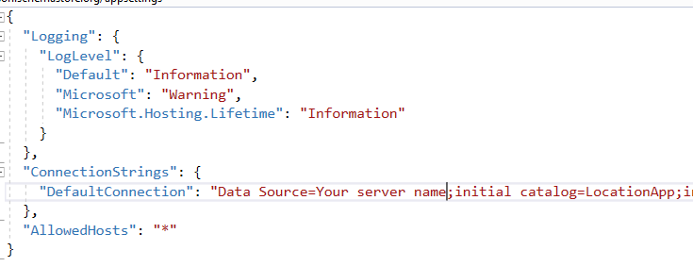

1. Uncomment below lines to create and seed db using entity framework migration

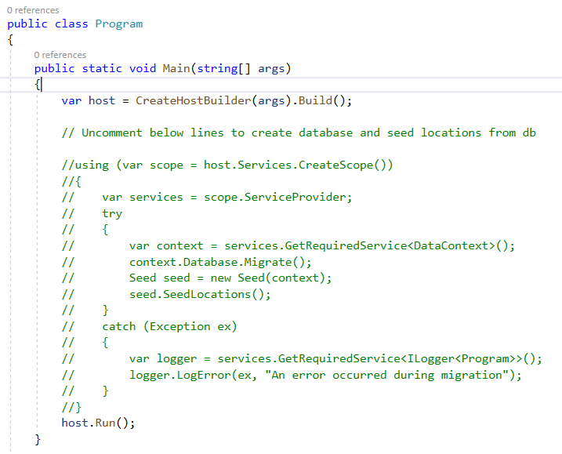

Below is the db table created

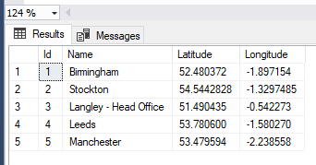

THANKS