**Stack :- VS Code, .NET Core 3.1, Angular 8, Entityframeworkcore, SQL Server, Web API, MS Test Cases, Bootstrap, Postman, .NET identity server, Repository pattern**

**Download project from github -**

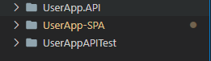

**Change your server name of Sql Server.**



**Navigate UserAPP.API > dotnet run**

**Navigate UserApp-SPA> ng serve**

**Db will be created and seeded with data from the json file. Below tables are created since using Identity server for role management.**

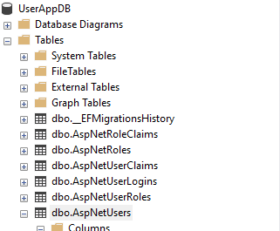

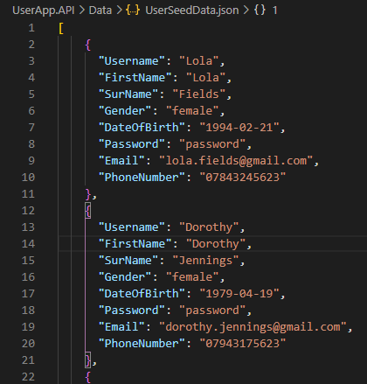

**Initial Login Page**

**Username : lola Password: password**

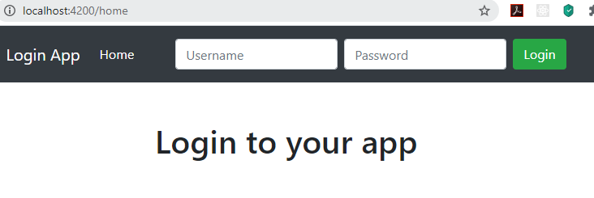

**Page with add and edit functionality**

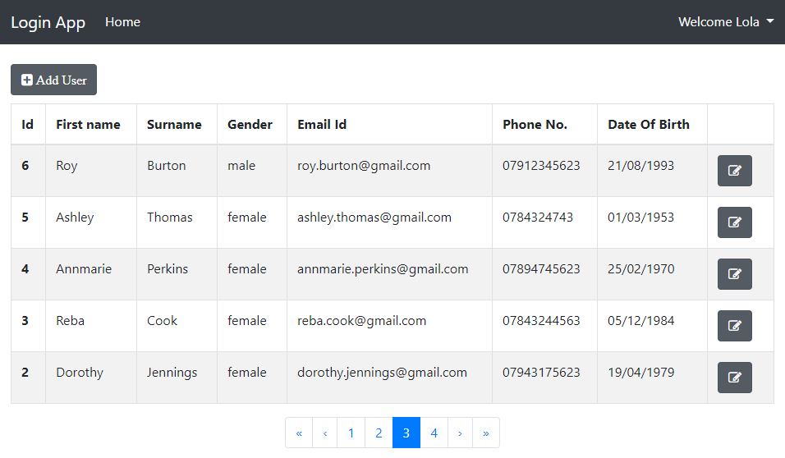

**EDIT/ADD page**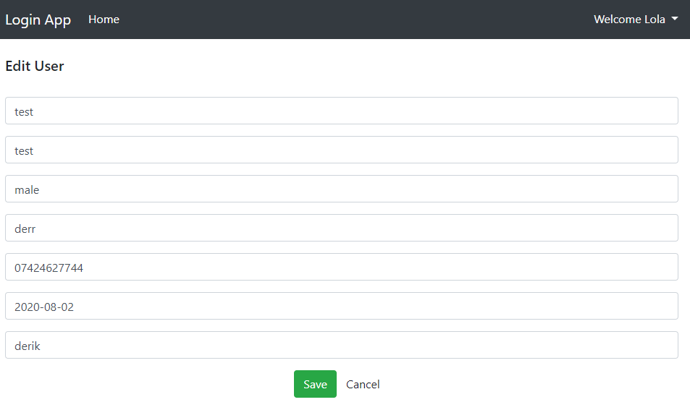

**Logout Option**



**Identity Server Db context**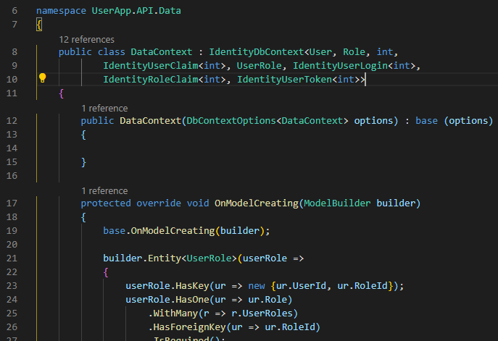

**PAGINATION Common helper. Additional pages can use this common helper**

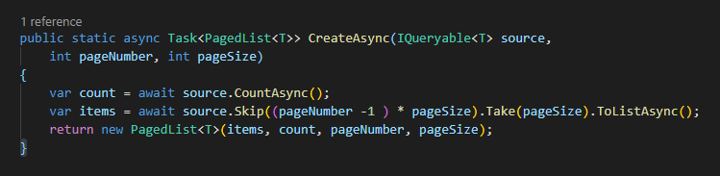

**ROUTING**

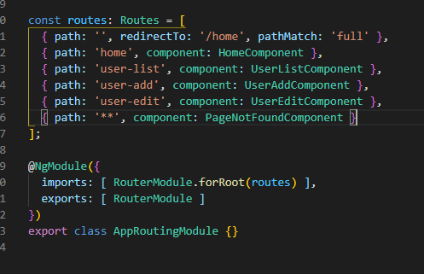

**Exception handling in production**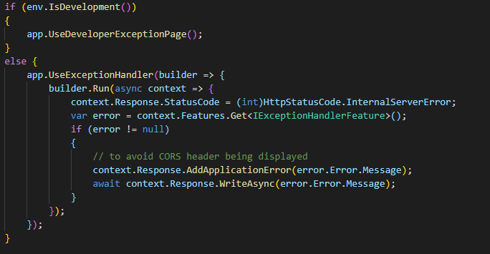

**Try Catch and logging of errors**

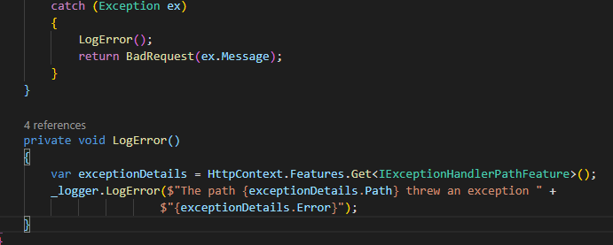

**TEST CASE INTEGRATION**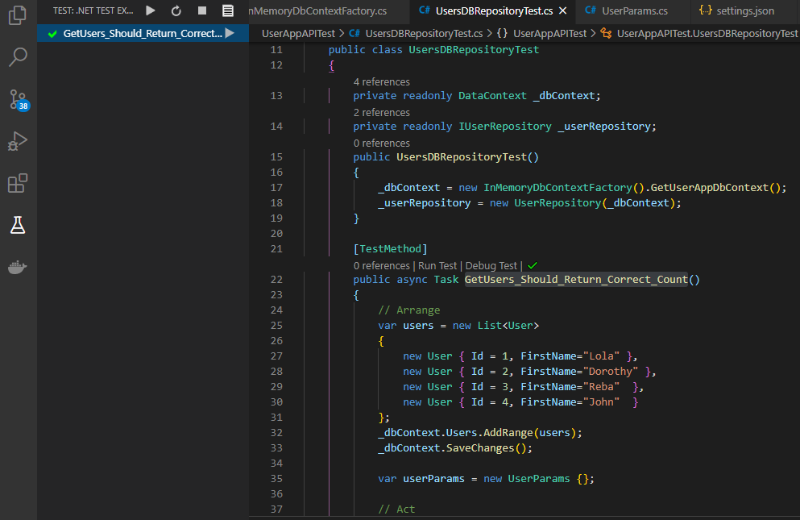

**Thank You**