Security Control Assessment and Coverage Guide
  - A practical workbook for personal security engineering labs
Use systems to build the inventory, then follow the data to verify coverage. This guide takes you from assessment and control design through implementation, verification, evidence, and remediation in your own lab.
The goal is to understand what each control protects and what your evidence actually proves. Use fictional or disposable data while practicing. A lab assessment is a learning record, not a certification of compliance.

Three questions for every system
Question | What it reveals | Evidence to seek
Where does data sit? | Storage and copies needing protection. | Encryption status, algorithm and key length, permissions, backup scope.
Where does data move? | Connections and boundaries to assess. | Protocol settings, negotiated encryption, endpoint validation, blocked insecure alternatives.
Who can access it and how? | Human and machine access paths. | MFA policy, roles, permissions, keys or tokens, positive and negative access tests.

Turn a requirement into a test
Example lab standard: sensitive test data uses AES-256 at rest; TLS services reject TLS below 1.2; interactive administrator access requires MFA through an approved path. Define approved alternatives for SSH, IPsec, and wireless protocols separately. These are practice requirements you choose, not universal requirements for every environment.
For each statement, identify the exact target, expected behavior, and proof. “The VM is secure” is too broad. “The application rejects a TLS 1.1 handshake at its HTTPS listener” is testable.

Keep three controls distinct
Encryption protects data. Authentication establishes identity. Authorization determines permitted actions. None of these proves the others. An SSH key or an API token alone is not evidence of MFA, and a certificate signature algorithm does not identify session encryption.

Map one complete lab workflow
Example: a browser accesses a test application through a reverse proxy. The application writes to a database, which has a backup. An administrator manages the application host through a separate access path.
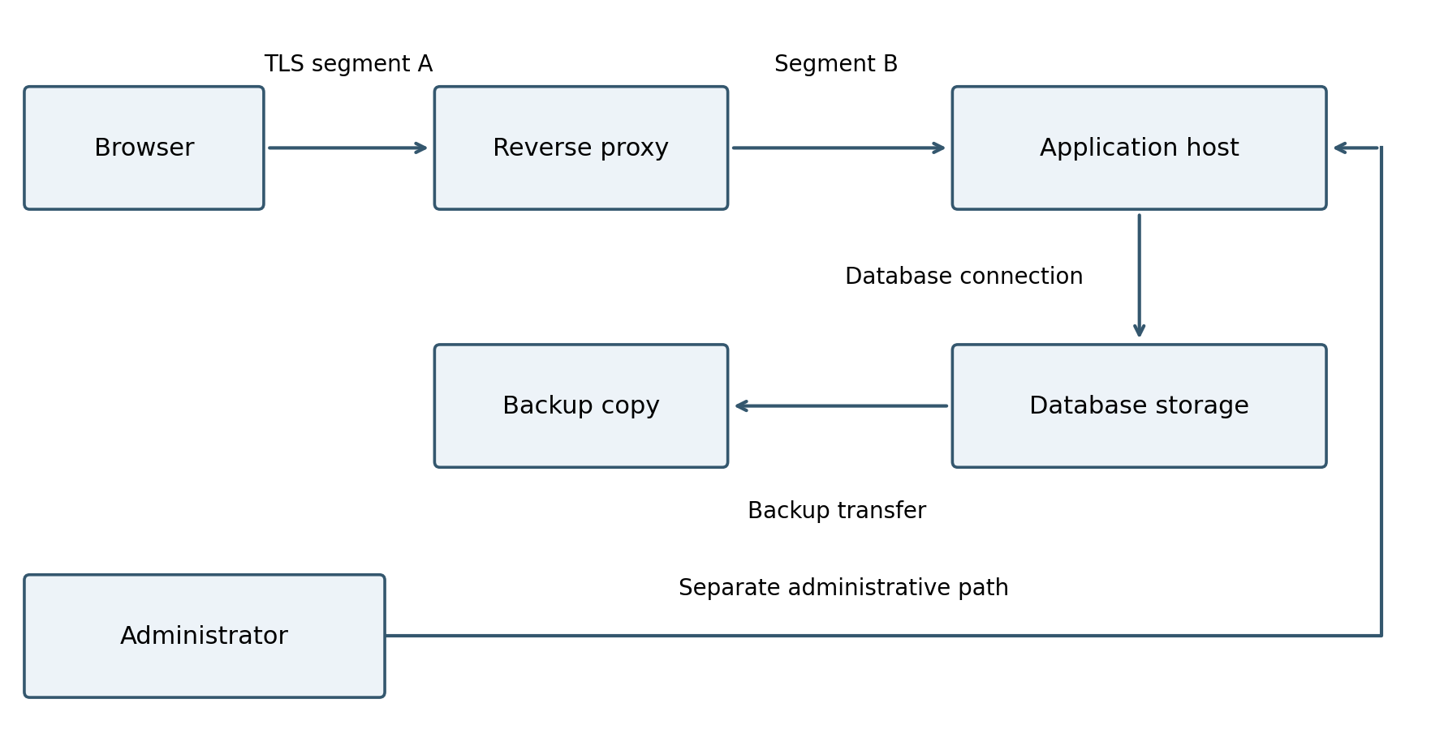
Boxes represent systems and data locations. Arrows represent connections. A box can have several disks, users, listeners, or credentials; an arrow can cross multiple trust boundaries.
Target | Questions to answer
Frontend and backend | Where does TLS terminate? Is the proxy-to-application segment protected?
Application and database | Are data, temporary files, database connections, and local credentials covered?
Backup path and copy | Is the transfer protected? Is the copy encrypted? Can it be restored?
Administrator path | Is MFA required? Which role is granted? Can an alternate route bypass it?
A trust boundary is a point where ownership, privilege, or trust changes: browser to service, proxy to backend, host to storage, or lab to cloud. Assess each segment instead of assuming protection continues through the boundary.

Choose the right verification targets
Begin with the assets you actually use. The examples below identify places to assess; they do not imply that a particular product already implements the control.
System | Stored data | Connections | Access
Linux or Windows VM | Virtual disks, logs, exports. | SSH, RDP, APIs, database traffic. | OS logins, sudo or administrator rights.
Web application | Database, uploads, sessions. | Client, proxy, backend, database. | Users, administrators, service identities.
NAS or file server | Volumes, shares, snapshots. | Management, SMB or NFS, sync jobs. | Web console, shell, share accounts.
Git service | Repositories, artifacts, backups. | Web HTTPS, Git SSH or HTTPS, CI. | Web MFA, keys, tokens, host administration.
Cloud resources | Volumes, objects, snapshots. | APIs, instance traffic, transfers. | Federation, CLI sessions, roles, keys.
Firewall or router | Configuration, credentials, logs. | Management, routing, VPN paths. | Console, SSH, privileged accounts.

Broaden beyond encryption and MFA
Control area | A useful lab verification
Least privilege | A standard test user can perform the intended task but cannot read another user’s data or change privileged settings.
Network exposure | An approved source can reach the service; an unapproved source cannot. Check alternate interfaces and routes.
Logging and detection | A controlled failed login appears with the correct user, source, and time; a configured alert is received.
Backup and recovery | Restore a disposable file or test service and record whether the chosen recovery targets were met.
Updates and secrets | Record versions and review credentials for scope, storage, expiration, and removal when no longer needed.
A VPN or private subnet controls only part of the picture. Review application protocols, endpoint validation, management access, and stored copies independently.

Implement the control deliberately
Implementation converts the requirement into an effective configuration at the correct layer. Write the verification tests before making the change so success has a clear definition.

1 Set the acceptance criteria
Define the exact asset, connection, or identity covered. Specify allowed and prohibited behavior. Example: the reverse proxy connects to the backend with TLS 1.2 or newer and validates the backend certificate and hostname.

2 Choose the enforcement point
Decide which layer can enforce the requirement: host, application, storage platform, identity provider, network, or cloud policy. Check dependencies and the installed version’s supported options using current official documentation. Document any path the selected control does not cover.

3 Prepare the baseline and recovery path
Save the relevant configuration and current test results. Use a disposable clone or snapshot where practical, verify recovery access, and define rollback steps and triggers. Keep an independent administrative session or console available when changing authentication or routing.

4 Apply one controlled change
Record the exact setting, command, or configuration change, including certificate and key placement where applicable. Protect secrets. Apply or reload the configuration using the supported procedure, then confirm that the effective runtime state matches the intended configuration.

5 Restrict bypass paths
Review old listeners, direct backend access, alternative identities, recovery flows, and persistent keys. Remove or restrict unintended alternatives only after the intended path works. Record any necessary exception and its scope.

6 Hand the change to verification
Record the implementation time, target version, configuration reference, test account, and expected results. Mark the control implemented but not yet verified until behavior testing is complete. If testing fails, troubleshoot or roll back, then repeat the tests.

Worked example backend TLS
Stage | Action or result to record
Before | Proxy to backend uses HTTP. The selected lab requirement is not met.
Implement | Enable backend TLS, install the correct certificate chain, configure proxy trust and hostname validation, and restrict plaintext access.
Verify | Secure requests succeed. Legacy TLS, an untrusted or mismatched endpoint, and any prohibited plaintext path are rejected. Isolate each test so the reason is clear.
Retain and review | Save effective settings and test output. Retest after proxy, application, certificate, or route changes.

Verify configuration and behavior
Use this sequence on systems you own or are authorized to test. Start read only, then use controlled tests and reversible changes in an isolated lab.

1 Define the objective
Choose one workflow and write a measurable requirement. Identify which assets and data are in scope, the expected protection, and the test that would demonstrate it. Record anything excluded and why.

2 Inventory and trace
List systems, versions, data classifications, storage copies, users, and service accounts. Trace normal operations, administration, file exports, backups, and recovery paths. Assign a stable identifier to each target.

3 Inspect the configuration
Capture the effective setting at the correct layer: storage, host, application, proxy, identity provider, or network. Distinguish a supported option from an enabled option, and an enabled option from enforced behavior.

4 Run positive and negative tests
Confirm an authorized secure action works. Then test that an insecure or unauthorized alternative is rejected. Record the exact target, test method, time, expected outcome, and actual outcome. Avoid altering primary accounts or locking yourself out.
Control | Positive test | Negative test
TLS minimum | TLS 1.2 or newer connects with valid endpoint identity. | An older protocol is rejected by the target, not merely unsupported by the test client.
MFA | A test user completes the approved factors. | A fresh, untrusted session cannot access the protected function without the required factors.
Authorization | A test user accesses its permitted resource. | The same user cannot access a separate restricted resource.
Storage encryption | The intended data location shows the required active encryption and coverage. | Review paths that could store plaintext copies, such as exports, temporary disks, or backups.

5 Explain the result
Record what the evidence proves, its limits, and the status. A cached MFA-authenticated session may legitimately reuse credentials. One successful TLS 1.3 session does not prove legacy rejection. A failed connection alone does not identify why it failed.

6 Remediate and retest
Use an approved or lab-safe change plan, preserve recovery access, apply the fix, and repeat the tests. Record residual gaps and the next review trigger. Retest after relevant configuration or architecture changes.

Keep a reusable coverage and evidence record
Create one record per control target or connection. This format works in a notebook, repository, or spreadsheet. Duplicate it as your lab grows.
Field | Fill in for your lab
Lab and target ID | Lab name: __________ Target ID: __________
System and version | Host or service: __________ Version: __________
Data and storage | Classification: __________ Locations and copies: __________
Connection or access path | Source: __________ Destination: __________ Human or automated: __________
Requirement | Expected protection and approved alternatives: __________
Existing configuration | Effective setting and where it is enforced: __________
Implementation record | Change reference: __________ Rollback plan: __________
Verification | Positive test: __________ Negative test: __________
Evidence references | Configuration: __________ Test output: __________ Logs: __________
Result and follow up | Status: __________ Limitation or gap: __________ POAM ID: __________
Review metadata | Collected by: __________ Date and time zone: __________ Next review: __________

Use precise status labels
Verified: the stated requirement is supported by evidence for the defined scope. Verification pending: information or testing is missing. Confirmed deficiency: observed behavior fails the requirement. Approved exception: an authorized decision accepts a defined deviation for a limited scope and period. For personal labs, record your own explicit acceptance decision.

Build an evidence package
Keep a short README describing the objective, architecture, procedure, expected and actual results, and conclusion. Link the configuration extract, test output, relevant logs, and remediation record. Use dated filenames and a version-controlled summary where appropriate.
Prefer readable exports and text results where available; screenshots can supplement them. Retain original evidence in restricted storage and make a sanitized copy for sharing. Exclude passwords, tokens, private keys, recovery codes, and MFA seeds. A file hash helps detect later changes but does not prove a control was effective.

Turn gaps into learning and remediation
A POAM is a Plan of Action and Milestones. Use it when a test fails or a verification task needs tracking. Keep discovery tasks distinct from confirmed deficiencies, and set closure criteria that can be tested.

Sample lab POAM
ID: LAB-001
Title: Unprotected proxy to application connection
Status: Open confirmed deficiency
Owner: Lab administrator
Priority: Medium for this isolated lab
Target date: Choose a realistic lab session date
Requirement: All sensitive test-data connections must use an approved encrypted transport.
Finding: The browser uses HTTPS to the reverse proxy, but the proxy forwards requests to the application over plaintext HTTP.
Risk: The backend segment does not meet the chosen lab requirement and could expose data if that path were observed or compromised.
Plan: Configure supported TLS on the application endpoint, update the proxy connection, and enable certificate and hostname validation. Test reachability from the intended proxy and review whether direct plaintext access remains available.
Milestones: Record the baseline; implement the change; run positive and negative tests; inspect logs; archive evidence and close the item.
Closure: The backend connection uses approved TLS, validates the intended endpoint, and has no unapproved plaintext alternative. Retain configuration and test evidence. If the design cannot meet the requirement, record the reason, compensating controls, accepted risk, and a review date.

Questions to ask after each lab
- Which storage location, connection, or identity did I overlook initially?
- Did I verify actual enforcement, or only observe a setting or successful session?
- Could another account, protocol, route, token, or recovery path bypass the control?
- Did I verify exported data, temporary files, snapshots, and backup copies?
- What would another person need to reproduce my conclusion?
- What change would invalidate today’s evidence and trigger a retest?

A useful standard for finishing
You can explain the architecture, identify where each requirement applies, reproduce the tests, show evidence, and describe what remains unverified. Start by completing one end-to-end workflow well, then repeat the same method across the rest of the lab.

