Understanding Security Control Coverage
  - A practical guide for AWS and on premises infrastructure
Security requirements describe what must happen to data. Your inventory describes the systems that handle it. Connect the two by identifying where sensitive data is stored, where it moves, and how people or services access it.
Use systems to build the inventory, then follow the data to verify coverage. Completing a phase organizes the assessment; retained evidence establishes whether the control is implemented and effective.

Three questions for every system
Question | Control to assess | Typical evidence
Where does data sit? | Encryption at rest | Encryption status, algorithm, AES key length, and storage coverage.
Where does data move? | Encryption in transit | Protocol configuration, negotiated encryption, and rejection of insecure alternatives.
Who can access it and how? | Authentication and authorization | MFA enforcement, permissions, credential controls, and sign in tests.

Keep the controls separate
An encrypted connection does not establish MFA. MFA does not establish storage encryption. A valid certificate does not, by itself, identify the negotiated TLS version or prove that older TLS versions are rejected.
For Confidential and Restricted data, verify AES-256 at rest at every in-scope storage location. For TLS-based connections, verify TLS 1.2 minimum and TLS 1.3 where supported under the approved standard. Assess SSH, IPsec, and wireless encryption against explicitly approved protocol and algorithm requirements.

A system is more than one verification target
A NAS includes volumes, DSM sign ins, SSH access, file shares, snapshots, and backup transfers. Each has its own configuration and evidence. Marking the NAS as a whole “encrypted” hides these differences.

Example NAS transfers to EC2
Your EDA and ML NASs transfer data to two EC2 instances using rsync tunneled through SSH. Apply this model to every actual source and destination pairing; the diagram shows one representative path.
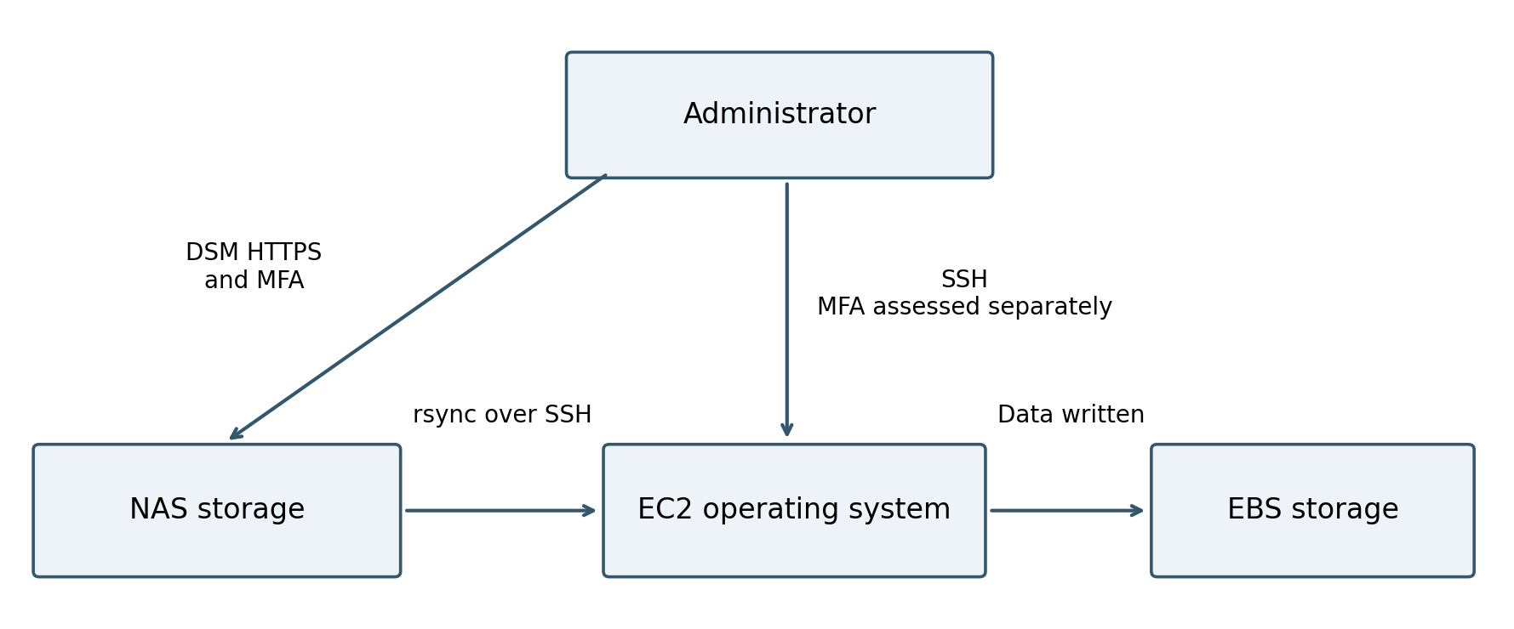
Boxes identify processing or storage locations. Arrows identify connections. Administrative access adds its own connection and authentication checks.
Verification target | What to verify
NAS storage | Sensitive data is on storage with verified AES-256 encryption coverage.
NAS to EC2 transfer | Every in-scope rsync job uses SSH with approved algorithms and destination host verification.
EC2 destination storage | Sensitive files and results land on encrypted EBS volumes, including any staging locations.
DSM access | HTTPS protection and MFA enforcement are verified separately.
EC2 administration | SSH encryption and the applicable MFA access control are verified separately.

Backups, replicas, snapshots, and exported files create additional copies to assess. Evidence for the primary data store does not automatically establish protection of those copies.

Apply the model across the environment
Use the same questions for AWS, GitLab, NASs, and the customer portal. The entries below are assessment targets, not statements that controls have already been verified.
System | Stored data | Connections | Access paths
AWS EC2 | EBS volumes, application data, backups. | SSH, application requests, database connections, exports. | AWS console and CLI; operating system logins.
Amazon S3 | Objects and applicable copies. | Uploads and downloads through S3 endpoints. | Console, APIs, roles, access keys.
GitLab | Repositories, database, artifacts, backups. | Browser HTTPS, Git SSH or HTTPS, integrations. | Web login, Git credentials, API tokens, server administration.
NASs | Volumes, snapshots, backups. | DSM HTTPS, SSH, file sharing, rsync. | DSM users, SSH users, service accounts.
Customer portal | Application and database storage. | User to frontend, frontend to backend, backend to database. | Customer and administrator accounts; application identities.

Network infrastructure controls the paths
VPCs, firewalls, switches, and wireless access points carry or restrict connections. Their presence alone does not establish encryption for every flow. Assess their own management access and sensitive locally stored configurations, credentials, or logs as well.
A private subnet and a security group restrict reachability; they do not establish application TLS enforcement. VPC encryption monitoring provides another source of evidence, but it must be interpreted within its scope.

Check every segment of a connection
If HTTPS ends at a load balancer or reverse proxy, the connection to the backend is a separate segment. Verify that segment and any database or external-service connection. Likewise, an IPsec VPN protects the traffic within the tunnel; it does not establish TLS enforcement or protection beyond the tunnel endpoints.

Treat human and automated access separately
DSM MFA does not establish SSH MFA. AWS console MFA does not automatically establish MFA for access keys, direct SSH, or customer-portal logins. Automated rsync jobs and application credentials need their own ownership, permissions, credential lifecycle, and exception records where required.

Build a coverage register
Start with Confidential and Restricted data. Trace each storage location, connection, and access method, then attach evidence to the relevant target. The same system can appear in several rows.
Use these fields in a spreadsheet or repository table. Together they make the assessment traceable across your ten phases.
Field | What to record
Data or service | Name and data classification.
Stored where | Asset and exact volume, bucket, database, backup, or other location.
Source and destination | Both ends of the connection, including intermediate termination points.
Protocol and control | TLS version policy, SSH, IPsec, at-rest encryption, MFA, or access restriction.
Evidence | Dated configuration record, test result, or log reference.
Status | Verified, verification pending, confirmed deficiency, or approved exception.
POAM reference | Related finding, owner, target date, and closure evidence.

Example register entry
Data or service: NAS export containing sensitive results. Stored where: NAS volume and destination EC2 EBS volume. Source and destination: NAS to EC2. Protocol: rsync over SSH. Evidence: transfer configuration and connection results pending. Status: verification pending. POAM: NAS-to-EC2 Data Transfer Encryption.

Use a repeatable assessment sequence
- Identify the data and its classification, then list all storage locations and copies.
- Draw or list the source and destination of every in-scope transfer and access path.
- Assign the applicable storage, transit, and authentication requirements to each target.
- Collect configuration evidence and test actual behavior, including insecure alternatives where appropriate.
- Record the result and create a POAM for confirmed deficiencies or missing verification evidence.
- Close the item only when evidence meets the stated closure criteria; track approved exceptions and review dates separately.

Keep evidence and status precise
Use configuration exports, relevant logs, and documented tests where available. Screenshots can supplement them. Record the asset, date, scope, collector, and reviewer; exclude passwords, recovery codes, MFA seeds, and private keys.
A successful TLS 1.3 session proves that session, not rejection of older TLS. Missing evidence is a verification gap, not proof of a failed control. The goal is to know which location or connection you are assessing, which requirement applies, and what evidence establishes coverage.

