Iris Flower Dataset Analysis

A classic dataset in statistical classification

Deri Siswara

## Species of Iris Flowers

# Summarize iris data by species  
iris_summary <- iris %>%  
 group_by(Species) %>%  
 summarize(  
 "Sepal Length" = mean(Sepal.Length),  
 "Sepal Width" = mean(Sepal.Width),  
 "Petal Length" = mean(Petal.Length),  
 "Petal Width" = mean(Petal.Width)  
 )

The dataset contains three species of Iris flowers: **setosa, versicolor, virginica**. The species with the largest average sepal length is **virginica**.

iris %>%  
 ggplot(  
 aes(x = Sepal.Length, y = Sepal.Width, color = Species)  
 ) +  
 geom_point(size = 3, alpha = 0.7) +  
 labs(  
 title = "Iris Sepal Dimensions by Species",  
 subtitle = "Comparing sepal length and width across three iris species",  
 color = "Species",  
 caption = "Source: Fisher's Iris dataset (1936)"  
 ) +  
 xlab("Sepal Length (cm)") +  
 ylab("Sepal Width (cm)") +  
 scale_color_brewer(palette = "Dark2") +  
 theme_minimal() +  
 theme(  
 plot.caption.position = "plot",  
 legend.position = "top"  
 )

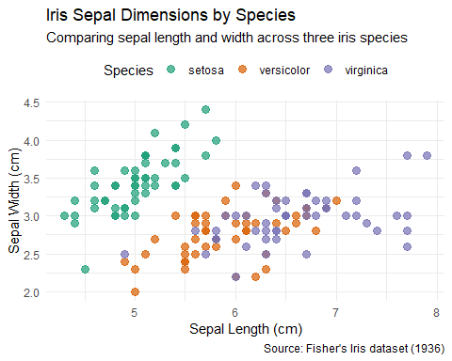

## Petal Characteristics

iris %>%  
 ggplot(  
 aes(x = Petal.Length, y = Petal.Width, color = Species)  
 ) +  
 geom_point(size = 3, alpha = 0.7) +  
 labs(  
 title = "Iris Petal Dimensions by Species",  
 subtitle = "Comparing petal length and width shows clear species separation",  
 color = "Species",  
 caption = "Source: Fisher's Iris dataset (1936)"  
 ) +  
 xlab("Petal Length (cm)") +  
 ylab("Petal Width (cm)") +  
 scale_color_brewer(palette = "Dark2") +  
 theme_minimal() +  
 theme(  
 plot.caption.position = "plot",  
 legend.position = "top"  
 )

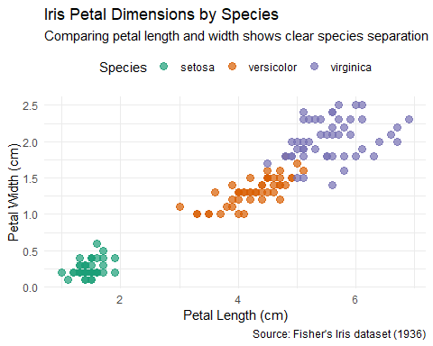

## Correlation Between Measurements

iris %>%  
 pivot_longer(cols = -Species,   
 names_to = "Measurement",   
 values_to = "Value") %>%  
 ggplot(aes(x = Measurement, y = Value, fill = Species)) +  
 geom_boxplot() +  
 labs(  
 title = "Distribution of Iris Measurements by Species",  
 subtitle = "Boxplots showing the range of values for each measurement",  
 fill = "Species",  
 caption = "Source: Fisher's Iris dataset (1936)"  
 ) +  
 theme_minimal() +  
 theme(  
 plot.caption.position = "plot",  
 legend.position = "top",  
 axis.text.x = element_text(angle = 45, hjust = 1)  
 )

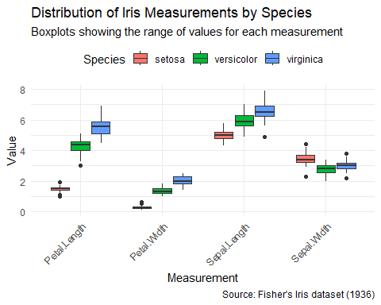

## About the Dataset

The Iris flower dataset is a multivariate dataset introduced by the British statistician and biologist Ronald Fisher in his 1936 paper. It includes 50 samples from each of three species of Iris:

* Iris setosa
* Iris virginica
* Iris versicolor

Four features were measured from each sample: the length and width of the sepals and petals.

This dataset is often used for classification tasks in machine learning and statistics as a standard testing dataset.