**Krisztian Der Cohort E17 PDA**

**DOB: 13/10/1985**

**Address: 2 Carrick Knowe Hill, Edinburgh, EH12 7BS**

**Evidence for Analysis and Design Unit**

A.D 1 Use Case Diagram

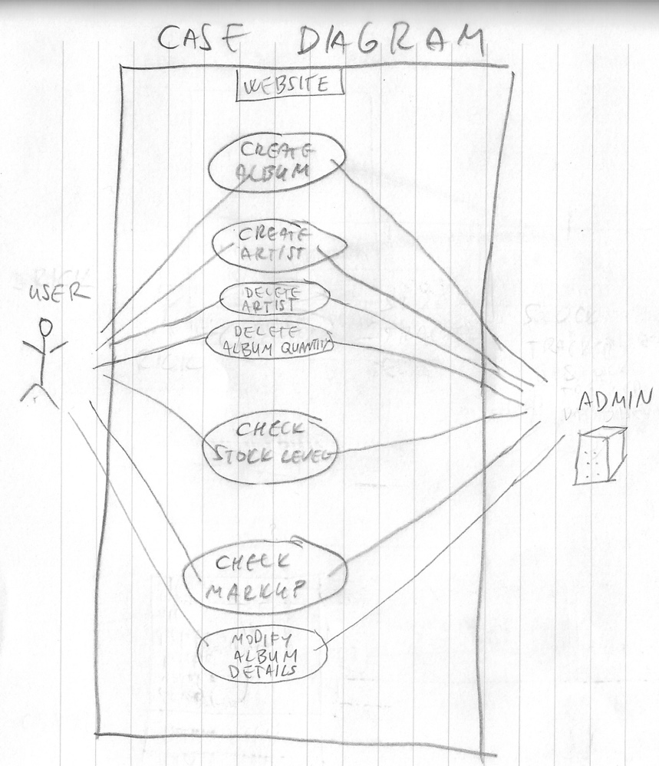

A.D 2 Class Diagram

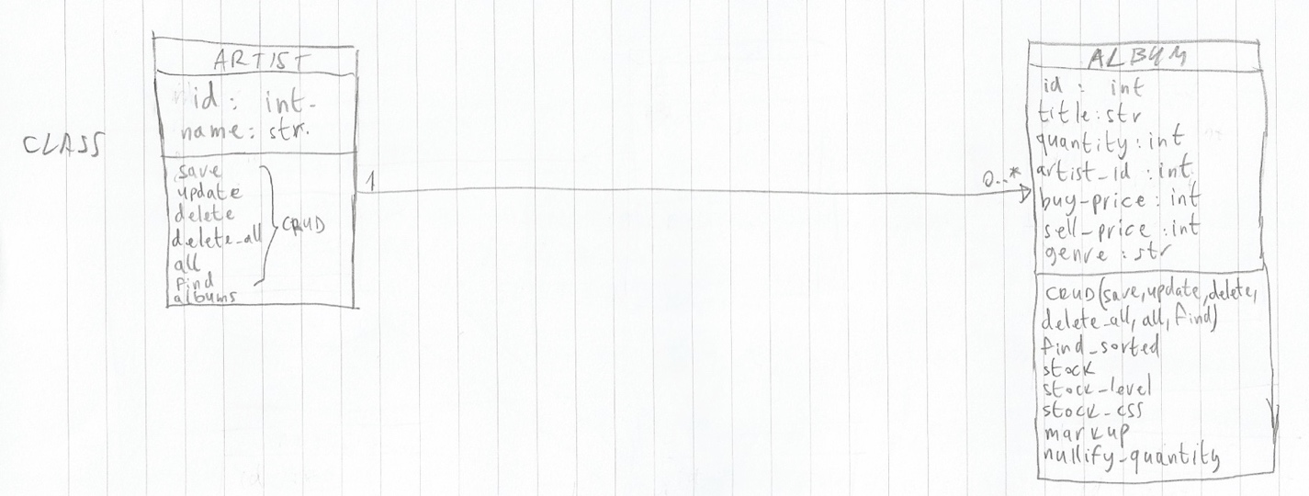

A.D 3 Object Diagram

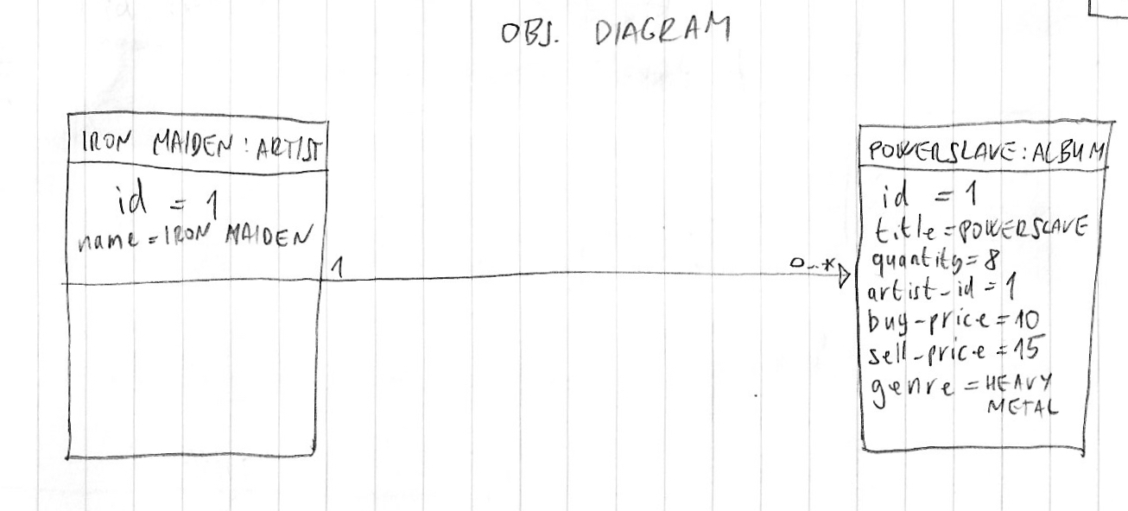

A.D 4 Activity Diagram

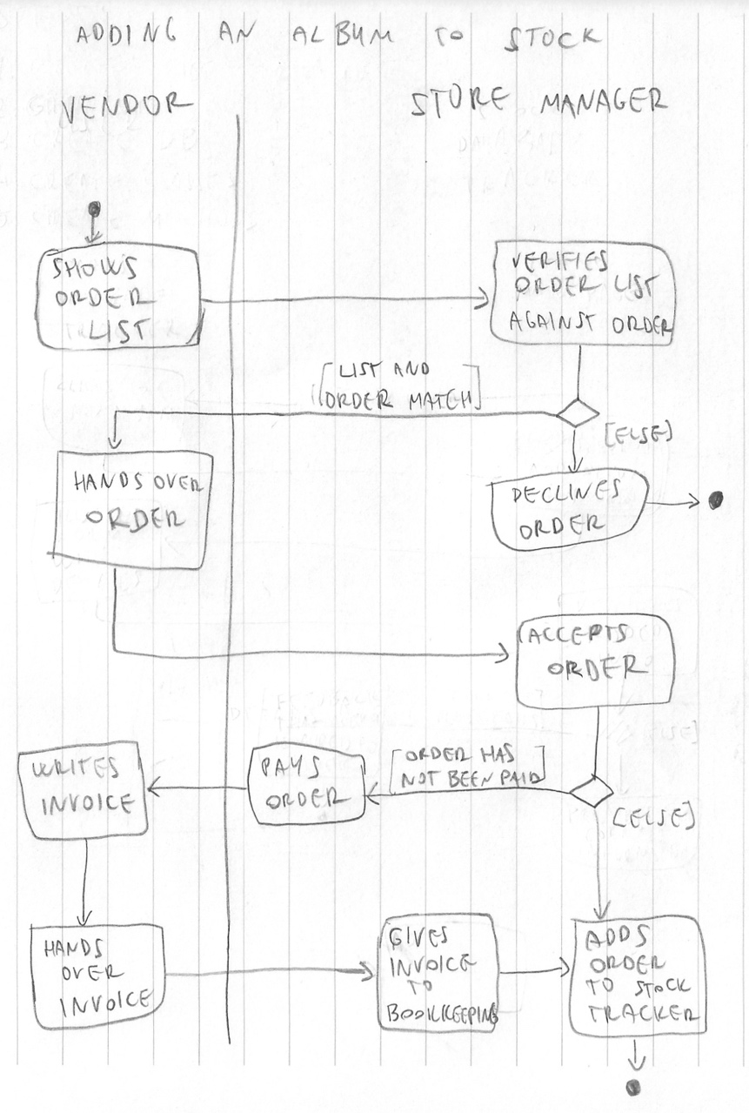

A.D 5 Inheritance Diagram

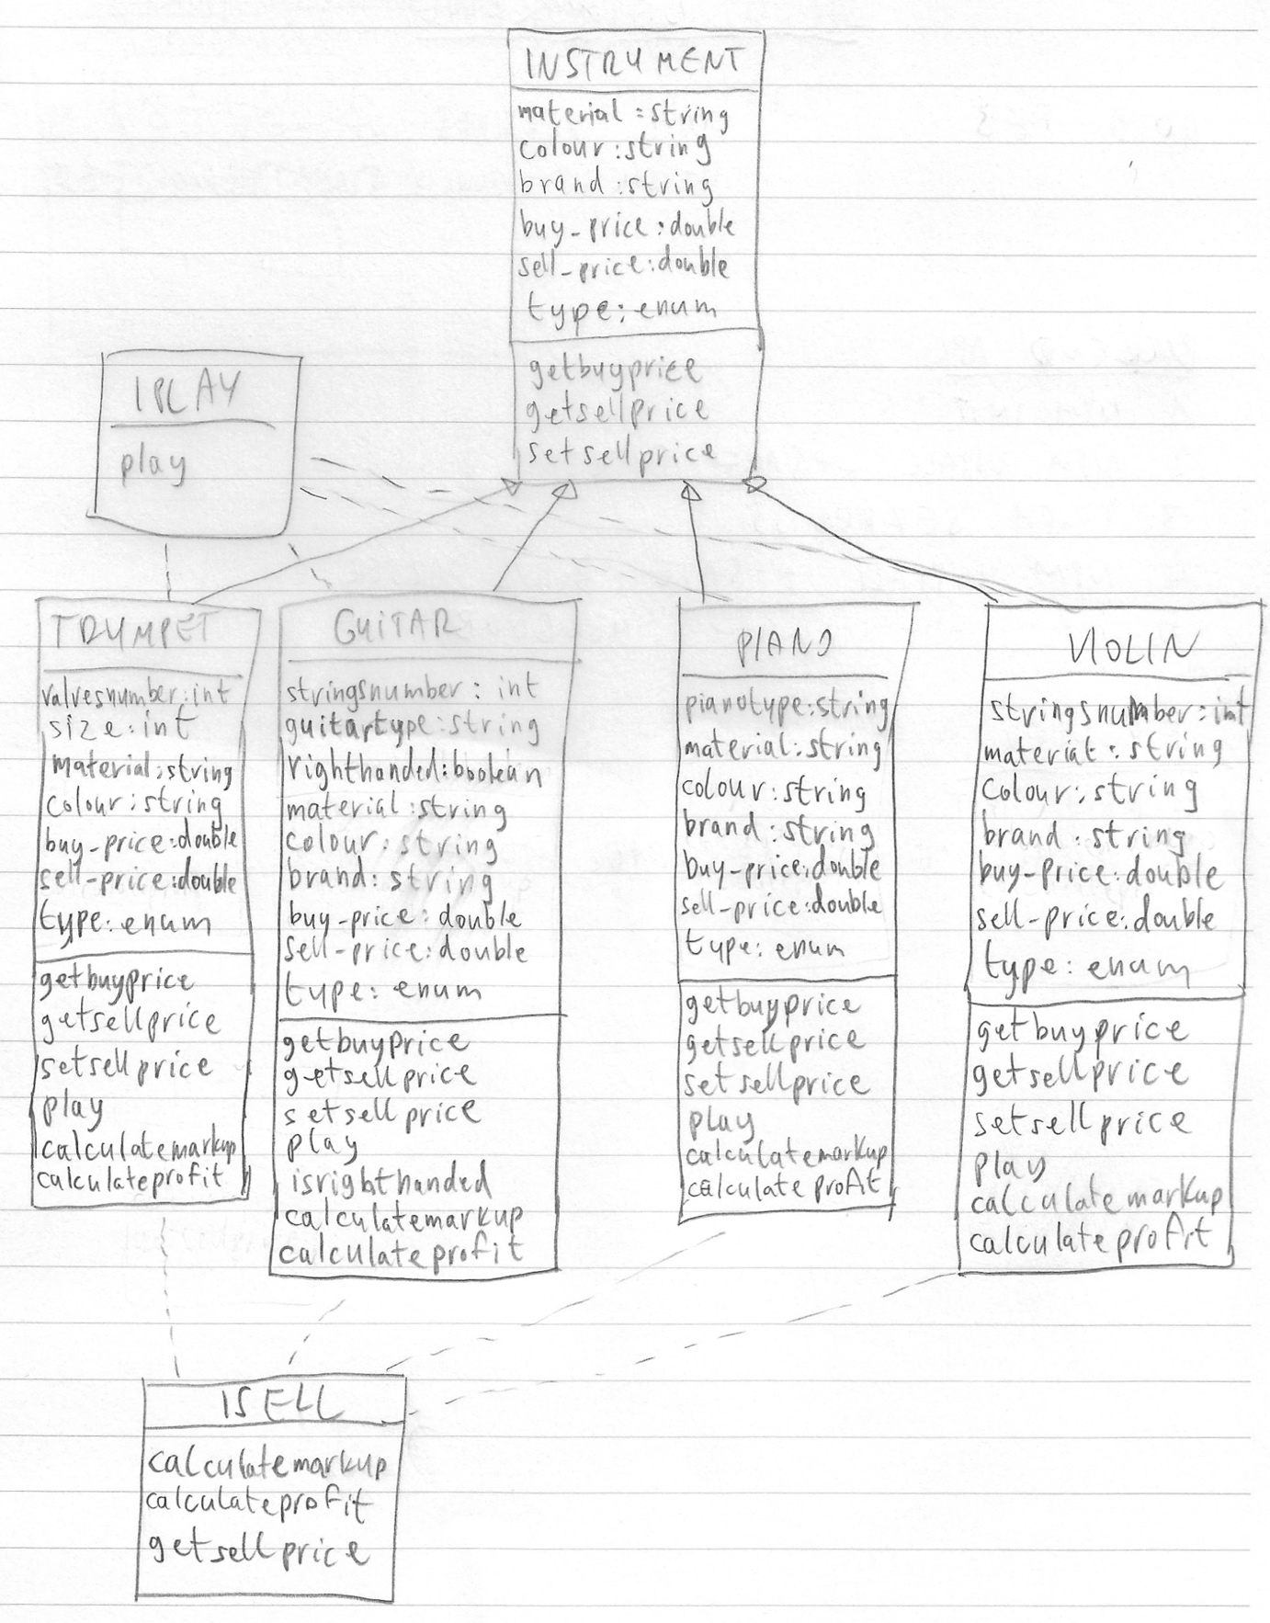

A.D 6 Implementations Constraints Plan

