**Krisztian Der Cohort E17 PDA**

**DOB: 13/10/1985**

**Address: 2 Carrick Knowe Hill, Edinburgh, EH12 7BS**

**Evidence for Project Unit**

P 5 User Sitemap

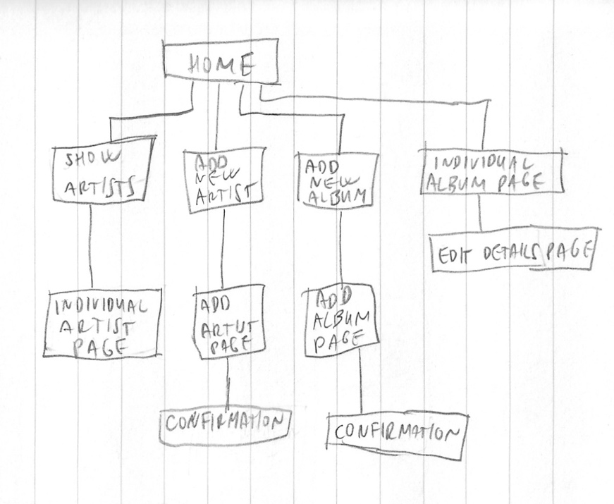

P 6 Wireframe designs

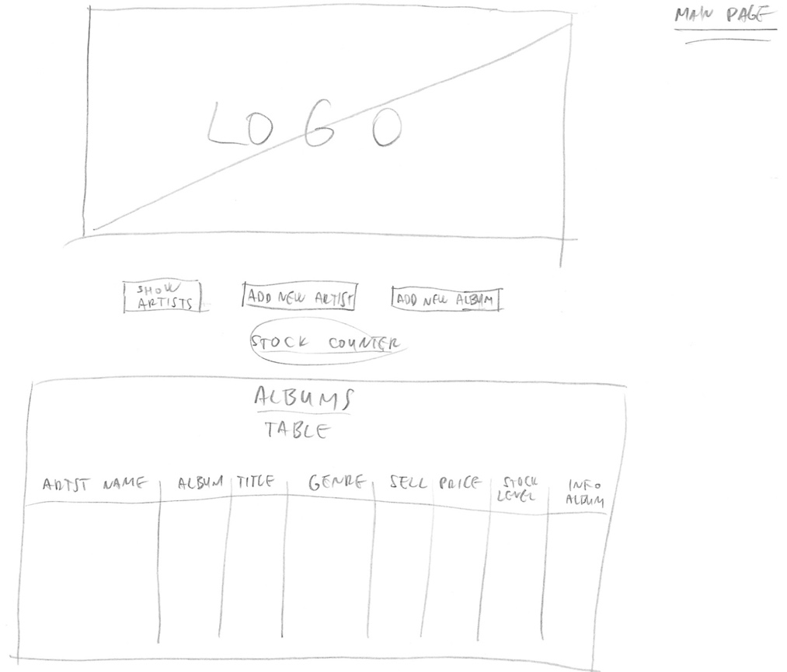

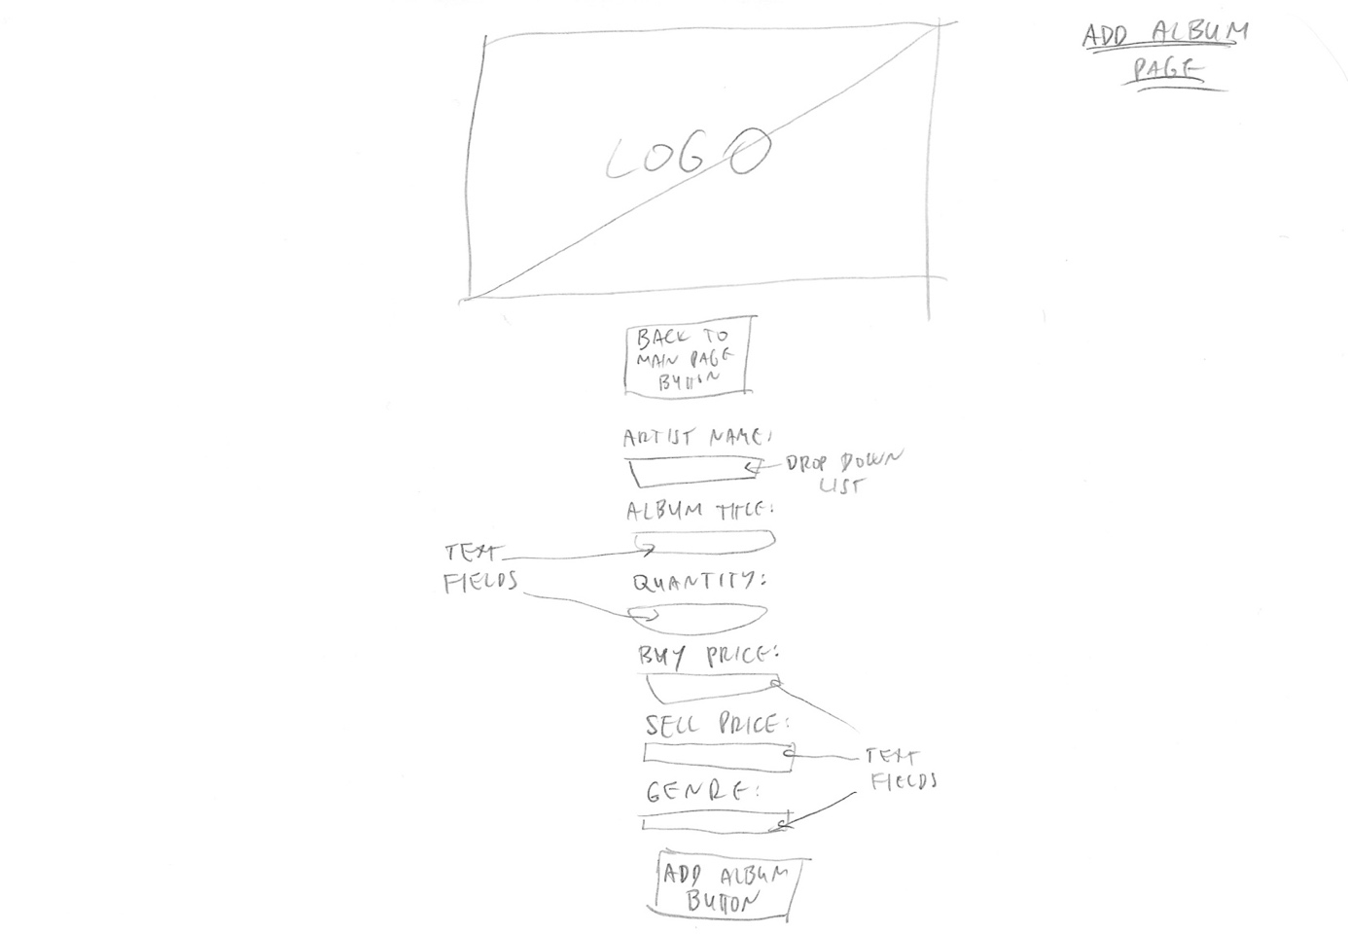

P 10 Pseudocode for a function

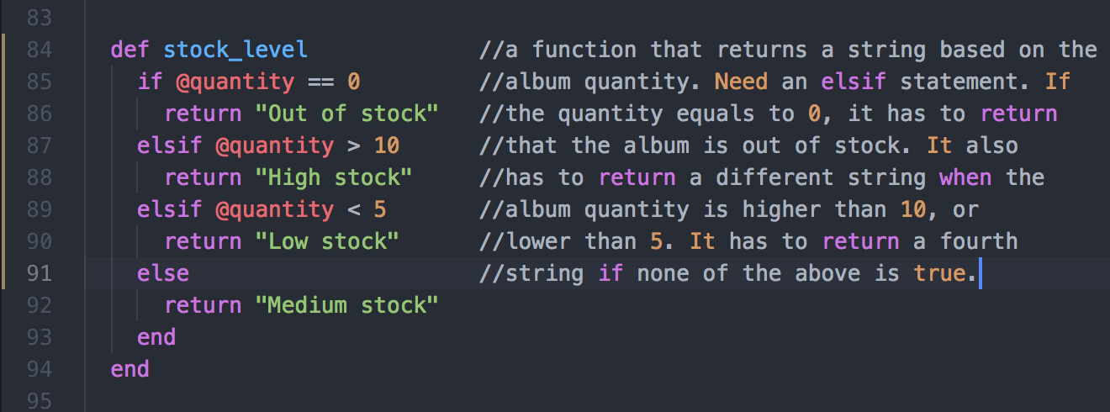

P 11 Own project and Github link

<https://github.com/derkrisz/project_todo_list>

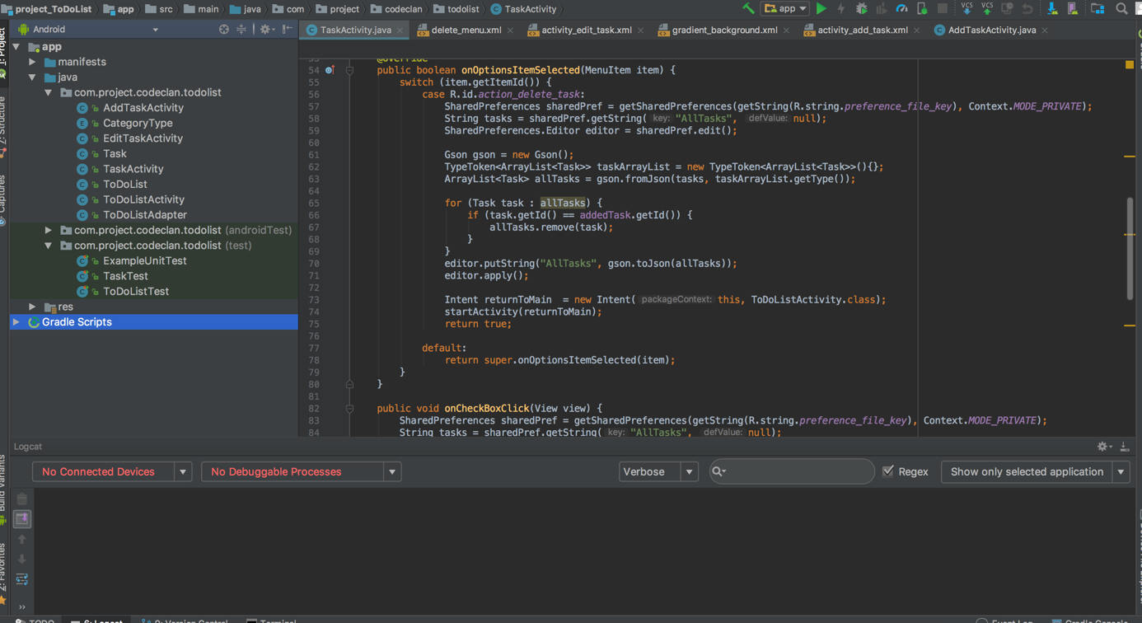

P 13 User input

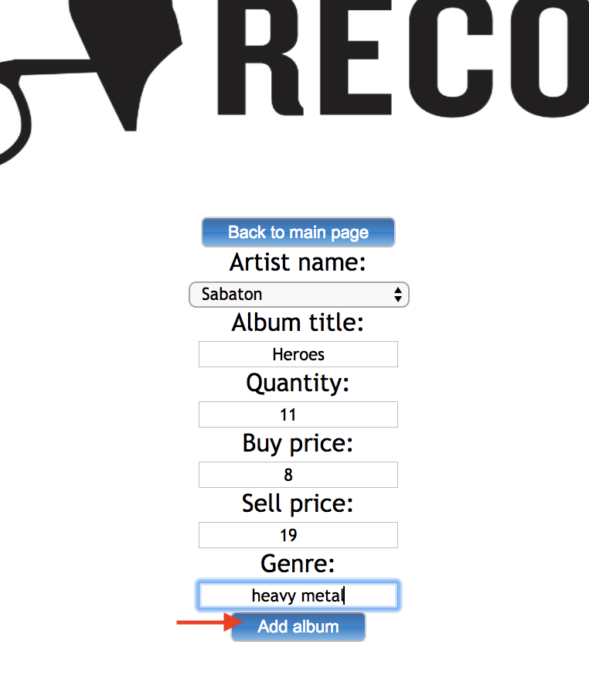





P 14 Interaction with data persistence

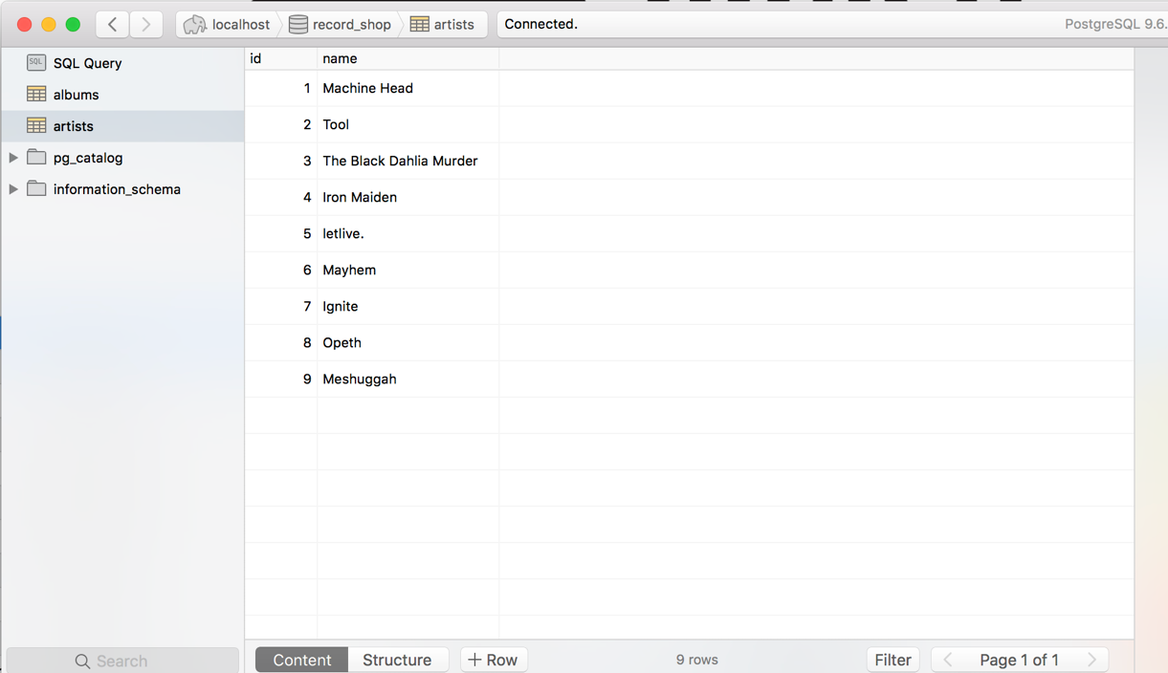

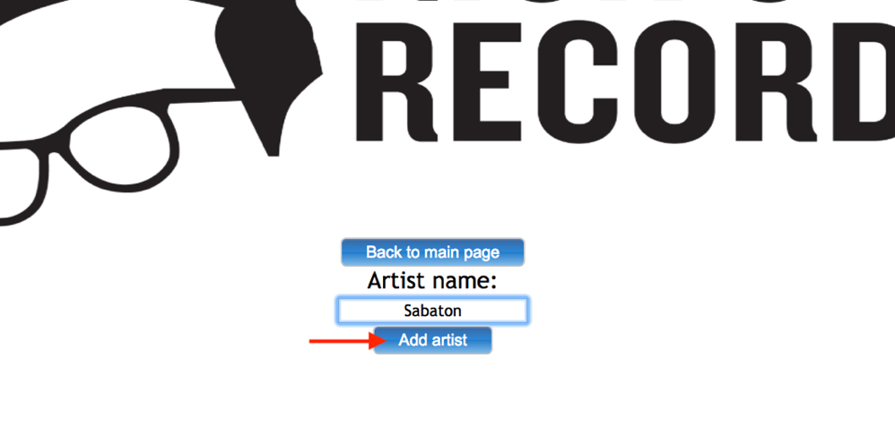

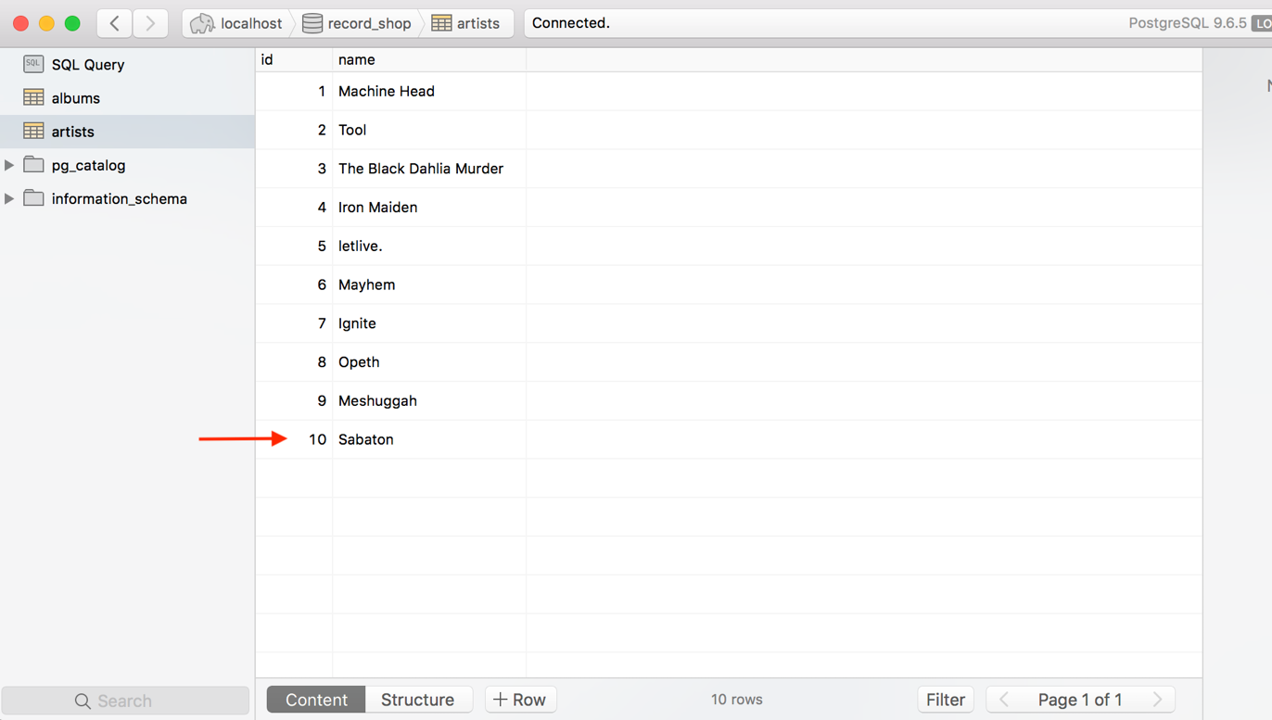

P 15 User output result

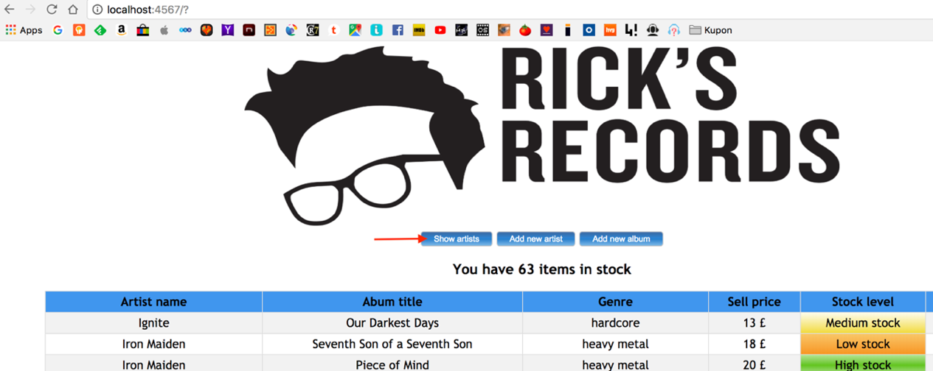

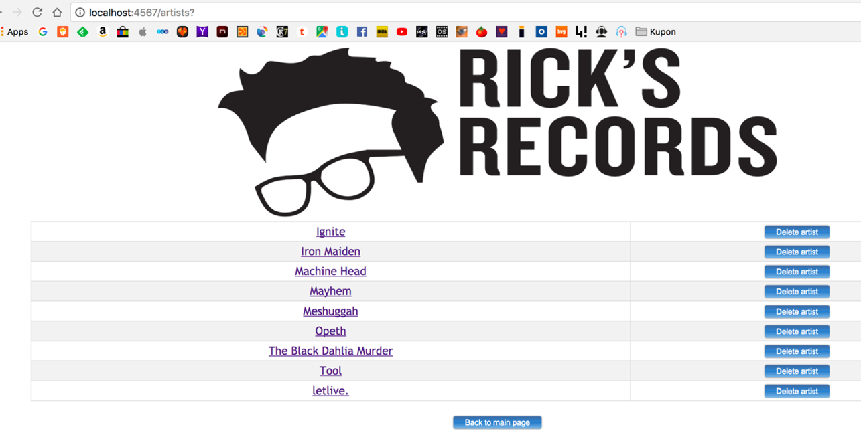

P 18 Demonstrate testing in a program

