**Krisztian Der Cohort E17 PDA**

**DOB: 13/10/1985**

**Address: 2 Carrick Knowe Hill, Edinburgh, EH12 7BS**

**I.T 5**

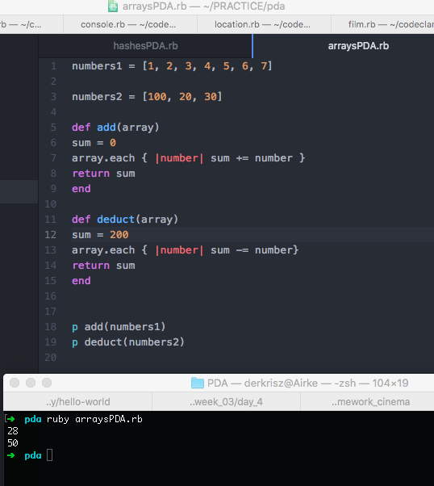

**I.T 6**

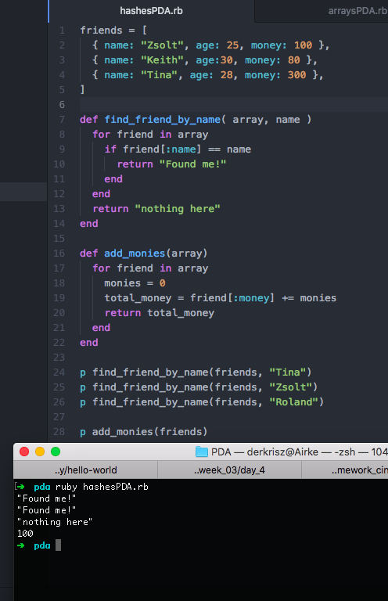

**I.T 3**

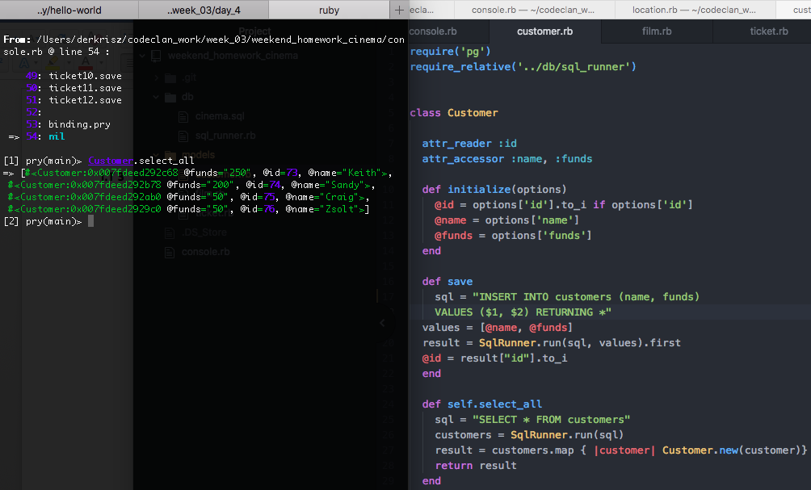

**I.T 4**

