**Title: The title goes here**

Myself, and authors

Target 3500 words

The abstract.

# ***___***

# **Introduction**

Please note that the line above the Introduction is required to separate the content from the title page. You can cite an article like this \‎cite{Eapen2020}. This citation is inserted by Zotero using the style provided with the paperaj template here <https://github.com/dermatologist/paperaj/blob/master/word2latex-pandoc.csl>. You can just insert citation in the above format. Table number and title should be at the top of the table and can be referred inline like Table_1.

Table 1: Ranking according to the lesion count

|  |  |  |
| --- | --- | --- |
| Rank | Numeric | Lesion count |
| Mild | 1 | 0-5 |
| Moderate | 2 | 6-20 |
| Severe | 3 | 21-50 |
| Very severe | 4 | >50 |

Figure 1: Multimodal machine learning with kedro-multimodal.

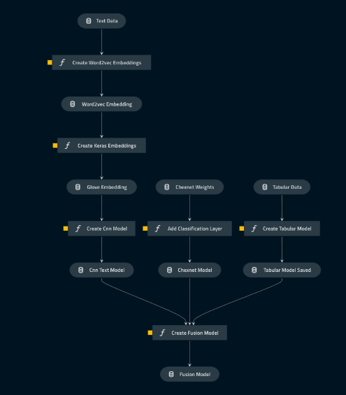

Figures should also have the number and title at the top and can be cited inline like Figure_1.

# **More subheadings**

More content.

# **Acknowledgements**

The demonstration images were kindly provided by Dr XXXX and were used with permission.

# ***References***

Automatic citation updates are disabled. To see the bibliography, click Refresh in the Zotero tab.