Caliph & Emir HowTo

Homepage: http://www.semantic-metadata.net
Mathias Lux, mathias@juggle.at

How to create annotations with Caliph
Before creating descriptions with Caliph you will have to find some photos you want to annotate. After putting a copy of the selected photos in a separate folder for annotation you can start Caliph.

Selecting a photo for annotation
On the left hand side of Caliph you will find a table showing the available drives and all files and folders in the current folder. With one single click you can select the drive or folder you want to navigate to. Navigate to the folder where you stored the photos for annotation. A single click on a photo opens the file, a preview is shown in the lower left border.

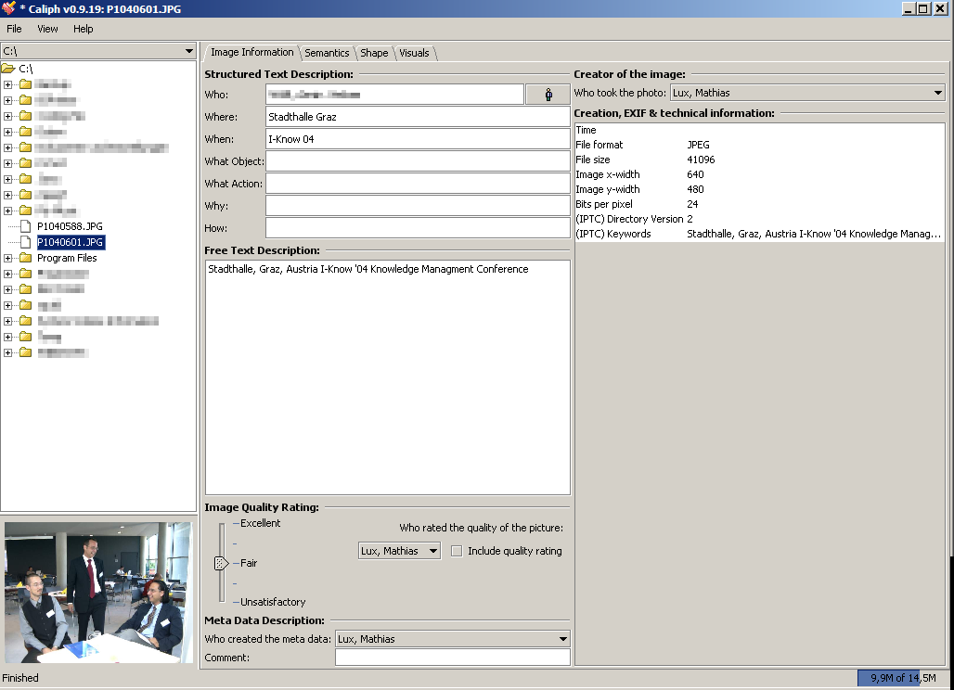
Shows preview when file is loaded
Use this tree to navigate through file system

Creating the basic annotation
After selecting a photo you can fill the available text fields with your information. Defining the creator of an image and the metadata itself uses MPEG-7 based agents. To create such an agent use the drop down list and select New agent … After filling out the form the newly created agent will be available in all drop down lists.

Creating a semantic annotation
Using the second tab named Semantics a semantic graph can be created, but before you can create the graph you have to create the nodes that you will use. These nodes will be stored in a separate file when Caliph exits which allows you to reuse them later on.
To create a new agent, event or semantic object just click new below the list of agents, objects or events on the left hand side.

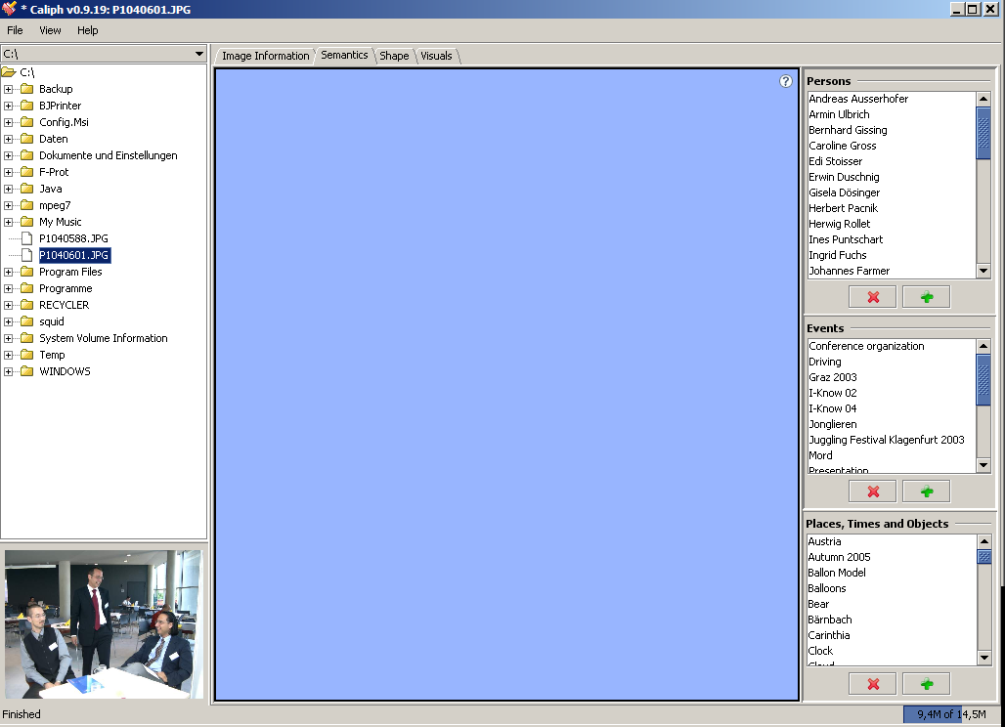
In this example we will create a new Agent, so we click on the button on the top. A new dialog will appear where you can fill in the data about the agent:

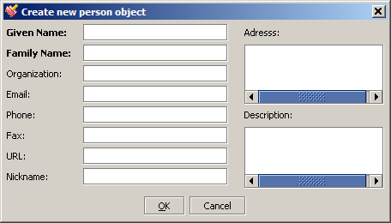

After filling in all values click the OK button and the agent will be available in the list. To create a graph from the semantic objects, agents and events just click and drag any entry from one of the three lists to the blue panel and drop it there:

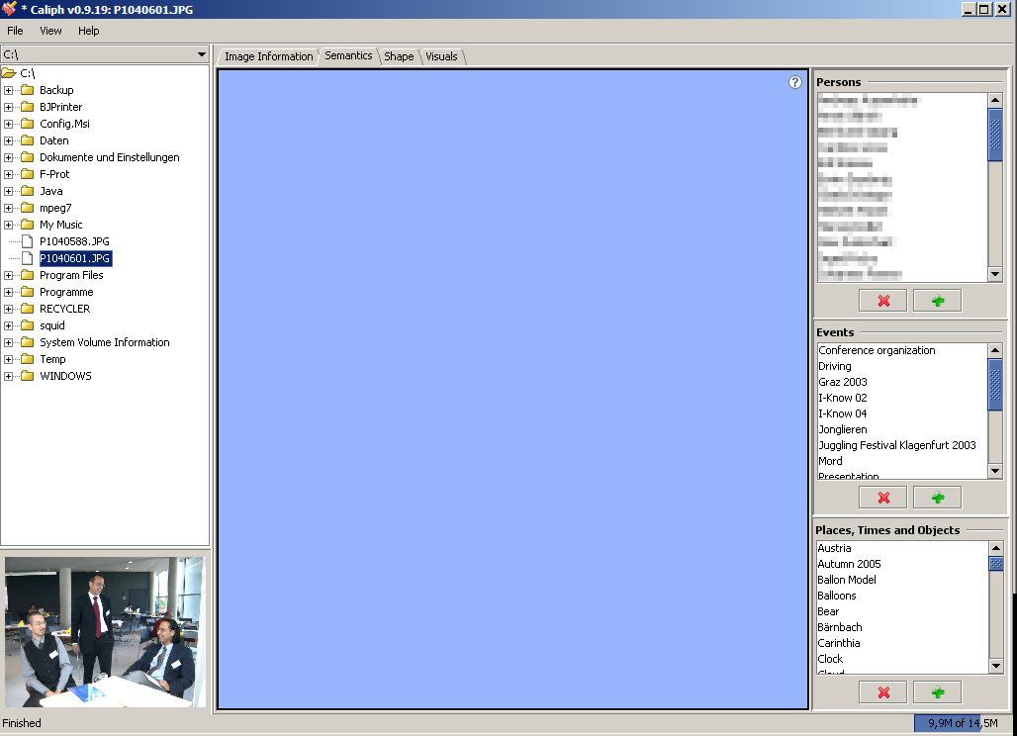
Drag objects here
After adding more nodes to the drawing panel you can interconnect them using MPEG-7 relations: Just click on one of the nodes with your middle mouse button or with your left mouse button while holding the Alt-Key and drag it towards another node. This will draw a line on the panel. After selecting a target node by releasing the button inside another node a dialog allows the selection of available relations.
Do not forget to save you annotation after creating it!

Exporting the Semantic Description as Image
You can save the semantic description to an image file by clicking on the drawing panel with the right mouse panel and selecting the option Export description. There are 3 options available, the third one will only be activated if you have the Batik libraries in your classpath. You can download them from http://xml.apache.org/batik.
Using the PNG export the background will be transparent for further editing in an image editor.

Autopilot
As the annotation is a time consuming task, you can use the autopilot. The autopilot allows you to create a basic and common annotation for a set of photos.
- Put all photos you want to annotate with the same description in one folder.
- Create a basic annotation which fits to all photos for the first one inside a directory.
- Start the autopilot.
After starting the autopilot (which can be done in the menu) this annotation will be added to all files in the directory. Please note that existing annotations will be erased.

How to search annotations with Emir
Emir allows users to search through the images annotated with Caliph. To do so the parent directory of all annotated images has to be selected within Emir, all subdirectories will be added automatically. Use the menu “Index -> Change data repository location” to select the parent directory of all annotated images. Then use the menu “Index –> Create/Update index” to create the index.
A more simple method is using the Indexing Wizard in the menu “Index -> Indexing Wizard”.
After creating the index you are able to use Emir for searching through your annotated images. Just type the term(s) you search for in the text box and hit <enter>.

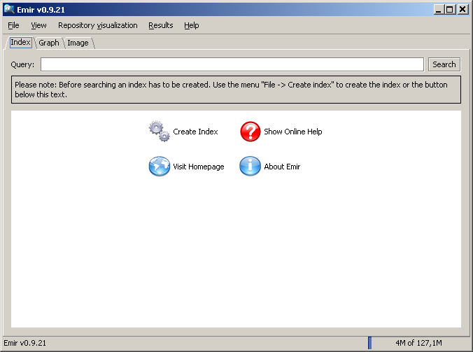
Click to create index

The results will be presented sorted by their relevance.

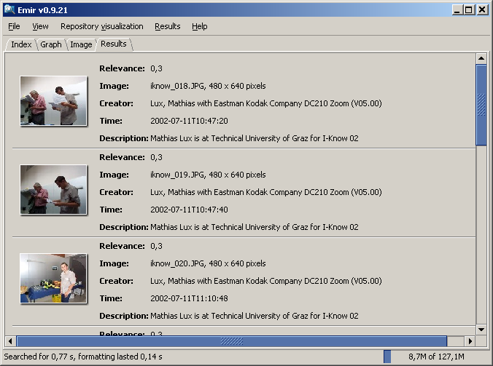

Use the second tab, called “Graph” to search for semantic graphs. Using the text box nodes can be created. In the brackets beside the node label you will find the number of matching indexed nodes. With mouse click and drag you can create relations between nodes, an untyped relation (wild card or “don’t-care”) is supported.

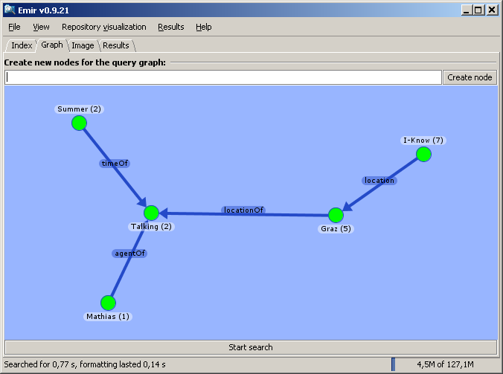

The third tab allows the search for similar images. After loading a sample images you can select whether you want to use ColorLayout, ScalableColor or EdgeHistorgram for image comparison. Hitting the “Search” button starts the retrieval.

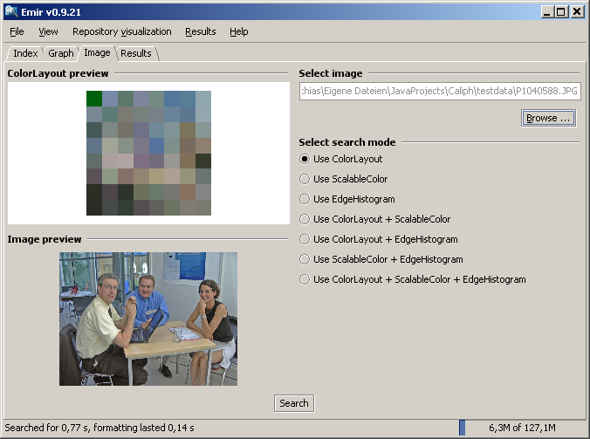

Using the menu “Repository visualization” you can create a 2D layout of all files in your repository using one of four different characteristics of the files.
