Test summary

**For logisticRegression**

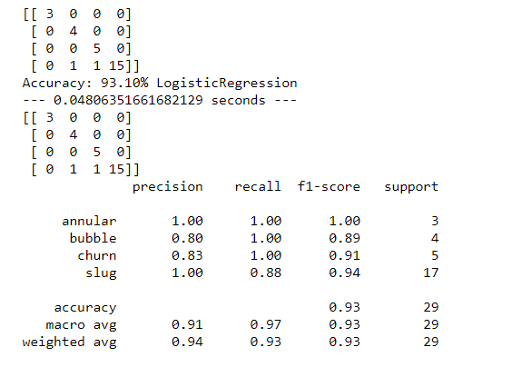

**For K-nearest Neighbour**

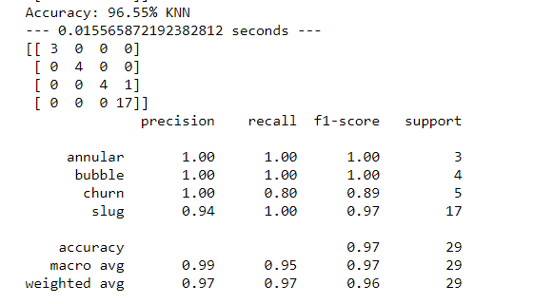

**For support Vector Machine( classifier)**

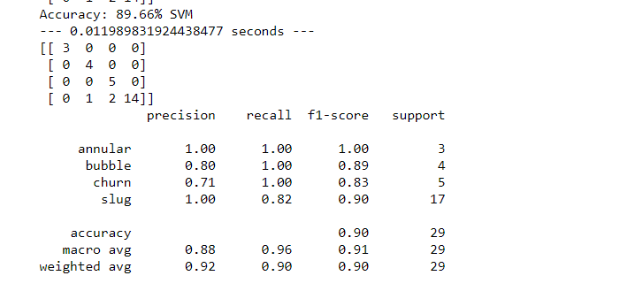

**For Extreme Gradient boosting**

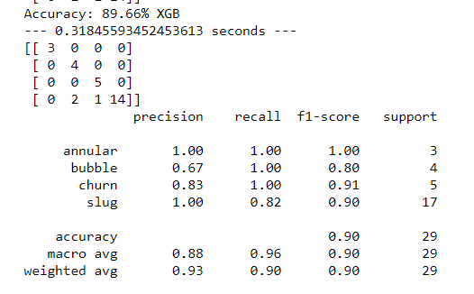

For decision tree

Accuracy= 0.91

