Summary of performance of Different machine learning models on DATA

Date: 02/10/21

**Extreme Gradient Boosting (XGboost)**

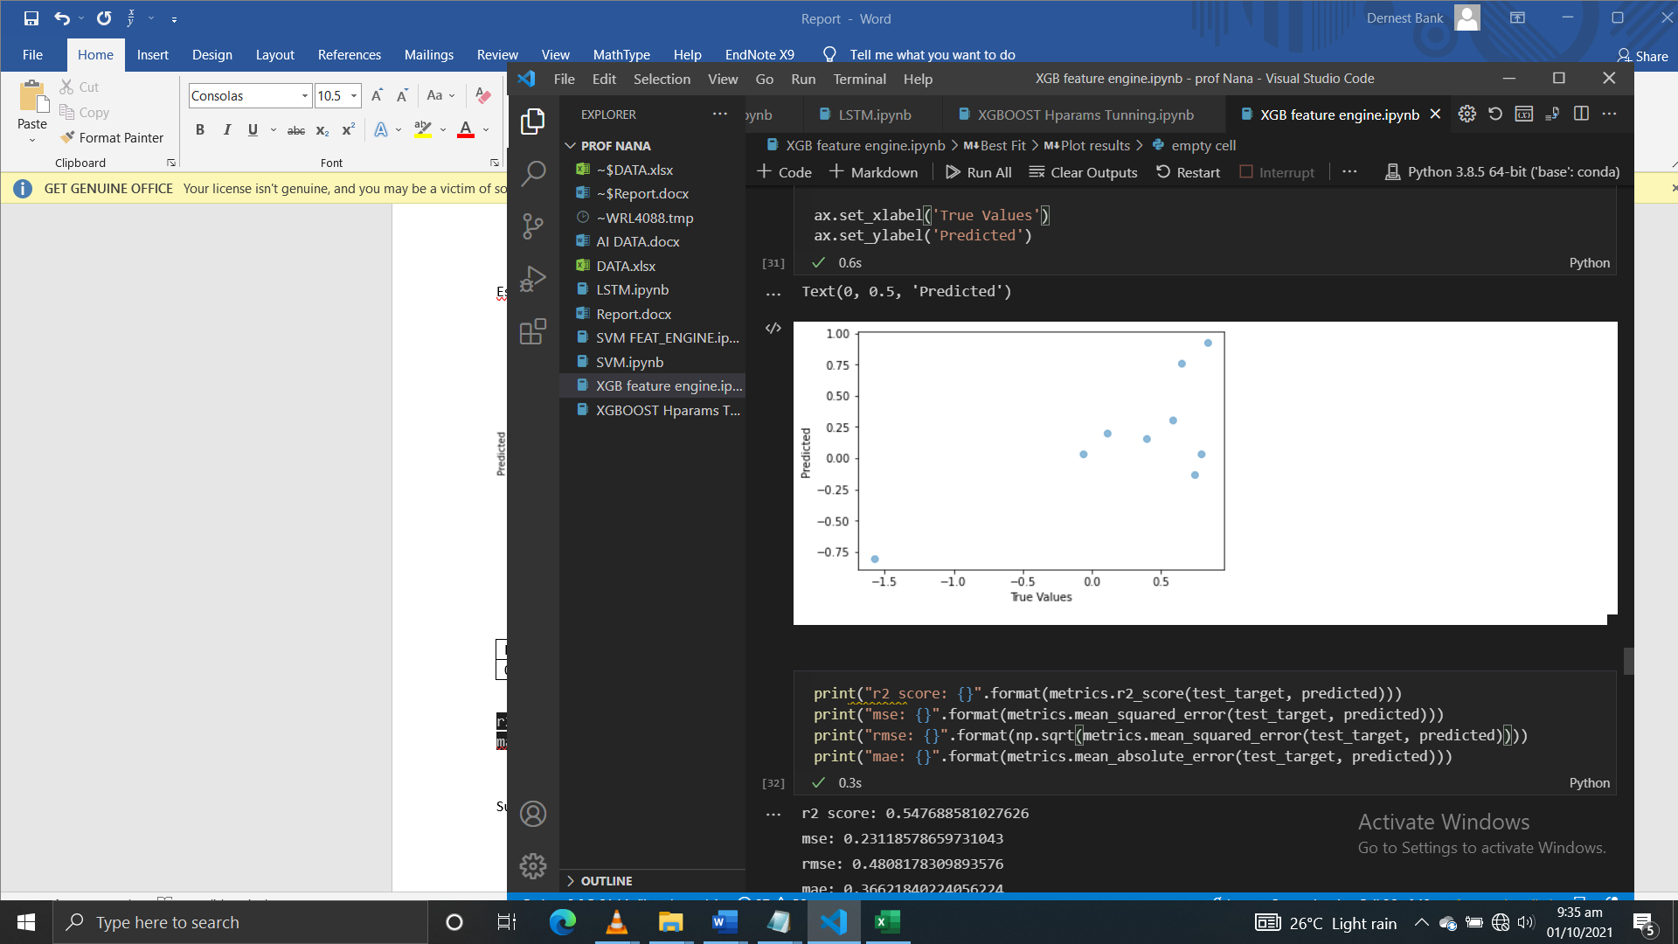

|  |  |  |  |
| --- | --- | --- | --- |
| **R2 score** | **MSE** | **RMSE** | **MAE** |
| 0.5280 | 0.2412 | 5.6541 | 0.4064 |

**Support Vector Machine (Regressor)**

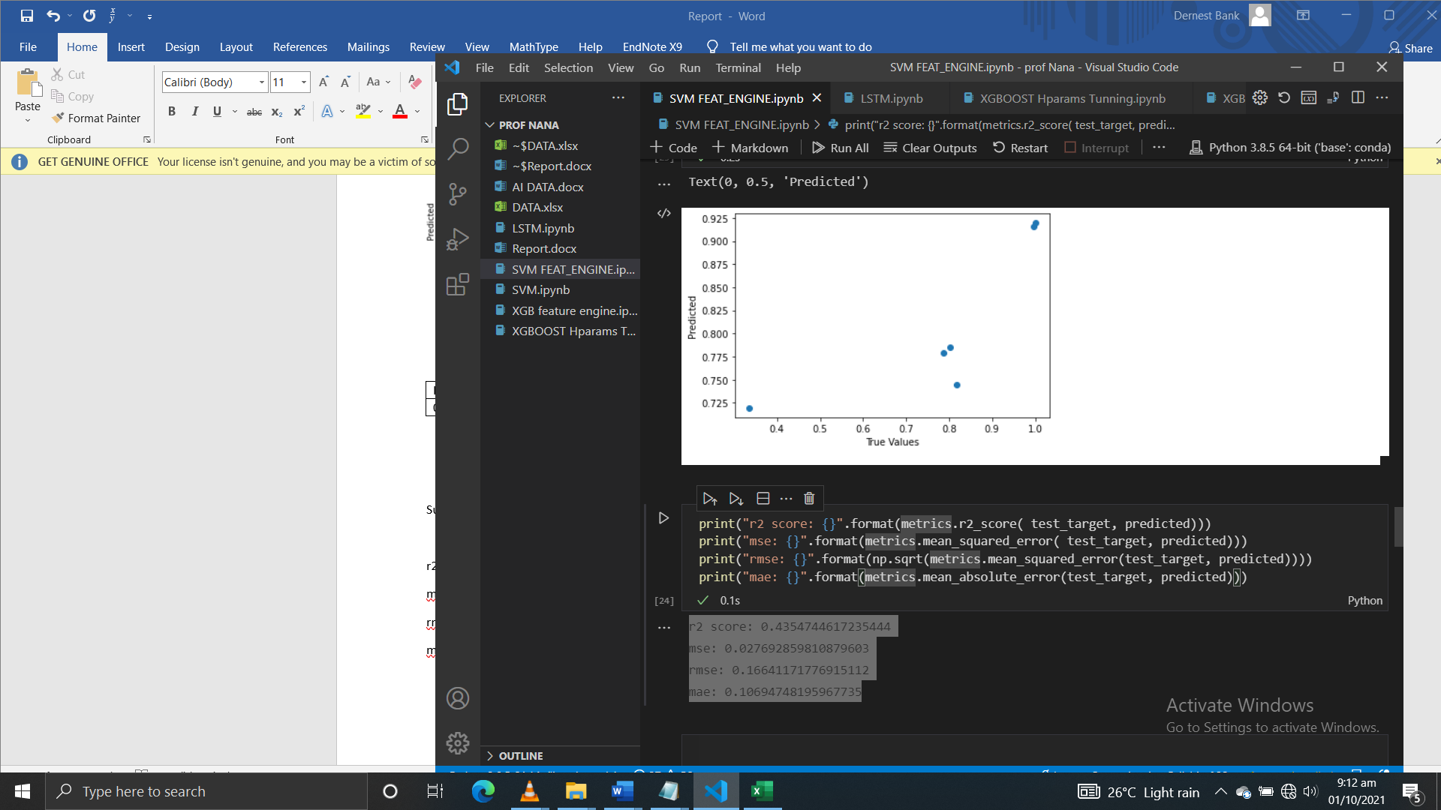

|  |  |  |  |
| --- | --- | --- | --- |
| **R2 score** | **MSE** | **RMSE** | **MAE** |
| 0.4355 | 0.0277 | 0.1664 | 0.1069 |

**Description**

The $R^{2}=1-\frac{SSE}{TSS}$

where SSE is the sum of squared errors $SSE=\sum_{i=1}^{n}{{(y_{i}-{\hat{y}}_{i} )}^{2}}$

The TSS is the total sum of squares and is equal to $TTS= \sum_{i=1}^{n}{{(y_{i}-{\overline{y}}_{i} )}^{2}}$

The mean squared error, $MSE=\frac{1}{n}\sum_{i=1}^{n}{{(y_{i}-{\hat{y}}_{i} )}^{2}}$

The root mean squared error is the square root thus $RMSE=\sqrt{MSE}$

Taking a test set about the shape of the input data, $y_{i}$ is predicted ${\hat{y}}_{i}$ actual value

**Recommendations**

* More data about 500+ data points
* Feature engineering (PCAs) and feature selection
* More hyper-parameter tuning if available
* Exploration of different models( ANN, LSTM…)
* More criteria for evaluating results