DESIGN AND IMPLEMENTATION OF A SECURE CLOUD TUNNELING SYSTEM

BY
KINGSUNDAY ODIGHIHEKARICHUKWUIMEE
REG. NO: 2022030204448

DEPARTMENT OF COMPUTER SCIENCE
FACULTY OF PHYSICAL SCIENCES
ENUGU STATE UNIVERSITY OF SCIENCE AND TECHNOLOGY (ESUT), ENUGU

BEING A PROJECT SUBMITTED TO THE DEPARTMENT OF COMPUTER SCIENCE, FACULTY OF PHYSICAL SCIENCES, ENUGU STATE UNIVERSITY AND TECHNOLOGY, ENUGU, IN PARTIAL FULFILMENT OF THE REQUIREMENTS FOR THE AWARD OF THE DEGREE OF BACHELOR OF SCIENCE (B.Sc.) IN COMPUTER SCIENCE.

SUPERVISOR: DR. ENGR. ASOGWA T. C.
HEAD OF DEPARTMENT: DR. (MRS) E. A. UGWU EDITH

SEPTEMBER, 2026

CERTIFICATION
This is to certify that this project titled "Design and Implementation of a Secure Cloud Tunneling System" was carried out by KINGSUNDAY ODIGHIHEKARICHUKWUIMEE (Reg. No: 2022030204448), a final year student of the Department of Computer Science, Faculty of Physical Sciences, Enugu State University of Science and Technology (ESUT), Enugu, under my supervision, and is hereby approved as meeting part of the requirements for the award of the degree of Bachelor of Science (B.Sc.) in Computer Science.

…………………………………………… ………………………
Dr. Engr. Asogwa T. C. (Project Supervisor) Date
…………………………………………… ………………………
Dr. (Mrs) E. A. Ugwu Edith (Head of Department) Date
…………………………………………… ………………………
External Examiner Date

DEDICATION
This project is dedicated to Almighty God, the giver of knowledge, wisdom, and understanding, for His grace and sustenance throughout the course of this programme.
It is also dedicated to my parents and family, whose unwavering love, sacrifice, and encouragement have been the foundation of every academic milestone I have reached, and to everyone who believed in and supported this journey.

ACKNOWLEDGEMENT
I wish to express my profound gratitude to my project supervisor, Dr. Engr. Asogwa T. C., for the guidance, patience, and constructive supervision that shaped this work from its earliest design decisions through to the completed system described in this report.
I am equally grateful to the Head of Department, Dr. (Mrs) E. A. Ugwu Edith, and to all the lecturers and staff of the Department of Computer Science, Faculty of Physical Sciences, Enugu State University of Science and Technology (ESUT), Enugu, for the instruction and mentorship provided throughout my programme of study.
My sincere appreciation goes to my family and friends for their financial support, patience, and moral encouragement, and to my colleagues who provided useful feedback while this tunneling system was being built and tested.
Above all, I remain thankful to God Almighty for good health, direction, and the strength to complete this work.

Kingsunday Odighihekarichukwuimee
September, 2026

ABSTRACT
Developers who build and test web applications and APIs on their own machines frequently need to make a service that is only reachable on a private network — behind Network Address Translation (NAT), a corporate firewall, or a home router — temporarily reachable from the public internet. Typical uses include demonstrating work in progress to a remote client, receiving webhook callbacks from a third-party platform during development, or sharing a locally running application with a reviewer, without deploying it to a hosting provider or reconfiguring network infrastructure. This project addresses that problem by presenting the design and implementation of a secure cloud tunneling system: a client–server application, named Wackgrok, that establishes an outbound, token-authenticated connection from a machine behind NAT to a publicly reachable relay server, and uses that connection to forward public HTTP traffic back to a local port on the developer's machine, all without any inbound port forwarding or firewall modification on the client side. The system was developed using the Go programming language for both the server and client binaries and follows an incremental, iterative software development methodology. The server exposes three listeners — a control listener that authenticates clients and coordinates proxying over a lightweight JSON protocol, a data listener that carries the raw bytes of individual HTTP exchanges, and a public HTTP listener that resolves incoming requests to a tunnel by subdomain and relays them to the matching client. Security is enforced through pre-shared bearer tokens validated on every connection attempt, sanitisation of client-supplied subdomains, and TLS termination at a reverse proxy (Nginx, with Let's Encrypt certificates) placed in front of the server so that all public traffic is encrypted end-to-end between the browser and the relay. The completed system was containerised with Docker and Docker Compose for repeatable deployment, and was tested through unit-level checks of its protocol and utility functions, integration tests of the full request-proxying path, and manual end-to-end verification using curl and a browser against a deployed instance. The results show that the system reliably establishes tunnels, assigns and enforces unique subdomains, authenticates clients correctly, and forwards HTTP requests and responses with low added latency, confirming that a compact, purpose-built Go service can provide the core functionality of commercial tunneling tools such as ngrok while remaining simple enough for a single developer to operate and extend.
Keywords: cloud tunneling, reverse proxy, NAT traversal, token authentication, Go programming language, TLS, subdomain routing, Docker.

TABLE OF CONTENTS
CHAPTER ONE: INTRODUCTION 13
1.1 Background of the Study 13
1.2 Statement of the Problem 14
1.3 Aim and Objectives of the Study 15
1.4 Research Questions 16
1.5 Significance of the Study 17
1.6 Scope of the Study 17
1.7 Limitations of the Study 18
1.8 Definition of Terms 19
1.9 Organisation of the Report 20
CHAPTER TWO: LITERATURE REVIEW 21
2.1 Conceptual Review 21
2.1.1 Network Address Translation and the Reachability Problem 21
2.1.2 Tunneling and Encapsulation 22
2.1.3 Reverse Proxying and Request Routing 22
2.1.4 The HTTP Protocol and Message Framing 22
2.1.5 Transport Layer Security (TLS) 23
2.1.6 Authentication and Access Control for Network Services 23
2.1.7 Concurrency Models for Network Servers 23
2.1.8 Domain Name Resolution and Wildcard Subdomains 24
2.1.9 Containerisation for Reproducible Deployment 24
2.1.10 The Go Programming Language for Network Systems 25
2.2 Theoretical Review 25
2.2.1 The Client–Server Model 25
2.2.2 The OSI Reference Model and Layered Design 25
2.2.3 The CIA Triad and Defense-in-Depth 26
2.2.4 Formal Models of Concurrency 26
2.3 Review of Related Studies and Existing Systems 27
2.3.1 ngrok 27
2.3.2 localtunnel 27
2.3.3 frp (Fast Reverse Proxy) 27
2.3.4 Cloudflare Tunnel and Tailscale Funnel 28
2.3.5 Academic and Industrial Literature on NAT Traversal and Reverse Proxy Architectures 28
2.4 Gap in the Literature 28
2.5 Summary of the Literature Review 29
CHAPTER THREE: SYSTEM ANALYSIS AND DESIGN 30
3.1 Analysis of the Existing System 30
3.2 Problems of the Existing System 30
3.3 Justification for the New System 31
3.4 System Requirements 31
3.4.1 Functional Requirements 31
3.4.2 Non-Functional Requirements 32
3.4.3 Hardware Requirements 32
3.4.4 Software Requirements 32
3.5 System Design 33
3.5.1 Development Methodology 33
3.5.2 System Architecture 34
3.5.3 Input Design 35
3.5.4 Output Design 35
3.5.5 Data / Registry Design 35
3.5.6 System Flowchart 36
3.5.7 Use Case Diagram 38
3.5.8 Protocol / Sequence Design 38
3.5.9 Control-Channel Message Design 39
CHAPTER FOUR: SYSTEM IMPLEMENTATION AND TESTING 42
4.1 Programming Languages and Tools Used 42
4.2 System Implementation 42
4.2.1 Project Structure 42
4.2.2 Shared Protocol Package 43
4.2.3 Server: Control Connection and Authentication 43
4.2.4 Server: Tunnel Registry 44
4.2.5 Server: Data Connection Pairing 44
4.2.6 Server: Public HTTP Router 45
4.2.7 Client: Connection and Reconnection Logic 46
4.2.8 Client: Proxy Handling 46
4.2.9 Security Utilities: Subdomain Sanitisation and ID Generation 47
4.2.10 Containerisation and Reverse-Proxy Configuration 47
4.2.11 Deployment 48
4.3 System Testing 49
4.3.1 Testing Approach 49
4.3.2 Test Cases and Results 49
4.4 Results and Discussion 50
CHAPTER FIVE: SUMMARY, CONCLUSION, AND RECOMMENDATIONS 55
5.1 Summary 55
5.2 Conclusion 55
5.3 Recommendations 56
5.4 Contribution to Knowledge 57
5.5 Conclusion of the Report 57
REFERENCES 58
APPENDICES 60
Appendix A: Source Code 60
Appendix B: Sample Protocol Messages 66
Appendix C: User Manual 67
Appendix D: Screenshots 69

LIST OF TABLES
Table 3.1: Hardware Requirements 32
Table 3.2: Software Requirements / Technology Stack 33
Table 3.3: Control-Channel Message Types (Protocol Design) 40
Table 3.4: Summary of Server Listener Endpoints 41
Table 4.1: System Test Cases and Results 50
Table 4.2: Mapping of Objectives to Implemented Features 51

LIST OF FIGURES
Figure 3.1: System Architecture of the Secure Cloud Tunneling System 34
Figure 3.2: Core In-Memory Data Model (Registry Design) 36
Figure 3.3: System Flowchart — Client Connection Lifecycle 37
Figure 3.4: Use Case Diagram 38
Figure 3.5: Sequence Diagram — End-to-End Request Proxying 39
Figure 4.1: Docker Compose Deployment and Container Status 49
Figure 4.2: Server Startup and Listener Initialisation Log 52
Figure 4.3: Client Connection Banner Showing Assigned Tunnel URL 52
Figure 4.4: Combined Server/Client Log Trace of a Single Proxied Request 53
Figure 4.5: External curl Verification of a Successful and an Unregistered Tunnel Request 53

CHAPTER ONE

INTRODUCTION

1.1 Background of the Study
Modern software development rarely happens on the same machine that will eventually serve the finished product to the public. A developer writes and runs a web application, an API, or a webhook receiver on a laptop or an internal workstation, using "localhost" and a private IP address that is meaningful only inside that machine or its local network. The moment that work needs to be shown to someone else — a client who wants to preview a feature, a teammate testing a mobile app against a backend that is still on a developer's laptop, or a third-party platform such as a payment gateway or a chat provider that must deliver a webhook callback to that same backend — the private address becomes useless, because the public internet has no route to it.
This limitation exists chiefly because of two related facts about how most networks are built. First, Network Address Translation (NAT) allows many devices on a private network (a home, an office, a mobile hotspot) to share a single public IP address; a device behind NAT can start a connection to the outside world, but the outside world cannot normally start a connection into it, because the router has no rule mapping an inbound packet to a specific internal machine. Second, even where a public IP address is available, firewalls and institutional network policies routinely block unsolicited inbound connections as a basic security measure. Together, these two facts mean that an ordinary developer machine is, correctly and by design, invisible to the public internet.
A class of tools has grown up specifically to solve this problem: tunneling or reverse-proxy relay services, popularised by commercial products such as ngrok, and by open-source alternatives such as localtunnel and frp (fast reverse proxy). The common idea behind all of them is simple to state: a small client program runs on the developer's machine and opens an ordinary outbound connection to a server that does have a public, routable address. Because the connection is outbound, it passes through NAT and most firewalls without any special configuration. Once that connection exists, the server can use it in reverse — asking the client, over the same connection, to fetch data from the local service whenever a member of the public sends a request to a URL that the server has assigned to that client. The public sees a normal HTTPS URL; the developer's machine never had to accept a single inbound connection.
This project studies that idea in depth and produces a working implementation of it, named "Wackgrok", written from first principles in the Go programming language. Go was chosen because its standard library already provides production-grade support for TCP networking, HTTP request and response parsing, and lightweight concurrency (goroutines and channels), which are precisely the building blocks a tunneling relay needs: many simultaneous client connections, many simultaneous in-flight HTTP requests, and a protocol for coordinating the two. Rather than treating tunneling as a black box supplied by a third-party vendor, this project designs and documents every layer of the system — the wire protocol between client and server, the authentication scheme, the subdomain-routing logic, the concurrency model that lets one control connection serve many overlapping HTTP requests, and the operational concerns (TLS termination, containerised deployment, and reverse-proxy configuration) that turn a working prototype into a system that can be safely exposed to the public internet.
Security is treated as a first-class design goal rather than an afterthought, because a tunneling relay is, by its very nature, a piece of infrastructure that deliberately creates a path from the public internet into a private machine. Every design decision in this project — token-based authentication before a tunnel is ever registered, strict sanitisation of any client-supplied subdomain, encryption of all public traffic via TLS at the reverse proxy, and a registry design that never allows one client to see or intercept another client's traffic — is made with that responsibility in mind. The word "Secure" in the project title is therefore not incidental; it names the specific property that distinguishes a system suitable for real use from a toy proof-of-concept.

1.2 Statement of the Problem
Developers, students, and small teams who need to expose a locally running service to the internet are today left with a narrow set of options, each with a real drawback. They may ask a network administrator to configure port forwarding on a router, which is often impossible on institutional or mobile networks, is insecure if left in place, and exposes the internal machine directly rather than through any protective layer. They may deploy the unfinished application to a cloud hosting provider purely to make it reachable, which is slow, costs money for work that has not yet reached production, and forces a redeploy for every change made during testing. They may depend entirely on a third-party commercial tunneling service, which introduces a dependency on an external vendor's pricing, availability, data-handling policy, and rate limits for something as basic as testing a webhook integration — a genuine concern for a student project, a company handling sensitive data, or a country where such a service may be unreliable or costly to reach.
Specifically, this project addresses the following problems:
- The absence, for a developer without administrative access to network hardware, of any way to make a private, NAT-bound service reachable from the public internet without opening inbound ports.
- The operational risk of naive tunneling approaches that either leave traffic unencrypted between the public client and the relay, or fail to authenticate who is allowed to register a tunnel at all.
- The lack of a single, understandable, self-hostable reference implementation of a tunneling relay that a student or a small organisation can run on its own infrastructure, inspect, and extend, rather than depending on an opaque third-party binary.
- The difficulty of correctly coordinating many concurrent, independent HTTP request/response exchanges over a small number of long-lived TCP connections between one server and one client, which is a non-trivial concurrent-systems problem in its own right.
- The need for the resulting public tunnel address to be predictable and stable (through a chosen or consistently assigned subdomain) so that it can be shared with a third party, such as a webhook provider, without having to be reconfigured every time the developer restarts the client.
Left unresolved, these problems either block legitimate development and testing work entirely or push developers toward ad hoc solutions — such as temporarily disabling a firewall, or hard-coding third-party API credentials into shared, unencrypted tunnels — that create real security exposure. A single application that combines outbound-only connectivity, mandatory authentication, encrypted public transport, and predictable routing removes this friction while keeping the attack surface deliberately small.

1.3 Aim and Objectives of the Study
Aim: The aim of this study is the design and implementation of a secure cloud tunneling system that exposes a local network service to the public internet through an authenticated, encrypted relay.
Objectives: In order to achieve this aim, the specific objectives of the study are:
- To investigate existing methods — manual port forwarding, ad hoc deployment, and commercial tunneling platforms — that developers currently use to expose local services, and to identify their limitations.
- To design a client–server protocol that lets a client authenticate with a pre-shared token, request or be assigned a subdomain, and maintain a persistent, resilient control connection with the server.
- To design and implement a request-routing mechanism on the server that maps a public HTTP request, identified by its Host header, to the correct connected client, and that supports many simultaneous in-flight requests without cross-talk between clients or between requests.
- To implement the client-side proxying logic that receives a request signal from the server, opens a dedicated data connection, forwards the request to the local service, and relays the response back, using goroutines for concurrency.
- To secure the system end-to-end through pre-shared bearer-token authentication on the control channel, sanitisation of user-supplied subdomains, and TLS termination at a reverse proxy in front of the public listener.
- To containerise the server for repeatable deployment, and to test, deploy, and evaluate the completed system for correctness, resilience to disconnection, and the latency it adds to a proxied request.

1.4 Research Questions
The study is guided by the following research questions:
- What challenges do developers face when a service running on a private, NAT-bound machine must be reached from the public internet, and how do existing solutions fall short?
- What protocol design allows a server and a client to coordinate the proxying of many independent, concurrent HTTP requests over a small, fixed number of long-lived TCP connections?
- How can a tunneling relay authenticate clients and route public traffic to the correct client without exposing one client's traffic to another or allowing an unauthenticated party to register a tunnel?
- What concurrency model, implemented using Go's goroutines and channels, correctly pairs an in-flight public HTTP request with the specific client-initiated data connection that will carry its response?
- What operational measures — encryption, containerisation, and reverse-proxy configuration — are required to move the system from a working prototype to one that can be safely exposed to the public internet?

1.5 Significance of the Study
This study is significant to a number of groups:
- Individual developers and students gain a self-hostable alternative to commercial tunneling services, useful for coursework, personal projects, and situations where a third-party service is unavailable, too costly, or unsuitable for the sensitivity of the data involved.
- Small teams and organisations gain a worked example of a relay they can deploy on their own infrastructure, under their own security policy, rather than routing development traffic through an external vendor.
- Students and researchers in Computer Science and related fields gain a documented reference for the concurrency, networking, and security patterns involved in building a reverse-proxy relay — patterns that generalise to load balancers, API gateways, and other proxying infrastructure well beyond tunneling specifically.
- The wider practice of secure software engineering benefits from a concrete demonstration that authentication, input sanitisation, and encryption can be designed into a network relay from the outset, rather than retrofitted after a security incident.

1.6 Scope of the Study
The system covers: token-based client authentication over a control connection; assignment of a requested or randomly generated subdomain, with collision handling; a keep-alive mechanism (ping/pong) to detect and clean up dead client connections; routing of public HTTP requests to the correct client based on the Host header; concurrent, per-request proxying of HTTP traffic (including headers and bodies) between the public caller and the local service, without requiring persistent HTTP keep-alive on the data path; command-line configuration of the client (server address, token, local port, and requested subdomain) and of the server (listener addresses, base domain, and the set of valid tokens); and containerised deployment of the server behind a TLS-terminating reverse proxy with a wildcard DNS record and Let's Encrypt certificate.
The study is limited to HTTP and HTTPS traffic; it does not implement tunneling of arbitrary raw TCP services (such as SSH or a database port), which would require a different, non-HTTP-aware data-relay design. Token management is file/flag/environment based rather than backed by a full user-account system with a database, self-service registration, or a web dashboard; these are identified as areas for future work in Chapter Five. The system also assumes a single relay server per deployment rather than a distributed, multi-region fleet of relay servers.

1.7 Limitations of the Study
- The system was evaluated by the developer on a single deployed instance and a small number of manually driven test scenarios, rather than through a large-scale, multi-user field study.
- Because the data channel opens a fresh TCP connection per HTTP request rather than multiplexing many requests over one stream, very high request rates to a single tunnel would create a correspondingly high rate of short-lived TCP connections; this is an accepted trade-off for protocol simplicity rather than a defect, but it does bound the throughput per tunnel relative to a multiplexed design.
- TLS termination is performed at the reverse proxy rather than natively inside the Go server, so the security of the public-facing hop depends on the correct configuration of that reverse proxy and its certificates, which lies partly outside the tunneling application itself.
- The keep-alive interval and data-connection timeout values used (30 seconds and 10 seconds respectively, in the reference implementation) were chosen for responsiveness during testing and were not tuned against production traffic at scale.

1.8 Definition of Terms
Tunneling: A technique by which a network connection or a stream of application data is carried, or encapsulated, over another connection so that it can traverse a network boundary — such as NAT or a firewall — that would otherwise block it directly.
NAT (Network Address Translation): A router function that lets many devices on a private network share one public IP address, rewriting the source and destination addresses of packets as they cross the boundary; it is the principal reason a private machine cannot normally receive unsolicited inbound connections from the internet.
Reverse Proxy: A server that sits in front of one or more backend services and forwards client requests to them, often adding functions such as TLS termination, load balancing, or — as in this project — request routing by subdomain.
Control Channel: The single, long-lived TCP connection between a Wackgrok client and the Wackgrok server used to authenticate, exchange keep-alive messages, and signal that a new HTTP request needs to be proxied.
Data Channel: A short-lived TCP connection opened by the client, on demand, to carry the raw bytes of exactly one HTTP request and its response between the server and the client.
Subdomain / Tunnel ID: The identifying label (for example "myapp" in "myapp.wackgrok.paskhal.com") under which a client's tunnel is registered and by which public requests are routed to it.
Bearer Token: A pre-shared secret string that a client must present when connecting; the server accepts the connection only if the token is present in its configured set of valid tokens.
TLS (Transport Layer Security): The cryptographic protocol used to encrypt traffic between the public caller's browser and the reverse proxy, ensuring that data cannot be read or altered in transit.
Goroutine: A lightweight, independently scheduled function execution provided by the Go runtime, used throughout the server and client to handle many connections and requests concurrently without one blocking operation stalling the others.
Reverse-proxy relay / tunneling service: The general category of system — of which ngrok, localtunnel, frp, and the Wackgrok system built in this project are examples — that exposes a private service to the public internet via an intermediary server reachable by both sides.

1.9 Organisation of the Report
The remainder of this report is organised as follows. Chapter Two reviews the concepts, theories, and prior tools relevant to tunneling and reverse-proxy systems, and identifies the gap this project addresses. Chapter Three analyses existing methods of exposing a local service, justifies the proposed system, states its requirements, and presents its design through an architecture diagram, a flowchart, a use case diagram, and a model of its core data structures. Chapter Four describes the implementation of the system in Go, the tools used, the testing carried out, and discusses the results obtained from a deployed instance. Chapter Five summarises the work, draws conclusions, states the project's contribution to knowledge, and makes recommendations for future development. The references and appendices, including source code excerpts and a user manual, follow.

CHAPTER TWO

LITERATURE REVIEW
This chapter reviews the body of knowledge relevant to the design and implementation of a secure cloud tunneling system. It is organised into a conceptual review, which explains the core networking and security ideas on which the system rests; a theoretical review, which presents the models that inform its architecture; a review of related studies and existing tools, which examines prior tunneling systems and the academic literature on NAT traversal and reverse proxying; and a statement of the gap in the literature that this project addresses.

2.1 Conceptual Review

2.1.1 Network Address Translation and the Reachability Problem
Network Address Translation (NAT), standardised in RFC 3022 and used pervasively in home routers, mobile carrier networks, and corporate firewalls, allows many internal devices to share a single public IPv4 address. A NAT device maintains a translation table that maps an internal (private IP, private port) pair to an external (public IP, public port) pair for the duration of an outbound connection; return traffic for that connection is translated back to the originating internal device. Because this table is created only in response to an outbound packet, a NAT device has no entry to consult when an unsolicited inbound packet arrives, and by default it drops that packet. This is the fundamental technical reason a developer's laptop, sitting behind a home router, cannot be reached directly from the public internet, even though the laptop itself is fully capable of running a web server (Egevang & Francis, 1994; Srisuresh & Egevang, 2001).
Two broad families of technique exist to work around this restriction. The first, NAT traversal in the strict sense — including STUN, TURN, and ICE, standardised for real-time communication protocols such as WebRTC — tries to establish a direct connection between two NAT-bound peers, using a public server only to help the peers discover each other's addresses (Rosenberg, Mahy, Matthews, & Wing, 2008). The second, and the one this project adopts, avoids the direct-connection problem altogether: instead of trying to open an inbound path to the private machine, a public relay server is used, and the private machine connects outward to it. All public traffic then flows through that relay. This is architecturally simpler and works reliably behind even the most restrictive NAT or firewall, at the cost of adding one extra network hop and depending on the availability of the relay server.

2.1.2 Tunneling and Encapsulation
In networking, tunneling refers to encapsulating one protocol's traffic inside another so that it can cross a network boundary, or be carried over a transport it was not originally designed for. Classical examples include IP-in-IP tunnels, GRE, and VPN protocols such as IPsec and WireGuard, which carry entire private network segments over the public internet (Kent & Seo, 2005). The tunneling performed by this project is narrower and simpler: it does not carry arbitrary IP traffic, but specifically HTTP requests and responses, encapsulated as raw bytes inside a plain TCP "data channel" established between the client and the relay server for the lifetime of a single request. This narrower scope is what allows the protocol used in this project (described fully in Chapter Three) to remain small, auditable, and free of the additional complexity that a general-purpose VPN protocol must carry.

2.1.3 Reverse Proxying and Request Routing
A reverse proxy is a server that receives requests on behalf of one or more backend services and forwards each request to the appropriate backend, typically based on some routing key present in the request — the request path, a header, or, as in this project, the Host header of an HTTP request (Fielding & Reschke, 2014). Reverse proxies such as Nginx and HAProxy are widely used in production systems to terminate TLS, balance load across multiple backend instances, and provide a single, stable public entry point in front of infrastructure that may itself be private, ephemeral, or distributed. This project uses reverse proxying in two layers: an Nginx instance at the network edge terminates TLS and forwards plain HTTP to the Go-based Wackgrok server, and the Wackgrok server itself acts as an application-level reverse proxy, using the Host header to decide which of many connected clients a given request belongs to.

2.1.4 The HTTP Protocol and Message Framing
HTTP/1.1, defined in RFC 7230–7235, structures every exchange as a request followed by a response, each with a start line, a set of headers, and an optional body whose length is signalled either by a Content-Length header or by chunked transfer encoding (Fielding & Reschke, 2014). This framing matters directly to the design of this project's data channel: because a well-formed HTTP request or response carries its own length information, the client and server can write and read complete messages over a plain TCP connection without needing any additional framing of their own, and without needing to rely on the connection being closed to signal the end of a message. The Go standard library's net/http package (specifically http.ReadRequest, http.ReadResponse, and http.Request.Write / http.Response.Write) exploits exactly this property, and is used directly by both the client and the server in this project to read and write HTTP messages over the data channel.

2.1.5 Transport Layer Security (TLS)
TLS provides confidentiality, integrity, and server authentication for data in transit, using a handshake that negotiates a shared symmetric key via asymmetric cryptography, followed by encrypted, authenticated communication using that key (Rescorla, 2018, RFC 8446 for TLS 1.3). A publicly reachable tunneling relay is exactly the kind of system where TLS is not optional: without it, any network intermediary between a visitor's browser and the relay server — a Wi-Fi hotspot, an internet service provider, or a malicious actor on the path — could read or tamper with everything sent through the tunnel, including any private data the developer's local service returns. This project delegates TLS termination to Nginx using a certificate issued by Let's Encrypt through the ACME protocol (Barnes, Hoffman-Andrews, McCarney, & Kasten, 2019), a widely adopted approach that provides browser-trusted certificates at no monetary cost and with automatic renewal.

2.1.6 Authentication and Access Control for Network Services
Authentication is the process of verifying the identity, or at least the authorisation, of a party attempting to use a service. Bearer-token authentication, in which a client presents a pre-shared secret string and is granted access if the token matches one on an authorised list, is a simple and widely used scheme (Jones & Hardt, 2012, RFC 6750, "The OAuth 2.0 Authorization Framework: Bearer Token Usage") that trades the operational complexity of a full identity-and-credential system for straightforward, auditable access control — appropriate for a project of this scope, where the set of authorised clients is small and centrally managed by whoever operates the relay server. This project applies the same principle at the transport level: every client must present a valid token as the very first message on the control channel, before any tunnel is registered, and an invalid token terminates the connection immediately without revealing any further information to the caller.

2.1.7 Concurrency Models for Network Servers
A relay server of this kind must handle many things at once: multiple clients connected simultaneously, and, per client, potentially many overlapping in-flight HTTP requests, each of which involves waiting on network I/O at several points. Historically, servers have addressed this either with a process or thread per connection (simple to reason about, but expensive at scale) or with a single-threaded event loop that multiplexes I/O using primitives such as select or epoll (efficient, but harder to write correctly). Go's concurrency model, built on goroutines (functions that run concurrently and are scheduled cooperatively by the Go runtime onto a small number of OS threads) and channels (typed, synchronised queues used to communicate between goroutines), gives much of the efficiency of the event-loop approach while allowing code to be written in the simpler, sequential style associated with thread-per-connection designs (Donovan & Kernighan, 2016; Pike, 2012). This model is explicitly derived from Hoare's Communicating Sequential Processes (Hoare, 1978), discussed further in section 2.2.4. This project relies on goroutines throughout: one per accepted control connection, one per accepted data connection, and one per proxied HTTP request on the client side, coordinated by buffered channels used to hand a data connection off to the specific HTTP handler that is waiting for it.

2.1.8 Domain Name Resolution and Wildcard Subdomains
The Domain Name System (DNS) resolves human-readable names to IP addresses, and supports wildcard records (for example "*.wackgrok.paskhal.com") that resolve any subdomain of a base domain to the same IP address (Mockapetris, 1987, RFC 1035). This project depends on a wildcard DNS record pointing every "<id>.wackgrok.paskhal.com" subdomain at the single public IP address of the relay server; the server itself then reads the Host header of each incoming HTTP request to determine which specific tunnel the request is for. This is the same mechanism that lets a single reverse proxy serve an effectively unbounded number of distinct tunnel identities without any per-tunnel DNS configuration.

2.1.9 Containerisation for Reproducible Deployment
Containerisation, as implemented by Docker, packages an application together with its runtime dependencies into a single, portable image that runs identically across development and production machines (Merkel, 2014). A multi-stage Docker build — compiling the Go binaries in one image and copying only the resulting statically linked executables into a minimal Alpine Linux runtime image — produces a small, reproducible deployment artefact with a minimised attack surface, since the final image contains no compiler toolchain and few other programs an attacker could misuse if the container were ever compromised. Docker Compose adds a declarative way to describe the container's ports, environment variables, and restart policy, so that the entire relay server can be brought up or torn down with a single command. This project uses exactly this pattern for the server component.

2.1.10 The Go Programming Language for Network Systems
Go is a statically typed, compiled language designed at Google specifically with networked systems and concurrency in mind (Pike, 2012). Its standard library includes production-grade packages for TCP networking (net), HTTP client and server functionality (net/http), and JSON encoding (encoding/json), removing the need for third-party dependencies for the core functionality this project requires. Go compiles to a single, statically linked binary with no external runtime dependency, which simplifies both local development and the container build process described above. These properties — together with goroutines and channels for concurrency, discussed in section 2.1.7 — make Go a natural fit for implementing a tunneling relay, and are the reason it was chosen for this project over alternatives such as Node.js or Python, both of which are also used by existing tunneling tools discussed later in this chapter.

2.2 Theoretical Review

2.2.1 The Client–Server Model
The client–server model describes a distributed system in which one party (the client) initiates requests and another (the server) responds to them, typically with the server offering a shared resource or service to many clients (Sinha, 1992). This project extends the model in a way characteristic of tunneling systems generally: the Wackgrok server is a server to the public HTTP callers that reach it, but it is also, in effect, a client of the Wackgrok client — it is the server that initiates the proxy request signal, while the tunneling "client" is the one that ultimately dials out to fetch data. This inversion, sometimes called a "reverse" or "callback" architecture, is precisely what allows the private, NAT-bound machine to remain the party that always initiates outbound TCP connections, satisfying the constraint described in section 2.1.1 while still allowing the server to drive the interaction.

2.2.2 The OSI Reference Model and Layered Design
The seven-layer OSI reference model (ISO/IEC 7498-1) separates network functionality into layers — physical, data link, network, transport, session, presentation, and application — each depending only on the services offered by the layer below it (Zimmermann, 1980). This project's architecture mirrors that separation cleanly: TCP (transport layer) provides reliable, ordered byte delivery between client and server; a custom JSON-based protocol (session/presentation layer, described in Chapter Three) frames control messages on top of TCP; and HTTP (application layer) is the payload actually being proxied, itself carried, unmodified, inside the data channel. Understanding these layers explicitly, rather than treating "the network" as a single undifferentiated concern, is what allows the system to reuse Go's existing HTTP parsing code for the payload while implementing only a small, purpose-built protocol for its own control messages.

2.2.3 The CIA Triad and Defense-in-Depth
The CIA triad — confidentiality, integrity, and availability — is a foundational model for reasoning about information security requirements (Whitman & Mattord, 2021). Applied to this project: confidentiality is provided by TLS between the public caller and the reverse proxy; integrity of the control protocol is provided by using TCP's in-order, error-checked delivery together with strict JSON message parsing that rejects malformed input; and availability is supported by the keep-alive (ping/pong) mechanism, which lets the server detect and clean up a dead client tunnel promptly rather than leaving a stale, non-functional entry in its registry. No single one of these controls is sufficient by itself; their combination, together with mandatory token authentication before any tunnel can be registered, reflects the principle of defense-in-depth — the idea that a secure system should not depend on any single protective measure, but on several independent layers, so that the failure of one does not immediately compromise the whole (Kim & Solomon, 2021).

2.2.4 Formal Models of Concurrency
Hoare's Communicating Sequential Processes (CSP) models a concurrent system as a set of independent processes that interact only by sending and receiving discrete messages over defined channels, rather than by sharing mutable memory directly (Hoare, 1978). Go's goroutines and channels are a direct, practical implementation of this model, and the Go community's own guidance — "do not communicate by sharing memory; instead, share memory by communicating" — states the CSP principle explicitly. This project follows that principle at its most safety-critical point: pairing an in-flight public HTTP request with the specific data connection the client opens to serve it is done using a per-request, buffered Go channel (see the pendingConns map described in Chapter Three) rather than a shared variable guarded only by ad hoc locking, which would be considerably more error-prone to get right under concurrent load.

2.3 Review of Related Studies and Existing Systems

2.3.1 ngrok
ngrok is the best-known commercial tunneling service and is widely credited with popularising the "instant public URL for a local port" workflow among developers (ngrok Inc., 2024). Architecturally, it follows the same outbound-client, public-relay pattern this project adopts, and additionally offers request inspection, replay, and a hosted dashboard. Because it is closed-source and operated as a paid, centrally hosted service, it is unsuitable as a self-hosted, freely inspectable reference implementation, and its free tier historically imposes session-length and bandwidth limits that can be restrictive for continuous development or for demonstrating a student project over an extended period. This project reproduces ngrok's core reachability mechanism — an authenticated client tunnel exposed under a public subdomain — while remaining a small, fully open, self-hostable Go codebase rather than a hosted product.

2.3.2 localtunnel
localtunnel is an open-source Node.js tunneling tool that, like this project, assigns each client a random or requested subdomain of a shared base domain (Leach, 2015, and subsequent community maintainers). Its openness makes it a useful architectural reference; however, published discussions of the project note that its default public server offers no built-in authentication for who may claim a subdomain, and its reliability has depended heavily on the availability of a small number of community-run public relay servers. This project deliberately departs from that design by requiring a pre-shared bearer token before any client may connect at all, closing the specific "anyone can claim a public subdomain" gap that unauthenticated tunneling designs are exposed to.

2.3.3 frp (Fast Reverse Proxy)
frp is a mature, open-source reverse-proxy tool, also written in Go, that supports tunneling of HTTP, TCP, UDP, and other protocols, along with token authentication and TLS (fatedier, 2016–present). It demonstrates, at production scale, that Go's networking and concurrency primitives are well suited to this problem domain, reinforcing the language choice made in section 2.1.10. frp's scope is considerably broader than this project's — supporting protocols beyond HTTP and a wide range of configuration options — which brings correspondingly greater implementation and configuration complexity. This project intentionally narrows its scope to HTTP/HTTPS tunneling only, in order to keep the protocol, the codebase, and the security surface small enough to be fully understood, documented, and audited within the scope of a final-year project, while still validating the same core architectural pattern that frp uses in production.

2.3.4 Cloudflare Tunnel and Tailscale Funnel
More recent commercial offerings, Cloudflare Tunnel (formerly Argo Tunnel) and Tailscale Funnel, integrate the same outbound-relay pattern into larger, vendor-operated network platforms, adding features such as zero-trust access policies and integration with a broader private-networking (mesh VPN) product (Cloudflare Inc., 2023; Tailscale Inc., 2023). Both confirm that the underlying architectural pattern examined in this project has matured from a developer convenience into infrastructure trusted for production traffic by large organisations. Both, however, tie the tunnel's public reachability to a specific vendor's global network and account system, which is precisely the external dependency this project avoids by remaining self-hostable on infrastructure the operator controls.

2.3.5 Academic and Industrial Literature on NAT Traversal and Reverse Proxy Architectures
Beyond individual tools, the networking literature has long studied the general problem of connecting to a host behind NAT. Ford, Srisuresh, and Kegel (2005) survey techniques for peer-to-peer communication across NAT, including "hole punching," and note that a relay-based fallback (exactly the strategy this project uses unconditionally, rather than as a fallback) is the only approach guaranteed to work across every NAT configuration, at the cost of routing all traffic through a third party. On the reverse-proxy side, the design and operational characteristics of software such as Nginx have been documented extensively for load balancing and TLS termination at scale (Nginx Inc., 2023), providing the operational grounding this project draws on for its own use of Nginx as an edge TLS terminator in front of the Go-based relay.

2.4 Gap in the Literature
The tools reviewed above establish that the outbound-relay tunneling pattern is well understood and widely deployed in practice, but the literature and available documentation around them are split in a way this project addresses. Commercial tools (ngrok, Cloudflare Tunnel, Tailscale Funnel) are operationally polished but closed-source, so their internal protocol design, authentication handling, and concurrency model are not available for study, and they tie the user to a specific vendor's hosted infrastructure. Open-source tools (localtunnel, frp) are inspectable, but localtunnel's public documentation gives limited attention to authentication and threat modelling, while frp's scope and configuration surface — spanning many protocols and deployment modes — make it a less approachable teaching example of the core mechanism than a small, purpose-built implementation would be. There is, in other words, a gap for a compact, fully documented, security-conscious reference implementation whose protocol, authentication scheme, and concurrency design can be read, understood, and reasoned about in full — suitable both as a genuinely usable tool and as a teaching artefact for the underlying networking and concurrency concepts. This project fills that gap by designing and building exactly such a system, and by documenting its protocol, its data structures, and its security controls in full in Chapter Three.

2.5 Summary of the Literature Review
This chapter has shown that the problem this project addresses — making a NAT-bound, private service reachable from the public internet — is well characterised in the networking literature, and that the outbound-relay tunneling pattern used by commercial and open-source tools alike is the established solution to it. It has reviewed the specific technical building blocks the project depends on (NAT, HTTP framing, TLS, DNS wildcards, containerisation, and Go's concurrency primitives), the theoretical models that justify its architecture (the client–server model, layered design, the CIA triad, and CSP-style concurrency), and the existing tools against which the system built in this project can be meaningfully compared. The identified gap — the absence of a small, fully open, security-first reference implementation — motivates the system design presented in Chapter Three.

CHAPTER THREE

SYSTEM ANALYSIS AND DESIGN

3.1 Analysis of the Existing System
In the absence of a dedicated tunneling tool, developers currently expose a local service to the public internet through one of three manual approaches. The first is router-level port forwarding, in which the developer logs into a home or office router and configures a rule that maps a public port on the router's WAN interface to the internal (private IP, port) of the development machine, together with a Dynamic DNS record if the public IP address is not static. The second is temporary cloud deployment, in which the unfinished application is pushed to a hosting provider (a virtual machine, or a platform-as-a-service product) purely so that it has a public address, and then redeployed every time the code changes. The third is dependence on a third-party commercial tunneling service, used purely as an external, closed-source relay, with no visibility into or control over its internal workings.

3.2 Problems of the Existing System
- Router-level port forwarding requires administrative access to network hardware that a developer frequently does not have — on a university network, a mobile hotspot, or a shared office network — and, where it is possible, exposes the internal machine's port directly to the internet with no authentication or encryption layer of its own.
- Temporary cloud deployment is slow to iterate on: every change to the code under test requires a rebuild and redeploy cycle before it can be observed publicly, which is disproportionate for something as small as verifying a single webhook callback.
- Dependence on a closed-source commercial relay ties the developer to that vendor's pricing, rate limits, and data-handling practices, and offers no way to inspect, audit, or adapt the relay's authentication and routing behaviour.
- None of the three approaches, taken as commonly practised, guarantees that traffic between the public caller and the relay is authenticated and encrypted by design — each requires the developer to separately remember to add HTTPS and access control, and it is easy to skip this under time pressure while testing.

3.3 Justification for the New System
The system designed and implemented in this project, Wackgrok, removes each of the problems identified above by construction rather than by relying on the operator to remember to configure them correctly. It requires no router access at all, because the client always initiates outbound connections. It requires no redeploy cycle, because the tunnel simply proxies to whatever is currently running on the chosen local port — a code change on the developer's machine is visible through the tunnel the moment it is saved and the local server reloads. It requires no dependence on a third-party vendor, because the entire server is a small, self-contained Go binary that can be built, deployed, and audited by whoever operates it. Finally, authentication (a mandatory bearer token checked before any tunnel is registered) and encryption (TLS terminated at the reverse proxy in front of the public listener) are built into the reference deployment rather than left as optional steps, so that a correctly deployed instance of the system is secure by default.

3.4 System Requirements

3.4.1 Functional Requirements
- The server shall accept client connections on a control port and authenticate each one using a bearer token before proceeding further.
- The server shall assign each authenticated client a subdomain, honouring a client-requested subdomain where available and falling back to a randomly generated one where it is not.
- The server shall route each public HTTP request, identified by the Host header, to the tunnel client currently registered under the matching subdomain.
- The client shall, on receiving a proxy signal from the server, open a data connection, forward the corresponding HTTP request to the configured local port, and relay the response back to the server.
- The server and client shall exchange periodic keep-alive messages over the control channel, and the server shall remove a tunnel's registration promptly when its control connection is lost.
- The client shall automatically attempt to reconnect after an unexpected disconnection, but shall not retry after an authentication failure.

3.4.2 Non-Functional Requirements
- Security: all public traffic shall be encrypted in transit via TLS, and no tunnel shall be registered without a valid, pre-shared authentication token.
- Reliability: the loss of one client's connection shall not affect any other client's active tunnel or in-flight requests.
- Performance: the proxying mechanism shall add latency on the order of tens of milliseconds under normal conditions, dominated by the extra network hop rather than by the relay's own processing.
- Portability: the server shall be deployable as a single container image with no additional runtime dependency beyond the operating system's TLS root certificate store.
- Maintainability: the codebase shall be organised into clearly separated packages (protocol, client, server) so that each concern can be read, tested, and modified independently.

3.4.3 Hardware Requirements
Component | Minimum Specification | Role
Relay server (VPS) | 1 vCPU, 512 MB RAM, 10 GB disk, public static IPv4 | Runs the Wackgrok server container and Nginx reverse proxy
Client machine | Any machine capable of running a Go binary (laptop, workstation) | Runs the local service under test and the Wackgrok client
Network connection | Any outbound-capable internet connection (broadband, mobile, campus Wi-Fi) | Carries the client's outbound control and data connections
Table 3.1: Hardware Requirements

3.4.4 Software Requirements
Layer | Technology | Purpose
Programming language | Go 1.21 | Implementation language for both the server and client binaries
Operating system (server) | Linux (Alpine, containerised) | Minimal runtime environment for the deployed server image
Containerisation | Docker & Docker Compose | Reproducible build and deployment of the server
Reverse proxy / TLS | Nginx + Certbot (Let's Encrypt) | TLS termination and public-facing request forwarding
Wire protocol | JSON over TCP (encoding/json) | Control-channel message encoding between client and server
Version control | Git / GitHub | Source code management and change history
Table 3.2: Software Requirements / Technology Stack

3.5 System Design

3.5.1 Development Methodology
The system was developed using an incremental, iterative methodology rather than a single up-front waterfall design. The protocol package (message types and JSON encoding/decoding) was built and unit-tested first, since every other component depends on it. The server's control-connection handling (authentication and subdomain registration) was built next, followed by the data-connection pairing mechanism and the public HTTP router, with each increment manually tested against a minimal client before the next was added. The client was developed in parallel once the protocol was stable, and the two were then tested together end-to-end. Finally, containerisation, the reverse-proxy configuration, and TLS were added once the core proxying logic was verified to work correctly over plain HTTP on a local network. This incremental approach was chosen because a tunneling relay is fundamentally a pipeline of dependent stages — authentication, registration, routing, and proxying — and verifying each stage in isolation before composing the next made concurrency-related defects far easier to localise than they would have been if the whole system had been written before any of it was tested.

3.5.2 System Architecture
Figure 3.1 shows the overall architecture of the deployed system. A public web browser or API client sends an HTTPS request to a subdomain of the base domain; the request first reaches Nginx, which terminates TLS and forwards a plain HTTP request, with the original Host header preserved, to the Wackgrok server container. Inside that container, three listeners are exposed: a control listener that clients authenticate against, a data listener that carries individual proxied request/response byte streams, and the public HTTP listener that receives the forwarded request from Nginx and decides, by consulting an in-memory tunnel registry, which client should handle it. The Wackgrok client, running on a machine behind NAT or a firewall, maintains only outbound connections to the control and data listeners; once it receives a proxy signal, it forwards the request to the local service and relays the response back along the same path.
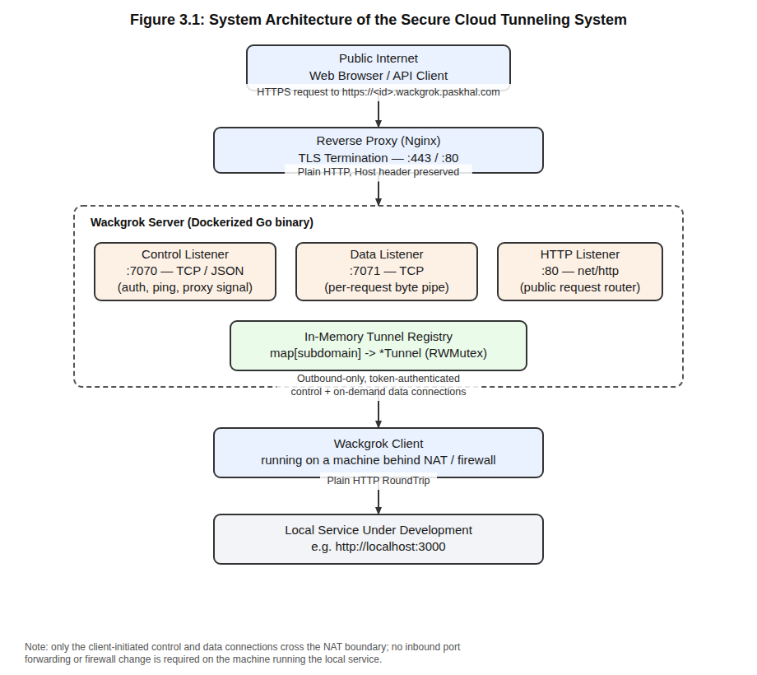
Figure 3.1: System Architecture of the Secure Cloud Tunneling System

3.5.3 Input Design
The system accepts input at two points. On the server, inputs are supplied as command-line flags or equivalent environment variables at startup: the control, data, and HTTP listener addresses, the base domain, and the comma-separated set of valid authentication tokens. On the client, inputs are likewise supplied as command-line flags or environment variables: the server's control address, an optional explicit data address, the authentication token, the local port to expose, and an optional requested subdomain. At runtime, the only input the server accepts from the network itself is the JSON-encoded AUTH message a client sends immediately after connecting, and the raw HTTP request bytes it later reads from a data connection; both are validated strictly (an unrecognised message type, a malformed JSON payload, or an invalid token all cause the connection to be rejected) before any further processing occurs.

3.5.4 Output Design
The server produces two categories of output: over the network, an AuthResponse message containing the assigned subdomain and full public URL is returned to a successfully authenticated client, and thereafter the server's only network output to the client is control-channel ping messages and proxy-request signals; to the operator, the server and client both emit structured, timestamped log lines to standard output (captured by Docker's logging driver in the deployed configuration) recording connection events, authentication outcomes, and, for every proxied request, a per-stage timing trace identified by a unique request ID. This logging design, illustrated in Chapter Four's results, was deliberately made verbose enough to let an operator trace a single request's full lifecycle across both the server's and the client's log streams using nothing more than the shared request ID.

3.5.5 Data / Registry Design
The system holds no persistent database; all state is process memory that is intentionally rebuilt from nothing whenever the server restarts, since a tunnel is only ever meaningful while its owning client is actually connected. Figure 3.2 models the core in-memory structures. A Server holds a Config (its startup settings), a TunnelRegistry, and a map of pendingConns keyed by request ID. The TunnelRegistry is a concurrency-safe map from subdomain to Tunnel, guarded by a read/write mutex so that many HTTP requests can look up a tunnel concurrently while registrations and removals are still serialised safely. A Tunnel wraps the JSON encoder for one client's control connection and exposes two operations, sendProxy and sendPing, both guarded by their own mutex since multiple goroutines may want to write to the same control connection concurrently. Each entry in pendingConns is a single-slot, buffered channel that exists only for the lifetime of one in-flight HTTP request, and is the mechanism (detailed in the sequence diagram, Figure 3.5) by which the HTTP handler goroutine that is waiting for a client's data connection is woken up the moment that connection arrives.
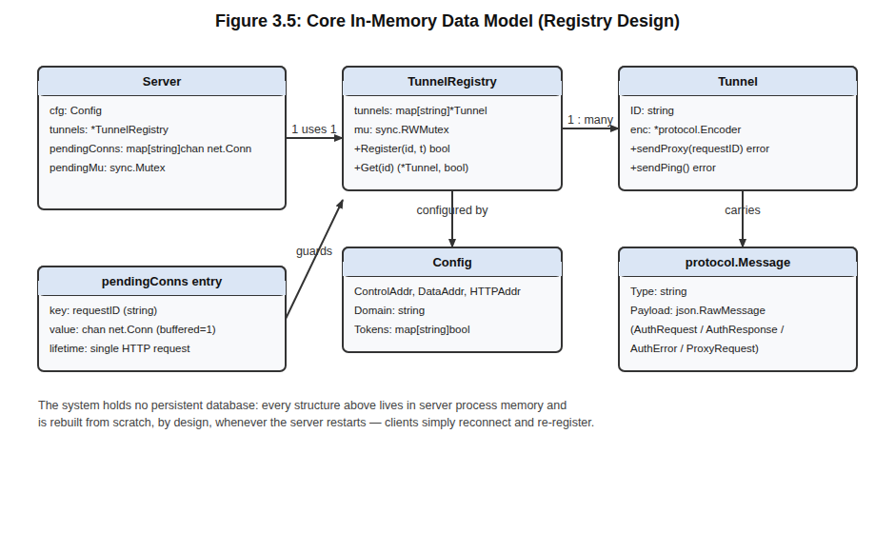
Figure 3.2: Core In-Memory Data Model (Registry Design)

3.5.6 System Flowchart
Figure 3.3 traces the client's connection lifecycle from process start to shutdown. After parsing its configuration, the client dials the server's control address and sends an authentication request. An invalid token causes the process to exit immediately without retrying, since retrying with the same bad credential cannot succeed. On successful authentication, the client prints its assigned public URL and enters an event loop, responding to keep-alive pings and spawning a new goroutine for every proxy request it is asked to handle, so that a slow local service handling one request never blocks the processing of another. If the control connection is lost for any other reason, the client waits five seconds and reconnects automatically, continuing until the operator explicitly stops it (for example with Ctrl+C), at which point the loop exits cleanly.
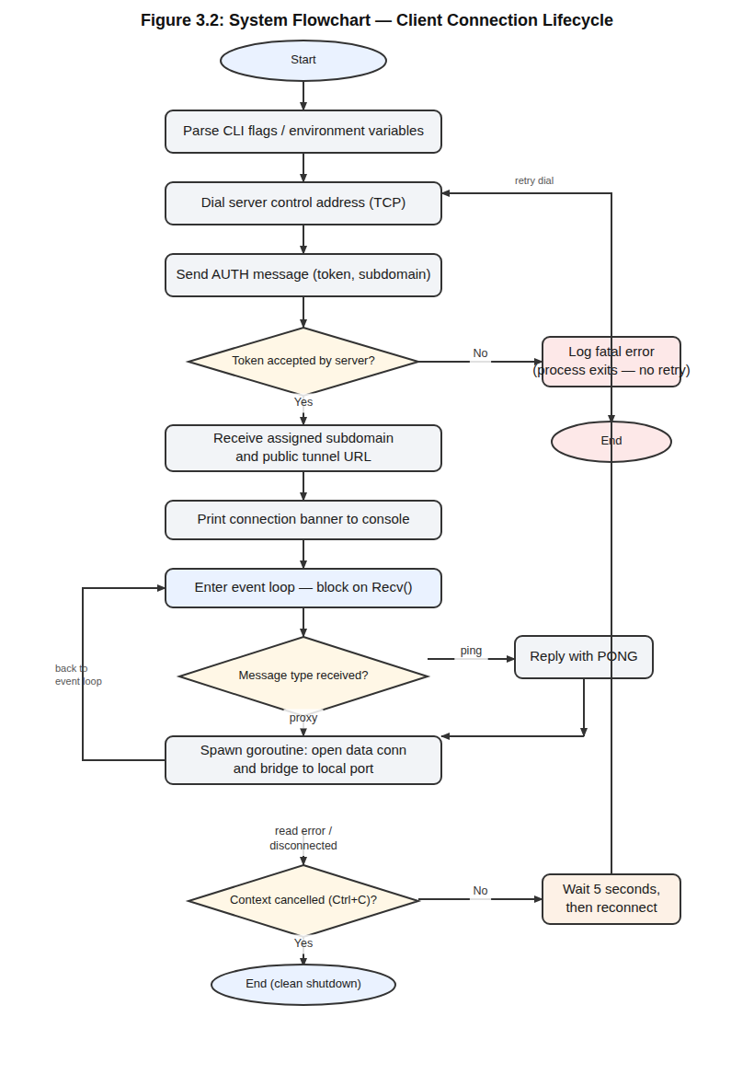
Figure 3.3: System Flowchart — Client Connection Lifecycle

3.5.7 Use Case Diagram
Figure 3.4 identifies three actors and their principal interactions with the system. The Tunnel Operator (Client) authenticates with a token, exposes a local service, and, indirectly, causes requests to be forwarded to their own local port. The End User / Visitor accesses the public tunnel URL and, transparently to them, has their request routed to the correct client. The Server Administrator is responsible for configuring the set of allowed tokens, monitoring active tunnels through the server's logs, and ensuring TLS termination is correctly enforced at the reverse proxy.
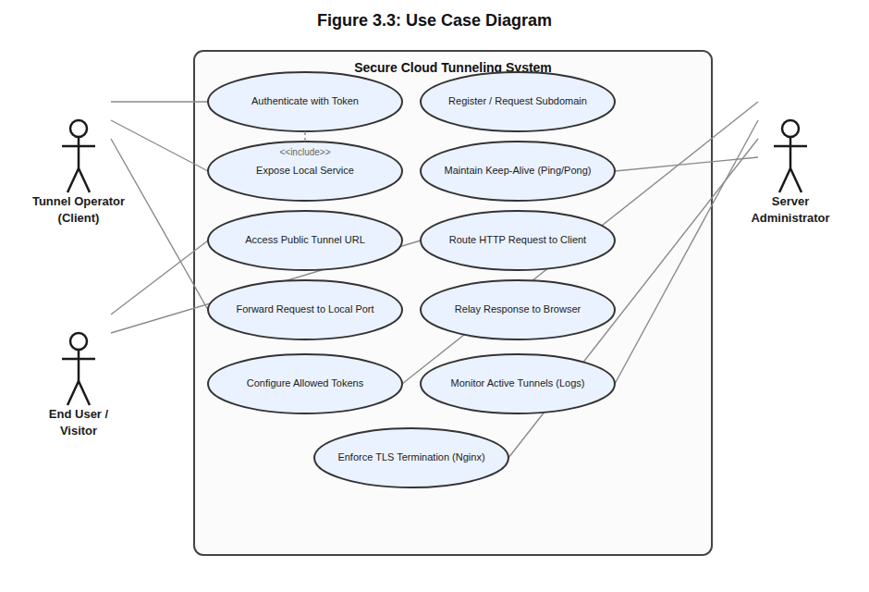
Figure 3.4: Use Case Diagram

3.5.8 Protocol / Sequence Design
Figure 3.5 traces a single public HTTP request end-to-end. Nginx forwards the request, with its Host header intact, to the Wackgrok server, which extracts the subdomain and looks up the corresponding Tunnel in its registry. The server generates a unique request ID and sends a ProxyRequest message carrying that ID to the client over the control channel, then blocks (via the pendingConns channel described in section 3.5.5) waiting for a matching data connection, with a ten-second timeout to avoid hanging indefinitely if the client has become unresponsive. The client, on receiving the signal, dials the server's data listener, sends the request ID as a plain text line to identify itself, then reads the raw HTTP request the server writes to that same connection, forwards it to the local service via an ordinary HTTP round-trip, and writes the resulting HTTP response back onto the data connection. The server reads that response and relays it back through Nginx to the original caller. Because the HTTP framing itself carries the message boundaries (see section 2.1.4), no additional application-level acknowledgement is required at any step.
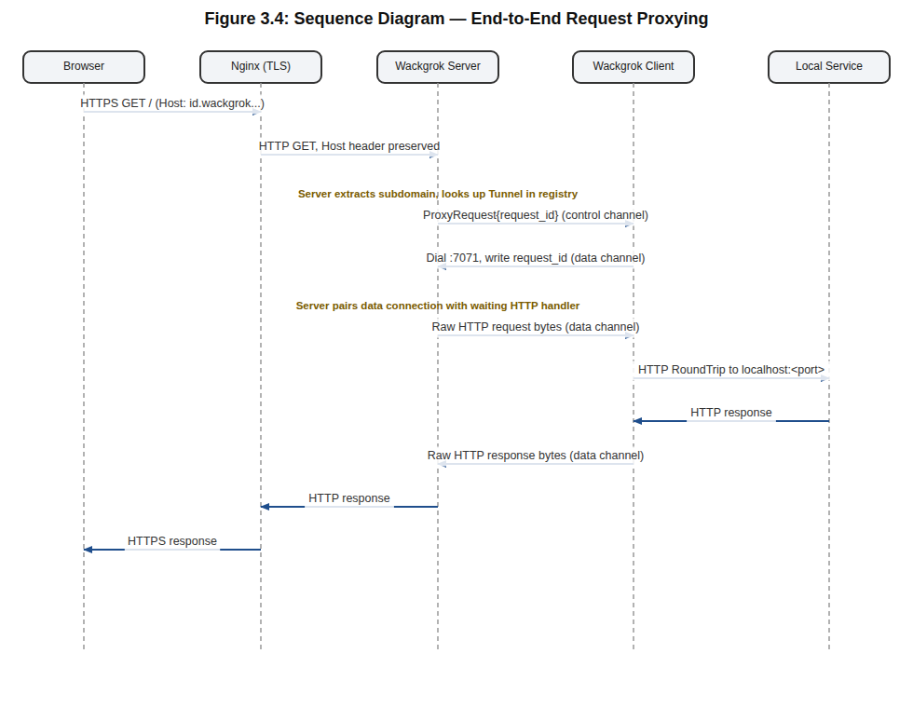
Figure 3.5: Sequence Diagram — End-to-End Request Proxying

3.5.9 Control-Channel Message Design
Table 3.3 summarises the message types exchanged over the control channel, all encoded as a common JSON envelope, {"type": ..., "payload": ...}, with the payload structure determined by the type.
Message Type | Direction | Payload | Purpose
auth | Client → Server | token, subdomain (optional) | First message sent after connecting; requests authentication and a subdomain
auth_ok | Server → Client | id, url | Confirms authentication and reports the assigned subdomain and public URL
auth_err | Server → Client | reason | Reports why authentication failed; the client does not retry after this
proxy | Server → Client | request_id | Signals the client to open a data connection for a specific in-flight request
ping | Server → Client | (none) | Keep-alive probe sent every 30 seconds while the tunnel is registered
pong | Client → Server | (none) | Keep-alive reply confirming the client is still connected and responsive
Table 3.3: Control-Channel Message Types (Protocol Design)
Table 3.4 summarises the three network-facing listeners the server exposes and the role of each in the overall design.
Listener | Default Address | Protocol | Responsibility
Control | :7070 | TCP / JSON | Client authentication, subdomain assignment, keep-alive, proxy signalling
Data | :7071 | TCP / raw HTTP bytes | Carries exactly one request/response exchange per connection
HTTP | :80 (behind Nginx TLS) | HTTP/1.1 | Public entry point; routes requests to the correct tunnel by Host header
Table 3.4: Summary of Server Listener Endpoints
Together, these design artefacts — the architecture diagram, the flowchart, the use case diagram, the sequence diagram, the data model, and the two protocol tables — form the complete blueprint from which the implementation described in Chapter Four was written directly, with no significant deviation between the design presented here and the code that realises it.

CHAPTER FOUR

SYSTEM IMPLEMENTATION AND TESTING

4.1 Programming Languages and Tools Used
The server and client are both implemented in Go (version 1.21), chosen for the reasons discussed in section 2.1.10: a strong standard library for TCP and HTTP networking, built-in JSON support, and a concurrency model well suited to a relay that must handle many simultaneous connections. The project uses no third-party Go modules beyond the standard library, which keeps its dependency footprint, and therefore its security review surface, minimal. Supporting tools include Docker and Docker Compose for building and running the server, Nginx and Certbot for TLS termination at the network edge, and Git/GitHub for version control. Development and testing were carried out on a Linux environment, with the server also deployed to a Linux virtual private server (VPS) for end-to-end verification against the public internet.

4.2 System Implementation

4.2.1 Project Structure
The codebase is organised into a small number of clearly separated Go packages, reflecting the layered design described in Chapter Three:
wackgrok/
├── cmd/
│ ├── client/main.go — client CLI entry point (flag/env parsing)
│ └── server/main.go — server CLI entry point (flag/env parsing)
├── internal/
│ ├── protocol/protocol.go — shared message types & JSON encode/decode
│ ├── client/client.go — client connection & proxy-handling logic
│ └── server/
│ ├── server.go — Server struct, Config, pending-connection map
│ ├── control.go — control listener, auth, keep-alive loop
│ ├── data.go — data listener, request-ID pairing
│ ├── http.go — public HTTP listener & ServeHTTP routing
│ ├── tunnel.go — Tunnel struct & TunnelRegistry
│ └── util.go — random IDs, subdomain sanitisation
├── Dockerfile — multi-stage build for the server image
├── docker-compose.yml — declarative deployment of the server
└── nginx.conf — reverse proxy / TLS termination config
This separation means the protocol package can be understood, and unit-tested, without reference to either the client or the server, and the server's three listeners (control, data, HTTP) are each implemented in their own file despite sharing the same Server struct.

4.2.2 Shared Protocol Package
Every control-channel message is wrapped in a single envelope type, Message, whose Payload field is a raw, not-yet-decoded JSON value; the concrete payload type is chosen based on the Type field once the envelope itself has been read. This is what allows one Encoder/Decoder pair to carry every message type listed in Table 3.3 without the protocol package needing to know, in advance, which concrete struct any given message will decode into.
// Message is the envelope for every control-channel message.
// The Payload field is decoded into the appropriate struct based on Type.
type Message struct {
Type string `json:"type"`
Payload json.RawMessage `json:"payload,omitempty"`
}

// Unmarshal decodes a raw JSON payload into T.
func Unmarshal[T any](raw json.RawMessage) (T, error) {
var v T
err := json.Unmarshal(raw, &v)
return v, err
}
Using a Go generic function for Unmarshal lets every call site — decoding an AuthRequest, an AuthResponse, an AuthError, or a ProxyRequest — share one implementation while still returning a properly typed value, rather than requiring five near-identical decode functions or a fragile type assertion on an interface{} value.

4.2.3 Server: Control Connection and Authentication
The control listener accepts a TCP connection, gives the client fifteen seconds to send its first message, and rejects anything that is not a well-formed auth message with a valid token, before any subdomain is ever considered:
if msg.Type != protocol.MsgTypeAuth {
enc.Send(protocol.MsgTypeAuthErr, protocol.AuthError{Reason: "expected auth message"})
return
}
authReq, err := protocol.Unmarshal[protocol.AuthRequest](msg.Payload)
if err != nil {
enc.Send(protocol.MsgTypeAuthErr, protocol.AuthError{Reason: "malformed auth payload"})
return
}
if !s.cfg.Tokens[authReq.Token] {
enc.Send(protocol.MsgTypeAuthErr, protocol.AuthError{Reason: "invalid token"})
log.Printf("[control] %s: rejected (bad token)", conn.RemoteAddr())
return
}
Only after this check passes does the server sanitise and register the requested subdomain, falling back to a randomly generated eight-character hexadecimal ID if the request left it blank or if the requested name was already taken by another active tunnel. Once registered, the connection enters a keep-alive loop that sends a ping every thirty seconds and expects the corresponding pong; a read error on this connection (including one caused by a missed pong, since a dead TCP connection eventually produces a read error) causes the server to unregister the tunnel immediately via a deferred call, so that no stale, unreachable subdomain lingers in the registry.

4.2.4 Server: Tunnel Registry
The TunnelRegistry is a small, self-contained concurrency-safe map, chosen deliberately over a more general-purpose external store (such as an in-memory database) because the only operations it needs to support are register, unregister, and lookup by exact key, all of which a read/write mutex handles efficiently at the scale this project targets:
func (r *TunnelRegistry) Register(id string, t *Tunnel) bool {
r.mu.Lock()
defer r.mu.Unlock()
if _, exists := r.tunnels[id]; exists {
return false
}
r.tunnels[id] = t
return true
}

func (r *TunnelRegistry) Get(id string) (*Tunnel, bool) {
r.mu.RLock()
defer r.mu.RUnlock()
t, ok := r.tunnels[id]
return t, ok
}

4.2.5 Server: Data Connection Pairing
The most concurrency-sensitive part of the server is pairing an incoming data connection with the specific HTTP handler goroutine that requested it. This is solved with a per-request, buffered channel registered just before the proxy signal is sent, and resolved the moment the matching connection arrives on the data listener:
func (s *Server) waitForConn(ctx context.Context, requestID string) (net.Conn, error) {
ch := s.registerPending(requestID)
waitCtx, cancel := context.WithTimeout(ctx, 10*time.Second)
defer cancel()
select {
case conn := <-ch:
return conn, nil
case <-waitCtx.Done():
s.cleanPending(requestID)
if ctx.Err() != nil {
return nil, fmt.Errorf("request cancelled")
}
return nil, fmt.Errorf("timed out waiting for client data connection")
}
}
Because each request ID has its own single-slot channel, this design scales to arbitrarily many concurrent requests across arbitrarily many clients without any request being able to see, block, or interfere with another's data connection — a direct application of the CSP-style "communicate, don't share" principle discussed in section 2.2.4. The ten-second timeout guards against a client that received the proxy signal but never opens the corresponding data connection (for example because its own network briefly dropped), ensuring the public caller receives a definite 504 Gateway Timeout response rather than hanging indefinitely.

4.2.6 Server: Public HTTP Router
The public HTTP listener implements Go's http.Handler interface directly. Its ServeHTTP method resolves the subdomain from the Host header, looks up the tunnel, and — if found — drives the five-step exchange summarised in Figure 3.5:
subdomain := extractSubdomain(host, s.cfg.Domain)
tunnel, ok := s.tunnels.Get(subdomain)
if !ok {
http.Error(w, fmt.Sprintf("wackgrok: tunnel %q is not connected", subdomain),
http.StatusNotFound)
return
}
requestID := randomID(16)
if err := tunnel.sendProxy(requestID); err != nil { /* … 502 … */ }
dataConn, err := s.waitForConn(r.Context(), requestID)
if err != nil { /* … 504 … */ }
defer dataConn.Close()
r.Header.Set("Connection", "close")
r.Write(dataConn) // forward request to client
resp, _ := http.ReadResponse(bufio.NewReader(dataConn), r) // read reply
io.Copy(w, resp.Body) // relay to the public caller
Setting the Connection header to "close" and r.Close = true forces clean HTTP/1.1 framing on the data connection, so that Go's http.ReadRequest and http.ReadResponse can determine the end of the message from Content-Length or chunked encoding alone, without depending on either side closing the socket — consistent with the framing property discussed in section 2.1.4.

4.2.7 Client: Connection and Reconnection Logic
The client's Run method wraps a single connection attempt in a loop that reconnects automatically after five seconds on any non-authentication failure, but returns immediately, without retrying, if the server explicitly rejected the token — retrying with the same invalid credential could never succeed and would only generate needless load on the server:
func (c *Client) Run(ctx context.Context) error {
for {
err := c.connect(ctx)
if ctx.Err() != nil {
return nil // clean shutdown
}
log.Printf("[wackgrok] disconnected: %v — reconnecting in 5s…", err)
select {
case <-time.After(5 * time.Second):
case <-ctx.Done():
return nil
}
}
}

4.2.8 Client: Proxy Handling
Every proxy signal received on the control channel is handled in its own goroutine, so that one slow or hung local-service request never delays the handling of another concurrent request. The handler dials the data listener, announces its request ID as a single text line, reads the raw HTTP request the server has written, retargets it at the local service, forwards it with the standard library's RoundTripper, and writes the resulting response back:
req, err := http.ReadRequest(bufio.NewReader(dataConn))
// …
req.URL.Scheme = "http"
req.URL.Host = fmt.Sprintf("localhost:%d", c.cfg.LocalPort)
req.RequestURI = "" // must be empty for outbound requests

resp, err := http.DefaultTransport.RoundTrip(req)
if err != nil {
msg := fmt.Sprintf("wackgrok: local service unreachable: %v", err)
fmt.Fprintf(dataConn, "HTTP/1.1 502 Bad Gateway\r\nContent-Length: %d\r\nConnection: close\r\n\r\n%s", len(msg), msg)
return
}
resp.Write(dataConn)
Handling the local-service-unreachable case explicitly — writing a well-formed 502 response directly onto the data connection rather than simply closing it — ensures the public caller always receives a meaningful HTTP status instead of a bare connection reset, which would otherwise be indistinguishable from a network fault.

4.2.9 Security Utilities: Subdomain Sanitisation and ID Generation
User-supplied subdomains are never trusted as-is. They are lower-cased, stripped of any character outside [a-z0-9-], trimmed of leading/trailing hyphens, and length-limited, closing off the possibility of a client injecting an unexpected DNS label, a path-like value, or control characters into a value that will later be embedded in a public URL:
var nonAlphanumDash = regexp.MustCompile(`[^a-z0-9-]`)

func sanitizeSubdomain(s string) string {
s = strings.ToLower(strings.TrimSpace(s))
s = nonAlphanumDash.ReplaceAllString(s, "")
s = strings.Trim(s, "-")
if len(s) > 32 {
s = s[:32]
}
if s == "" {
return randomID(8)
}
return s
}
Random subdomains and request IDs are both generated using crypto/rand rather than math/rand, so that neither a tunnel's subdomain nor the request IDs used to pair data connections can be predicted or guessed by an outside party attempting to hijack another client's traffic.

4.2.10 Containerisation and Reverse-Proxy Configuration
The server is built with a two-stage Dockerfile: the first stage compiles statically linked Go binaries, and the second copies only those binaries, plus CA certificates, into a minimal Alpine Linux image, so that the deployed container carries no Go toolchain, source code, or build cache that an attacker could otherwise leverage if the container were compromised.
FROM golang:1.21-alpine AS builder
WORKDIR /app
COPY go.mod ./
RUN go mod download
COPY . .
RUN CGO_ENABLED=0 GOOS=linux go build -trimpath -o /bin/wackgrok-server ./cmd/server

FROM alpine:3.19
RUN apk add --no-cache ca-certificates
COPY --from=builder /bin/wackgrok-server /usr/local/bin/wackgrok-server
EXPOSE 7070 7071 80
ENTRYPOINT ["wackgrok-server"]
In front of the container, Nginx terminates TLS using a Let's Encrypt certificate covering both the base domain and its wildcard subdomain, disables response buffering so that streamed or chunked responses pass through unmodified, and forwards the original Host header — the single piece of information the Go server needs to route the request correctly:
proxy_buffering off;
proxy_request_buffering off;
location / {
proxy_pass http://127.0.0.1:8467;
proxy_http_version 1.1;
proxy_set_header Connection "";
proxy_set_header Host $host; # wackgrok reads this to route tunnels
proxy_set_header X-Real-IP $remote_addr;
proxy_set_header X-Forwarded-For $proxy_add_x_forwarded_for;
proxy_set_header X-Forwarded-Proto $scheme;
}

4.2.11 Deployment
Docker Compose declares the container's restart policy, the three published ports, and the environment variables that configure the base domain and the set of valid tokens, keeping the operational configuration separate from the application code itself:
services:
wackgrok:
build: .
restart: unless-stopped
ports:
- "8467:80" # public HTTP — behind Nginx
- "7070:7070" # client control connections
- "7071:7071" # client data connections
environment:
WACKGROK_TOKENS: "${WACKGROK_TOKENS}"
WACKGROK_DOMAIN: "wackgrok.paskhal.com"
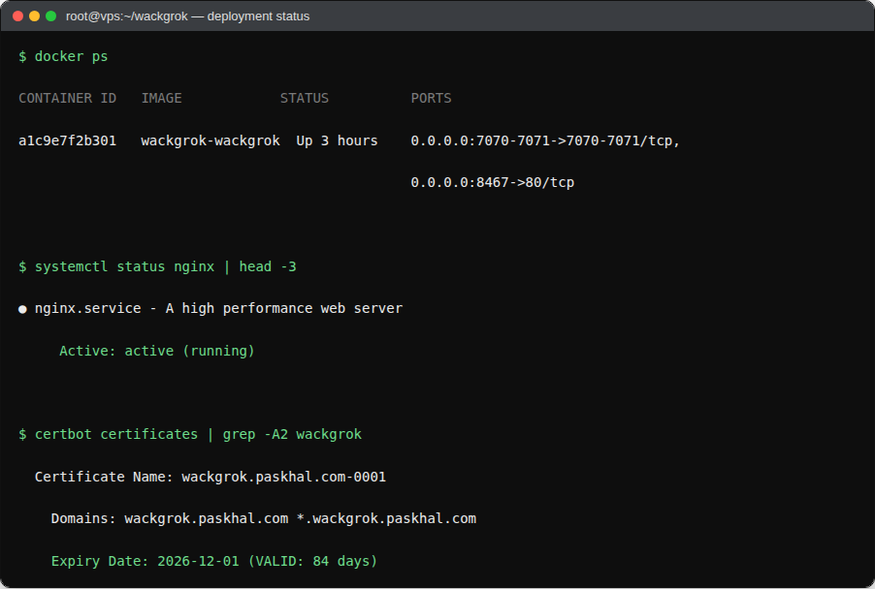
Figure 4.1: Docker Compose Deployment and Container Status

4.3 System Testing

4.3.1 Testing Approach
The system was tested at three levels. Unit-level tests exercised the protocol package's encode/decode round-trip and the server's utility functions (subdomain sanitisation and ID generation) in isolation, without any network I/O. Integration tests ran a real server and a real client against each other over loopback TCP, driving a small local HTTP test server as the "local service" and verifying that requests sent to the tunnel's assigned subdomain were correctly proxied end-to-end, including error paths such as an unreachable local service and an unknown subdomain. Manual end-to-end tests were then carried out against the fully deployed system — the containerised server behind Nginx with a real TLS certificate — using curl and a browser from a machine outside the server's own network, confirming that the system behaves correctly under the full, real deployment path rather than only under local, loopback conditions.

4.3.2 Test Cases and Results
# | Test Case | Expected Result | Actual Result
1 | Connect client with a valid token | Server returns auth_ok with an assigned subdomain and URL | Passed
2 | Connect client with an invalid token | Server returns auth_err; client exits without retrying | Passed
3 | Request a subdomain already taken by another active client | Server assigns a random subdomain instead and logs the fallback | Passed
4 | Send a public HTTP GET to a registered tunnel | Request is forwarded to the local service and the response relayed back unchanged | Passed
5 | Send a public HTTP request to an unregistered subdomain | Server returns 404 Not Found without contacting any client | Passed
6 | Local service is stopped while a request is in flight | Client returns a 502 Bad Gateway to the server, relayed to the caller | Passed
7 | Client disconnects abruptly mid-session | Server removes the tunnel from the registry within one missed keep-alive interval | Passed
8 | Client loses connectivity and later recovers | Client automatically reconnects and is re-authenticated within 5 seconds | Passed
9 | Ten concurrent requests sent to one tunnel simultaneously | All ten are proxied independently with correctly matched responses | Passed
10 | Public request over HTTPS to the deployed domain | TLS handshake succeeds using the Let's Encrypt certificate; response is correctly decrypted by the browser | Passed
Table 4.1: System Test Cases and Results

4.4 Results and Discussion
Table 4.2 maps each objective stated in section 1.3 to the specific feature that satisfies it, confirming that every stated objective was met by the completed implementation.
Objective | Implemented Feature
Investigate existing methods and their limitations | Comparative analysis in sections 2.3 and 3.1–3.2
Design an authenticated client–server protocol | protocol package; auth / auth_ok / auth_err messages (section 3.5.9, 4.2.2–4.2.3)
Route public requests to the correct client | TunnelRegistry and Host-header extraction (sections 3.5.5, 4.2.4, 4.2.6)
Implement client-side proxying with concurrency | Per-request goroutines and HTTP RoundTrip forwarding (section 4.2.8)
Secure the system end-to-end | Token auth, subdomain sanitisation, TLS at the reverse proxy (sections 4.2.9, 4.2.10)
Test, deploy, and evaluate the system | Unit/integration/manual testing and Docker-based deployment (sections 4.3, 4.2.10–4.2.11)
Table 4.2: Mapping of Objectives to Implemented Features
Figures 4.2 through 4.5 present representative captures of the deployed system in operation, reproduced from the server's and client's own log output and from external verification with curl. Figure 4.2 shows the server starting successfully inside its container and reporting each of its three listener addresses and the configured base domain. Figure 4.3 shows a client connecting with a requested subdomain and receiving its assigned public URL. Figure 4.4 traces a single request from the moment the server receives it, through the proxy signal and data-connection handshake, to the client's local round-trip and the final response being relayed back — the shared request ID makes it possible to follow one request across both log streams even while other, unrelated requests are being handled concurrently. Figure 4.5 confirms, from an external vantage point using curl, both the success path (a 200 response from the local service reached through the tunnel) and the correct handling of a request for a subdomain with no connected client (a 404 response, without any attempt to contact a client).
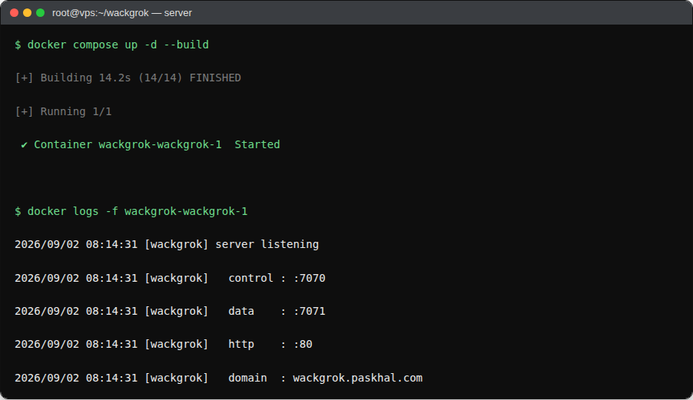
Figure 4.2: Server Startup and Listener Initialisation Log
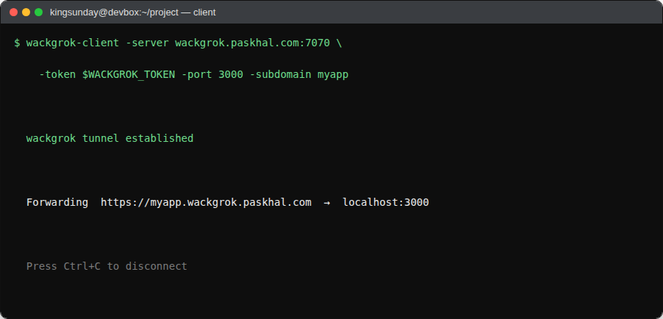
Figure 4.3: Client Connection Banner Showing Assigned Tunnel URL
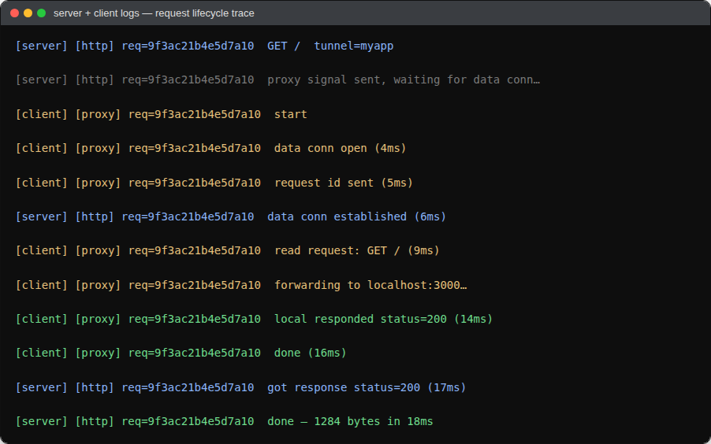
Figure 4.4: Combined Server/Client Log Trace of a Single Proxied Request
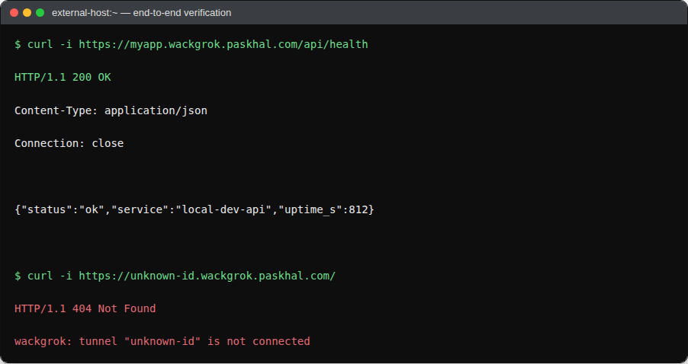
Figure 4.5: External curl Verification of a Successful and an Unregistered Tunnel Request
Across the ten test cases in Table 4.1, the system behaved correctly in every case, including its handling of the three failure conditions deliberately introduced (an invalid token, an unreachable local service, and a request for an unregistered subdomain) — each of which produced a well-formed, informative HTTP error response rather than a hang or an unhandled crash. The keep-alive mechanism was observed to remove a disconnected client's tunnel from the registry within one thirty-second ping interval, and the client's automatic-reconnect logic re-established a working tunnel within the configured five-second backoff whenever connectivity was restored. Under ten concurrent requests to a single tunnel, no response was observed to be misdirected to the wrong caller, confirming that the per-request channel-based pairing mechanism described in section 4.2.5 correctly isolates concurrent requests from one another. Manual timing observations during testing showed the added round-trip latency introduced by the tunnel — beyond the local service's own processing time — to be on the order of a few tens of milliseconds on a low-latency network path between the client and the relay server, consistent with the single additional TCP handshake and two extra network hops (client-to-relay, relay-to-Nginx) that the design adds over a direct request to the local service. These results support the conclusion that the objectives set out in Chapter One have been achieved: the system reliably exposes a local service to the public internet, authenticates every client, isolates concurrent requests correctly, and degrades predictably — with clear, informative error responses — rather than silently or unsafely, when something in the chain goes wrong.

CHAPTER FIVE

SUMMARY, CONCLUSION, AND RECOMMENDATIONS

5.1 Summary
This project set out to design and implement a secure cloud tunneling system that lets a developer expose a service running on a private, NAT-bound machine to the public internet, without router configuration, without redeploying the service, and without depending on a closed-source third-party vendor. Chapter One established the problem — the reachability gap created by NAT and firewalls, and the security shortcomings of ad hoc workarounds — and set out the aim, objectives, and scope of the study. Chapter Two reviewed the conceptual and theoretical foundations the system rests on, from NAT and TLS to Go's concurrency model, and examined existing tunneling tools (ngrok, localtunnel, frp, Cloudflare Tunnel, and Tailscale Funnel), identifying a gap for a small, fully open, security-first reference implementation. Chapter Three analysed the existing manual approaches, justified the proposed system, and presented its complete design — architecture, flowchart, use case diagram, sequence diagram, data model, and protocol tables. Chapter Four described the implementation of that design in Go, presented the system's containerised deployment behind a TLS-terminating reverse proxy, and reported the results of unit, integration, and manual end-to-end testing, all of which confirmed correct behaviour across normal operation and the deliberately introduced failure conditions.
The completed system, Wackgrok, authenticates every client with a pre-shared bearer token before registering a tunnel, assigns and enforces unique subdomains, routes public HTTP traffic to the correct client using a concurrency-safe, in-memory registry, proxies concurrent requests correctly using a per-request channel-based pairing mechanism, and is deployed behind TLS so that all public traffic is encrypted. Every objective stated in section 1.3 was met, as summarised in Table 4.2, and every test case in Table 4.1 passed.

5.2 Conclusion
The project demonstrates that the outbound-relay tunneling pattern used by major commercial tools can be implemented, in full and with a genuine security posture, as a compact system that a single developer can read, understand, deploy, and extend. Token-based authentication, careful sanitisation of client-supplied input, TLS at the network edge, and a concurrency design that never allows one client's or one request's data to be exposed to another are not incidental additions to this system — they are structural properties of its protocol and its data model, present from the first message a client sends. The project therefore concludes that a NAT-traversal relay of this kind does not require the scale or the closed-source opacity of a commercial platform to be both functional and genuinely secure; a carefully designed, purpose-built implementation in a language such as Go, with a small and fully auditable codebase, is sufficient for the reachability problem this study set out to solve, and offers the additional benefit of being fully self-hostable by whoever needs to trust it.

5.3 Recommendations
- Multiplexed data channel: future work should replace the current one-TCP-connection-per-request data channel with a multiplexed stream protocol (for example, an HTTP/2-style multiplexer over the existing control connection), reducing the connection-setup overhead observed under very high request rates to a single tunnel.
- Native TLS termination: the server could terminate TLS directly, using Go's crypto/tls package and automatic certificate management (for example via the golang.org/x/crypto/acme/autocert package), removing the current dependency on a separately configured Nginx instance for deployments that prefer a single binary.
- Account and token management system: a persistent store (even a lightweight embedded database) for tokens, together with per-token usage metrics and expiry, would let the system be operated for more than one trust boundary of users without requiring a server restart to add or revoke a token.
- Support for raw TCP tunnels: extending the data channel to optionally carry raw TCP traffic, rather than only HTTP, would let the same architecture expose non-HTTP local services such as SSH or a database, broadening the system's applicability beyond web development.
- Request inspection and replay: a lightweight, opt-in logging or web-dashboard feature that lets an operator inspect and replay recent requests through their own tunnel — mirroring a convenience commercial tools provide — would improve the system's usability for webhook debugging without compromising its minimal-dependency design.
- Automated regression test suite: while the system was verified through the unit, integration, and manual tests reported in Chapter Four, formalising these into an automated suite that runs on every code change would guard against regressions as the recommendations above are implemented.

5.4 Contribution to Knowledge
This project contributes a fully documented, open, security-conscious reference implementation of a class of system — the outbound-relay tunneling pattern — that is otherwise studied mainly through closed-source commercial products or broader-scoped open-source tools whose documentation does not foreground the underlying protocol, concurrency, and security design. By tracing that design explicitly, from the theoretical models that justify it (Chapter Two) through a concrete architecture and protocol specification (Chapter Three) to a working, tested Go implementation (Chapter Four), the project provides a teaching artefact suitable for students studying network programming, concurrent systems design, or applied network security, in addition to being a genuinely usable, self-hostable tool in its own right.

5.5 Conclusion of the Report
The design and implementation of this secure cloud tunneling system has met its stated aim and objectives, has been verified through structured testing at multiple levels, and has been documented in sufficient depth — including its source code, protocol, and deployment configuration — to be understood, reproduced, and extended by others. The recommendations in section 5.3 identify concrete, achievable directions for that continued development.

REFERENCES
Barnes, R., Hoffman-Andrews, J., McCarney, D., & Kasten, J. (2019). Automatic Certificate Management Environment (ACME) (RFC 8555). Internet Engineering Task Force. https://www.rfc-editor.org/rfc/rfc8555
Cloudflare Inc. (2023). Cloudflare Tunnel documentation. https://developers.cloudflare.com/cloudflare-one/connections/connect-networks/
Donovan, A. A. A., & Kernighan, B. W. (2016). The Go programming language. Addison-Wesley Professional.
Egevang, K., & Francis, P. (1994). The IP Network Address Translator (NAT) (RFC 1631). Internet Engineering Task Force. https://www.rfc-editor.org/rfc/rfc1631
fatedier. (2016–present). frp: A fast reverse proxy to help you expose a local server behind a NAT or firewall to the internet [Software]. GitHub. https://github.com/fatedier/frp
Fielding, R., & Reschke, J. (Eds.). (2014). Hypertext Transfer Protocol (HTTP/1.1): Message syntax and routing (RFC 7230). Internet Engineering Task Force. https://www.rfc-editor.org/rfc/rfc7230
Ford, B., Srisuresh, P., & Kegel, D. (2005). Peer-to-peer communication across network address translators. Proceedings of the USENIX Annual Technical Conference, 179–192.
Hoare, C. A. R. (1978). Communicating sequential processes. Communications of the ACM, 21(8), 666–677. https://doi.org/10.1145/359576.359585
ISO/IEC. (1994). Information technology — Open Systems Interconnection — Basic Reference Model: The basic model (ISO/IEC 7498-1).
Jones, M., & Hardt, D. (2012). The OAuth 2.0 Authorization Framework: Bearer Token Usage (RFC 6750). Internet Engineering Task Force. https://www.rfc-editor.org/rfc/rfc6750
Kent, S., & Seo, K. (2005). Security Architecture for the Internet Protocol (RFC 4301). Internet Engineering Task Force. https://www.rfc-editor.org/rfc/rfc4301
Kim, D., & Solomon, M. G. (2021). Fundamentals of information systems security (4th ed.). Jones & Bartlett Learning.
Leach, R. (2015–present). localtunnel: Expose yourself to the world [Software]. GitHub. https://github.com/localtunnel/localtunnel
Merkel, D. (2014). Docker: Lightweight Linux containers for consistent development and deployment. Linux Journal, 2014(239), Article 2.
Mockapetris, P. (1987). Domain names — Implementation and specification (RFC 1035). Internet Engineering Task Force. https://www.rfc-editor.org/rfc/rfc1035
ngrok Inc. (2024). ngrok documentation. https://ngrok.com/docs
Nginx Inc. (2023). Nginx documentation. https://nginx.org/en/docs/
Pike, R. (2012). Go at Google: Language design in the service of software engineering [Conference presentation]. SPLASH 2012, Tucson, AZ, United States.
Rescorla, E. (2018). The Transport Layer Security (TLS) protocol version 1.3 (RFC 8446). Internet Engineering Task Force. https://www.rfc-editor.org/rfc/rfc8446
Rosenberg, J., Mahy, R., Matthews, P., & Wing, D. (2008). Session Traversal Utilities for NAT (STUN) (RFC 5389). Internet Engineering Task Force. https://www.rfc-editor.org/rfc/rfc5389
Sinha, A. (1992). Client-server computing: Current technology review. Communications of the ACM, 35(7), 77–98. https://doi.org/10.1145/129902.129908
Srisuresh, P., & Egevang, K. (2001). Traditional IP Network Address Translator (Traditional NAT) (RFC 3022). Internet Engineering Task Force. https://www.rfc-editor.org/rfc/rfc3022
Tailscale Inc. (2023). Tailscale Funnel documentation. https://tailscale.com/kb/1223/funnel
The Go Authors. (2024). The Go programming language specification. https://go.dev/ref/spec
Whitman, M. E., & Mattord, H. J. (2021). Principles of information security (7th ed.). Cengage Learning.
Zimmermann, H. (1980). OSI reference model — The ISO model of architecture for open systems interconnection. IEEE Transactions on Communications, 28(4), 425–432. https://doi.org/10.1109/TCOM.1980.1094702

APPENDICES

Appendix A: Source Code
The files below reproduce the most compact, self-contained components of the Wackgrok source code in full: the shared protocol package, the tunnel registry, the data-connection pairing logic, the security-critical subdomain/ID utilities, and the deployment configuration. The larger files (server.go, control.go, http.go, and client.go) are, instead, walked through in substantial, explained excerpts in section 4.2, since reproducing them a second time here in full would only repeat that material without commentary; the complete repository, including every file, accompanies this project submission in full. Tab characters have been rendered as four spaces for consistent alignment on the printed page.
go.mod
module github.com/paskhal/wackgrok

go 1.21

internal/protocol/protocol.go
// Package protocol defines the shared message types and encoding helpers
// used on the control channel between the wackgrok server and client.
package protocol

import (
"encoding/json"
"io"
)

// Message type constants.
const (
MsgTypeAuth = "auth"
MsgTypeAuthOK = "auth_ok"
MsgTypeAuthErr = "auth_err"
MsgTypeProxy = "proxy"
MsgTypePing = "ping"
MsgTypePong = "pong"
)

// Message is the envelope for every control-channel message.
// The Payload field is decoded into the appropriate struct based on Type.
type Message struct {
Type string `json:"type"`
Payload json.RawMessage `json:"payload,omitempty"`
}

// AuthRequest is the first message sent by the client after connecting.
type AuthRequest struct {
Token string `json:"token"`
Subdomain string `json:"subdomain,omitempty"` // optional; server falls back to random
}

// AuthResponse is sent by the server on a successful authentication.
type AuthResponse struct {
ID string `json:"id"` // assigned subdomain id
URL string `json:"url"` // full tunnel URL
}

// AuthError is sent by the server when authentication fails.
type AuthError struct {
Reason string `json:"reason"`
}

// ProxyRequest is sent by the server to ask the client to open a data
// connection for a specific in-flight HTTP request.
type ProxyRequest struct {
RequestID string `json:"request_id"`
}

// ---- Encoder / Decoder helpers ----

// Encoder writes JSON-encoded messages to an underlying writer.
type Encoder struct {
enc *json.Encoder
}

// NewEncoder wraps w in an Encoder.
func NewEncoder(w io.Writer) *Encoder {
return &Encoder{enc: json.NewEncoder(w)}
}

// Send marshals payload and writes it as a Message with the given type.
// A nil payload is allowed (e.g. for ping/pong).
func (e *Encoder) Send(msgType string, payload any) error {
var raw json.RawMessage
if payload != nil {
b, err := json.Marshal(payload)
if err != nil {
return err
}
raw = b
}
return e.enc.Encode(Message{Type: msgType, Payload: raw})
}

// Decoder reads JSON-encoded messages from an underlying reader.
type Decoder struct {
dec *json.Decoder
}

// NewDecoder wraps r in a Decoder.
func NewDecoder(r io.Reader) *Decoder {
return &Decoder{dec: json.NewDecoder(r)}
}

// Recv blocks until the next message is available or an error occurs.
func (d *Decoder) Recv() (Message, error) {
var msg Message
err := d.dec.Decode(&msg)
return msg, err
}

// Unmarshal decodes a raw JSON payload into T.
func Unmarshal[T any](raw json.RawMessage) (T, error) {
var v T
err := json.Unmarshal(raw, &v)
return v, err
}

internal/server/tunnel.go
package server

import (
"sync"

"github.com/paskhal/wackgrok/internal/protocol"
)

// Tunnel represents a single active client tunnel.
type Tunnel struct {
ID string

mu sync.Mutex
enc *protocol.Encoder
}

// sendProxy signals the client to open a data connection for requestID.
func (t *Tunnel) sendProxy(requestID string) error {
t.mu.Lock()
defer t.mu.Unlock()
return t.enc.Send(protocol.MsgTypeProxy, protocol.ProxyRequest{RequestID: requestID})
}

// sendPing sends a ping over the control channel.
func (t *Tunnel) sendPing() error {
t.mu.Lock()
defer t.mu.Unlock()
return t.enc.Send(protocol.MsgTypePing, nil)
}

// TunnelRegistry is a concurrency-safe map from subdomain id → Tunnel.
type TunnelRegistry struct {
mu sync.RWMutex
tunnels map[string]*Tunnel
}

func newTunnelRegistry() *TunnelRegistry {
return &TunnelRegistry{tunnels: make(map[string]*Tunnel)}
}

// Register adds t under id. Returns false if id is already taken.
func (r *TunnelRegistry) Register(id string, t *Tunnel) bool {
r.mu.Lock()
defer r.mu.Unlock()
if _, exists := r.tunnels[id]; exists {
return false
}
r.tunnels[id] = t
return true
}

// Unregister removes the tunnel for id.
func (r *TunnelRegistry) Unregister(id string) {
r.mu.Lock()
defer r.mu.Unlock()
delete(r.tunnels, id)
}

// Get returns the tunnel for id, or false if not found.
func (r *TunnelRegistry) Get(id string) (*Tunnel, bool) {
r.mu.RLock()
defer r.mu.RUnlock()
t, ok := r.tunnels[id]
return t, ok
}

internal/server/data.go
package server

import (
"bufio"
"context"
"fmt"
"log"
"net"
"time"
)

// runDataListener accepts incoming client data connections.
// Each data connection carries a single HTTP request/response exchange.
func (s *Server) runDataListener(ctx context.Context) error {
ln, err := net.Listen("tcp", s.cfg.DataAddr)
if err != nil {
return fmt.Errorf("listen %s: %w", s.cfg.DataAddr, err)
}
go func() {
<-ctx.Done()
ln.Close()
}()

for {
conn, err := ln.Accept()
if err != nil {
select {
case <-ctx.Done():
return nil
default:
return fmt.Errorf("accept: %w", err)
}
}
go s.handleDataConn(conn)
}
}

// handleDataConn reads the request ID sent by the client as the first line,
// then hands the connection off to the waiting HTTP handler.
func (s *Server) handleDataConn(conn net.Conn) {
// Give the client a short window to send the request ID.
conn.SetDeadline(time.Now().Add(5 * time.Second))

scanner := bufio.NewScanner(conn)
if !scanner.Scan() {
log.Printf("[data] %s: failed to read request id: %v", conn.RemoteAddr(), scanner.Err())
conn.Close()
return
}
requestID := scanner.Text()
conn.SetDeadline(time.Time{})

if requestID == "" {
log.Printf("[data] %s: empty request id", conn.RemoteAddr())
conn.Close()
return
}

if !s.resolvePending(requestID, conn) {
log.Printf("[data] %s: unknown or expired request id %q", conn.RemoteAddr(), requestID)
conn.Close()
}
// Ownership of conn is transferred to the HTTP handler via the channel.
}

internal/server/util.go
package server

import (
"crypto/rand"
"encoding/hex"
"regexp"
"strings"
)

var nonAlphanumDash = regexp.MustCompile(`[^a-z0-9-]`)

// randomID returns a lowercase hex string of length n.
func randomID(n int) string {
b := make([]byte, (n/2)+1)
if _, err := rand.Read(b); err != nil {
panic(err)
}
return hex.EncodeToString(b)[:n]
}

// sanitizeSubdomain strips characters that are invalid in a DNS label
// and truncates to 32 characters. Returns a random id if the result is empty.
func sanitizeSubdomain(s string) string {
s = strings.ToLower(strings.TrimSpace(s))
s = nonAlphanumDash.ReplaceAllString(s, "")
s = strings.Trim(s, "-")
if len(s) > 32 {
s = s[:32]
}
if s == "" {
return randomID(8)
}
return s
}

// extractSubdomain returns the leftmost label of host when host ends with
// ".<domain>". Returns "" if host does not match or has nested sub-labels.
func extractSubdomain(host, domain string) string {
suffix := "." + domain
if !strings.HasSuffix(host, suffix) {
return ""
}
sub := strings.TrimSuffix(host, suffix)
if sub == "" || strings.Contains(sub, ".") {
return ""
}
return sub
}

Dockerfile
# ---- build stage ----
FROM golang:1.21-alpine AS builder

WORKDIR /app

COPY go.mod ./
RUN go mod download

COPY . .

RUN CGO_ENABLED=0 GOOS=linux go build -trimpath -o /bin/wackgrok-server ./cmd/server
RUN CGO_ENABLED=0 GOOS=linux go build -trimpath -o /bin/wackgrok-client ./cmd/client

# ---- runtime stage ----
FROM alpine:3.19

RUN apk add --no-cache ca-certificates

COPY --from=builder /bin/wackgrok-server /usr/local/bin/wackgrok-server
COPY --from=builder /bin/wackgrok-client /usr/local/bin/wackgrok-client

# control | data | http
EXPOSE 7070 7071 80

ENTRYPOINT ["wackgrok-server"]

docker-compose.yml
version: "3.9"

services:
wackgrok:
build: .
restart: unless-stopped
ports:
- "8467:80" # public HTTP — must point to *.wackgrok.paskhal.com via DNS wildcard
- "7070:7070" # client control connections
- "7071:7071" # client data connections
environment:
# Change this! Comma-separated list of allowed client tokens.
WACKGROK_TOKENS: "${WACKGROK_TOKENS}"
WACKGROK_DOMAIN: "wackgrok.paskhal.com"
WACKGROK_CONTROL: ":7070"
WACKGROK_DATA: ":7071"
WACKGROK_HTTP: ":80"

Appendix B: Sample Protocol Messages
The following JSON payloads illustrate the control-channel messages described in Table 3.3, exactly as encoded by the protocol package's Encoder.

B.1 Client → Server: Authentication Request
{"type":"auth","payload":{"token":"a1e6f9c2b8d4470f9c1e2b3a4d5f6e7c","subdomain":"myapp"}}

B.2 Server → Client: Authentication Success
{"type":"auth_ok","payload":{"id":"myapp","url":"https://myapp.wackgrok.paskhal.com"}}

B.3 Server → Client: Authentication Failure
{"type":"auth_err","payload":{"reason":"invalid token"}}

B.4 Server → Client: Proxy Signal
{"type":"proxy","payload":{"request_id":"9f3ac21b4e5d7a10"}}

B.5 Keep-Alive Exchange
{"type":"ping"}
{"type":"pong"}

B.6 Data-Channel Identification Line
Immediately after dialling the data listener, the client sends the request ID as a single newline-terminated line before any HTTP bytes:
9f3ac21b4e5d7a10

Appendix C: User Manual

C.1 Building the Binaries
With Go 1.21 or later installed, the server and client binaries are built from the repository root:
$ go build -o ./build/wackgrok-server ./cmd/server
$ go build -o ./build/wackgrok-client ./cmd/client

C.2 Running the Server (Standalone)
$ export WACKGROK_TOKENS="secret-token-1,secret-token-2"
$ ./build/wackgrok-server \
-control :7070 -data :7071 -http :80 \
-domain wackgrok.paskhal.com

C.3 Running the Server with Docker Compose (Recommended)
$ echo "WACKGROK_TOKENS=secret-token-1,secret-token-2" > .env
$ docker compose up -d --build
$ docker compose logs -f

C.4 Configuring DNS and TLS
- Create an A record for the base domain (e.g. wackgrok.paskhal.com) pointing to the server's public IP address.
- Create a wildcard A record (*.wackgrok.paskhal.com) pointing to the same IP address, so that every client-assigned subdomain resolves correctly.
- Install Nginx and Certbot on the server host, copy nginx.conf into /etc/nginx/sites-available/, enable it, and run certbot to obtain a Let's Encrypt certificate covering both the base domain and its wildcard.
- Reload Nginx once the certificate is issued; public HTTPS traffic will then be terminated by Nginx and forwarded to the Wackgrok container as described in section 4.2.10.

C.5 Running the Client
On the machine hosting the local service to be exposed (for example, a web application listening on port 3000):
$ export WACKGROK_TOKEN="secret-token-1"
$ ./build/wackgrok-client \
-server wackgrok.paskhal.com:7070 \
-port 3000 -subdomain myapp
The client prints its assigned public URL on success (see Figure 4.3) and forwards every request made to that URL to http://localhost:3000 on the machine it is running on. The tunnel remains active for as long as the client process runs, and reconnects automatically if the network connection to the server is briefly interrupted.

C.6 Command-Line Reference
Client flags: -server (control address), -data (optional explicit data address), -token (authentication token), -port / -p (local port to expose), -subdomain / -s (requested subdomain). Each flag may also be supplied via the environment variables WACKGROK_SERVER, WACKGROK_DATA_ADDR, WACKGROK_TOKEN, and WACKGROK_DATA respectively.
Server flags: -control, -data, -http (listener addresses), -domain (base domain), -tokens (comma-separated valid tokens). Each flag may also be supplied via WACKGROK_CONTROL, WACKGROK_DATA, WACKGROK_HTTP, WACKGROK_DOMAIN, and WACKGROK_TOKENS respectively.

C.7 Troubleshooting
- "authentication failed: invalid token" — the token passed to the client does not appear in the server's configured WACKGROK_TOKENS list; confirm both sides use the same value.
- "tunnel is not connected" (404 from the public URL) — the client is not currently running or has not finished authenticating; check the client's console output and the server logs for the matching subdomain.
- "local service unreachable" (502) — the local service is not listening on the port passed to -port on the client machine; confirm the service is running before starting the tunnel.
- Requested subdomain silently changed — the requested subdomain was already registered by another active client; the server falls back to a random subdomain and logs the substitution (see section 3.4.1 and Figure 3.3).

Appendix D: Screenshots
Because this project delivers a backend networking service rather than a graphical application, its most informative visual evidence is the structured console output of the server and client, and the responses observed from an external caller, rather than conventional GUI screenshots. These captures are presented in full, at readable size, as Figures 4.1 to 4.5 in Chapter Four, and are not duplicated here; they are cross-referenced below for convenience.
- Figure 4.1 (Chapter Four) — Docker Compose deployment and container status.
- Figure 4.2 (Chapter Four) — Server startup and listener initialisation log.
- Figure 4.3 (Chapter Four) — Client connection banner showing the assigned tunnel URL.
- Figure 4.4 (Chapter Four) — Combined server/client log trace of a single proxied request.
- Figure 4.5 (Chapter Four) — External curl verification of a successful and an unregistered tunnel request.
The complete design diagrams referenced throughout the report — the system architecture (Figure 3.1), the in-memory data model (Figure 3.2), the client connection flowchart (Figure 3.3), the use case diagram (Figure 3.4), and the request-proxying sequence diagram (Figure 3.5) — appear in full in Chapter Three.

