Database Modifications

* Customer table was modified to have a “password” column.

API Changes and Modifications

* Endpoint 1 was changed from searching by actor_id by searching by first_name and last_name. (Also changed from GET to POST request)

* Endpoint 3 was changed to use JWT verification.

* Endpoint 7 was changed to use JWT verification, and additional error catching was implemented.

* Endpoint 8 was changed to a PUT request, and updates customer information.

* Endpoint 10 was changed to a PUT request, and updates staff information

* Endpoints 11 through 14 are used to login and verify the login of both admin (staff) and customers. (11 and 13 are POST requests, and 12 and 14 are GET requests.)

* Endpoint 15 gets all film categories. (GET request)

* Endpoint 16 gets all film ratings (GET request)

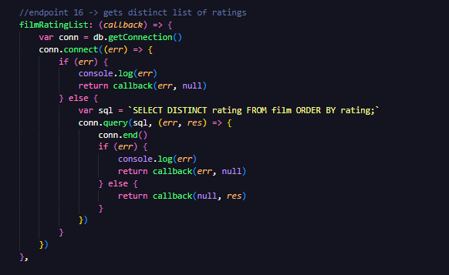

* Endpoint 17 searches on films based on criteria parsed in from the front-end. (POST request)Text

  Description automatically generated

* Endpoint 18 gets all film details based on their ID (GET request)

* Endpoint 19 gets films that the actor has acted. (GET request)

* Endpoint 20 gets all stores (GET request)

* Endpoint 21 gets list of all cities (POST request)Text

  Description automatically generated

* Endpoint 22 gets list of all countries (GET request)

* Endpoint 23 gets staff details from the database (GET request)

* Endpoint 24 gets customer details from the database (GET request)

* Endpoint 25 posts new customer to the database (POST request)

