Name: Lee Hong Yi

Admin Number: 2223010

Class: DAAA/FT/1B/05

Endpoint 1

* Test if working

* Test for 204 (No Content)

Endpoint 3

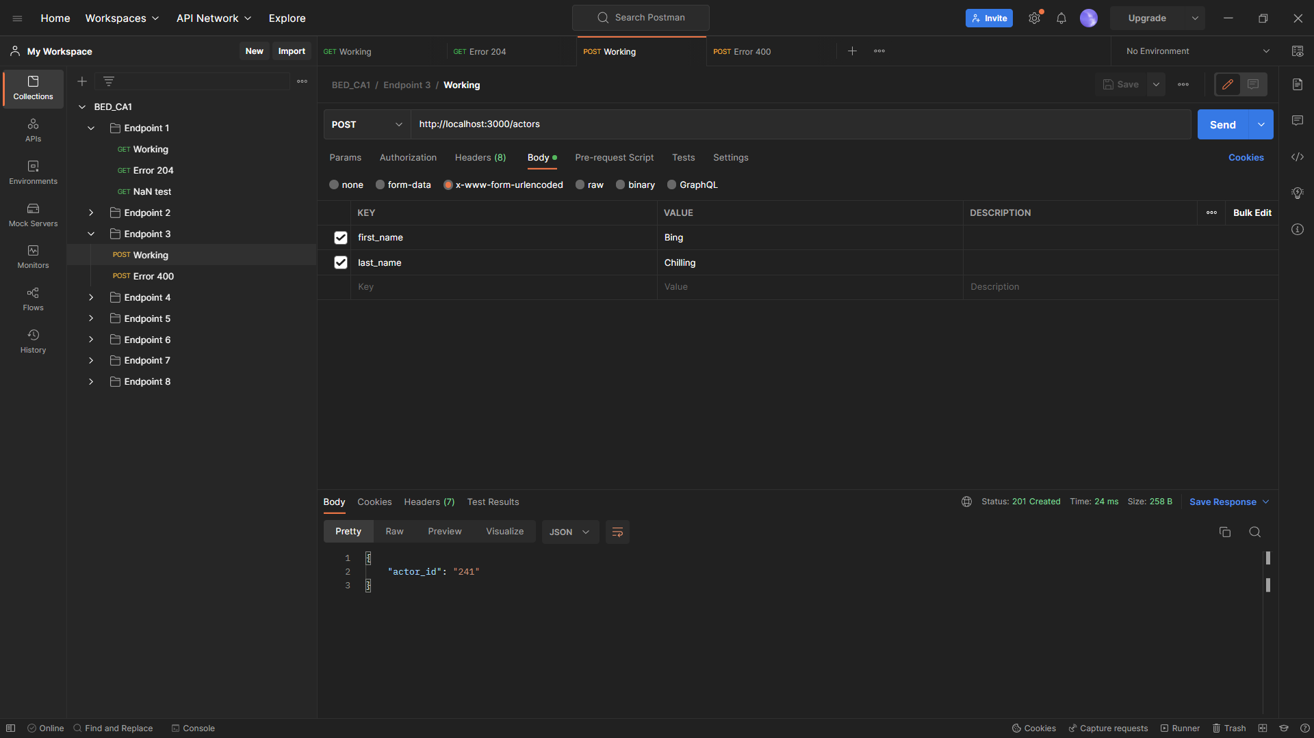

* Test for 400 (Bad Request)

