How to Enable TV-OUT Function

Preparedness
  - Make sure M/B version is 501X or 502X, and with S-Video connector
  - Make sure BIOS version is V2.XX, the current version is V2.09

Procedures
  - Connect Notebook and TV by S-Video cable
  - Go to CMOS setup, and set “NTSC” for TV Mode in USA
  - Install Video driver in OS, run “setup.exe” in Video driver root
  - After installing Video drive, there is a “SiS” icon in the task bar

e. Move Mouse to “SiS” icon, press right click, go to “Display Property → Display settings”, the “Driver Mode Setting” window will be popped out as shown the following pictures

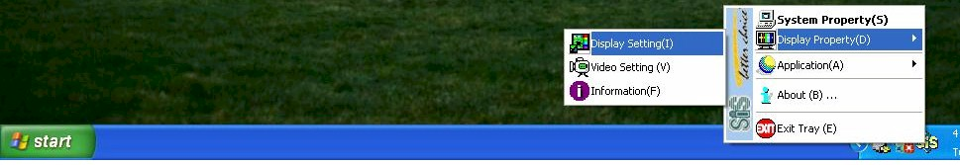

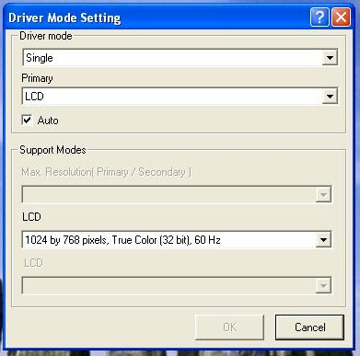
f. Disable “Auto” in Primary, if Driver Mode is Single, selecting TV as Primary as shown in the following picture

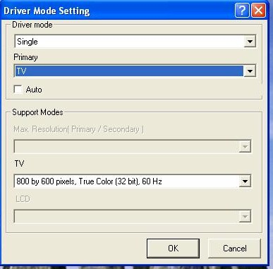

g. If the Driver mode is Mirror or Multimonitor, selecting “TV” as Secondary as shown in the following pictures, there is a limitation that when selecting “TV” as Secondary, you just could use “VGA” as Primary, couldn’t use “LCD” as Primary

