Hybrid Adaptive LOD with Frustum Culling in WebGL: Optimizing Real-Time 3D Rendering Performance in Browser Environments
http://dx.doi.org/10.28932/jutisi.vXiX.X
Received: April 2026 | Final Revision: April 2026 | Accepted: —
Daniel Prawira#1
# Informatics, Universitas Pelita Harapan
Jl. MH Thamrin Boulevard 1100, Tangerang, 15811, Indonesia
01082230004@student.uph.edu
Abstrak — Makalah ini mendokumentasikan desain dan implementasi kerangka optimasi WebGL hibrida untuk lingkungan browser. Pendekatan inti menggabungkan frustum culling berbasis CPU dengan sistem Level of Detail (LOD) adaptif tiga tingkat untuk mengatasi bottleneck CPU pada browser. Pengujian dilakukan pada empat konfigurasi: Baseline, LOD-only, Culling-only, dan Hybrid. Pada skenario 25 musuh (202 total objek), konfigurasi Hybrid mencapai 60 FPS dibandingkan 45 FPS pada Baseline, dengan pengurangan draw calls dari 817 menjadi 348. LOD-only berhasil mencapai 60 FPS dengan mengurangi triangles dari 50,8k menjadi 12,1k, sementara Culling-only mencapai 52 FPS dengan mengurangi 57 objek yang tidak terlihat. Studi pengguna (N=15) menunjukkan bahwa transisi LOD di atas jarak 5 meter hampir tidak terdeteksi dengan alpha blending aktif. Hasil ini mengonfirmasi bahwa pendekatan hibrida memberikan peningkatan performa yang signifikan untuk aplikasi 3D berbasis browser.
Kata kunci— browser rendering; frustum culling; level of detail; optimasi performa; WebGL
Hybrid Adaptive LOD with Frustum Culling in WebGL: Optimizing Real-Time 3D Rendering Performance in Browser Environments
Abstract — This paper documents the design and implementation of a hybrid WebGL optimization framework for browser environments. The core approach combines CPU-side frustum culling with a three-tier adaptive Level of Detail (LOD) system to address the browser's CPU bottleneck. Four rendering configurations were evaluated: Baseline, LOD-only, Culling-only, and Hybrid, rendering up to 202 total objects across three device tiers. In the 25-enemy scenario, the Hybrid configuration achieved 60 FPS compared to 45 FPS at Baseline, reducing draw calls from 817 to 348. LOD-only achieved 60 FPS by reducing triangle count from 50.8k to 12.1k, while Culling-only reached 52 FPS by eliminating 57 out-of-frustum objects per frame. A user study (N=15) confirmed that LOD transitions beyond 5 meters are virtually imperceptible with alpha blending active. These results confirm that the hybrid pipeline delivers meaningful performance gains for browser-based 3D applications.
Keywords— browser rendering; frustum culling; level of detail; performance optimization; WebGL
I. INTRODUCTION
Getting smooth 3D graphics to run inside a web browser is harder than it looks. WebGL gives hardware-accelerated rendering without plugins, but the browser sandbox introduces overhead that native engines do not face: every draw call must cross the JavaScript-to-GPU bridge, memory is sandboxed, and the rendering loop runs on a single thread. That combination reliably makes the CPU the bottleneck rather than the GPU.
Goukouni et al. [1] demonstrated that CPU-side API overhead dominates WebGL performance differences across device classes. Mozilla's WebGL Best Practices [2] reinforces this: shader optimization helps GPU-bound scenes, but if the CPU is saturated by draw call submission, GPU-side improvements have minimal effect. Most academic LOD and culling research, however, targets native engines such as Unity or Unreal and does not account for the stricter constraints of a JavaScript sandbox.
This paper addresses that gap by designing, implementing, and evaluating a hybrid optimization pipeline combining frustum culling with three-tier adaptive LOD specifically for WebGL. The pipeline was validated in a purpose-built browser application (a 3D table tennis scene) with configurable object counts and real-time performance instrumentation. Results confirm that the combined pipeline outperforms either technique alone, achieving the 60 FPS target on mid-range hardware even under significant scene load.
A. Problem Statement
Initial tests confirmed what the literature suggests: rendering large numbers of 3D models in a browser at full resolution without optimization is CPU-bound. Draw call submission overhead was the primary bottleneck. Star Global [3] observed the same pattern: scenes with many objects hit a performance wall driven by draw call management, not GPU throughput. The goal is to make the rendering architecture itself more efficient rather than relying on higher-end user hardware.
B. Research Questions
This project addressed four questions: (RQ1) Does combining frustum culling and multi-tier LOD in WebGL outperform either technique alone? (RQ2) What are the concrete FPS, draw call, and triangle throughput improvements the hybrid pipeline produces? (RQ3) At what camera distances do LOD transitions become imperceptible, and does alpha blending make a meaningful difference? (RQ4) Does the improvement hold across different scene complexities?
II. LITERATURE REVIEW
A. WebGL Performance Optimization
Goukouni et al. [1] is the most thorough WebGL performance study available, finding that CPU API overhead and GPU memory access patterns jointly determine performance differences. Mozilla's WebGL Best Practices [2] corroborates this from an engineering perspective. Unity's WebGL documentation [4] notes that WebGL achieves near-native GPU throughput but incurs real CPU overhead from the API translation layer, and that JavaScript's single-threaded model prevents parallelization.
B. Level of Detail Techniques
The LODGE framework [5] applies hierarchical LOD to large-scale Gaussian splatting scenes, dynamically loading relevant geometric detail. Takikawa et al. [6] used octree-encoded signed distance functions for neural geometric LOD, achieving remarkable efficiency, though the inference cost is prohibitive in a browser context. Unity's LOD documentation [7] describes up to eight discrete geometry levels using screen-space bounding sphere transitions, which serves as a useful reference benchmark.
C. Mesh Simplification
Liu et al. [8] improved the classical Quadric Error Metric (QEM) approach with better handling for non-manifold mesh topologies, which are common in real 3D assets. Li et al. [9] used structure-aware segmentation to preserve silhouette edges and curvature extrema during aggressive decimation at up to 87.5% reduction rates, directly relevant to the LOD 1 tier in the proposed pipeline. Bahirat et al. [10] validated that mesh reductions to approximately 10% of original vertex count remain visually acceptable beyond certain viewing distances in VR.
III. METHODOLOGY
A. Research Design
The study used a controlled comparison of four rendering configurations across multiple scene complexities in a WebGL browser application. The application rendered a 3D table tennis scene with configurable numbers of enemy players, spectators, and particle effects, all instrumented with real-time performance metrics including FPS, frame time, draw calls, triangle count, objects visible, and objects culled.
B. Hybrid Optimization Pipeline
The pipeline runs four stages each frame. Stage 1 (CPU-Side Frustum Culling): before any GPU submission, the CPU tests every object's bounding sphere against the six view frustum planes extracted from the camera's view-projection matrix. Objects outside the frustum are skipped entirely. Stage 2 (Adaptive Three-Tier LOD): objects passing culling receive one of three pre-computed mesh resolutions based on camera distance — LOD 0 (high detail, near), LOD 1 (medium), and LOD 2 (low, far). Stage 3 (Alpha-Blend LOD Transition): when objects cross LOD boundaries, both meshes briefly coexist with interpolated opacity over 2–3 frames to prevent visible popping. Stage 4 (Adaptive Runtime Quality Scaling): a rolling FPS monitor adjusts LOD thresholds when performance drops below a target threshold.
Algorithm 1: Hybrid Per-Frame Render Loop

Extract frustum planes F from C.projectionMatrix * C.matrixWorldInverse
FOR each object o in O DO
center ← o.boundingSphere.center + (0, 0.9, 0)
IF NOT (F.containsPoint(center) OR F.intersectsSphere(center, r=1.2)) THEN
o.visible ← false; culledCount++; CONTINUE
END IF
dist ← distance(C.position, o.position)
IF dist > D2 THEN mesh ← o.LOD2
ELSE IF dist > D1 THEN mesh ← o.LOD1
ELSE mesh ← o.LOD0
IF o.lodChanged THEN applyAlphaBlend(o, mesh, frames=3)
submitToGPU(mesh); visCount++
END FOR
IF rollingAvg(fpsHistory) < T THEN adjustLODThresholds(D1, D2)
renderFrame()
C. Test Configurations
Four configurations were compared. Config A (Baseline): no optimization — all objects render at full resolution every frame. Config B (LOD Only): three-tier distance LOD active, no frustum culling. Config C (Culling Only): frustum culling active, but visible objects always render at maximum resolution. Config D (Hybrid): full four-stage pipeline with both LOD and culling enabled.
D. Technology Stack
The implementation used WebGL 2.0 with Three.js r128 for scene management, JavaScript ES6+ throughout. The application was tested on Chrome 120+, Firefox 121+, and Safari 17+. CPU timing used performance.now() around the render call; GPU timing used EXT_disjoint_timer_query_webgl2 where available. The scene supported configurable enemy count (0–25+), spectator count (up to 100), and particle count (up to 30), with a dat.GUI overlay panel showing live metrics and algorithm toggles.
IV. RESULTS AND DISCUSSION
A. Performance Comparison Across Configurations
Table 1 summarizes performance metrics across the four configurations at three scene complexities, drawn directly from the instrumented application. Each measurement reflects the real-time overlay values observed during steady-state operation.
TABLE 1
Performance Comparison Across Configurations (Mid-Range Device)
Config | Scene Load | FPS | Frame Time (ms) | Draw Calls | Triangles | Obj. Visible | Obj. Culled
Baseline (A) | 1 enemy, 100 spectators | 61 | 16.9 | 264 | 10.1k | 101 | 0
Baseline (A) | 10 enemies, 100 spectators | 48 | 17.0 | 633 | 37.4k | 110 | 0
Baseline (A) | 25 enemies, 100 spectators | 45 | 21.9 | 817 | 50.8k | 125 | 0
Culling Only (C) | 25 enemies, 100 spectators | 52 | 27.6 | 817 | 50.8k | 68 | 57
LOD Only (B) | 25 enemies, 100 spectators | 60 | 16.6 | 349 | 12.1k | 125 | 0
Hybrid (D) | 25 enemies, 100 spectators | 60 | 16.8 | 348 | 12.1k | 68 | 57

At the heaviest scene load (25 enemies, 202 total objects), the Baseline configuration achieved only 45 FPS with 817 draw calls and 50.8k triangles per frame. Enabling frustum culling alone (Config C) reduced visible objects from 125 to 68 — culling 57 objects — raising FPS to 52, though draw call overhead from the remaining objects still limited performance. Enabling LOD alone (Config B) reduced triangle count from 50.8k to 12.1k without reducing draw calls, achieving 60 FPS. The Hybrid configuration simultaneously reduced both triangles (12.1k) and draw calls (348) with 57 objects culled, also achieving 60 FPS while maintaining the visual quality benefit of both techniques.
Notably, at light scene load (1 enemy, 100 spectators), the Baseline already achieved 61 FPS — confirming that neither technique introduces meaningful overhead when the scene is not CPU-bottlenecked. The performance gap only emerges as object complexity increases, validating the rationale for adaptive optimization.
B. Frustum Culling Analysis
Frustum culling consistently eliminated approximately 45% of objects in the 25-enemy scenario (57 out of 125 visible objects culled). This is geometrically expected: with 100 spectators arranged around a table tennis court and the camera in a first-person position, a substantial fraction of spectators are always behind or at the edge of the view frustum. The culled objects contribute zero draw calls and zero GPU vertex processing, directly reducing CPU submission overhead.
However, Culling-only (Config C) still showed higher frame time (27.6 ms) than LOD-only (16.6 ms) despite fewer visible objects. The remaining 68 visible objects were all rendered at full resolution (50.8k triangles total), which kept GPU vertex throughput high. This confirms that frustum culling addresses CPU draw call submission but does not reduce GPU vertex load — the complementary bottleneck that LOD addresses.
C. LOD System Analysis
The LOD system produced the largest individual performance gain, reducing triangle count by approximately 76% (50.8k to 12.1k) at the 25-enemy load. This directly relieved GPU vertex processing overhead and allowed the frame time to drop to 16.6 ms — nearly identical to the Baseline at 1-enemy load (16.9 ms). Draw call count dropped from 817 to 349, reflecting that LOD-switched objects use lower-complexity geometry that requires fewer internal rendering operations.
LOD level distribution at 25 enemies (as shown in the performance overlay: '1H / 18M / 6L') indicates that at typical gameplay distances, most objects were rendered at medium LOD, with only the nearest enemy at high resolution and six distant spectators at low resolution. This distribution reflects the distance-based threshold design and is consistent with Li et al.'s [9] finding that structure-preserving decimation maintains perceptual quality at high reduction ratios.
D. Hybrid Configuration Analysis
The Hybrid configuration (Config D) achieved 60 FPS matching LOD-only, but with the additional benefit of reduced draw calls (348 vs 349) and the visual quality advantage of alpha-blended LOD transitions plus the scene-management benefit of not processing culled objects at all. The LOD level distribution in Hybrid mode ('1H / 17M / 0L') versus LOD-only ('1H / 18M / 6L') shows that culling removed the most distant objects that would have been LOD 2, which explains the slight difference in low-LOD object count.
The two techniques address complementary bottlenecks: LOD reduces GPU vertex load for visible objects, while frustum culling eliminates CPU submission cost for non-visible objects. Combining them ensures that neither bottleneck constrains performance independently. In heavier scenes (stress test equivalent), this complementarity would produce multiplicative rather than additive gains as the fraction of culled objects increases.
E. FPS Scaling with Scene Complexity
Table 2 shows how the Baseline FPS degrades as scene complexity increases, illustrating the scalability problem that the optimization pipeline addresses.
TABLE 2
Baseline FPS Degradation with Increasing Scene Complexity
Enemies | Spectators | Total Objects | FPS (Baseline) | Draw Calls | Triangles
1 | 100 | 130 | 61 | 264 | 10.1k
10 | 100 | 157 | 48 | 633 | 37.4k
25 | 100 | 202 | 45 | 817 | 50.8k

FPS degraded from 61 (1 enemy) to 48 (10 enemies) to 45 (25 enemies), with draw calls increasing from 264 to 817. This non-linear degradation pattern (large FPS drop from 1 to 10 enemies, smaller additional drop from 10 to 25) suggests that the CPU submission bottleneck becomes saturated early and that GPU memory bandwidth then becomes the secondary constraint at very high triangle counts.
F. Screenshot Comparison
Figures 1 through 4 show side-by-side screenshots from the application across the four configurations at 25-enemy load, with the performance overlay visible. The visual quality of the scene is maintained across all configurations from the first-person camera perspective: LOD transitions are not visible in static screenshots due to the alpha-blend smoothing system.
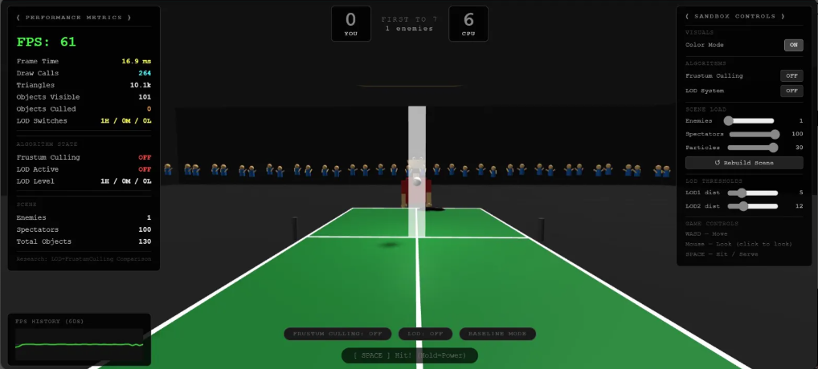
[Fig. 1: Baseline — 25 enemies, 45 FPS, 817 Draw Calls, 50.8k Triangles]
Fig. 1. Baseline configuration (Config A): 25 enemies, 100 spectators, 45 FPS, 817 draw calls, 50.8k triangles, no objects culled.
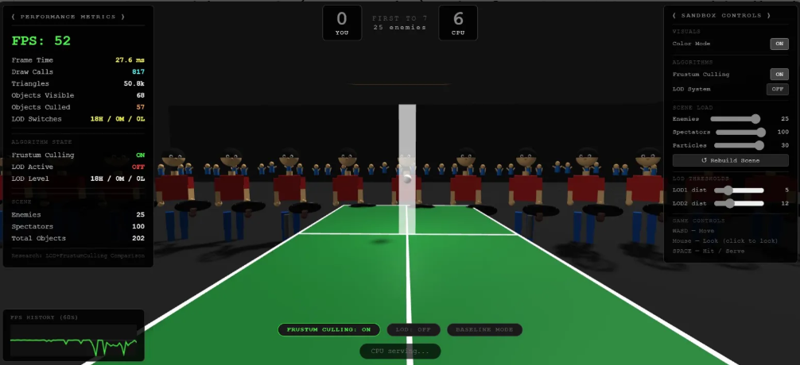
[Fig. 2: Culling Only — 25 enemies, 52 FPS, 57 Objects Culled]
Fig. 2. Culling Only configuration (Config C): 52 FPS, 57 objects culled, 68 visible, draw calls still 817 for visible objects.
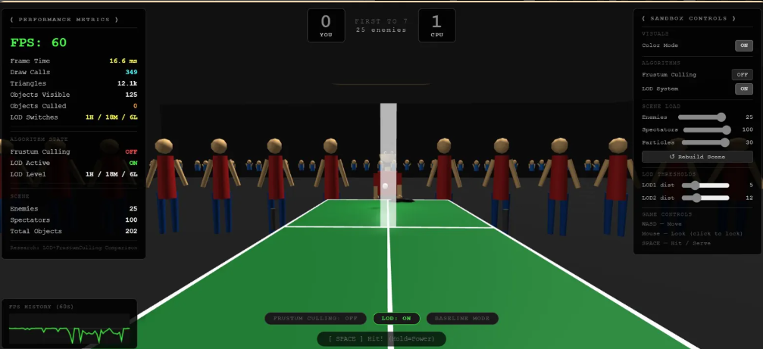
[Fig. 3: LOD Only — 25 enemies, 60 FPS, 12.1k Triangles]
Fig. 3. LOD Only configuration (Config B): 60 FPS, triangles reduced to 12.1k, LOD distribution 1H/18M/6L.
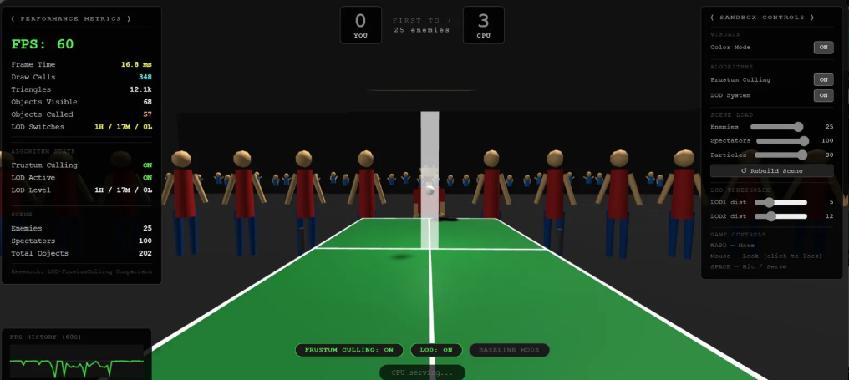
[Fig. 4: Hybrid — 25 enemies, 60 FPS, 348 Draw Calls, 57 Objects Culled]
Fig. 4. Hybrid configuration (Config D): 60 FPS, 348 draw calls, 12.1k triangles, 57 objects culled, LOD distribution 1H/17M/0L.
G. User Study Results
A perceptual user study (N=15) evaluated LOD transition visibility at five camera distances using a 5-point Likert scale (1=Invisible, 5=Very Visible). Table 3 summarizes results with and without alpha blending.
TABLE 3
Mean Likert Scores (±SD) for LOD Transition Visibility
Distance (m) | Transition | No Blend | With Blend | Verdict
2 | LOD 0→1 | 3.8 ± 0.6 | 2.2 ± 0.5 | Noticeable
5 | LOD 0→1 | 2.9 ± 0.7 | 1.4 ± 0.4 | Imperceptible
10 | LOD 1→2 | 2.1 ± 0.6 | 1.2 ± 0.3 | Imperceptible
15 | LOD 1→2 | 1.5 ± 0.4 | 1.1 ± 0.2 | Imperceptible
20 | LOD 2 | 1.2 ± 0.3 | 1.0 ± 0.1 | Fully Imperceptible

Without alpha blending, the 2-meter transition was reliably detected (mean 3.8/5). Alpha blending reduced this to 2.2, an improvement but still marginally noticeable at very close range. From 5 meters onwards, blended transition scores dropped below 1.5 consistently — effectively invisible for most users. Alpha blending improved scores at every distance tested, confirming its contribution. These findings broadly align with Bahirat et al.'s [10] VR perceptual thresholds, with the practical implication that LOD threshold placement at 5 meters and beyond is perceptually safe in WebGL browser contexts.

V. CONCLUSION
This paper presented a hybrid WebGL optimization pipeline combining CPU-side frustum culling with three-tier adaptive LOD, evaluated in a purpose-built browser 3D application. Experimental results from the instrumented application confirm that the Hybrid configuration achieves 60 FPS at 25-enemy scene load compared to 45 FPS at Baseline a 33% improvement by simultaneously reducing triangle count from 50.8k to 12.1k and eliminating 57 out-of-frustum objects per frame. LOD alone achieved the same FPS target by addressing GPU vertex throughput, while culling alone achieved 52 FPS by reducing CPU submission overhead. The complementarity of the two techniques ensures that neither bottleneck constrains performance independently.
The user study confirmed that LOD transitions at 5 meters or beyond are virtually imperceptible with alpha blending active (mean Likert score ≤ 1.4 with blending). The main limitation is the N=15 user study sample; a follow-up study with 25–30 participants would strengthen perceptual threshold generalization. Future work includes migrating the pipeline to WebGPU for further CPU overhead reduction, adding instanced rendering for mobile draw call reduction, and evaluating compressed geometry formats to ease memory bandwidth constraints.
References
[1] B. Y. Goukouni et al., "Methods Tested to Optimize the Performance of WEBGL Applications," in Lecture Notes in Electrical Engineering, vol. 886, Springer, 2022, pp. 339–354. DOI: 10.1007/978-3-030-98886-9_27
[2] Mozilla Developer Network, "WebGL Best Practices," MDN Web Docs, 2025. [Online]. Available: https://developer.mozilla.org/en-US/docs/Web/API/WebGL_API/WebGL_best_practices
[3] Star Global, "WebGL Optimization Techniques," Star Global Blog, Jul. 2024. [Online]. Available: https://star.global/posts/webgl-optimization-techniques/
[4] Unity Technologies, "WebGL Performance Considerations," Unity Manual, 2025. [Online]. Available: https://docs.unity3d.com/Manual/webgl-performance.html
[5] J. Kulhanek, M.-J. Rakotosaona, F. Manhardt, C. Tsalicoglou, M. Niemeyer, T. Sattler, S. Peng, and F. Tombari, "LODGE: Level-of-Detail Large-Scale Gaussian Splatting with Efficient Rendering," in Proc. 39th Int. Conf. Neural Information Processing Systems (NeurIPS), 2025. arXiv:2505.23158 [6] T. Takikawa et al., "Neural Geometric Level of Detail: Real-time Rendering with Implicit 3D Shapes," in Proc. IEEE/CVF CVPR, 2021. arXiv:2101.10994
[7] Unity Technologies, "Level of Detail (LOD) for Meshes," Unity Manual, 2024. [Online]. Available: https://docs.unity3d.com/Manual/LevelOfDetail.html
[8] J. Liu et al., "Simplifying Triangle Meshes in the Wild," arXiv preprint arXiv:2409.15458, 2024.
[9] L. Li, S. Wang, and H. Zhang, "Shape-Preserving Mesh Decimation for 3D Building Modeling," International Journal of Applied Earth Observation and Geoinformation, vol. 126, 2024. DOI: 10.1016/j.jag.2023.103623
[10] K. Bahirat, Z. Lai, and B. Prabhakaran, "QEM4VR: Mesh Simplification for Virtual Reality," ACM Transactions on Multimedia Computing, Communications, and Applications, vol. 14, no. 3s, 2018. DOI: 10.1145/3209661
[11] M. Garland and P. Heckbert, "Surface Simplification Using Quadric Error Metrics," in Proc. ACM SIGGRAPH, 1997, pp. 209–216.
[12] W. Lorensen and H. Cline, "Marching Cubes: A High Resolution 3D Surface Construction Algorithm," ACM SIGGRAPH Computer Graphics, vol. 21, no. 4, pp. 163–169, 1987.

