Stock Prediction with LSTM/SVR

Time-Series Financial Analysis with TensorFlow

Derrek Gass  
Engineering & Computer Science  
CSU-Sacramento  
 Sacramento, California USA  
 derrekgass@ecs.csus.edu

Alexander Lee  
Engineering & Computer Science  
CSU-Sacramento  
 Sacramento, California USA  
 alexwlee@ecs.csus.edu

ABSTRACT

• Motivation (1-2 sentences): Why the problem matters?

• Problem statement (1-2 sentences): What problem are you trying to solve?

• Approach: How did you solve the problem?

• Results: How did your solution(s) outperform the baseline approach?

CCS CONCEPTS

• Computing Methodologies • Applied Computing

KEYWORDS

Machine Learning, Artificial Intelligence, Computers in other domains

1 Introduction

• Briefly describe the problem you are addressing. What is the problem? Why is it important?

• Provide an overview of your approach. What is your approach?

• List your contributions. A bulleted list is fine.

• Show the organization of the rest of the paper.

2 Problem Formation

Precisely define the problem you are addressing (i.e. formally specify the inputs and outputs). Identify a well-known task or a dataset (e.g., a problem from Kaggle or UCI repository). Implement and evaluate at least two different models in terms of their performance on the selected task and dataset. Your goal here is to evaluate how well each model performs for your selected task. You must do feature normalization/encoding and parameter tuning.

3 System/Algorithm Design

Precisely define the problem you are addressing (i.e. formally specify the inputs and outputs).

3.1 System Architecture

Provide reader a high-level idea about your whole design/system. How all modules in your design interact with each other? This should talk about the tensorflow etc.

3.2 Module 1

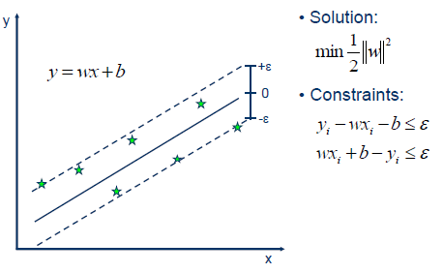

Figure 1: SVR Algorithm

*3.2.1 Algorithm Description (Algorithm for Module 2)* This algorithm is great in theory, yet it only is accurate for predictions about the next day.

3.3 Module 2

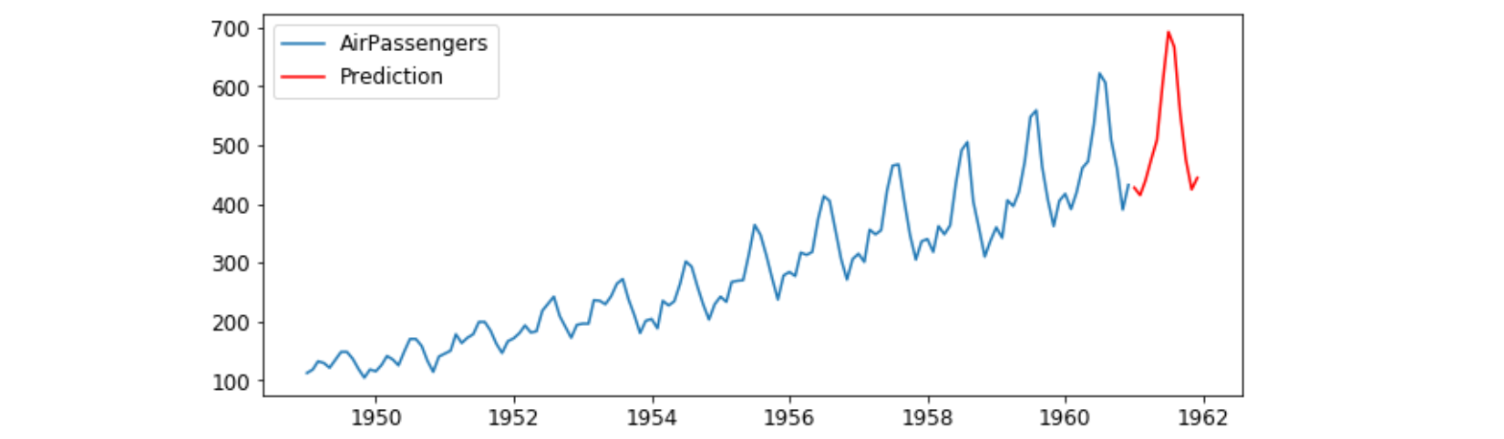

Figure 2: LSTM Algorithm

*3.3.1 Algorithm Description (Algorithm for Module 1)* This algorithm is great, except that it takes moment for the effect of the current day to have an impact in the model.

4 Experimental Evaluation

Precisely define the problem you are addressing (i.e. formally specify the inputs and outputs).

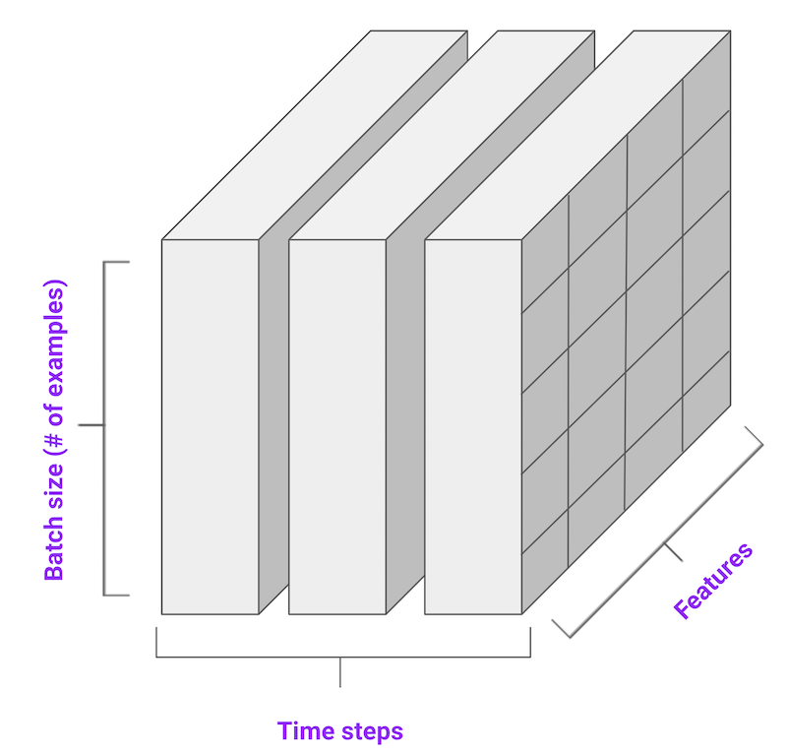

Figure 3: Encoding of Time-Series Data

4.1 Methodology

• What was data used? How you split data to training and testing?

• What was the experimental setting?

• What metrics were used to compare different methods?

• What methods were implemented and compared? Make sure you include the competing methods that address the same problem as comparison baseline.

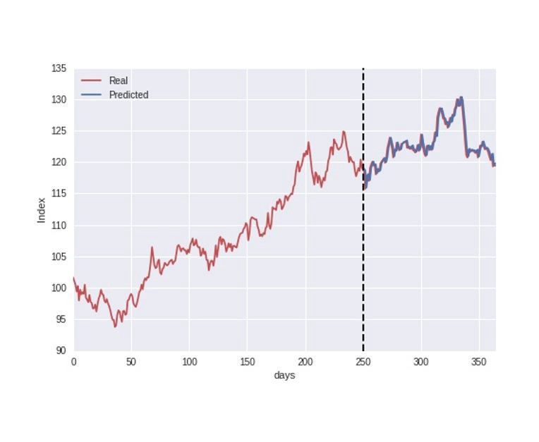 Figure 4: Train/Test Split

4.2 Results

Present the quantitative results of your experiments. Figures such as charts or histograms are frequently better than tables. For each figure, explain the result. What conclude we can draw from each figure?

5 Related Work

Answer the following questions for each related work that addresses the same or a similar problem.

• What is their problem and method?

• How is your problem and method different?

• Why is your problem and method better?

6 Conclusion

Briefly summarize the results and conclusions.

7 Work Division

A paragraph stating how the work is divided over all team members in your project.

8 Learning Experience

One or two paragraphs stating what you (and your partners) have learn from this project.

ACKNOWLEDGMENTS

Special thanks to Dr. Haiquan Chen. Without your guidance through the machine learning class, this endeavor would remain elusively out of reach to undergraduate students.

REFERENCES

[1] FNM Surname (2018). Article Title. Journal Title, 10(3), 1–10.

[2] F.N.M Surname, Article Title, https://www.acm.org/publications/proceedings-template.

[3] F.N.M Surname and F.N.M Surname, 2018 Article Title, The title of book two (2nd. ed.). Publisher Name, City, State, Country.

[4] Ian Editor (Ed.). 2018. *The title of book two* (2nd. ed.). University of XXX Press, City, Chapter 100. DOI: <http://dx.doi.org/10.1000/0-000-00000-0>.

Conference Name:ACM Woodstock conference

Conference Short Name:WOODSTOCK’18

Conference Location:El Paso, Texas USA

ISBN:978-1-4503-0000-0/18/06

Year:2018

Date:June

Copyright Year:2018

Copyright Statement:rightsretained

DOI:10.1145/1234567890

RRH: F. Surname et al.

Price:$15.00