**Sight Word Helper**

**SYSTEM TEST REPORT**

**Prepared by Senior Project Team**

FlashPoint



**College of Engineering and Computer Science**

**Department of Computer Science**

**Date:** 12/13/2019

**TABLE OF CONTENTS**

**Page**

**1.0 LOGIN 1**

1.1 Logging in Using a Username and Password 1

1.2 Continuing as a Guest 2

**2.0 QUIZ SELECTION 3**

2.1 Viewing the Quizzes 3

2.2 Selecting a Quiz 4

2.3 Viewing Quiz Overview 5

**3.0 TAKING A QUIZ 6**

3.1 Viewing the Words 6

3.2 Playing Audio of the Correct Word 7

3.3 Selecting a Word 8

3.3.1 Selecting Correct Word 8

3.3.2 Selecting Wrong Word 9

3.4 Viewing Test Results 10

3.4.1 Test Success 10

3.4.2 Test Failure 11

**4.0 ROSTER 12**

4.1 Viewing the Roster 12

4.2 Adding a Student 13

4.3 Removing a Student 14

**5.0 ABOUT US 15**

5.1 Viewing the About Us 15

**1. LOGIN**

This section will cover testing of the Login screen.

**1.1 Logging in Using Username and Password**

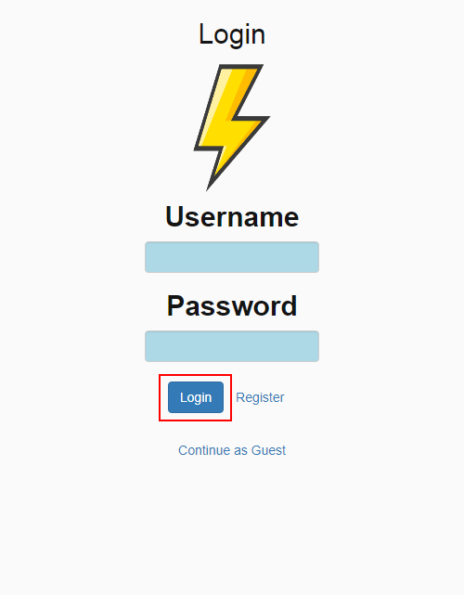

Test Description: This test is to verify that when you click on “Login” button after filling out Username and Password fields, the Quiz Selection screen will be displayed.

Tester: Amandeep Singh

Recorder: Matt Swart

Date: 12/5/19

Test input: After filling out login fields, click on “Login” button.

Expected output: Quiz selection screen is displayed.

☒ Verified

☐ Not Verified

**1.2 Continuing as a Guest**

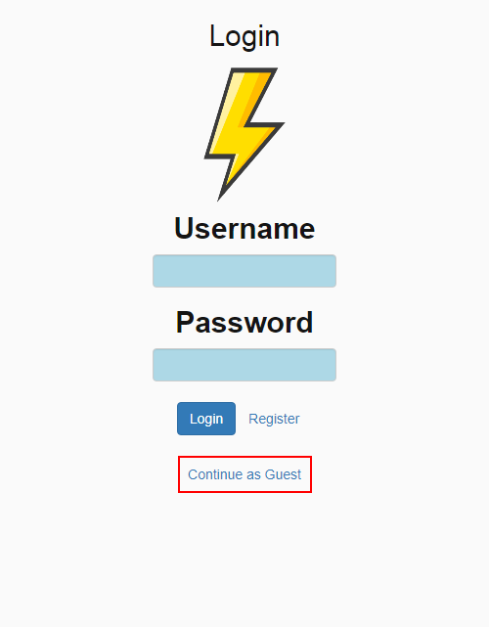

Test Description: This test is to verify that when you click on “Continue as Guest”, the Quiz Selection screen will be displayed.

Tester: Amandeep Singh

Recorder: Matt Swart

Date: 12/5/19

Test input: Click on “ Continue as Guest”

Expected output: Quiz selection screen is displayed.

☒ Verified

☐ Not Verified

**2. QUIZ SELECTION**

This section will cover testing of the Quiz Selection screen.

**2.1 Viewing the Quizzes**

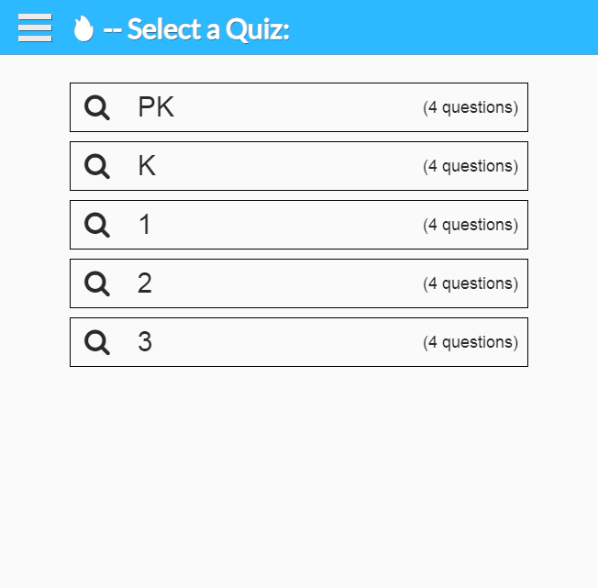

Test Description: This test is to verify that after logging in or continuing as a guest, a list of quizzes will be displayed, using quizzes from the database.

Tester: Amandeep Singh

Recorder: Matt Swart

Date: 10/30/19

Test input: Log in or continue as guest.

Expected output: List of quizzes will be displayed using quiz data from database.

☒ Verified

☐ Not Verified

**2.2 Selecting a Quiz**

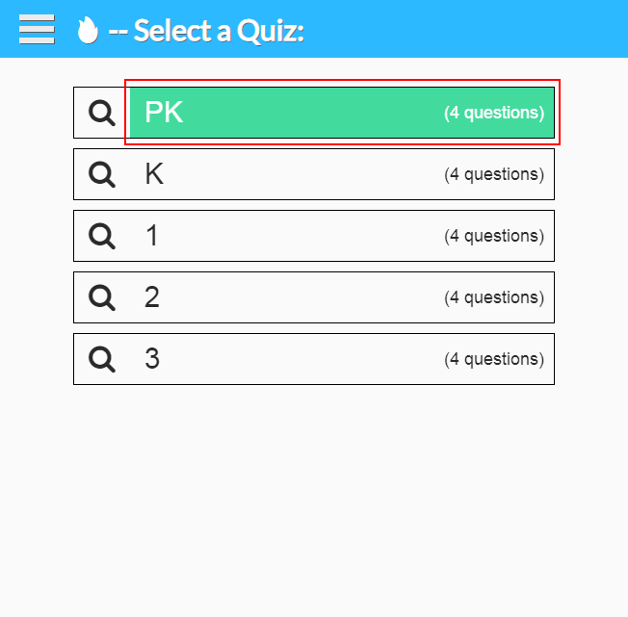

Test Description: This test is to verify that when a quiz is selected, the quiz will start, using data from the selected quiz.

Tester: Amandeep Singh

Recorder: Matt Swart

Date: 10/30/19

Test input: Click on a quiz.

Expected output: The selected quiz will start, using quiz data from database.

☒ Verified

☐ Not Verified

**2.3** **Viewing Quiz Overview**

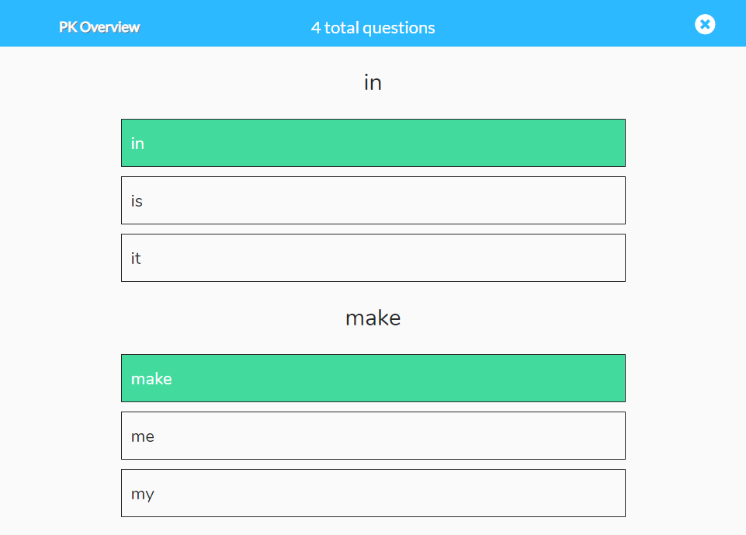

Test Description: This test is to verify that when the magnifying glass on the left of a quiz is clicked, the Quiz Overview screen will be displayed, using data from the selected quiz.

Tester: Amandeep Singh

Recorder: Matt Swart

Date: 10/30/19

Test input: Click on the magnifying glass on left of quiz.

Expected output: An overview of the selected quiz will be displayed, using quiz data from database.

☒ Verified

☐ Not Verified

**3.0 Taking a Quiz**

This section will cover testing of the Quiz screen.

**3.1 Viewing the Words**

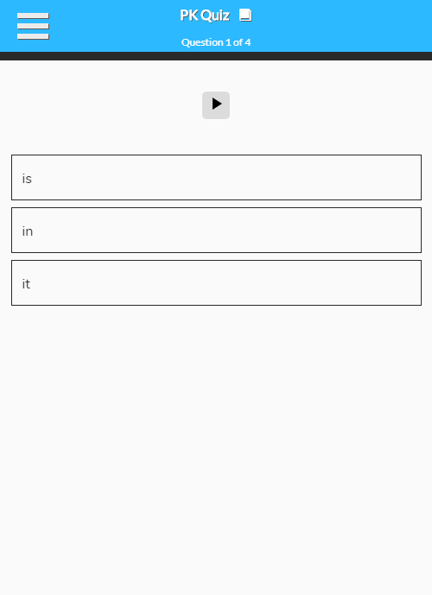

Test Description: This test is to verify that when a quiz is selected, the correct quiz is displayed using data from the database.

Tester: Amandeep Singh

Recorder: Matt Swart

Date: 10/30/19

Test input: Select a quiz from the quiz selection screen.

Expected output: Selected quiz is displayed, using data from database.

☒ Verified

☐ Not Verified

**3.2 Playing Audio of Correct Word**

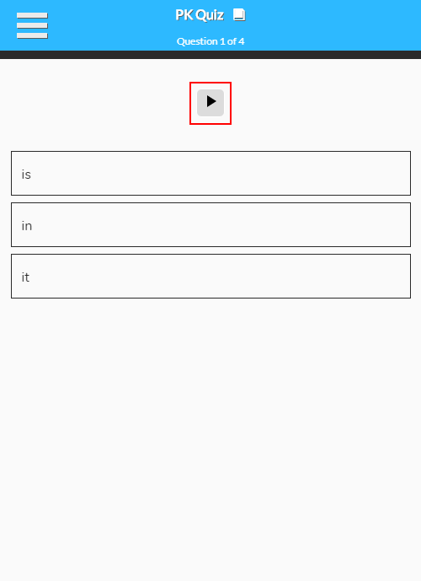

Test Description: This test is to verify that when the “Play” button is clicked, audio of the correct word is played.

Tester: Amandeep Singh

Recorder: Matt Swart

Date: 10/30/19

Test input: Click on the “Play” button.

Expected output: Correct word is played through audio.

☒ Verified

☐ Not Verified

**3.3 Selecting a Word**

This section will cover selecting a word during a quiz.

**3.3.1 Selecting Correct Word**

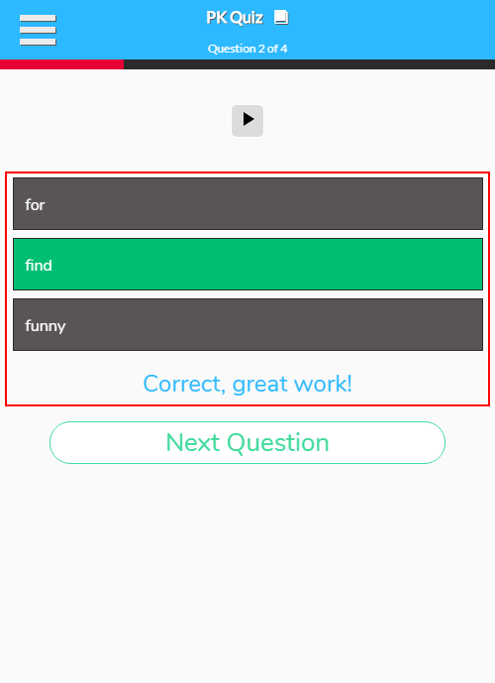

Test Description: This test is to verify that when a correct word on quiz is selected, the student is shown that they answered correctly.

Tester: Amandeep Singh

Recorder: Matt Swart

Date: 10/30/19

Test input: Select the correct word for the quiz question.

Expected output: Indication that correct word was selected.

☒ Verified

☐ Not Verified

**3.3.2 Selecting Wrong Word**

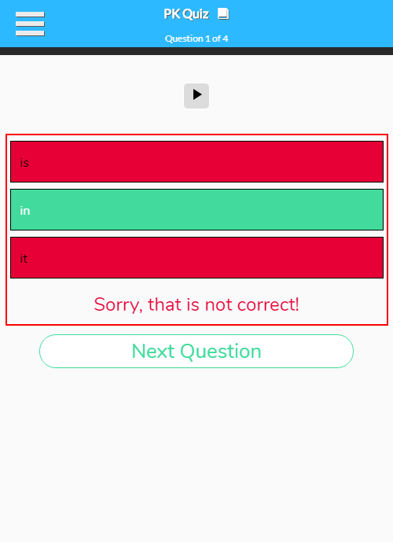

Test Description: This test is to verify that when a wrong word on quiz is selected, the student is shown that they answered incorrectly, with the correct word being indicated.

Tester: Amandeep Singh

Recorder: Matt Swart

Date: 10/30/19

Test input: Select the wrong word for the quiz question.

Expected output: Indication that wrong word was selected, with the correct word being indicated.

☒ Verified

☐ Not Verified

**3.4 Viewing Test Results**

The results of the current quiz will be displayed.

**3.4.1 Test Success**

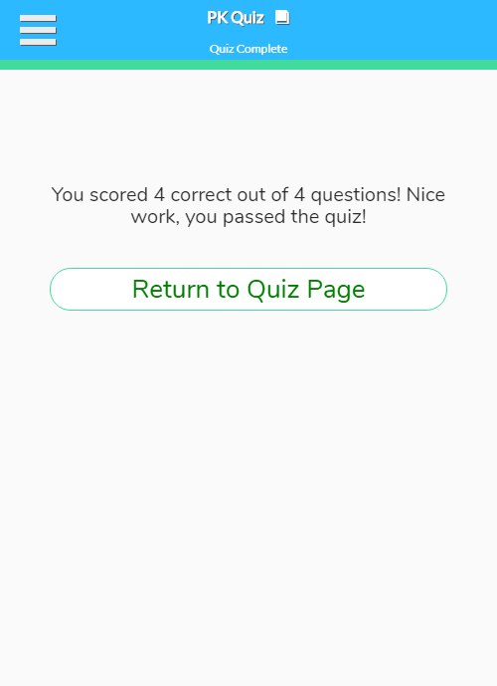

Test Description: This test is to verify that if a student answers at least 75% of the questions correctly, they pass the quiz.

Tester: Amandeep Singh

Recorder: Matt Swart

Date: 11/12/19

Test input: Answer 75% or more of the questions correctly, then click on “View Results” at the end of quiz.

Expected output: Confirmation displayed that we passed the quiz.

☒ Verified

☐ Not Verified

**3.4.2 Test Failure**

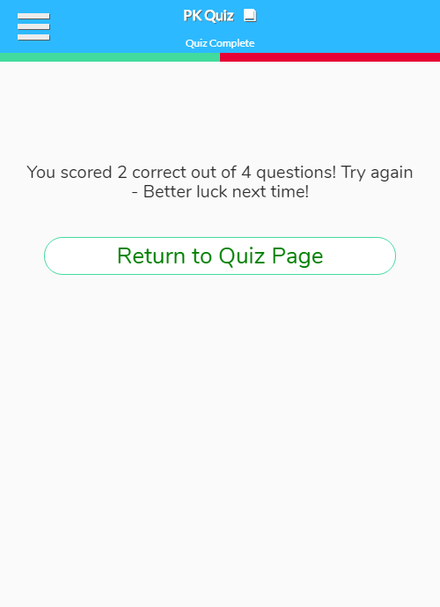

Test Description: This test is to verify that if a student answers less than 75% of the questions correctly, they do not pass the quiz.

Tester: Amandeep Singh

Recorder: Matt Swart

Date: 11/12/19

Test input: Answer less than 75% of the questions correctly, then click on “View Results” at the end of quiz.

Expected output: Confirmation displayed that we failed the quiz.

☒ Verified

☐ Not Verified

**4.0 Roster**

This section will cover testing of the Student Roster and Add Student screens.

**4.1 Viewing the Roster**

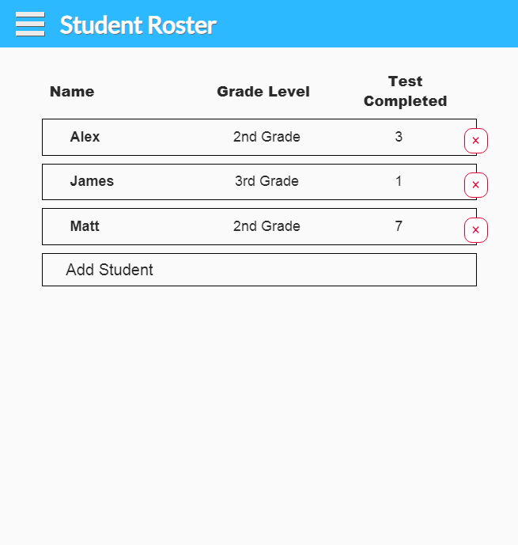

Test Description: This test is to verify that the roster is being displayed, and the information it is filled with is being correctly pulled from the database.

Tester: Amandeep Singh

Recorder: Ian Colvin

Date: 11/12/19

Test input: Click “Roster” on side menu and see the roster.

Expected output: Roster is displayed using data from database.

☒ Verified

☐ Not Verified

**4.2 Adding a Student**

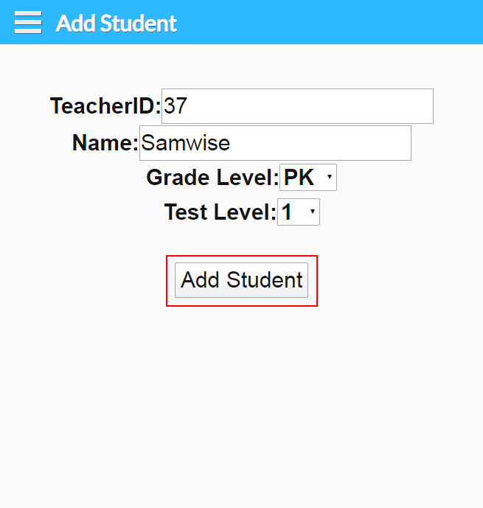

Test Description: This test is to verify that students may be added to the roster.

Tester: Amandeep Singh

Recorder: Ian Colvin

Date: 11/12/19

Test input: Fill out the fields on Add Student screen, then click on the “Add Student” button.

Expected output: Student is added to the current roster.

☒ Verified

☐ Not Verified

**4.3 Removing a Student**

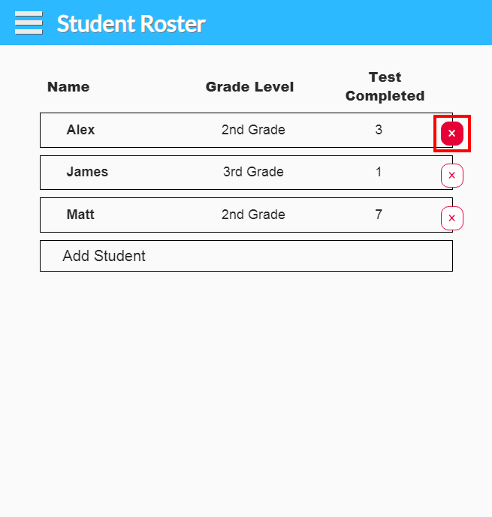

Test Description: This test is to verify that students may be removed from the roster.

Tester: Amandeep Singh

Recorder: Ian Colvin

Date: 11/12/19

Test input: Click on the X on a student’s row to delete the student.

Expected output: Selected student is removed from the current roster.

☒ Verified

☐ Not Verified

**5.0 About Us**

This section will cover testing of the About Us screen.

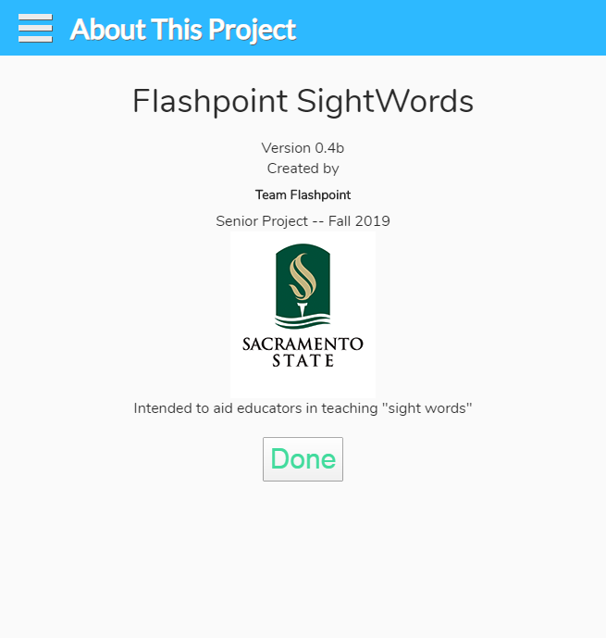

**5.1 Viewing the About Us**

Test Description: This test is to verify that the “About Us” screen is displayed correctly.

Tester: Amandeep Singh

Recorder: Ian Colvin

Date: 10/30/19

Test input: Click on “About Us” in the side menu.

Expected output: We will see the About Us screen.

☒ Verified

☐ Not Verified

**Team Members:** **System Test** **Verification Completed: Date: 12/06/2019**

|  |  |
| --- | --- |
| **Name** | **Signature** |