IB HL Math Quiz: Complex Numbers Solutions
Date: 9/7/07

Directions: Please show all of your work and answers on a separate piece of paper

Perform the following computations and answer each in the form a+bi.

1) 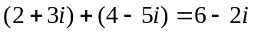
2) 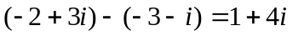
3)
4) 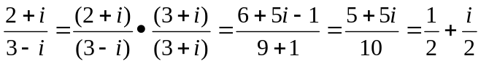

Convert the following complex numbers into rcisθ form.

5) 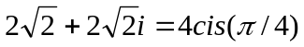 6) 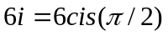

7) 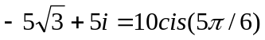 8) 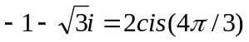

9) 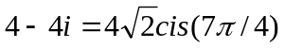 10) 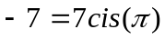

Calculate each of the following values, answering in the form a+bi. (Hint: Use DeMoivre's Theorem for exponentiating complex numbers in the form rcisθ.)

11) 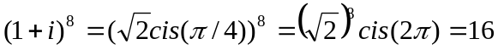

12)

13)

