**REPUBULIC OF RWANDA** **WDA**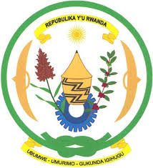 

**MINISTRY OF EDUCATION**

**WORKFORCE DEVELOPMENT AUTHORITY**

**COLLEGE ACEJ/KARAMA**

**TOPIC**: COMPUTIRIZED LAND MANAGEMENT SYSTEM

**CASE STUDY: Kimironko sector**

**OPTION:** COMPUTER SCIENCE

Submitted by: MUNEZERO derrick

Supervised by: Eng. TUYISHIME marius.

*For the award of the* ***A2 Level***

**

**Computer Science**

**COLLEGE ACEJ/KARAMA**

**September, 2018**

**Reg. No : 020703017CSC001**

**Email :** [**acejcollege@gmail.com**](mailto:acejcollege@gmail.com)

**P.O. Box 108 MUHANGA**

PROJECT ID: CSC/Y6/18/084