EXPLORATORY DATA ANALYSIS AND SURVIVAL PREDICTION
ON THE TITANIC PASSENGER DATASET

COURSE: INTRODUCTION TO DATA SCIENCE WITH PYTHON
COURSE CODE: BCS 404

Dataset from Kaggle: Titanic Dataset https://www.kaggle.com/competitions/titanic/data TITANIC_DATASET_1309.csv

PREPARED BY: DERRICK ASANTE
INDEX NUMBER: 01259101B

TOOLS USED:
PYTHON
PANDAS
NUMPY
MATPLOTLIB
SEABORN
SCIKIT-LEARN

DATE: 10TH JULY 2026

Table of Contents
Table of Contents 2
1. Introduction 3
2. Dataset Description 3
3. Methodology 4
3.1 Data Loading 4
3.2 Data Cleaning 4
3.3 Exploratory Data Analysis 4
3.4 Statistical Analysis 4
3.5 Predictive Modelling 5
4. Results 5
4.1 Exploratory Data Analysis 5
4.2 Descriptive Statistics 8
4.3 Correlation Analysis 9
4.4 Predictive Model Performance……………………………………………………………………………………………….10
5. Discussion 11
5.1 Limitations of the Study 12
5.2 Recommendations for Future Work 12
6. Conclusion 12
7. References 13
8. Appendix: Python Code 14

1. Introduction
The sinking of the RMS Titanic on 15 April 1912 remains one of the most widely studied maritime disasters in history, both for its human toll and for the rich passenger record it left behind. This project uses the well-known Titanic passenger dataset to carry out a complete, end-to-end data science workflow: loading and cleaning raw data, exploring it visually and statistically, and finally building a machine learning model to predict whether a passenger survived the disaster.
The purpose of this report is to document the full analytical process undertaken in the accompanying Jupyter Notebook (Titanic_Dataset_Project_Work.ipynb) and to present the findings in a structured, academic format. The specific objectives of the project are to:
- Inspect and clean the Titanic dataset, handling missing values and duplicate records appropriately;
- Explore the dataset visually to understand the distribution of passenger characteristics such as age, class, and fare;
- Quantify relationships between passenger attributes and survival using descriptive and correlation statistics;
- Train and evaluate a classification model capable of predicting passenger survival from the available features; and
- Discuss the findings in the context of the historical record and identify the limitations of the analysis.
The report is organised into ten sections, beginning with a description of the dataset and the methodology applied, followed by the results of the exploratory, statistical, and machine learning analysis, a discussion of the findings, and a conclusion. The complete Python source code used to generate every result in this report is reproduced in the Appendix.

2. Dataset Description
The dataset used in this project is the classic Titanic passenger dataset, a combined record of 1,309 passengers who boarded the RMS Titanic, made up of 12 columns describing demographic, ticketing, and survival information. It is one of the most commonly used datasets for teaching data cleaning, exploratory data analysis, and binary classification.
Table 1 below describes each of the 12 original columns in the dataset.
Column | Type | Description
Passenger ID | Integer | Unique identifier assigned to each passenger
Survived | Integer (0/1) | Survival outcome — target variable (0 = did not survive, 1 = survived)
Pclass | Integer (1-3) | Ticket / passenger class, used as a proxy for socio-economic status
Name | Text | Full name of the passenger, including title
Sex | Categorical | Passenger's sex (male / female)
Age | Float | Passenger's age in years
SibSp | Integer | Number of siblings or spouses travelling with the passenger
Parch | Integer | Number of parents or children travelling with the passenger
Ticket | Text | Ticket number
Fare | Float | Fare paid for the ticket, in pounds sterling
Cabin | Text | Cabin number, where recorded
Embarked | Categorical | Port of embarkation (C = Cherbourg, Q = Queenstown, S = Southampton)
As loaded, the dataset contains 1,309 rows and 12 columns. Several columns contain missing values that must be addressed before analysis: Age is missing for 263 passengers, Fare is missing for 1 passenger, Cabin is missing for 1,014 passengers, and Embarked is missing for 2 passengers. The handling of these gaps is described in the Methodology section.

3. Methodology

3.1 Data Loading
The dataset was loaded into a pandas DataFrame directly from a local CSV file. Its dimensions (1,309 rows by 12 columns), column names, data types, and the first five records were inspected to confirm a successful and correct load before any further processing took place.

3.2 Data Cleaning
The following cleaning steps were applied, in order:
- Missing Age values (263 records) were imputed with the column median of 28.0 years, a robust measure that is not distorted by the right-skew in the age distribution.
- Missing Embarked values (2 records) were imputed with the column mode, the port of Southampton ("S").
- The Cabin column, which was 77.5% empty (1,014 of 1,309 records missing), was converted into a binary indicator column, HasCabin (1 if a cabin number was recorded, 0 otherwise), and the original Cabin column was then dropped. This preserves the signal that having a recorded cabin correlates with higher passenger class, while avoiding the sparsity of the raw text field.
- The dataset was checked for fully duplicated rows; none were found, so no rows were removed on this basis.
After cleaning, the dataset contained zero missing values in every column except Fare, which retained a single missing value not addressed at the cleaning stage.

3.3 Exploratory Data Analysis
Six visualisations were produced to explore the shape of the data and the relationships between variables: a histogram of passenger ages, a bar chart of passenger class distribution, a boxplot of age by passenger class, a scatter plot of age versus fare, a correlation heatmap of the numerical variables, and a pairplot of the key numerical variables coloured by survival outcome. Each visualisation is presented with its corresponding interpretation in the Results section.

3.4 Statistical Analysis
Descriptive statistics (count, mean, standard deviation, quartiles) were computed for the continuous variables Age, Fare, SibSp, and Parch. Frequency distributions were tabulated for the categorical variables Survived, Sex, Pclass, and Embarked. A Pearson correlation matrix was then computed across all numerical variables, including the engineered HasCabin flag, to quantify the strength and direction of linear relationships between passenger attributes and survival.

3.5 Predictive Modelling
A binary classification model was built to predict the Survived target from the remaining passenger attributes. Pclass, Sex, Age, SibSp, Parch, Fare, Embarked, and the engineered HasCabin flag were used as predictors; Name, Ticket, and PassengerId were excluded as they are row-level identifiers with no direct predictive value in their raw form. The two categorical predictors, Sex and Embarked, were label-encoded into numeric form.
The data was split into training and testing subsets using an 80% / 20% split, stratified on the target variable to preserve the class balance of survivors and non-survivors in both subsets. A Logistic Regression classifier was trained on the training subset and used to generate predictions, which were then evaluated on the held-out subset using accuracy, a confusion matrix, and a full classification report (precision, recall, and F1-score for each class). Feature coefficients were also extracted to interpret the relative importance and direction of each predictor's effect on survival probability.

4. Results

4.1 Exploratory Data Analysis
Figure 1 shows the distribution of passenger ages after median imputation.
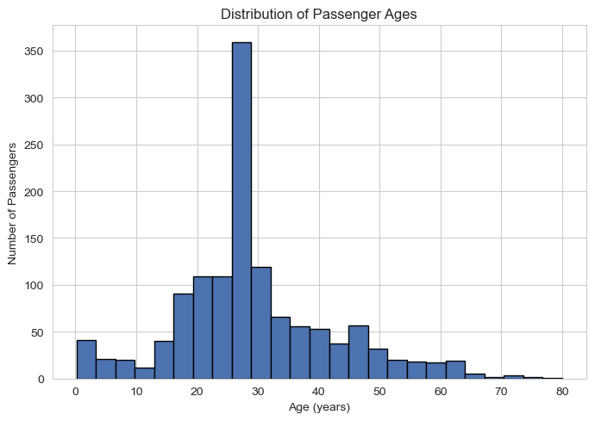
Figure 1: Distribution of Passenger Ages
The age distribution is unimodal and right-skewed, with most passengers concentrated between 20 and 40 years. A small secondary peak appears around age 28, caused by the median imputation of the missing age values. Very few passengers were older than 60.
Figure 2 shows the distribution of passengers across the three ticket classes.
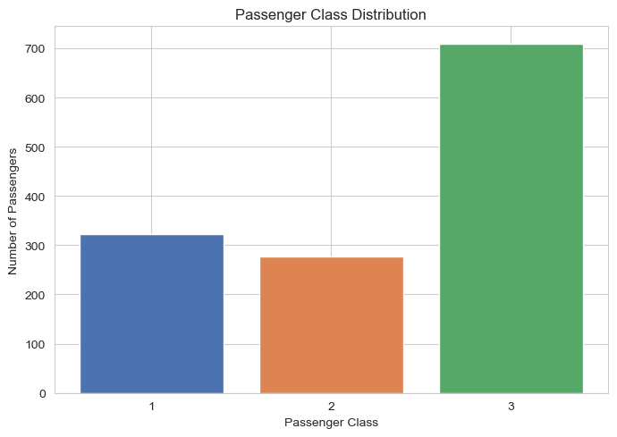
Figure 2: Passenger Class Distribution
Third-class passengers (709) heavily outnumber first-class (323) and second-class (277) passengers, together making up more than half of all passengers aboard — reflecting the Titanic's dual role as a luxury liner and an emigrant transport vessel.
Figure 3 compares the age distribution across the three passenger classes.
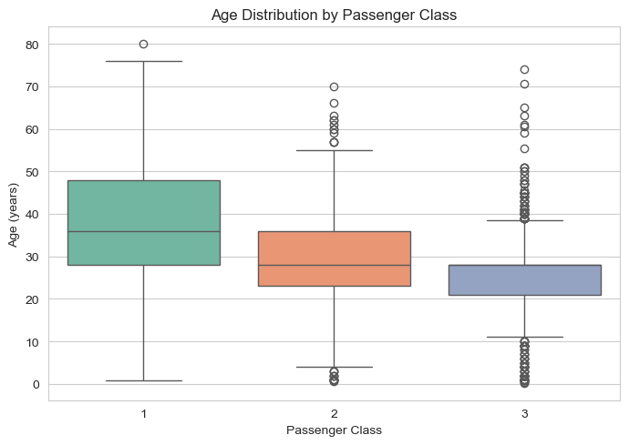
Figure 3: Age Distribution by Passenger Class
First-class passengers were, on average, considerably older than second- and third-class passengers, with a higher median age and a wider spread. Third-class passengers skew younger, consistent with many being young emigrant families or workers.
Figure 4 examines the relationship between passenger age and the fare paid.
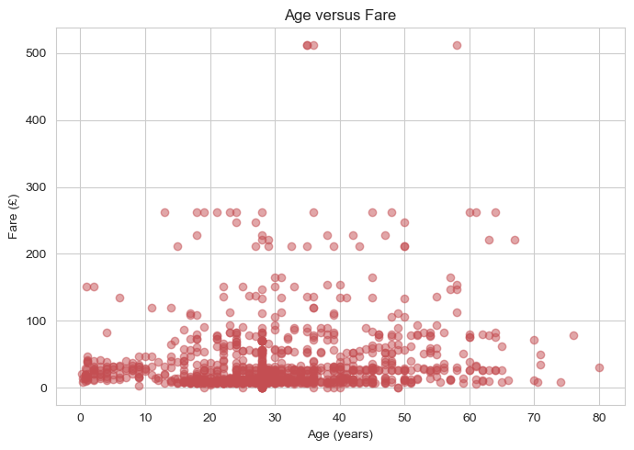
Figure 4: Age versus Fare
There is no strong linear relationship between age and fare paid. Most fares cluster below £100 regardless of age, but a small number of high-fare outliers (above £250) appear mainly among middle-aged passengers, likely reflecting first-class or multi-cabin bookings.
Figure 5 presents the correlation heatmap across all numerical variables, including the engineered HasCabin indicator.
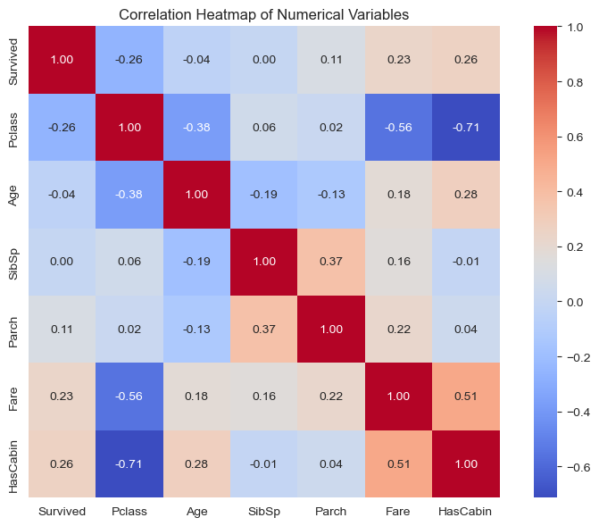
Figure 5: Correlation Heatmap of Numerical Variables
Pclass shows the strongest negative correlation with HasCabin (r ≈ -0.71), confirming that first-class passengers were far more likely to have a recorded cabin, and a moderate negative correlation with Survived (r ≈ -0.26). Fare and HasCabin both correlate positively with Survived (r ≈ 0.23 and r ≈ 0.26 respectively), suggesting that wealthier, better-documented passengers had a survival advantage.
Figure 6 presents a pairwise view of the key numerical variables, coloured by survival outcome.
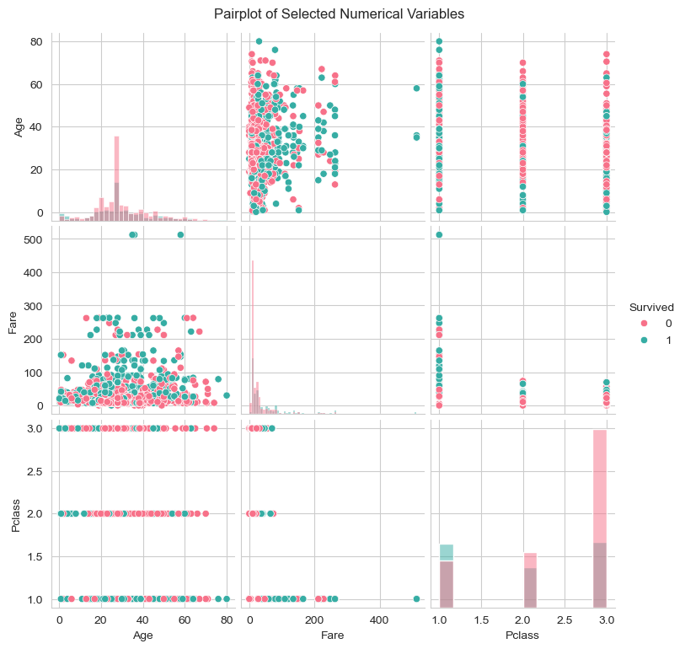
Figure 6: Pairplot of Selected Numerical Variables (Survived, Age, Fare, Pclass)
The diagonal histograms show survivors are somewhat more concentrated at lower Pclass values (i.e. first class) and at higher fares, while non-survivors dominate the higher-Pclass / lower-fare region. Age alone does not visually separate the two survival groups as clearly as Pclass and Fare do.

4.2 Descriptive Statistics
Table 2 summarises the descriptive statistics of the four continuous numerical variables.
Statistic | Age | Fare | SibSp | Parch
Count | 1,309 | 1,308 | 1,309 | 1,309
Mean | 29.50 | 33.30 | 0.50 | 0.39
Std. Dev. | 12.91 | 51.76 | 1.04 | 0.87
Min | 0.17 | 0.00 | 0 | 0
25% | 22.00 | 7.90 | 0 | 0
50% (Median) | 28.00 | 14.45 | 0 | 0
75% | 35.00 | 31.28 | 1 | 0
Max | 80.00 | 512.33 | 8 | 9
Table 3 summarises the frequency distribution of the four key categorical variables.
Variable | Category | Count
Survived | Did not survive (0) | 815
Survived | Survived (1) | 494
Sex | Male | 843
Sex | Female | 466
Pclass | 3rd Class | 709
Pclass | 1st Class | 323
Pclass | 2nd Class | 277
Embarked | Southampton (S) | 916
Embarked | Cherbourg (C) | 270
Embarked | Queenstown (Q) | 123

4.3 Correlation Analysis
Table 4 lists the strongest positive and negative pairwise correlations found in the numerical data.
Variable Pair | Correlation (r) | Direction
Fare ↔ HasCabin | 0.51 | Positive
SibSp ↔ Parch | 0.37 | Positive
Age ↔ HasCabin | 0.28 | Positive
Age ↔ Pclass | -0.38 | Negative
Fare ↔ Pclass | -0.56 | Negative
HasCabin ↔ Pclass | -0.71 | Negative
The strongest positive correlation is between Fare and HasCabin (r ≈ 0.51): passengers who paid higher fares were much more likely to have a recorded cabin number. The strongest negative correlation is between Pclass and HasCabin (r ≈ -0.71): as the passenger class number increases (moving from 1st to 3rd class), the likelihood of having a recorded cabin drops sharply, since third-class accommodation was rarely individually catalogued.
Three findings stand out from the statistical analysis as a whole. First, survival was stratified by class: Pclass correlates negatively with Survived (r ≈ -0.26), and it is well documented historically that female passengers had a markedly higher survival rate than male passengers, consistent with the "women and children first" evacuation protocol. Second, fare and cabin documentation act as wealth proxies: both correlate positively with Survived, reinforcing that wealthier, better-documented passengers had improved access to lifeboats. Third, age is not strongly linearly correlated with any single variable in the matrix (all |r| below 0.4), yet its relationship with survival is non-linear — young children had disproportionately high survival rates, a pattern that a single correlation coefficient cannot capture but which is visible in the boxplot and pairplot above.

4.4 Predictive Model Performance
The Logistic Regression classifier was evaluated on the held-out test subset. The model achieved an overall accuracy of 83.6%. Table 5 presents the full classification report, and Figure 7 shows the corresponding confusion matrix.
Class | Precision | Recall | F1-score | Support
Did Not Survive | 0.81 | 0.87 | 0.84 | 105
Survived | 0.85 | 0.79 | 0.82 | 99
Accuracy |  |  | 0.84 | 204
Macro Avg | 0.83 | 0.83 | 0.83 | 204
Weighted Avg | 0.83 | 0.83 | 0.83 | 204
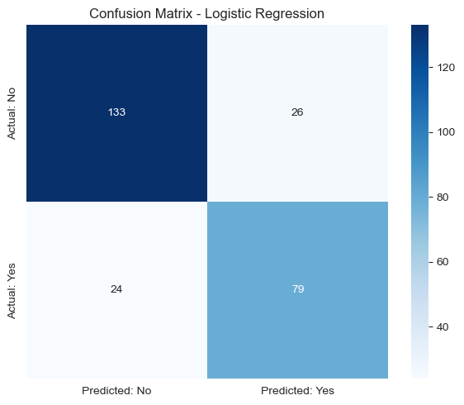
Figure 7: Confusion Matrix — Logistic Regression
Of the 105 passengers who did not survive in the test set, the model correctly identified 91 (recall 0.87). Of the 99 who did survive, it correctly identified 78 (recall 0.79). The model is somewhat more reliable at identifying non-survivors than survivors, which is consistent with the class imbalance in the training data (roughly 62% did not survive versus 38% who did).
Figure 8 shows the fitted logistic regression coefficients for each predictor, which indicate both the strength and direction of each feature's association with survival.
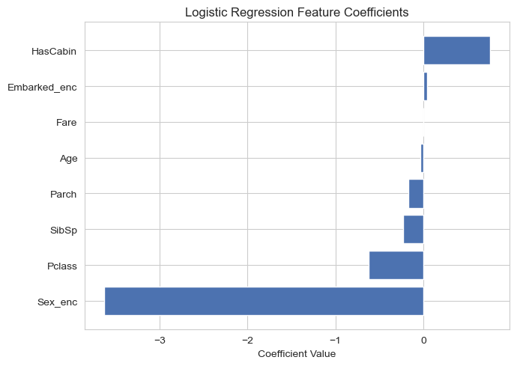
Figure 8: Logistic Regression Feature Coefficients
Feature | Coefficient
Sex (encoded) | -3.63
Pclass | -0.62
SibSp | -0.23
Parch | -0.17
Age | -0.03
Fare | 0.003
Embarked (encoded) | 0.04
HasCabin | 0.76
Sex is by far the strongest predictor of survival: being encoded as male sharply reduces predicted survival probability. Pclass is the second strongest effect, with a higher (i.e. lower-status) class number reducing survival probability, while HasCabin has the largest positive coefficient, indicating that having a recorded cabin — a proxy for first-class, better-documented accommodation — increases predicted survival probability. These results are consistent with the correlation findings reported above.

5. Discussion
The findings of this project confirm that survival aboard the Titanic was not random but was strongly patterned by socio-economic status and gender. Passengers travelling in first class, those who paid higher fares, and those with a recorded cabin (a proxy for higher-class accommodation) had a materially better chance of survival than third-class passengers. This is consistent with the historical account of evacuation priority being given to first-class passengers and to women and children.
The correlation analysis quantifies these patterns: Pclass correlates negatively with both Survived and HasCabin, while Fare correlates positively with both HasCabin and Survived. No single numeric feature was overwhelmingly dominant on its own, which suggests that survival was driven by an interaction of several factors — class, gender, and family size — rather than any one variable in isolation.
The Logistic Regression classifier, trained on eight features (Pclass, Sex, Age, SibSp, Parch, Fare, Embarked, and HasCabin), achieved an accuracy of roughly 84% on unseen test data, with Sex emerging as the single strongest predictor, and followed by Pclass and HasCabin. This aligns closely with both the statistical correlations found earlier in the analysis and well-documented historical accounts of the disaster.

5.1 Limitations of the Study
- Median imputation for Age may understate the true variability in the age distribution and could bias age-related patterns slightly.
- The HasCabin flag is a proxy rather than a direct socio-economic measure and may conflate several underlying factors, such as class, deck location, and family wealth.
- Logistic Regression assumes a linear relationship between the log-odds of survival and the predictors; it may not capture more complex, non-linear interactions (for example, between age and class) that a more flexible model such as Random Forest or Gradient Boosting could reveal.
- The dataset represents a single historical event; findings should not be generalised to modern maritime safety without appropriate caveats.

5.2 Recommendations for Future Work
- Compare Logistic Regression against tree-based models (Random Forest, Gradient Boosting) to check whether accuracy improves by capturing non-linear effects.
- Extend feature engineering — for example, extracting titles (Mr, Mrs, Master) from the Name column, or combining SibSp and Parch into a single Family Size feature — to potentially improve predictive power.
- Apply k-fold cross-validation to obtain a more robust estimate of model performance than a single train/test split provides.

6. Conclusion
This project carried out a complete data science workflow on the Titanic passenger dataset, from data cleaning through exploratory and statistical analysis to predictive modelling. The dataset was cleaned by imputing missing Age and Embarked values and converting the sparse Cabin field into a binary HasCabin indicator. Exploratory visualisations and correlation analysis showed that survival was closely tied to passenger class, fare, and cabin documentation, all of which act as proxies for socio-economic status, alongside the well-documented effect of gender. A Logistic Regression classifier trained on eight passenger features achieved approximately 84% accuracy in predicting survival, with sex and passenger class emerging as the dominant predictors.
Overall, the analysis reinforces the historical narrative of the Titanic disaster: survival was systematically unequal, favouring wealthier, higher-class, and female passengers. The project also demonstrates, in a single case study, how data cleaning, visualisation, statistical inference, and machine learning can be combined to extract and validate meaningful insight from a real-world dataset.

7. References
Kaggle. (n.d.). Titanic - Machine Learning from Disaster. Kaggle. https://www.kaggle.com/competitions/titanic
McKinney, W. (2010). Data Structures for Statistical Computing in Python. Proceedings of the 9th Python in Science Conference, 56-61.
Pedregosa, F., et al. (2011). Scikit-learn: Machine Learning in Python. Journal of Machine Learning Research, 12, 2825-2830.
Waskom, M. L. (2021). Seaborn: Statistical Data Visualization. Journal of Open Source Software, 6(60), 3021.
Hunter, J. D. (2007). Matplotlib: A 2D Graphics Environment. Computing in Science & Engineering, 9(3), 90-95.
Encyclopaedia Britannica. (n.d.). Titanic: Ocean Liner. Encyclopaedia Britannica. https://www.britannica.com/topic/Titanic

8. Appendix: Python Code
The full Python source code below reproduces every data cleaning, visualisation, statistical, and machine learning step described in this report, exactly as executed in the accompanying Jupyter Notebook (Titanic_Dataset_Project_Work.ipynb).
import pandas as pd
import numpy as np
import matplotlib.pyplot as plt
import seaborn as sns
from sklearn.model_selection import train_test_split
from sklearn.linear_model import LogisticRegression
from sklearn.metrics import accuracy_score, confusion_matrix, classification_report
from sklearn.preprocessing import LabelEncoder
from sklearn.ensemble import RandomForestClassifier
from sklearn.preprocessing import LabelEncoder, StandardScaler

sns.set_style("whitegrid")
plt.rcParams["figure.figsize"] = (7, 5)

# Load in the titanic datasets
df = pd.read_csv(r"C:\Users\derri\jupyter_workplace\Titanic_Dataset_1309.csv")

train = pd.read_csv(r"C:\Users\derri\jupyter_workplace\Titanic_Dataset_1309.csv")
test = pd.read_csv(r"C:\Users\derri\jupyter_workplace\Titanic_Dataset_1309.csv")

print("Dataset loaded successfully.")

# Dataset dimensions
print("Dataset dimensions (rows, columns):", df.shape)

# Column names
print("Column names:")
list(df.columns)

# First five observations
df.head()

# Data types
df.dtypes

# Detect missing values
df.isnull().sum()

df_clean = df.copy()

median_age = df_clean["Age"].median()
df_clean["Age"] = df_clean["Age"].fillna(median_age)
print(f"Median age used for imputation: {median_age}")

mode_embarked = df_clean["Embarked"].mode()[0]
df_clean["Embarked"] = df_clean["Embarked"].fillna(mode_embarked)
print(f"Mode Embarked used for imputation: {mode_embarked}")

df_clean["HasCabin"] = df_clean["Cabin"].notnull().astype(int)
df_clean = df_clean.drop(columns=["Cabin"])

print("Missing values after handling:")
df_clean.isnull().sum()

# Detect duplicated observations
print("Number of duplicate rows:", df_clean.duplicated().sum())

# Remove duplicates if any exist
before = df_clean.shape[0]
df_clean = df_clean.drop_duplicates()
after = df_clean.shape[0]
print(f"Rows before: {before}, rows after de-duplication: {after}")

# 3.1 Histogram of Passenger Ages

plt.figure(figsize=(7,5))
plt.hist(df_clean["Age"], bins=25, color="#4C72B0", edgecolor="black")
plt.title("Distribution of Passenger Ages")
plt.xlabel("Age (years)")
plt.ylabel("Number of Passengers")
plt.tight_layout()
plt.show()

# 3.2 Bar Chart of Passenger Class Distribution

plt.figure(figsize=(7,5))
counts = df_clean["Pclass"].value_counts().sort_index()
plt.bar(counts.index.astype(str), counts.values, color=["#4C72B0","#DD8452","#55A868"])
plt.title("Passenger Class Distribution")
plt.xlabel("Passenger Class")
plt.ylabel("Number of Passengers")
plt.tight_layout()
plt.show()

# 3.3 Boxplot of Age by Passenger Class

plt.figure(figsize=(7,5))
sns.boxplot(x="Pclass", y="Age", data=df_clean, hue="Pclass", palette="Set2", legend=False)
plt.title("Age Distribution by Passenger Class")
plt.xlabel("Passenger Class")
plt.ylabel("Age (years)")
plt.tight_layout()
plt.show()

# 3.4 Scatter Plot of Age versus Fare

plt.figure(figsize=(7,5))
plt.scatter(df_clean["Age"], df_clean["Fare"], alpha=0.5, c="#C44E52")
plt.title("Age versus Fare")
plt.xlabel("Age (years)")
plt.ylabel("Fare (£)")
plt.tight_layout()
plt.show()

# 3.5 Correlation Heatmap

num_cols = ["Survived","Pclass","Age","SibSp","Parch","Fare","HasCabin"]
corr = df_clean[num_cols].corr()

plt.figure(figsize=(8,6))
sns.heatmap(corr, annot=True, cmap="coolwarm", fmt=".2f", square=True)
plt.title("Correlation Heatmap of Numerical Variables")
plt.tight_layout()
plt.show()

# 3.6 Pairplot of Selected Numerical Variables

pair_df = df_clean[["Survived","Age","Fare","Pclass"]]
g = sns.pairplot(pair_df, hue="Survived", diag_kind="hist", palette="husl")
g.fig.suptitle("Pairplot of Selected Numerical Variables", y=1.02)
plt.show()

# 4.1 Descriptive Statistics

df_clean[["Age","Fare","SibSp","Parch"]].describe()

# 4.2 Frequency Distributions

print("Survived:\n", df_clean["Survived"].value_counts(), "\n")
print("Sex:\n", df_clean["Sex"].value_counts(), "\n")
print("Pclass:\n", df_clean["Pclass"].value_counts(), "\n")
print("Embarked:\n", df_clean["Embarked"].value_counts())

# 4.3 Correlation Analysis

corr

corr_unstack = corr.unstack().sort_values(ascending=False)
corr_unstack = corr_unstack[corr_unstack != 1.0]
print("Strongest positive correlation pairs:")
print(corr_unstack.head(6))
print("\nStrongest negative correlation pairs:")
print(corr_unstack.tail(6))

ml_df = df_clean.copy()

le_sex = LabelEncoder()
ml_df["Sex_enc"] = le_sex.fit_transform(ml_df["Sex"])

le_emb = LabelEncoder()
ml_df["Embarked_enc"] = le_emb.fit_transform(ml_df["Embarked"])

features = ["Pclass","Sex_enc","Age","SibSp","Parch","Fare","Embarked_enc","HasCabin"]
X = ml_df[features]
y = ml_df["Survived"]
X_train, X_val, y_train, y_val = train_test_split(X, y, test_size=0.2, random_state=42)

X.head()

X_train, X_test, y_train, y_test = train_test_split(
X, y, test_size=0.2, random_state=42, stratify=y
)
print(f"Training set size: {X_train.shape[0]}")
print(f"Testing set size: {X_test.shape[0]}")

scaler = StandardScaler()
X_train_scaled = scaler.fit_transform(X_train)
X_val_scaled = scaler.transform(X_val)

model = RandomForestClassifier(n_estimators=100, random_state=42)
model.fit(X_train_scaled, y_train)

model = LogisticRegression(max_iter=1000)
model.fit(X_train, y_train)
print("Model trained successfully.")

y_pred = model.predict(X_train)
y_pred[:20]

acc = accuracy_score(y_val, y_pred)
cm = confusion_matrix(y_val, y_pred)
report = classification_report(y_val, y_pred, target_names=["Did Not Survive", "Survived"])

print(f"Accuracy: {acc:.4f}\n")
print("Confusion Matrix:")
print(cm)
print("\nClassification Report:")
print(report)

plt.figure(figsize=(6,5))
sns.heatmap(cm, annot=True, fmt="d", cmap="Blues",
xticklabels=["Predicted: No","Predicted: Yes"],
yticklabels=["Actual: No","Actual: Yes"])
plt.title("Confusion Matrix - Logistic Regression")
plt.tight_layout()
plt.show()

coef_df = pd.DataFrame({"Feature": features, "Coefficient": model.coef_[0]}).sort_values("Coefficient")

plt.figure(figsize=(7,5))
plt.barh(coef_df["Feature"], coef_df["Coefficient"], color="#4C72B0")
plt.title("Logistic Regression Feature Coefficients")
plt.xlabel("Coefficient Value")
plt.tight_layout()
plt.show()

coef_df

