# **CIS 332 Week 6 Assignment**

Import the Sql files my_guitar_shop1 and my_guitar_shop2 using phpMyAdmin. Please keep the username and password to root, (if your machine is not shared by other).

## **Problem 1: Complete the steps and submit the sql file.**

1. We will extend the Sql code as written in the original file my_guitar_shop1.

Write a Foreign Key statement to link the table orders to product.

1. Insert new values into the orders table as shown below:

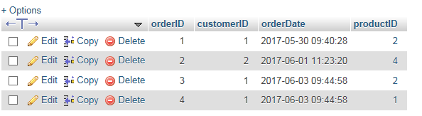

1. Grant privilege to a new user called abc@localhost to perform a select, insert, delete and update on the tables categories and products.The password is **pa55word**
2. Import the my_guitar_shop1.sql file back into phpMyAdmin. This will re-write the existing code.

You should be able to see the updated orders table and under userAccounts of the home page, --see the new user **abc**.

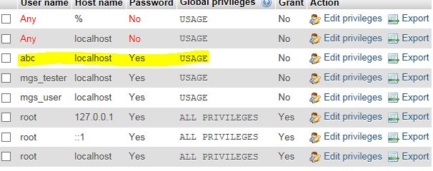

## Problem2: Perform queries on phpMyAdmin and copy the sql script for all the queries, along with a screen shot of the results.

## **Use the database my_guitar_shop2 to perform the queries:**

1. Select the name and id of all categories for which categoryID is less than or equal 2.
2. List the product name of all products have been ordered , and whose price is greater than 300.00. This will be an INNER JOIN . Pick appropriate tables and columns to write the query.
3. Update the quantity of item in Order with OrderID 3 to be a 3.

USE my_guitar_shop2;

SELECT categoryName, categoryID FROM categories

WHERE categoryID <= 2;

SELECT productName, listPrice

FROM products

INNER JOIN orderItems

ON products.productID = orderItems.productID

WHERE listPrice > 300.00;

UPDATE orderItems

SET quantity = 3

WHERE orderID = 3;

## Problem 3: Connect to the database from a php webpage. Copy paste the php code below

1. Write the php code block to connect to my_guitar_shop1 database as the root user. Use at ry catch block to catch the PDO exception. Give an error message if there was an exception while connecting to the database.

<?php

// Connect to the database

$dsn = 'mysql:host=localhost;dbname=my_guitar_shop1';

// Connect as root

$username = 'root';

$password = '';

try {

$db = new PDO($dsn, $username, $password);

echo '<p> You are connected. </p>';

}

catch (PDOException $e) {

$error_message = $e->getMessage();

echo '<p> Connection failed due to an error : $error_message </p>';

}

?>

1. Rewrite the code in problem 1) above, if the user were mgs_user. Look into the sql script of my_guitar_shop1 for the password of mgs_user.

<?php

// Connect to the database

$dsn = 'mysql:host=localhost;dbname=my_guitar_shop1';

// Connect as root

$username = 'mgs_user';

$password = 'pa55word';

try {

$db = new PDO($dsn, $username, $password);

echo '<p> You are connected. </p>';

}

catch (PDOException $e) {

$error_message = $e->getMessage();

echo '<p> Connection failed due to an error : $error_message </p>';

}

?>

## Problem 4: Given the sql code that connects to the database my_guitar_shop1. Also given is the sql code that performs a select query on the categories table and displays the categoryID and categoryName of all items in the category table.

1. Hack this code so that it performs a select query of the products table of the my_guitar_shop1 database and prints the productID and productName of all products. Copy/paste the php code of this page here:

<?php

$dsn = 'mysql:host=localhost;dbname=my_guitar_shop1';

$username = 'root';

$password = '';

try { $db = new PDO($dsn, $username, $password);

echo '<p> You are connected. </p>'; }

catch (PDOException $e) {

$error_message = $e->getMessage();

echo '<p> Connection failed due to an error : $error_message </p>'; }

$queryString = 'SELECT productID, productName FROM products ORDER BY productID';

$statement = $db->prepare($queryString);

$statement->execute();

$products = $statement-> fetchAll();

foreach ($products as $product) { echo $product['productID'] . ' - ' . $product['productName'] . '<br>'; }

?>