Derrick Musuya

ICS4A

Lab 2

The scanner takes information from the real world (e.g., a document or picture) and converts it into digital information for a computer to store or manipulate. Part of a compiler that takes the source code as input and translates this stream of characters into a stream of tokens.

The Lexical analyzer:

1. Divides the program into valid tokens a process called Tokenization.
2. Removes white space characters.
3. Removes comments.
4. It also provides help in generating error messages by providing row numbers and column numbers.

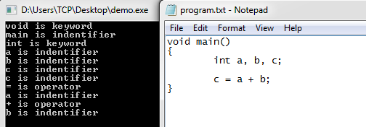

The equation (c=a+b) when passed through the lexical analyzer is then tokenized using the input file source program where Void is a keyword, Main is an identifier and Int is keyword

a is identifier

b is identifier

c is identifier

= is operator

a is identifier

+ is operator

b is identifier

Therefore, for every specified valid token, the analyzer is able to return each token with a specified value.