Building GridLAB-D from Source on Windows with MSYS2

# Installing MSYS2:

The MSYS2 environment is used to build GridLAB-D 4.1 or newer for the Windows OS. It can be downloaded from <https://www.msys2.org/>. From the website download the appropriate MSYS2 installer for 32bit (i686) and 64bit (x86_64) OS’s.

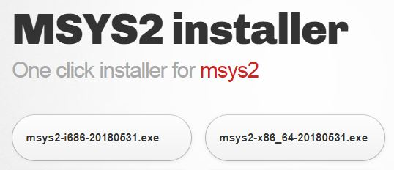

The website also walks through the installation process. This guide will also walk through the installation process for the 64bit installer. Once the installer is downloaded the execute the installer. This is the first window that pops up.

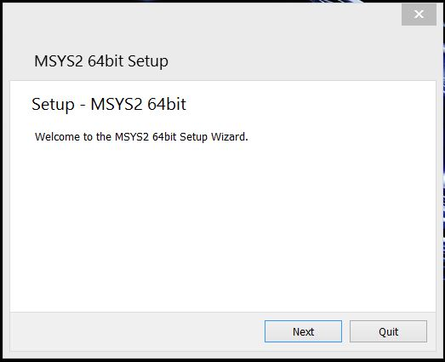

Click Next. It will then ask where to install MSYS2 64bit. The default location is C:\msys64 for MSYS2 64bit.

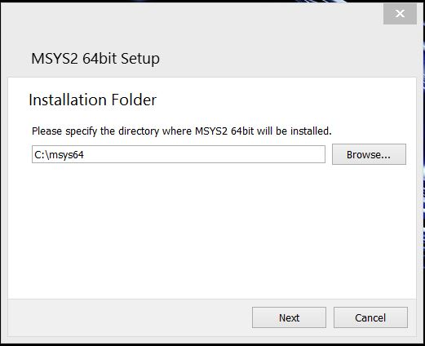

Once the location has been specified click Next. Then it will ask where to create the program’s shortcuts. Use an existing one or create a new name.

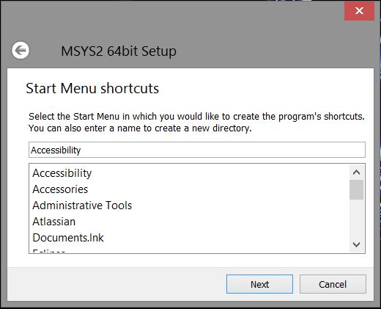

Once a destination is chosen click Next. At this point the installer begins to install MSYS2 onto the computer.

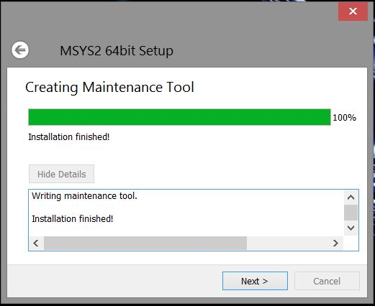

Once installation is complete click Next. Then click Finish and installation is successful.

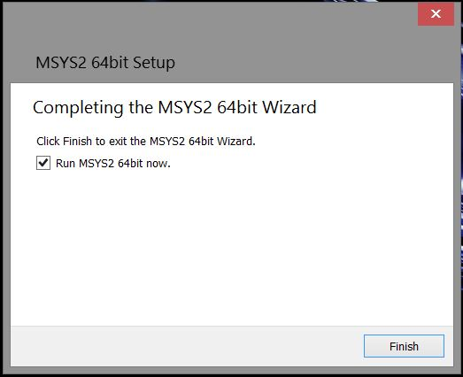

# Setting Up the MSYS2 Environment:

To start the MSYS2 environment start msys2.exe. A window like below should pop up.

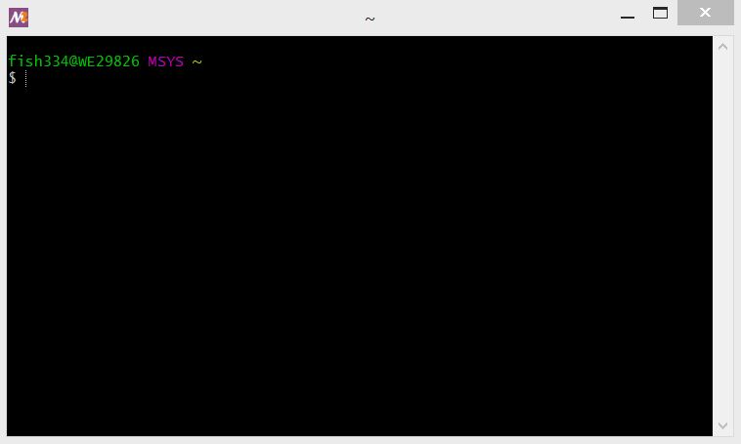As can be seen MSYS2 provides a Linux-like command terminal and environment for building GNU compliant C/C++ executables for Windows OS’s. When Running the MSYS2 environment for the first time updates will need to be performed. To perform update run

$ pacman -Syuu

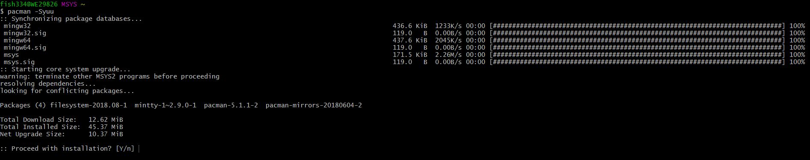

Type “y” and hit enter to continue. If you get a line like the following:



Simply close the MSYS2 window and restart the MSYS2 executable. Then to continue the updates run

* $ pacman –Su

Type “y” and hit enter. You shouldn’t get the warning messages above this time.

In order to build GridLAB-D There are a couple MSYS2 packages that need to be installed. They are as follows:

* base-devel: This package provide the necessary autotools programs and libtool program needed to compile GridLAB-D
* mingw-w64-i686-toolchain (32 bit machines): This package provides gcc compiler for compiling C/C++ code.
* mingw-w64-x86_64-toolchain(64 bit machines): This package provides gcc compiler for compiling C/C++ code.
* git: This is required so the GridLAB-D github repository can be checked out.
* mingw-w64-i686-xerces-c (32 bit machines): This package provides xerces-c, a prerequisite for compiling GridLAB-D.
* mingw-w64-x86_64-xerces-c (64 bit machines): This package provides xerces-c, a prerequisite for compiling GridLAB-D.
* mingw-w64-i686-dlfcn (32 bit machines): This package provides libdl.dll and dlfcn.h, prerequisites for compiling GridLAB-D.
* mingw-w64-x86_64-dlfcn (64 bit machines): This package provides libdl.dll and dlfcn.h, prerequisites for compiling GridLAB-D.

In order to install these packages type the following:

* 32 bit machines:
  + $ pacman -S --needed base-devel mingw-w64-i686-toolchain git mingw-w64-i686-dlfcn mingw-w64-i686-xerces-c
* 64 bit machines:
  + $ pacman -S --needed base-devel mingw-w64-x86_64-toolchain git mingw-w64-x86_64-dlfcn mingw-w64-x86_64-xerces-c

Important note!!!!! After doing this /mingw64/bin or /mingw32/bin needs to be added to the path variable. In fact it would be a good idea to build a shell script so that /mingw64/bin or /mingw32/bin is added to PATH when MSYS2 is started.

# Building GridLAB-D from Source:

Now That MSYS2 has been set up and all needed packages have been installed the installation process for GridLAB-D can start.

Start by cloning the GridLAB-D git repository from <https://github.com/gridlab-d/gridlab-d>. Checkout this the develop branch or release/RC4.1.

## Installing GridLAB-D:

Change directories to the GridLAB-D repository directory. Type the following.

1. $ autoreconf –if
2. 32 bit machines:
   1. ./configure --build=i686-mingw32 --prefix=<installation directory of your choice> --with-xerces=/mingw32 --enable-silent-rules ‘CFLAGS=-g -O2 -w’ ‘CXXFLAGS=-g -O2 -w’ ‘LDFLAGS=-g -O2 -w –L/mingw32/bin’
3. 64 bit machines:
   1. ./configure --build=x86_64-mingw32 --prefix=<installation directory of your choice> --with-xerces=/mingw64 --enable-silent-rules ‘CFLAGS=-g -O2 -w’ ‘CXXFLAGS=-g -O2 -w’ ‘LDFLAGS=-g -O2 -w -L/mingw64/bin’
4. make
5. make install

## Building Optional Features:

There are several optional features that can be built with GridLAB-D. Those are the FNCS library, HELICS library, MySQL module, and MATLAB link.

**Building with the FNCS Library:**

In order to build GridLAB-D with the FNCS library. FNCS must be installed on your machine. For instructions on building FNCS please see <https://github.com/FNCS/fncs>. Once FNCS has been installed, the path to the FNCS library and its third party libraries ZMQ and CZMQ must be added to the PATH in MSYS2. To build GridLAB-D with FNCS add the following option to the configure lines in steps 2 or 3 above:

* --with-fncs=<path to FNCS root installation directory>

For more information on the FNCS library functionality within GridLAB-D see <http://gridlab-d.shoutwiki.com/wiki/Connection:fncs_msg>.

**Building with the HELICS Library:**

In order to build GridLAB-D with the FNCS library. HELICS must be installed on your machine. For instructions on building HELICS please see <https://github.com/GMLC-TDC/HELICS-src>. Once HELICS has been installed, the path to the HELICS library and its third party libraries ZMQ must be added to the PATH in MSYS2. To build GridLAB-D with HELICS add the following option to the configure lines in steps 2 or 3 above:

* --with-helics=<path to HELICS root installation directory>

For more information on the HELICS library functionality with GridLAB-D see <http://gridlab-d.shoutwiki.com/wiki/Connection:helics_msg>.

**Building with the MATLAB Link:**

In order to build the MATLAB link inside of GridLAB-D a version of MATLAB must be installed on the system. Add the following option to the configure line in steps 2 or 3 above:

* --with-matlab=<path to MATLAB install>

It is important to note that the MATLAB installation path contain no spaces. If there are spaces in the paths you can find the short name windows uses for the directory by opening up a command window and typing dir /X one directory above the directory with the spaces. An example of what --with-matlab might look like is below.

* Install path on the windows explorer: C:\Program Files\MATLAB\R2017A
* Option set with the short names: --with-matlab=/c/PROGRA~1/MATLAB/R2017A

**Attention:** before running a simulation with MATLAB, the environment variable %PATH% must contain the path to the MATLAB DLLs, e.g., MATLAB_DIR\bin\win64 or MATLAB_DIR\bin\win32.

For more information on the MATLAB functionality within GridLAB-D see <http://gridlab-d.shoutwiki.com/wiki/Matlab_link>.

**Building the MySQL Module:**

In order to build GridLAB-D with MySQL set the following option to the configure line in step 2 or 3 above:

* --with-mysql=<path to the MySQL connector folder>

It is important that no space be contained in the paths. If there are spaces in the paths you can find the short name windows uses for the directory by opening up a command window and typing dir /X one directory above the directory with the spaces. An example of what --with-mysql might look like is below.

* Install path on the windows explorer: C:\Program Files\MySQL\MySQL Connector C
* Option set with short names: --with-mysql=/c/PROGRA~1/MySQL/MYQLC~1

**Attention:** Before running a simulation with MySQL, %PATH% must contain the path location to the MySQL DLLs, MYSQL_DIR\lib.