<http://www.cs.cornell.edu/courses/cs4780/2015fa/web/lecturenotes/lecturenote13.html>

overfitting, underfitting, validation error, training error

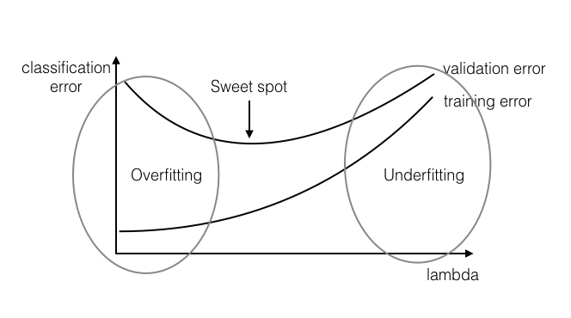

Standard NN (e.g. real estate)

CNN (e.g. photo tagging)

RNN (speech recognition)

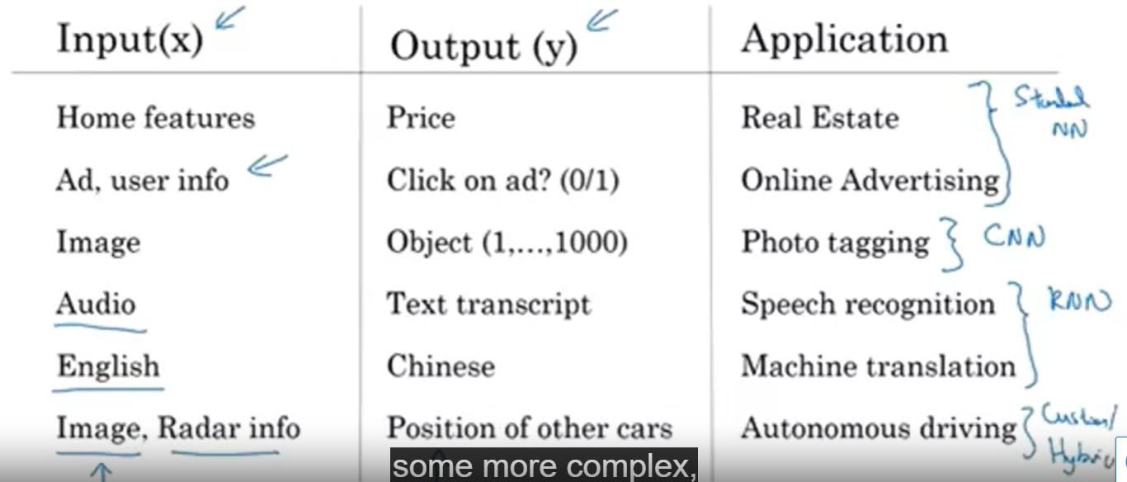

Dropout Regularization: