**UNYOLO MIXED SECONDARY SCHOOL STUDENT MANAGEMENT**

**SOFTWARE DOCUMENTATION**

**Software Version (1.0.0)**

# USER LOGIN

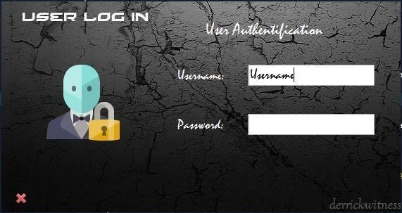

**User is required to enter username password: then press “ENTER” on the keyboard Without the password, you cannot access the system.**

# Main Window

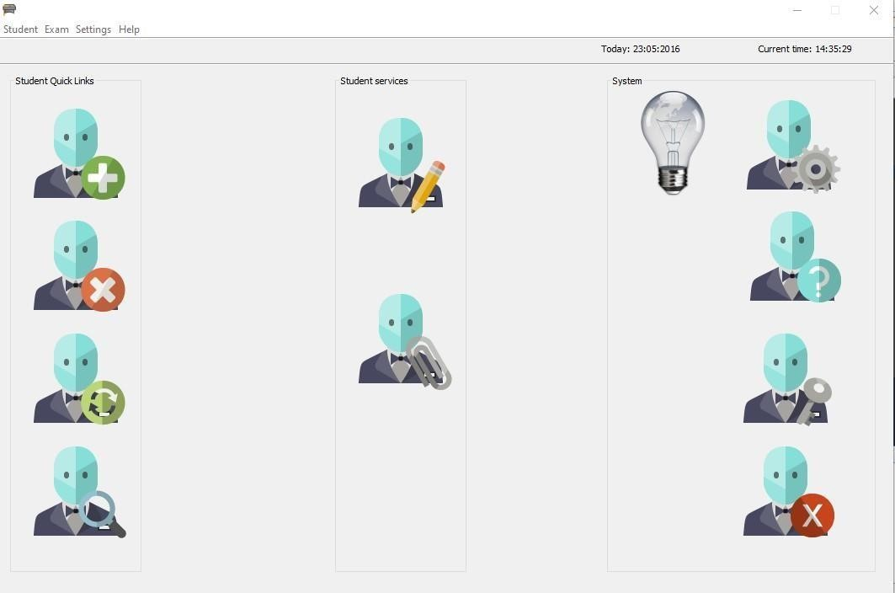

# Click on the available menus to navigate to your desired module either using the quick links

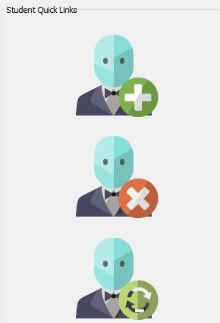

# Or using the menus e.g below



# Add Student

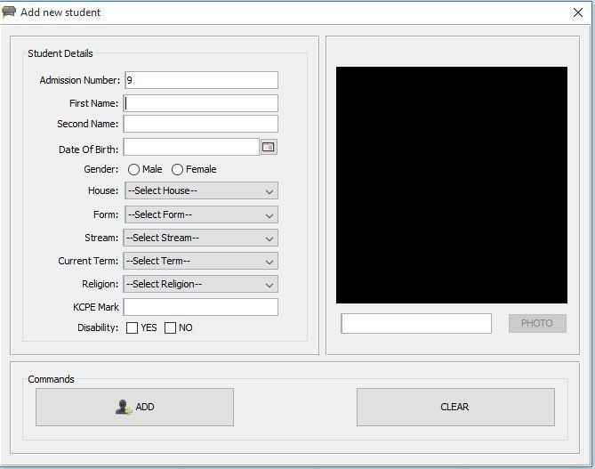

**Feed student details into the system.**

# Subject Selection

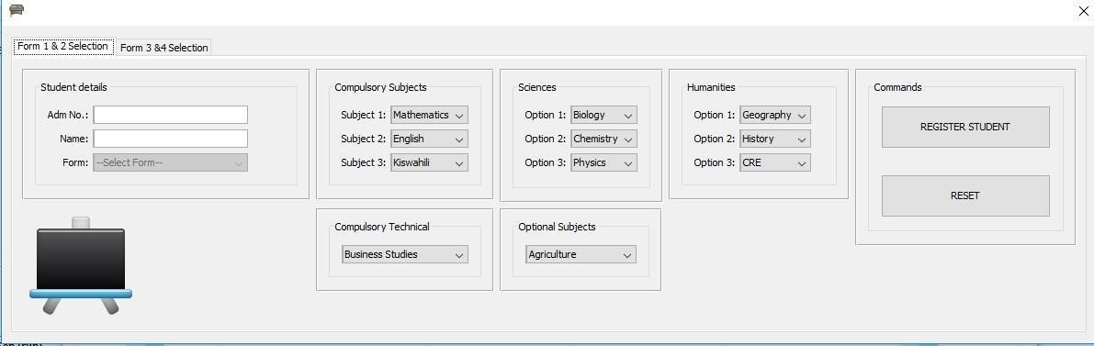

**Select the various subjects the student is taking.**

* **Form 1 and 2 do all the 11 subjects.**
* **Subject selection MUST BE DONE BEFORE RECORDING ANY STUDENT MARKS**

# Record Exam

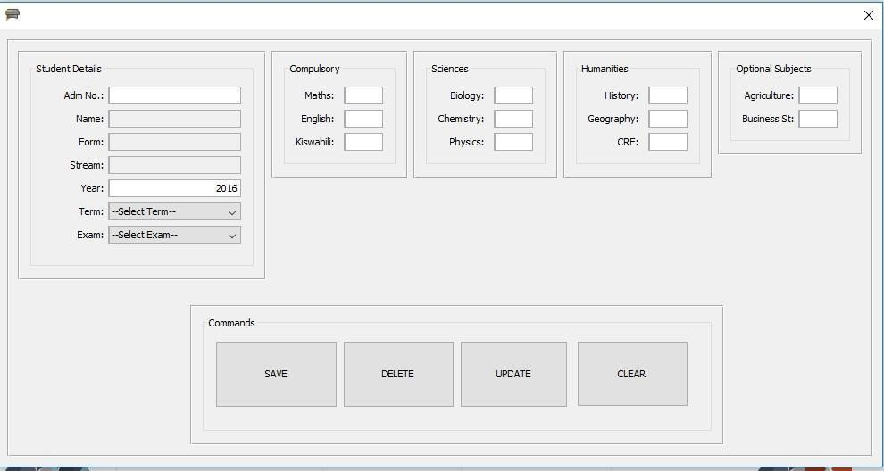

Feed the student exam details into the system.

# View Student exam details

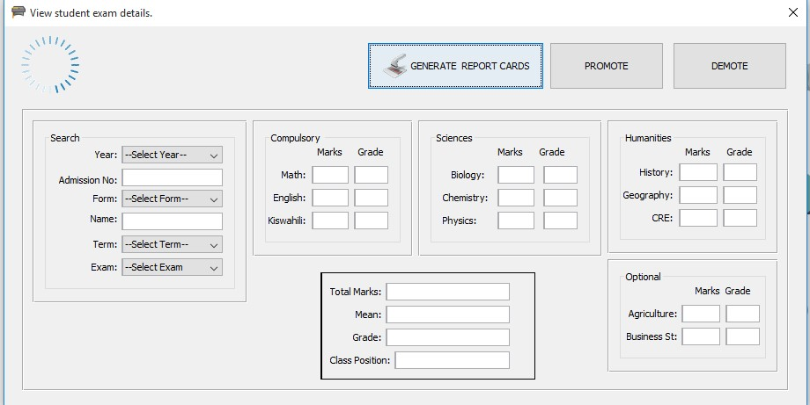

# Steps

* Select Year • Enter Adm No.
* Select Term
* Select Exam

* Button **GENERATE REPORT CARDS** when clicked Auto Generates the class report cards if the selected exam is of end of the term.
* The generated report cards are auto-saved in the *‘Student Report Cards’* folder located in *‘Unyolo’* folder under the ***Documents*** folder.

# Class Exam View And Mark list

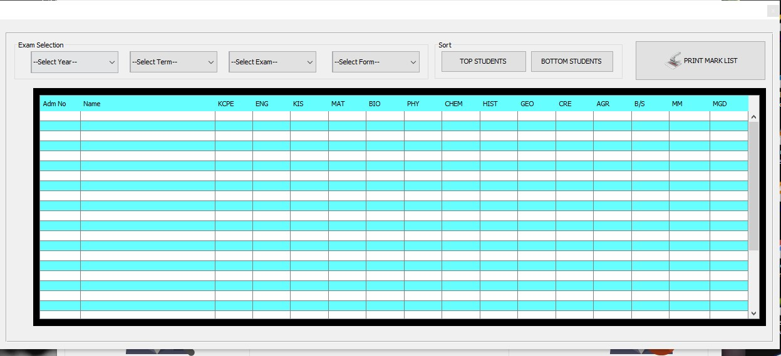

View Student performance by their class.

* Steps: Select Year
* Select Term
* Select Exam
* Select Form

**PRINT MARK LIST** button generates exam marklist of the currently selected exam.

The marklist generated is stored in the Class marklists folder in the Unyolo folder under the documents folder.

# Subject Analysis

This is where the exam analysis is done. You MUST first select the exam; ANALYSE it then generates the analysis mark list.

When the ANALYSE button is clicked, it should notify you **“Exam Analysis Successful!”** before you generate the mark lists.

Example 1

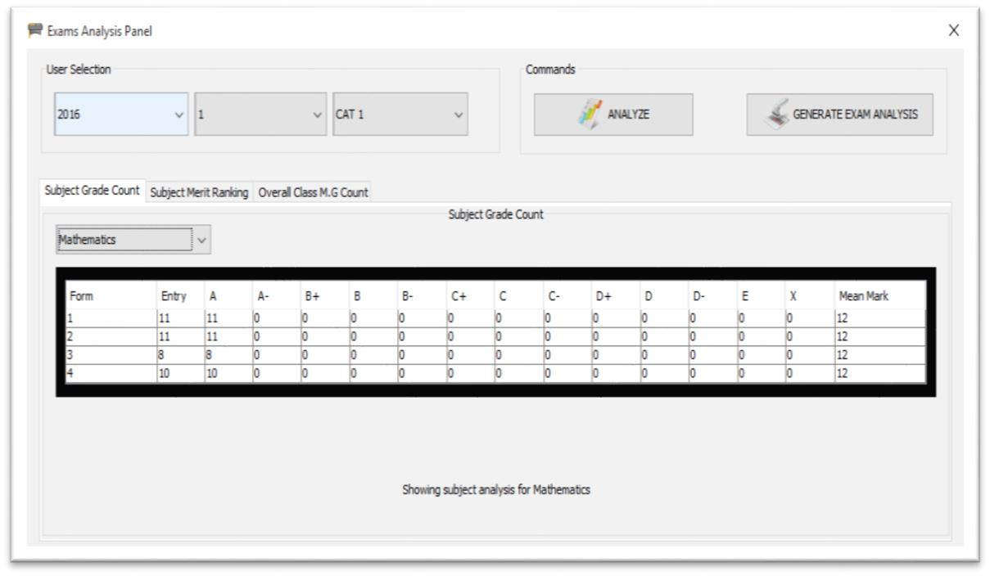

Example 2

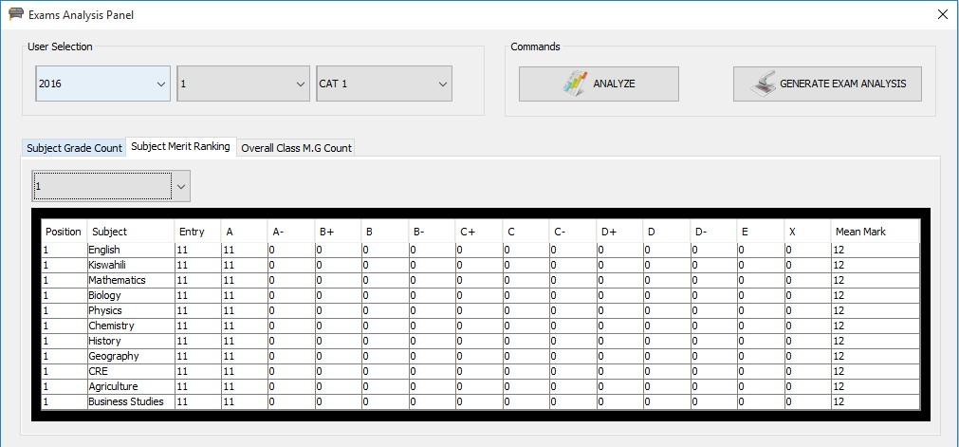

Example 3

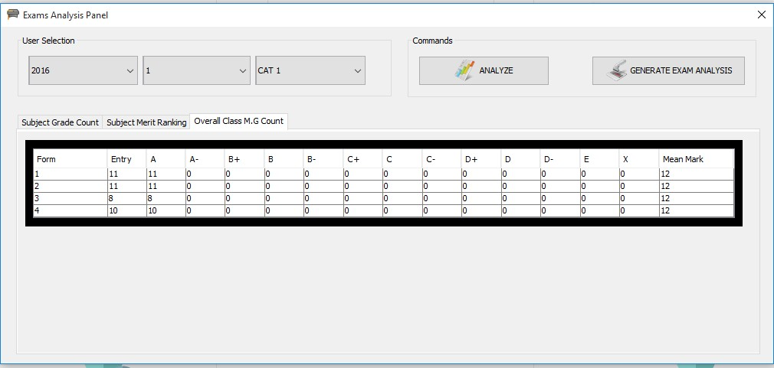

# System Settings

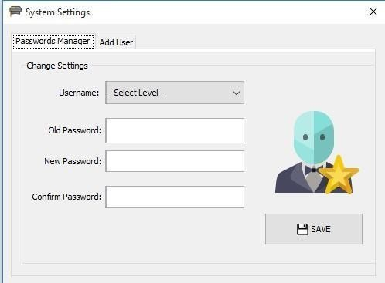

**Add user or change user passwords.**