**Lab 5 Report**

張嗣岱

107598069

6/3

1. **Test Plan**
   1. **Summary/Scope**

The LibSystem (<http://127.0.0.1/LibSystem>) which is a website for booking system. This report is a Load/Stress test for operate website. (e.g., Login/ search for book/ borrow the book)

* 1. **Feature to be tested**

1. Login

* Login and Logout with ramp-up
* Login and Logout without ramp-up

1. ISBN Search books

* ISBN search books synchronous
* ISBN search books asynchronous

1. Check out books/ Check in books

* Check out and Check in book synchronous
* Check out and Check in book asynchronous
  1. **Success criteria of completing the test**

Test pass: thread’s status is success.

Test fail criteria, response time > 40000 (ms) with 1024 users

* 1. **Test environment and/or infrastructure**

1. [Docker Desktop for Windows](https://docs.docker.com/docker-for-windows/install/) & [Docker Hub](https://hub.docker.com/r/ntutselab/keystonejs)
2. Apache JMeter 5.1.1 (Require Java 8+)
   1. **Test approaches**

In the script of Login, Login and Logout without ramp-up I design it with logout after every thread login and the assert with login is success.

Then, Login and Logout with ramp-up which the difference between the previous version is setting thread 256’s ramp-up in 10 and thread 512’s ramp-up in 20 and thread 1024’s ramp-up in 40.

In the script of ISBN Search books, ISBN search books synchronous

the script is when every thread searching the book with ISBN then logout and the assertion after ISBN is randomly, and the other script difference between synchronous is searching the book with ISBN after every thread login.

In the script of Check out books/ Check in books, check out and check in book synchronous the step is first login, second searching book with ISBN, third check the free code, then check in and check out the book, logout finally.

And the difference between synchronous is waiting until every thread login then start the action.

* 1. **Testing tasks**

To implement the proposed strategy, the following activities are planned to perform.

|  |  |  |  |
| --- | --- | --- | --- |
| **No.** | **Activity Name** | **Plan hours** | **Schedule Date** |
| 1 | Study JMeter | 4 | 5/26 |
| 2 | Familiar with LibSystem | 3 | 5/27 |
| 3 | Study Postman | 3 | 5/28 |
| 4 | Study JavaScript | 3 | 5/28 |
| 5 | Design test cases | 2 | 5/29 |
| 6 | Implement test cases | 10 | 5/29 |
| 7 | Perform tests | 3 | 5/30 |
| 8 | Complete Lab5 report | 6 | 5/30-6/3 |

1. **Test Design**

To fulfill the test requirements listed in section 1.2, the following test cases are selected and corresponding designed.

**2.1**

|  |  |
| --- | --- |
| **Use Case Section** | **Comment** |
| **Use Case Name** | Login and Logout with ramp-up |
| **Precondition** | 可以運行在<http://127.0.0.1/LibSystem>，並且用TA給的範例檔修改。 |
| **Expected output** | Every thread’s status is success |
| **Input actions** | 1. login request   assertion   1. logout request   assertion  Synchronizing Timer |
| **Design of workload** | 1. ramp-up is 10 in thread 256 2. ramp-up is 20 in thread 512 3. ramp-up is 40 in thread 1024 4. the assertion of login is {“status”:”success”,”authority”:”2”} 5. the assertion of logout is success |

**2.2**

|  |  |
| --- | --- |
| **Use Case Section** | **Comment** |
| **Use Case Name** | Login and Logout without ramp-up |
| **Precondition** | 可以運行在<http://127.0.0.1/LibSystem>，並且用TA給的範例檔修改。 |
| **Expected output** | Every thread’s status is success |
| **Input actions** | 1. login request   assertion   1. logout request   assertion  Synchronizing Timer |
| **Design of workload** | 1.the assertion of login is {“status”:”success”,”authority”:”2”}  2.the assertion of logout is success |

**2.3**

|  |  |
| --- | --- |
| **Use Case Section** | **Comment** |
| **Use Case Name** | ISBN search books synchronous |
| **Precondition** | 可以運行在<http://127.0.0.1/LibSystem>，並且用TA給的範例檔修改。 |
| **Expected output** | Every thread’s status is success |
| **Input actions** | 1. login   assertion   1. get all ISBN data   JSON Extractor   1. Get a random ISBN   JSR223 PreProcessor  assertion   1. Logout   Assertion  Synchronizing timer |
| **Design of workload** | 1. ramp-up is 10 in thread 256 2. ramp-up is 20 in thread 512 3. ramp-up is 40 in thread 1024 4. the assertion of login is { "status":"success","authority":"2"} 5. the assertion of get a random ISBN is "isbn":"${randIsbn}" 6. the assertion of logout is success |

**2.4**

|  |  |
| --- | --- |
| **Use Case Section** | **Comment** |
| **Use Case Name** | ISBN search books asynchronous |
| **Precondition** | 可以運行在<http://127.0.0.1/LibSystem>，並且用TA給的範例檔修改。 |
| **Expected output** | Every thread’s status is success |
| **Input actions** | 1. login   assertion   1. get all ISBN data   JSON Extractor  Synchronizing timer   1. Get a random ISBN   JSR223 PreProcessor  assertion   1. Logout   Assertion  Synchronizing timer |
| **Design of workload** | 1. ramp-up is 10 in thread 256 2. ramp-up is 20 in thread 512 3. ramp-up is 40 in thread 1024 4. the assertion of login is { "status":"success","authority":"2"} 5. the assertion of get a random ISBN is "isbn":"${randIsbn}" 6. the assertion of logout is success |

**2.5**

|  |  |
| --- | --- |
| **Use Case Section** | **Comment** |
| **Use Case Name** | Check out and Check in book synchronous |
| **Precondition** | 可以運行在<http://127.0.0.1/LibSystem>，並且用TA給的範例檔修改。 |
| **Expected output** | Every thread’s status is success |
| **Input actions** | 1. login   assertion   1. get all ISBN data   JSON Extractor   1. Get a random ISBN   JSR223 PreProcessor  Assertion   1. Book data   JSON Extractor   1. Get a random code number   JSR223 PreProcessor  Assertion   1. Critical Section Controller   Borrow Book  Assertion  Give it back  Assertion   1. Logout   Assertion  Synchronizing timer |
| **Design of workload** | 1. ramp-up is 10 in thread 256 2. ramp-up is 20 in thread 512 3. ramp-up is 40 in thread 1024 4. the assertion of login is { "status":"success","authority":"2"} 5. the assertion of get a random ISBN is "isbn":"${randIsbn}" 6. the assertion of get a random code number is ${randCode} 7. the assertion of borrow book is success 8. the assertion of give it back is success 9. the assertion of logout is success |

**2.6**

|  |  |
| --- | --- |
| **Use Case Section** | **Comment** |
| **Use Case Name** | Check out and Check in book asynchronous |
| **Precondition** | 可以運行在<http://127.0.0.1/LibSystem>，並且用TA給的範例檔修改。 |
| **Expected output** | Every thread’s status is success |
| **Input actions** | 1. login   assertion   1. get all ISBN data   JSON Extractor  Synchronizing timer   1. Get a random ISBN   JSR223 PreProcessor  Assertion   1. Book data   JSON Extractor   1. Get a random code number   JSR223 PreProcessor  Assertion   1. Critical Section Controller   Borrow Book  Assertion  Give it back  Assertion   1. Logout   Assertion  Synchronizing timer |
| **Design of workload** | 1. ramp-up is 10 in thread 256 2. ramp-up is 20 in thread 512 3. ramp-up is 40 in thread 1024 4. the assertion of login is { "status":"success","authority":"2"} 5. the assertion of get a random ISBN is "isbn":"${randIsbn}" 6. the assertion of get a random code number is ${randCode} 7. the assertion of borrow book is success 8. the assertion of give it back is success 9. the assertion of logout is success |

1. **Test Implementation**

The design of test cases specified in Section 1.2 was implemented JMeter IDE and JavaScript with random variables. All test scripts of scenario are given below. The test script implementations can also be found in the [link](https://github.com/derry95922/STV/tree/master/lab4/src).

|  |  |  |
| --- | --- | --- |
| **No.** | **Test method** | **Test script** |
| 1 | Login and Logout with ramp-up |  |
| 2 | Login and Logout without ramp-up |  |
| 3 | ISBN search books synchronous |  |
| 4 | ISBN search books asynchronous |  |
| 5 | Check out and Check in book synchronous |  |
| 6 | Check out and Check in book asynchronous |  |

1. **Test Results**

**Login:**

1. **Thread 256 without ramp-up**



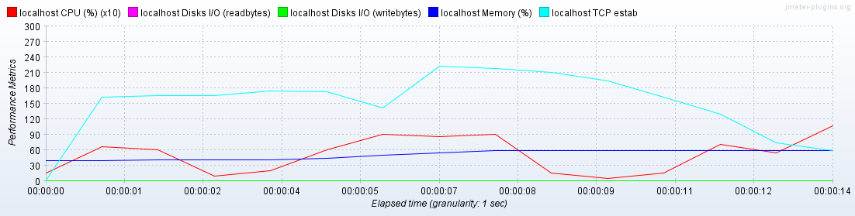

1. **Thread 256 with ramp-up**



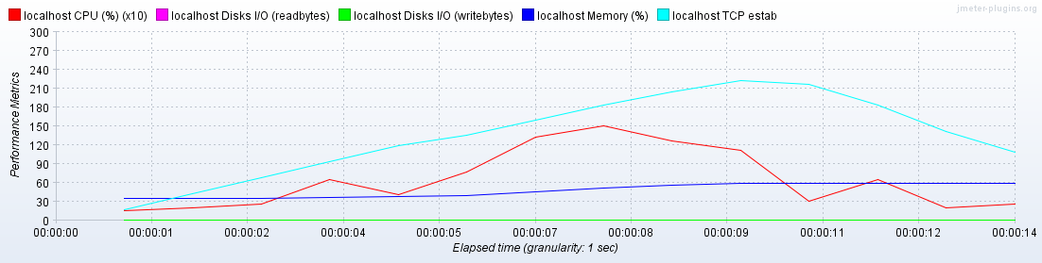

|  |  |  |
| --- | --- | --- |
| **Attribute** | **Without ramp-up** | **With ramp-up** |
| response time(Average Total) | 3841(ms) | 2089(ms) |
| CPU | 起伏較多 | 緩慢上升到7.5秒下降最後一起logout在上升 |
| Memory | 較為平緩 | 緩慢上升 |
| Network | 一開始就飆高直到9秒後才下降 | 緩慢上升到10秒後開始下降 |
| Disk | 沒什麼變化 | 沒什麼變化 |

1. **Thread 512 without ramp-up**



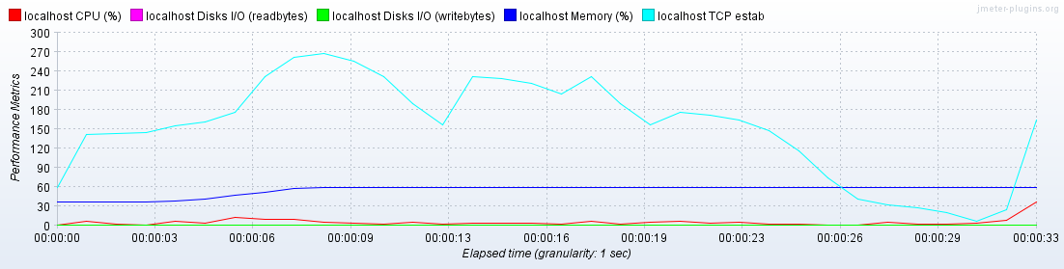

1. **Thread 512 with ramp-up**



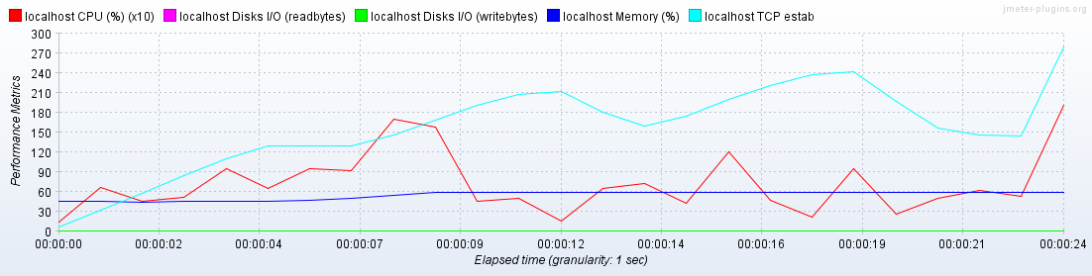

|  |  |  |
| --- | --- | --- |
| **Attribute** | **Without ramp-up** | **With ramp-up** |
| response time(Average Total) | 7664 (ms) | 2124 (ms) |
| CPU | 只有最後logout才上升 | 起伏較多，大多和網路的曲線呈正相關 |
| Memory | 較為平緩 | 較為平緩 |
| Network | 一開始就飆高直到8秒到達最高，17秒後開始下降，最後logout再飆高 | 緩慢上升到19秒後開始下降，22秒後因為logout飆高 |
| Disk | 沒什麼變化 | 沒什麼變化 |

1. **Thread 1024 without ramp-up**



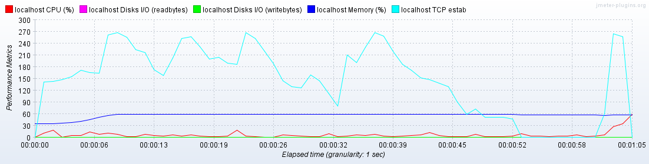

1. **Thread 1024 with ramp-up**



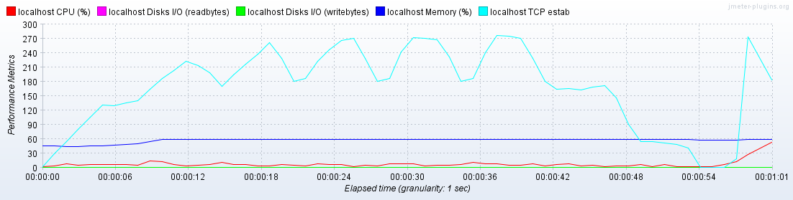

|  |  |  |
| --- | --- | --- |
| **Attribute** | **Without ramp-up** | **With ramp-up** |
| response time(Average) | 14393 (ms) | 3732 (ms) |
| CPU | 只有最後logout才上升 | 只有最後logout才上升 |
| Memory | 較為平緩 | 較為平緩 |
| Network | 一開始就飆高，37秒後開始下降，最後logout再飆高 | 持續上升到19秒後開始在180-270(metrics)來回，47秒後下降，55秒後因為logout飆高 |
| Disk | 沒什麼變化 | 沒什麼變化 |

**ISBN Search books**

1. **Thread 256 with ISBN search books synchronous**

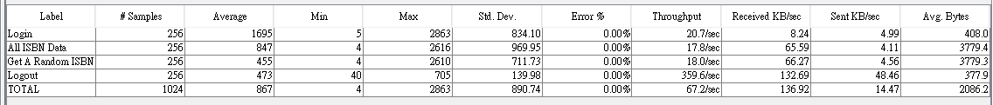

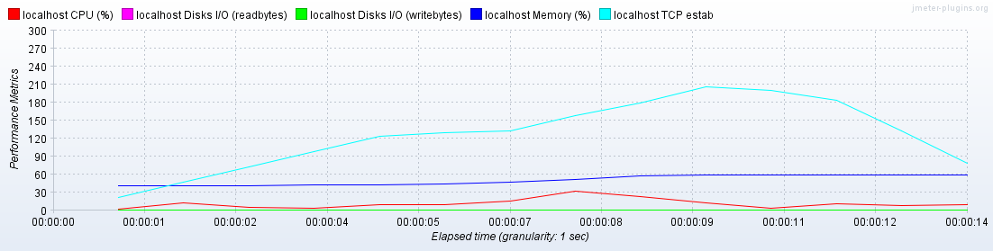

1. **Thread 256 with ISBN search books asynchronous**

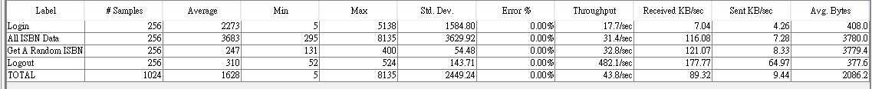

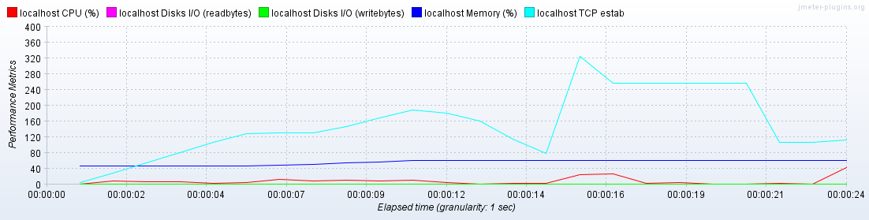

|  |  |  |
| --- | --- | --- |
| **Attribute** | **synchronous** | **asynchronous** |
| response time(Average Total) | 867 (ms) | 1628 (ms) |
| CPU | 較為平緩 | 只有在logout才上升 |
| Memory | 較為平緩 | 較為平緩 |
| Network | 緩慢上升至9秒後開始下降 | 緩慢上升至10秒下降，15秒飆高後再20秒下降 |
| Disk | 沒什麼變化 | 沒什麼變化 |

1. **Thread 512 with ISBN search books synchronous**

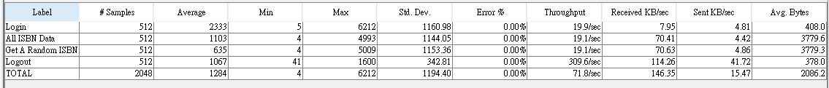

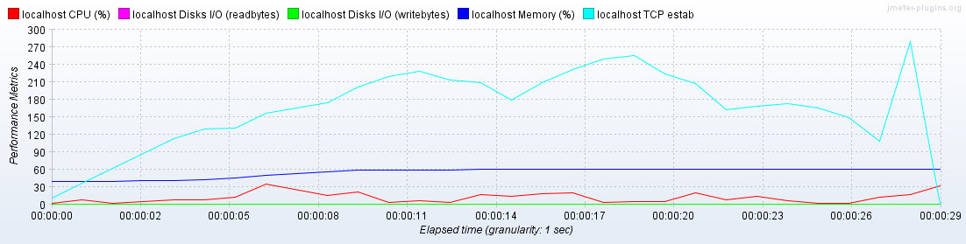

1. **Thread 512 with ISBN search books asynchronous**

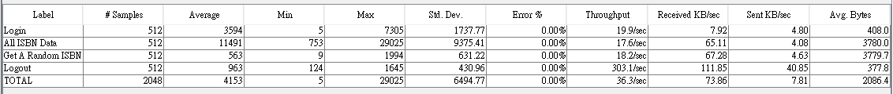

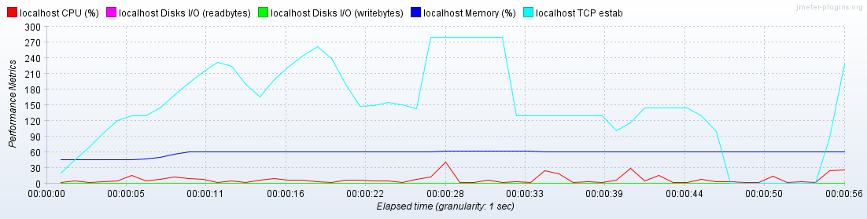

|  |  |  |
| --- | --- | --- |
| **Attribute** | **synchronous** | **asynchronous** |
| response time(Average Total) | 1284(ms) | 4153 (ms) |
| CPU | 6秒到高峰，logout也有上升 | 28秒到高峰 |
| Memory | 較為平緩 | 較為平緩 |
| Network | 緩慢上升至19秒後開始下降，27秒開始飆高後開始下降 | 較為極端在27秒飆高32秒急速下降，至47秒為最低點，logout再飆高 |
| Disk | 沒什麼變化 | 沒什麼變化 |

1. **Thread 1024 with ISBN search books synchronous**

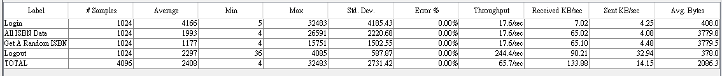

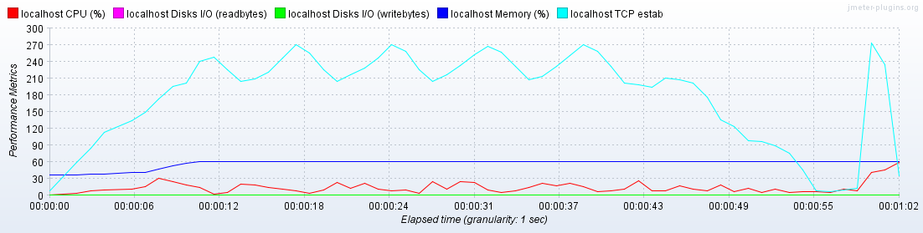

1. **Thread 1024 with ISBN search books asynchronous**

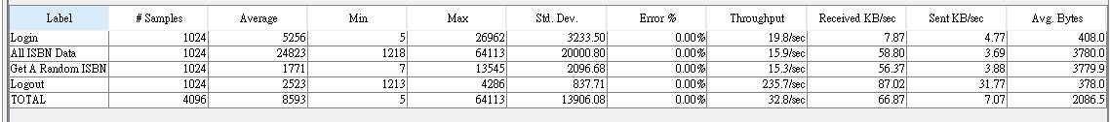

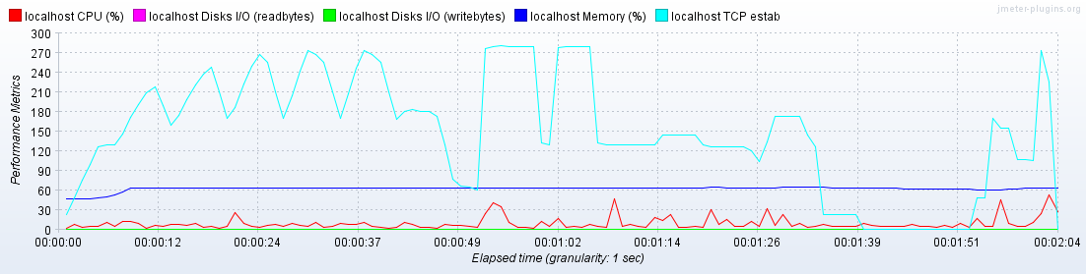

|  |  |  |
| --- | --- | --- |
| **Attribute** | **synchronous** | **asynchronous** |
| response time(Average Total) | 2408(ms) | 8593 (ms) |
| CPU | Logout是最高點 | 除了logout外也有幾處到30 |
| Memory | 較為平緩 | 較為平緩 |
| Network | 線性上升至11秒後開始在240-270震盪，44秒後下降到最低點，logout再飆高 | 10秒到48秒在150-270震盪，50秒飆高，最後logout再飆高 |
| Disk | 沒什麼變化 | 沒什麼變化 |

**Check out books /Check in books**

1. **Thread 256 with Check out and check in books synchronous**

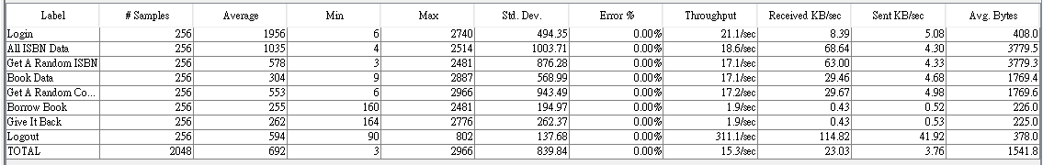

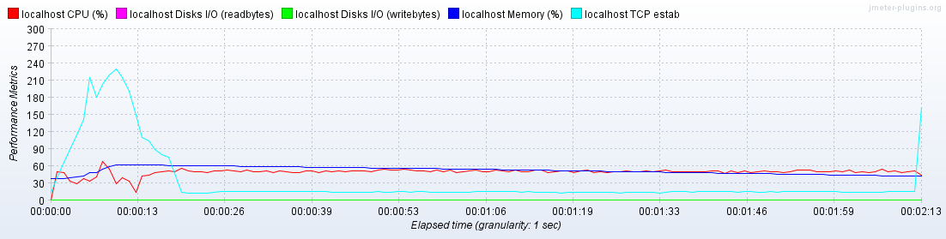

1. **Thread 256 with Check out and check in books asynchronous**

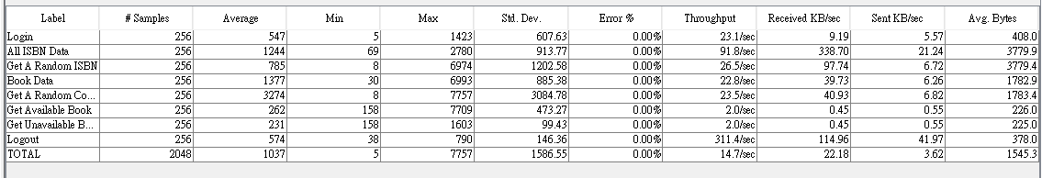

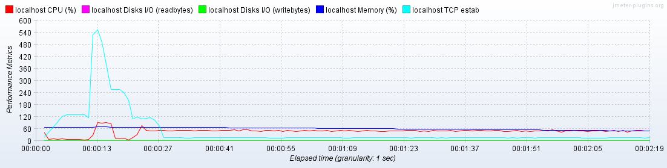

|  |  |  |
| --- | --- | --- |
| **Attribute** | **synchronous** | **asynchronous** |
| response time(Average Total) | 692(ms) | 1037 (ms) |
| CPU | 7秒到最高13秒後都維持在60 | 13秒到最高22秒後都維持在60 |
| Memory | 較為平緩 | 較為平緩 |
| Network | 7-10秒都在最高之後下降後再也沒上升 | 13秒到最高之後就下降了 |
| Disk | 沒什麼變化 | 沒什麼變化 |

1. **Thread 512 with Check out and check in books synchronous**

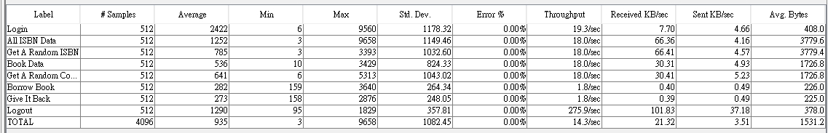

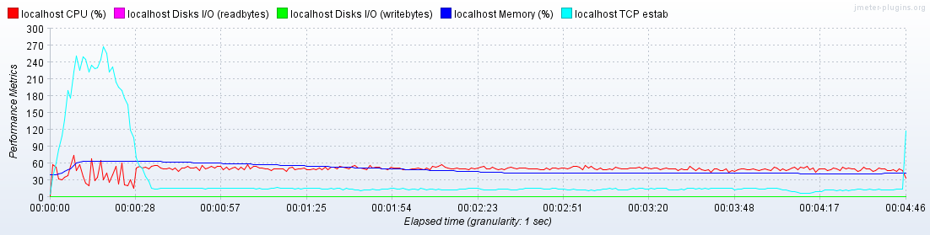

1. **Thread 512 with Check out and check in books asynchronous**

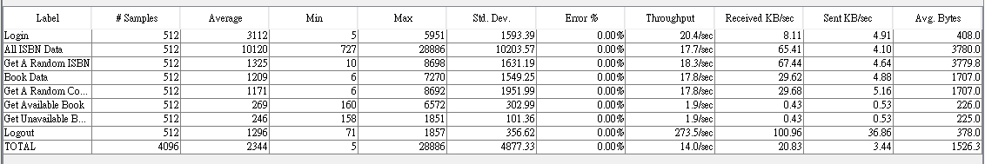

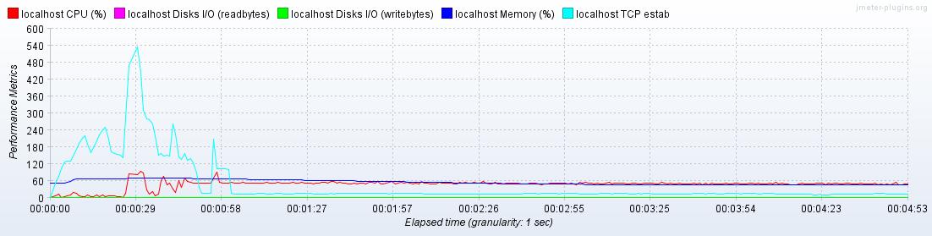

|  |  |  |
| --- | --- | --- |
| **Attribute** | **synchronous** | **asynchronous** |
| response time(Average Total) | 935(ms) | 2344 (ms) |
| CPU | 28秒前在20-60震盪，28秒後幾乎都在60 | 28秒到60秒起伏最大，之後維持在60 |
| Memory | 較為平緩 | 較為平緩 |
| Network | 28秒前幾乎都在270，最後只有logout時飆升 | 29秒到達最高，起伏只有在60秒前較為劇烈 |
| Disk | 沒什麼變化 | 沒什麼變化 |

1. **Thread 1024 with Check out and check in books synchronous**

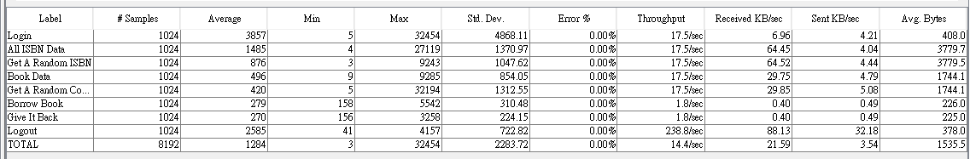

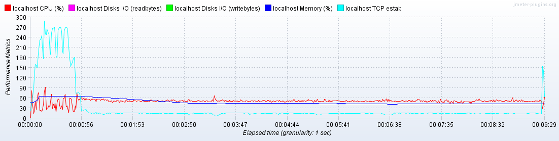

1. **Thread 1024 with Check out and check in books asynchronous**

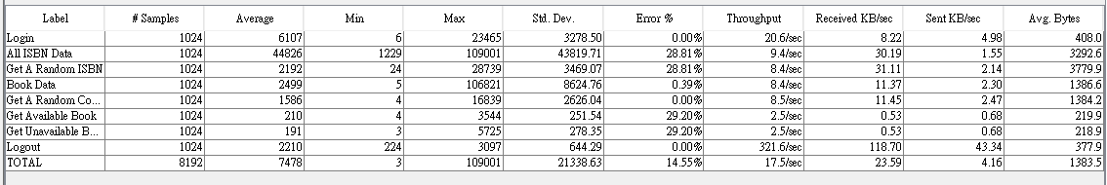

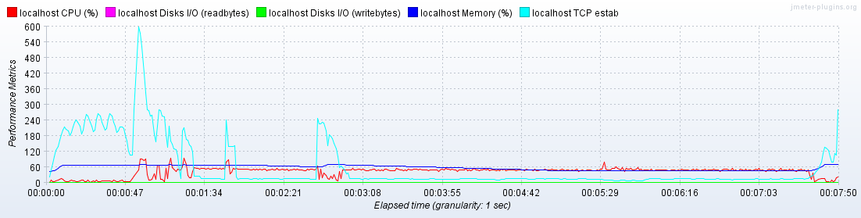

|  |  |  |
| --- | --- | --- |
| **Attribute** | **synchronous** | **asynchronous** |
| response time(Average Total) | 1284(ms) | 7478 (ms) |
| CPU | 60秒前在20-90震盪，60秒後幾乎都在60 | 最高是60左右 |
| Memory | 較為平緩 | 較為平緩 |
| Network | 58秒前主要在180-270震盪，最後只有logout飆高 | 50秒到達最高，起伏只有在3分前較為劇烈，最後logout飆高 |
| Disk | 沒什麼變化 | 沒什麼變化 |

1. **Summary**

In Lab 5, 6 **test scripts have been designed and implemented using JMeter with JavaScript**. The **previous five test scripts execution results are all pass**. **And the last test was failed because its response time.** Thus, the test requirements described in Section 1 are satisfied. By using JMeter let me learn a lit bit of JavaScript and the reality of the test facing on which problem.