Lab 3 Report

Name
Student ID
Date

- Test Plan
  - Test requirements
The Lab 3 requires to
(1) select 6 methods from 6 classes of the SUT (GeoProject)
(2) design Unit test cases by using basis path and graph coverage technique for the selected methods
(3) develop test scripts to implement the test cases
(4) execute the test scripts on the selected methods
(5) report the test results
(6) specify your experiences of designing test cases systematically using the ISP technique.
In particular, based on the statement and branch coverage criteria, the test requirements for Lab 3 are to design test cases with basis path and/or graph coverage for each selected method so that “each statement and branch of the method will be covered by at least one test case and the both minimum statement (node) and branch (edge) coverage are 90%, respectively (greater than Lab 2)”.

  - Test Strategy
To satisfy the test requirements listed in Section 1, a proposed strategy is to
- select those 3 methods that were chosen in Lab1 or Lab2 and 3 new methods that are NOT selected previously. The selected methods MUST contain predicate and loop structures (as many as possible).
- set the objective of the minimum statement coverage to be greater than that of Lab 2 and adjust the test objective based on the time available (if necessary).
- design the test cases for those selected methods by using the basis path and graph coverage testing technique.

  - Test activities
To implement the proposed strategy, the following activities are planned to perform.

No. | Activity Name | Plan hours | Schedule Date
1 | Study GeoProject | 2 | 4/19
2 | Learn basis path and graph coverage | 5 | 4/20
3 | Design test cases for the selected methods | 5 | 4/21
4 | Implement test cases | 3 | 4/22
5 | Perform tests | 3 | 4/22
6 | Complete Lab3 report | 2 | 4/24

  - Design Approach
The basis path and graph coverage technique will be used to design the test cases. Specifically, the control flow graph (CFG) of each selected method shall be drawn first, and the possible test paths that satisfy the test requirements (i.e., statement (node) and branch (edge) coverage) shall be derived from the CFG. The possible inputs and expected outputs for the derived test paths shall be computed for each selected method. Add more test cases by considering to satisfy other coverage criteria, such as edge-pair, all-use, or prime-path coverage criteria.

  - Success criteria
All test cases designed for the selected methods must pass (or 90% of all test cases must pass) and both statement and branch coverage should have achieved at least 90%, respectively.

- Test Design
To fulfill the test requirements listed in section 1.1, the following methods are selected and corresponding test cases are designed.

No. | Class | Method | CFG | Basis Path | Inputs | Expected Outputs
1 | Base32
2 | Coverage
3 | CoverageLongs
4 | GeoHash
5 | Geomem
5 | Info

The details of the design are given below:
The Excel file of test cases…

- Test Implementation
The design of test cases specified in Section 2 was implemented using JUnit 4. The test scripts of 3 selected test cases are given below. The rest of the test script implementations can be found in the link (or JUnit files).

No. | Test method | Source test code
1 | testMethod1() | …
2 | testMethod2() | …
3 | testMethod3() | …

- Test Results
  - JUnit test result snapshot
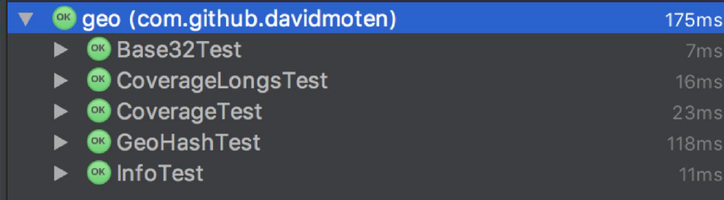
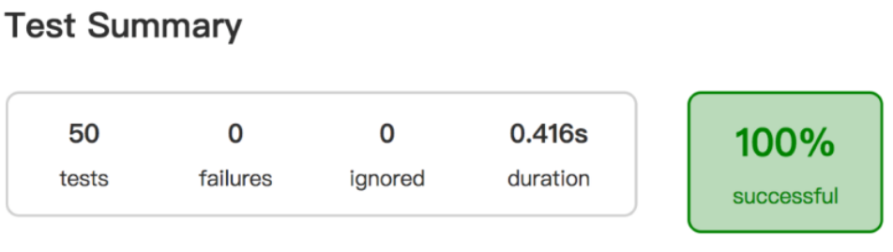
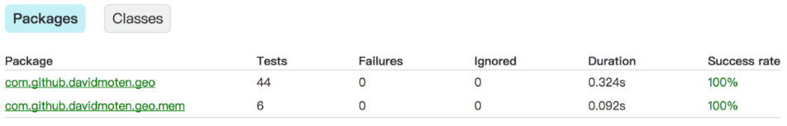

  - Code coverage snapshot
- Coverage of each selected method
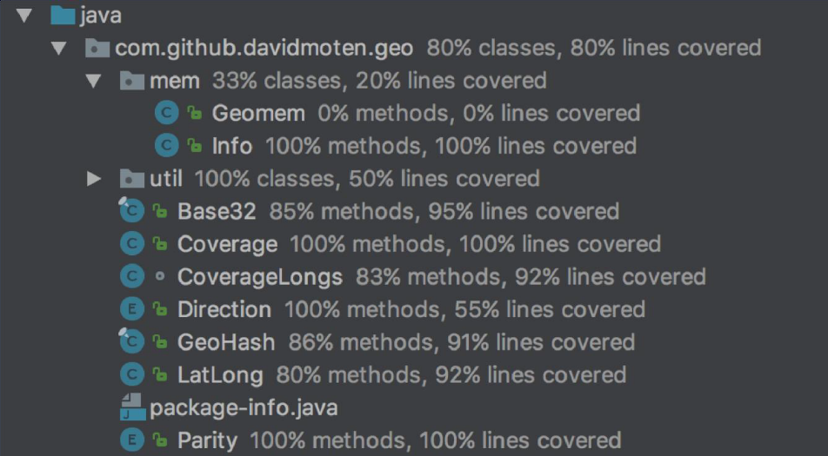

- Total coverage
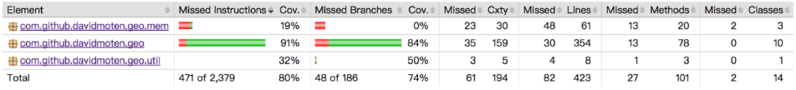

  - CI result snapshot (3 iterations for CI)

- CI#1
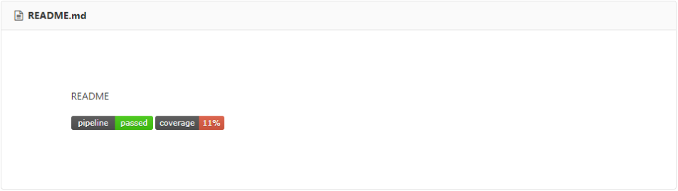
- CI#2
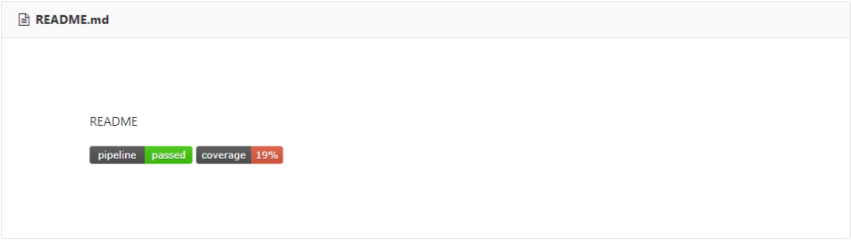
- CI#3
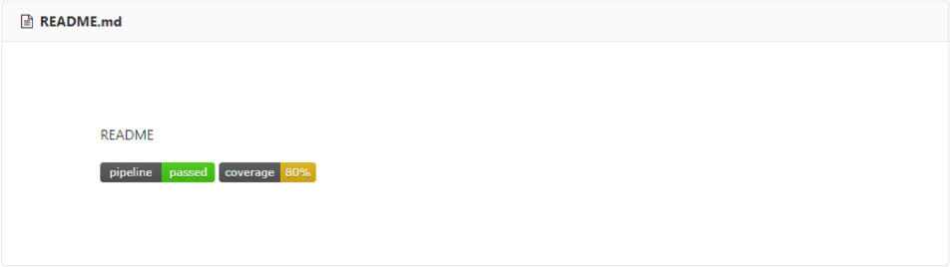
- CI Pipeline
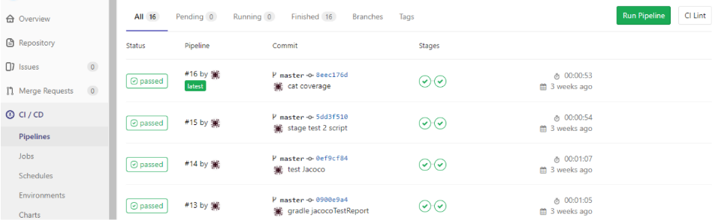

- Summary
In Lab 3, 5 test cases have been designed and implemented using JUnit and the basis path/graph coverage technique. The test is conducted in 3 CI and the execution results of the 5 test methods are all passed. The total statement and branch coverage of the test are 95% and 100%, respectively. Thus, the test requirements described in Section 1 are satisfied. Some lessons learned in this Lab are …

