# Generation of a worm

A user can set stroke direction for a group of selected nodes (there are 50 nodes – as 50 segments in experiments).

Physical parameters such as node mass, stroke strength (universal for all nodes for now) affect the speed of the worm, the total force acting on it.

Directionality of all 50 strokes can be set according to the data that you sent me. Here are the 3 mutants; the thick magenta line is the total force actin on the worm. The thick red line is the total torque acting on the worm.

WT

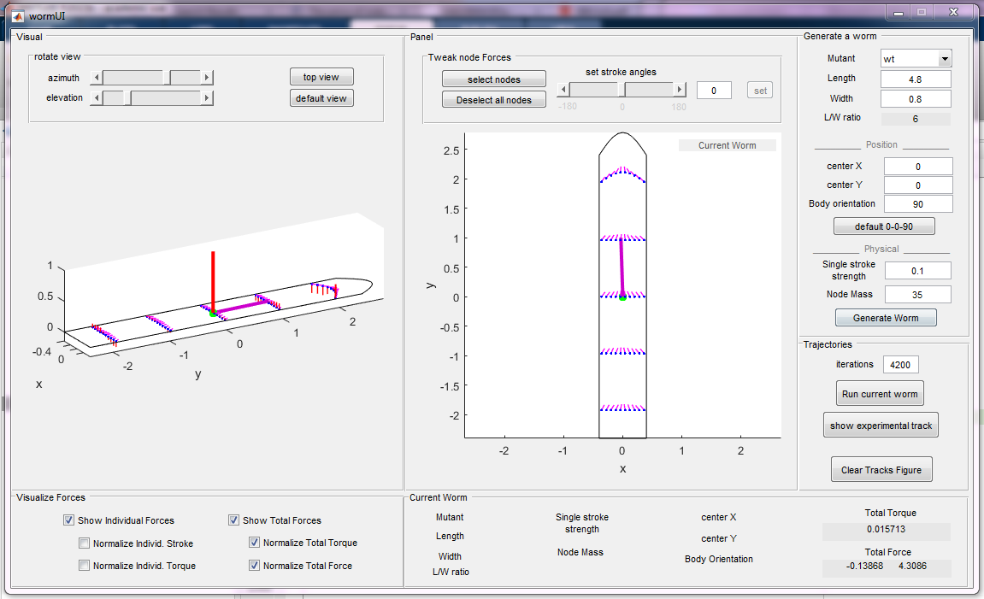

Vfl3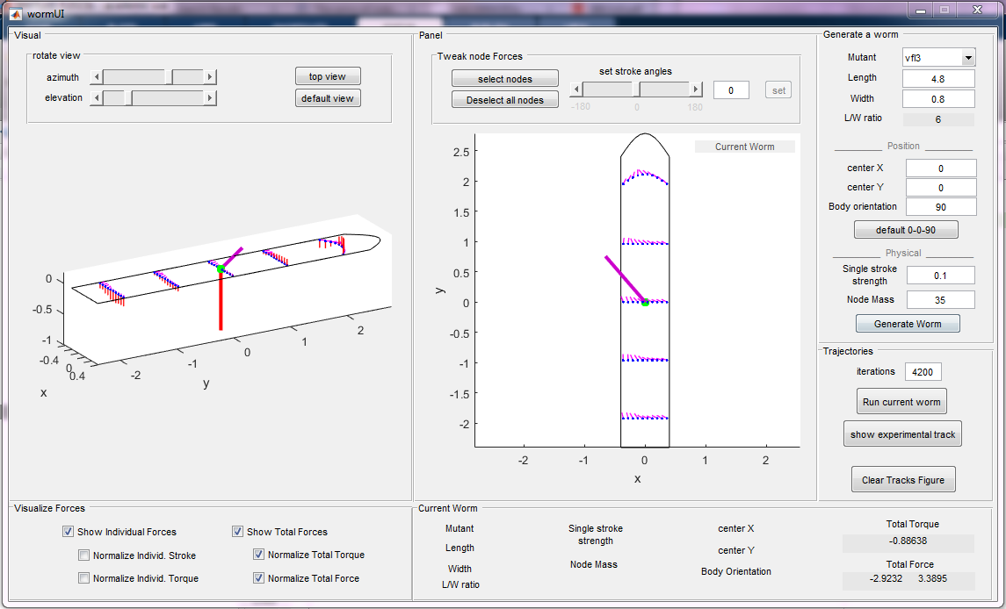

Odf2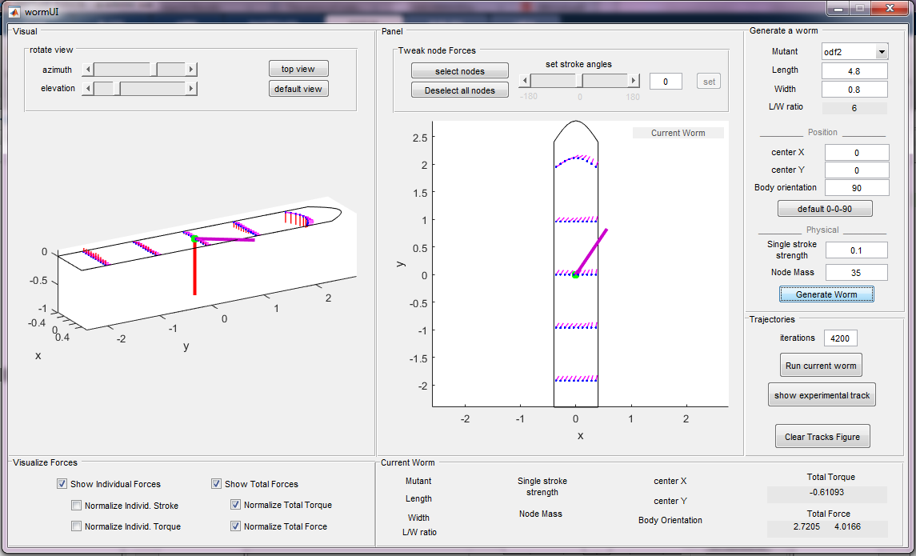

After the worm is generated, the user can run it for a chosen amount of ms.

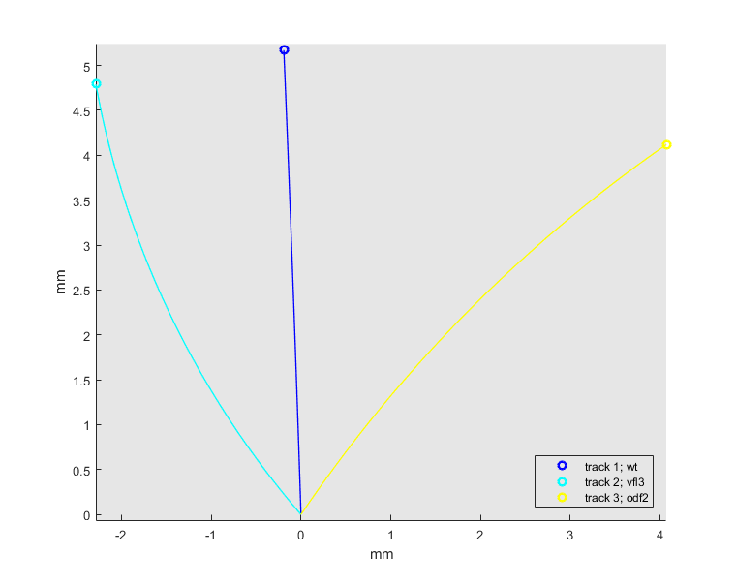

**Figure 2.**

The figure shows trajectories for the three mutants. Each trajectory is obtained in a run of 4200 milliseconds.

All worms have the same mass and strength, only the strokes directionality differs (angles are taken from experiments).

One can see that the rigid-body simulations can predict experimentally observed displacements: vfl3 – to the left, odf2 – to the right. One can also see that in the generating figures the forces (magenta thick lines) act in the corresponding directions: left for vfl3 and right to odf2.

However, the torques generated in the two mutants act in the same direction, which results in rotation in the same direction (clockwise). This rotation is also visible in the Figure 2. In the Figure 3 is shown what happens if we run simulations for longer times:

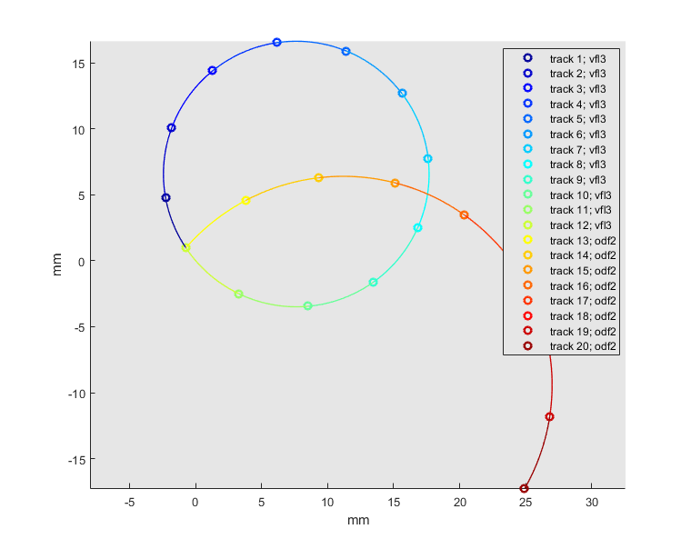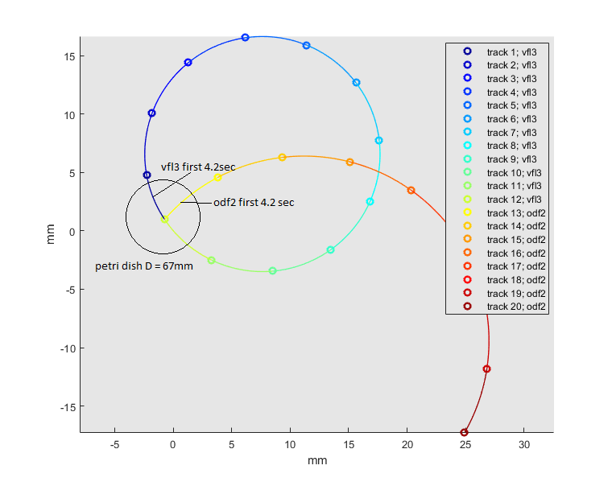

**Figure 3.**

Each short piece is a trajectory obtained in a run of 4200 milliseconds. The first runs are the same as in the Figure 2.

Actually, if one looks very carefully at the movies of Vfl3 and Odf2 worms, one can notice, that in both mutants there are some worms that have displacement to the right. So, even if the direction of the total force points to the left (Vfl3), the trajectory will be curled clockwise, because of the total torque. Torque can change significantly due to cutting of a worm.