**Easy Chicken Tetrazzini**

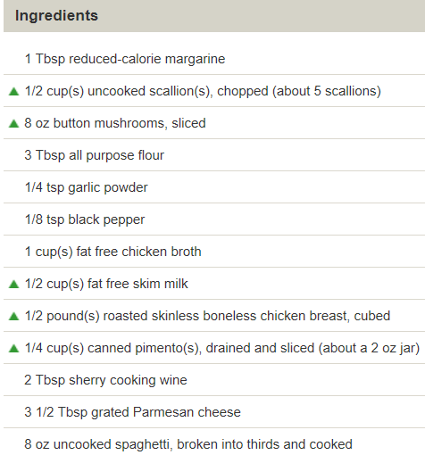

**Instructions**

1. Melt margarine in a large saucepan over medium-high heat.
   * Add scallions and mushrooms
   * Cook until tender, stirring, about 5 minutes.
2. Combine flour, garlic powder, pepper, broth and milk in a small bowl.
   * Mix until well blended.
3. Add flour mixture to saucepan.
   * Cook until mixture boils and thickens, stirring constantly, about 10 minutes.
4. Add chicken, pimentos and sherry; cook until thoroughly heated, stirring occasionally, about 2 minutes.
   * Stir in cheese and add cooked spaghetti; toss gently.

Yields about 1 cup per serving.

**Slow Cooker Red Bean, Sausage and Rice Soup**

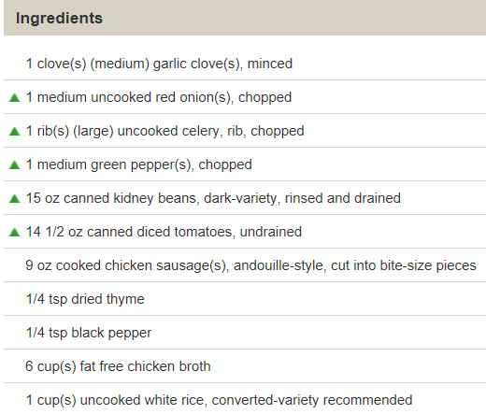

**Instructions**

1. Place garlic, onion, celery, bell pepper, beans, tomatoes with their juices and sausage in a 5-quart slow cooker.
2. Add thyme and pepper; stir well.
3. Pour in broth and rice; stir again.
4. Cover slow cooker and set on high power; cook for 4 hours.

Yields about 1 1/2 cups per serving.

NOTE: We recommend converted rice because regular long-grain rice can become mushy in slow cooker recipes.

* To turn up the heat, add 1/8 teaspoon of cayenne pepper with the thyme.
* Season to taste with salt and pepper

**Hamburger-Noodle Bake**

**Ingredients**

* 12 oz uncooked no-yolk egg noodles
* 2 medium uncooked red onion(s), chopped
* 1 small green pepper(s), yellow pepper or green pepper, chopped
* 1 1/2 pound(s) uncooked 95% lean ground beef
* 29 oz canned diced tomatoes
* 1/3 cup(s) parsley, flat-leaf, chopped
* 1/4 tsp black pepper
* 1 1/2 cup(s) low-fat shredded Cheddar cheese
* 3 3/4 oz Nabisco Ritz Reduced-fat crackers, about 35 crackers

**Directions**

1. Cook the noodles according to the package directions, omitting the salt if desired.

Meanwhile:

1. Preheat the oven to 350ºF.
2. Spray a 9x13-inch baking dish with nonstick spray.
3. Spray a large nonstick skillet with nonstick spray and set over medium-high heat.
   * Add the red onion and bell pepper; cook, stirring occasionally, until softened, about 5 minutes.
4. Combine the beef mixture, noodles, tomatoes, parsley, and pepper in the baking dish.
   * Stir in the ¾ cup of the cheese.
5. Sprinkle the top with the remaining ¾ cup of cheese and the crackers.
6. Spray the topping with nonstick spray.
7. Bake until hot and the cheese is melted, about 45 minutes.

**Chicken with Broccoli and Garlic Sauce**

**Ingredients**

2 tsp olive oil

1 pound(s) uncooked boneless, skinless chicken breast, cut into 1-inch pieces

1 tsp dried thyme, or 2 tbsp fresh minced thyme, or to taste

1/2 tsp table salt

1/4 tsp black pepper

3 medium garlic clove(s), minced, or more to taste

2 cup(s) broccoli, florets

1 1/2 cup(s) reduced-sodium chicken broth, divided

1 1/2 tbsp cornstarch

2 cup(s) cooked brown rice, kept hot

**Instructions**

Heat oil in a large skillet over medium-high heat. Place chicken on a plate and season with thyme, salt and pepper. Add garlic to skillet and cook, stirring, 1 minute. Add chicken to skillet and cook until browned on all sides, stirring frequently, about 3 minutes.

Add broccoli to skillet, cover and cook 2 minutes. Add 1 cup of broth, cover and simmer until chicken is cooked through, about 5 minutes.

In a cup, dissolve cornstarch in remaining 1/2 cup of broth; add to skillet. Simmer until mixture thickens, stirring constantly, about 1 minute; serve over rice. Yields about 1 cup of chicken and broccoli and 1/2 cup of rice per serving.

**Greek-Style Slow Cooker Meatballs and Artichokes**

**Ingredients**

1 spray(s) cooking spray

1 pound(s) uncooked ground turkey breast

1/2 tsp table salt, or more to taste

1/4 tsp ground sage, or more to taste

8 small uncooked new potato(es), scrubbed, unpeeled

9 oz frozen artichokes, hearts

1/2 tsp dried oregano, crushed

1/4 tsp black pepper

1 cup(s) canned chicken broth

1 Tbsp cornstarch

1 Tbsp fresh lemon juice

**Instructions**

Coat a 12-inch nonstick skillet with cooking spray.

Season turkey with salt and sage; shape into 1-inch balls. Add turkey to skillet and brown on all sides, about 3 to 5 minutes; remove and place in 4- to 5-quart slow cooker.

Add potatoes, frozen artichoke hearts, oregano, pepper and broth; cover and cook on high heat for 5 to 6 hours. (Note: When layering the ingredients in your slow cooker, arrange the artichoke hearts near the top so they don’t overcook. Do not thaw the artichokes first. Or, add the artichokes toward the end of the cooking process if you prefer a firmer texture.)

About 15 minutes before serving, spoon cornstarch into a cup. Add 1 tablespoon of the slow cooker liquid and lemon juice; stir well. Stir into slow cooker, cover and cook on low heat for 15 minutes more. Yields about 1 2/3 cups per serving.

**Seasoned Pork Tenderloin**

**Ingredients**

1/2 cup(s) reduced-calorie pancake syrup

1 tsp dry mustard

1 tsp ground cloves

1 tsp ground ginger

1 tsp table salt

1/2 tsp ground cinnamon

1/2 tsp black pepper, freshly ground

2 1/2 pound(s) uncooked lean pork tenderloin, use two 1 1/4-pound pieces

**Instructions**

In a large zip-close plastic bag, combine syrup, dry mustard, cloves, ginger, salt, cinnamon and pepper. Trim pork of all visible fat and cut each tenderloin in half widthwise. Add tenderloins to plastic bag, squeeze out air and seal bag; turn to coat tenderloins. Place bag on a plate and refrigerate on bottom shelf, turning bag occasionally, at least 2 hours or overnight.

Preheat broiler. Place tenderloins in a roasting pan and pour marinade over them. Broil 5 inches from heat until pork reaches an internal temperature of 160°F, about 6 minutes per side. Let stand at room temperature for 5 minutes before slicing. Yields about 4 ounces pork per serving.

**Grilled Fish with Tomato-Avocado Salsa**

**Ingredients**

3 1/2 cup(s) grape tomatoes, halved

1 item(s) (medium) avocado, diced

2 Tbsp basil, chopped

1 tsp fresh lime juice

1/2 tsp garlic clove(s), minced

1/2 tsp olive oil

1/8 tsp table salt

1/8 tsp black pepper, freshly ground

1/2 tsp table salt

1/4 tsp black pepper, freshly ground

1 1/2 pound(s) uncooked halibut fillet(s), four 6-oz pieces

1 spray(s) cooking spray

1 medium fresh lime(s), cut in wedges

**Instructions**

Prepare grill.

Combine tomato and next 7 ingredients in a bowl; set aside.

Sprinkle 1⁄2 teaspoon salt and 1⁄4 teaspoon pepper over fish. Coat fish with cooking spray.

Place fish on grill rack coated with cooking spray; grill 4 minutes on each side or until fish flakes easily when tested with a fork.

Arrange fish on serving plates; squeeze lime wedges over fish. Spoon salsa over fish. Yield: 4 servings (serving size: 1 fillet and about 1⁄4 cup salsa).

Note: Fish may be cooked on a preheated grill pan over medium-high heat, if desired.

**Herbed Pesto Chicken**

**Ingredients**

1/2 cup(s) cilantro

1/2 cup(s) fresh parsley

1 Tbsp fresh lemon juice

1 tsp olive oil

1 Tbsp mineral water

1 tsp Dijon mustard

1/2 tsp table salt

1/8 tsp black pepper

1 1/4 pound(s) uncooked boneless skinless chicken breast(s), four 5-oz pieces

3 1/2 cup(s) cooked linguini

**Instructions**

Preheat oven to 350ºF.

In a food processor, process all sauce ingredients until well-blended.

Coat each chicken breast generously with sauce and place on a baking pan lined with aluminum foil. Bake until chicken is no longer pink in center, 20 minutes.

**Herbed Pork Loin Roast**

**Ingredients**

3 Tbsp fresh sage, chopped

2 Tbsp fresh parsley, chopped

2 Tbsp fresh oregano, chopped

1 1/2 Tbsp chives, minced

1/2 tsp table salt

1/2 tsp black pepper, freshly ground

1 1/2 pound(s) uncooked lean only pork loin, boneless roast, trimmed

1/2 tsp olive oil

1 spray(s) cooking spray

**Instructions**

Preheat oven to 375°F.

Combine first 6 ingredients in a small bowl.

Rub pork roast with oil. Rub herb mixture over oil.

Place pork roast on a broiler pan coated with cooking spray. Insert meat thermometer into thickest part of roast. Bake at 375°F for 1 hour and 5 minutes or until thermometer registers 160°. Let stand 10 minutes before slicing. Yield: 5 servings (serving size: about 3 ounces).

Slow Cooker Pulled Pork

**Ingredients**

1 (2 pound)pork tenderloin

1 (12 fluid ounce) can or bottleroot beer

1 (18 ounce) bottleyour favorite barbecue sauce

8hamburger buns, split and lightly toasted

**Instructions**

Place the pork tenderloin in a slow cooker; pour the root beer over the meat. Cover and cook on low until well cooked and the pork shreds easily, 6 to 7 hours. Note: the actual length of time may vary according to individual slow cooker. Drain well. Stir in barbecue sauce. Serve over hamburger buns.

**Amazing Pork Tenderloin in the Slow Cooker**

**Ingredients**

1 (2 pound)pork tenderloin

1 (1 ounce) envelopedry onion soup mix

1 cupwater

3/4 cupred wine

3 tablespoonsminced garlic

3 tablespoonssoy sauce

freshly ground black pepper to taste

**Directions**

Place pork tenderloin in a slow cooker with the contents of the soup packet. Pour water, wine, and soy sauce over the top, turning the pork to coat. Carefully spread garlic over the pork, leaving as much on top of the roast during cooking as possible. Sprinkle with pepper, cover, and cook on low setting for 4 hours. Serve with cooking liquid on the side as au jus.

**Tangy Slow Cooker Pork Roast**

**Ingredients**

1 largeonion, sliced

2 1/2 poundsboneless pork loin roast

1 cuphot water

1/4 cupwhite sugar

3 tablespoonsred wine vinegar

2 tablespoonssoy sauce

1 tablespoonketchup

1/2 teaspoonblack pepper

1/2 teaspoonsalt

1/4 teaspoongarlic powder

1 dashhot pepper sauce, or to taste

**Directions**

- Arrange onion slices evenly over the bottom of the slow cooker, and then place the roast on top of the onion. In a bowl, mix together water, sugar, vinegar, soy sauce, ketchup, black pepper, salt, garlic powder, and hot sauce; pour over roast.

- Cover, and cook on Low for 6 to 8 hours, or on High for 3 to 4 hours.

**Balsamic Roasted Pork Loin**

**Ingredients**

2 tablespoonssteak seasoning rub

1/2 cupbalsamic vinegar

1/2 cupolive oil

2 poundsboneless pork loin roast

**Directions**

1. Dissolve steak seasoning in balsamic vinegar, then stir in olive oil. Place pork into a resealable plastic bag and pour marinade overtop. Squeeze out air and seal bag; marinate 2 hours to overnight.

2. Preheat oven to 350 degrees F (175 degrees C).

3. Place pork into a glass baking dish along with marinade. Bake in preheated oven, basting occasionally until the pork reaches an internal temperature of 145 degrees F (65 degrees C), about 1 hour. Let the roast rest for 10 minutes before slicing and serving.

**Autumn Pork Chop Dinner Recipe**

**Ingredients**

2 loin pork chops (1 inch thick)

1 tablespoon canola oil

2 cups shredded cabbage

2 tablespoons brown sugar

1 tablespoon minced fresh parsley

2 medium potatoes, peeled and sliced 1/4 inch thick

1 cup cut fresh or frozen cut green beans

1 to 1-1/2 teaspoons lemon-pepper seasoning

3/4 cup apple juice

1/4 cup seasoned bread crumbs

1 tablespoon butter, melted

**Directions**

1. In a large skillet, brown chops in oil on both sides; remove and set aside. Toss cabbage with brown sugar and parsley; place in an 11-in. x 7-in. baking dish. Top with potatoes and beans. Arrange chops over vegetables. Sprinkle with lemon-pepper. Pour apple juice over all.

2. Cover and bake at 350° for 45 minutes or until the pork chops and vegetables are tender. Combine the bread crumbs and butter; sprinkle on top. Bake for 15 minutes longer.Yield: 2 servings.

**Baked Pork Chops with Hot and Spicy Seasoning Recipe**

**Ingredients**

1 teaspoon cayenne pepper

1 teaspoon chili powder

1 teaspoon dried oregano

1 teaspoon salt

1/2 teaspoon garlic powder

1/2 teaspoon pepper

1/4 teaspoon ground mustard

1/4 teaspoon paprika

4 to 6 bone-in pork loin chops (1 inch thick)

1 Eggland's Best Egg

1/2 cup milk

3/4 cup cornflakes, crushed

1/2 cup grated Parmesan cheese

1/3 cup dry bread crumbs

**Directions**

1. In a small bowl, combine the first eight ingredients; rub over both sides of pork chops. Cover and refrigerate 1-4 hours.

2. Place a baking sheet in a 375° oven for 15 minutes. Meanwhile, in a shallow dish, beat egg and milk. In another shallow dish, combine cornflake crumbs, cheese and bread crumbs. Dip pork into the egg mixture, then into the crumb mixture.

3. Remove the baking sheet from the oven and coat with cooking spray. Place chops on the sheet; bake for 15 minutes. Turn and bake for 10 additional minutes or until meat is no longer pink.Yield: 4-6 servings.

**Braised Herb Pork Chops Recipe**

**Ingredients**

1/4 cup dried parsley flakes

2 teaspoons paprika

1 teaspoon rubbed sage

1 teaspoon dried thyme

1 teaspoon ground mustard

1 teaspoon pepper

1/2 teaspoon salt

1/2 teaspoon dried oregano

7 bone-in pork loin chops (1/2 inch thick)

2 tablespoons vegetable oil

2 cups thinly sliced onions

4 large garlic cloves, sliced

5 medium carrots, cut into 2-inch pieces

2 cups chicken broth

Hot mashed potatoes

**Directions**

1. Combine the first eight ingredients; rub over both sides of pork chops. In a Dutch oven, brown chops in oil for 2-3 minutes on each side. Remove and set aside. In the same pan, saute onions and garlic for 2 minutes. Add carrots and broth. Bring to a boil; reduce heat.

2. Return chops to pan. Cover and bake at 325° for 1-1/2 to 2 hours or until meat and vegetables are tender. Thicken pan juices for gravy if desired. Serve with potatoes.Yield: 7 servings.

**Chicken Tortilla Soup**

**Ingredients**

1 ½ tsp Cumin

1 tsp Chili powder

½ tspGarlic powder

½ Salt

(Or just use Taco Seasoning packet)

2-4 boneless skinless chicken breasts

1 Tbsp Olive oil

1 cup Onion

3 cloves Garlic

¼ cup Green bell pepper

¼ cup Red bell pepper

¼ cup Yellow bell pepper

1 can Rotel tomatoes (or Diced tomatoes)

32 oz Chicken broth

2-3 Tbsp Tomato paste

4 cups hot water

2 can Black beans (drained)

Cornmeal (for thickening) mixed with a little lukewarm water.

Corn tortillas, cut in strips

TOPPINGS:

1 Red onion

1 Avacado

Sour cream

Monterey jack cheese, grated

Cilantro

**Directions**

1. Mix the seasonings (cumin, chili powder, garlic powder and salt)
2. Drizzle uncooked chicken breasts with olive oil.
3. Sprinkle seasonings on the chicken. (Save some for later).
4. Cook chicken in over at 375 deg for 20-25 minutes, or until chicken is done.
5. Shred the cooked chicken with two forks.
6. Set chicken aside.
7. Dice veggies (onion, garlic, and peppers)
8. Saute veggies in olive oil.
9. After a few minutes, add remaining seasoning mixture. Finish cooking.
10. Add shredded chicken and stir.

IN A SOUP POT:

1. Pour in Rotel (or diced tomatoes).
2. Add chicken broth.
3. Add tomato paste.
4. Add water.
5. Add black beans.
6. Add veggies.
7. Bring soup to a boil.
8. Reduce heat and simmer for about 30 minutes, uncovered.
9. Sprinkle cornmeal mixture into soup and stir.
10. Cook for another 30 minutes.
11. Dice red onion and avocado.
12. Taste soup and season more if necessary.
13. Just before serving, thrown in tortilla strips and stir.

**Roasted Chicken Wings With Buffalo Sauce**

Yield: 4 to 5 servings (20 pieces)

Time: 1¼ to 1½ hours, mostly unattended

Oil for greasing the oven rack

10 chicken wings

Salt and black pepper

¼ cup (½ stick) butter

2 tablespoons Frank’s Red Hot Original Cayenne Pepper Sauce or other hot sauce

1 tablespoon white vinegar

1. Heat the oven to 450°F. Lay a sheet of aluminum foil on the lowest rack of the oven. Remove the middle oven rack and grease it with oil.

2. Cut off the small tip of each wing; discard or keep for stock. Cut through each wing bone at the joint to separate it into two pieces. Season the wings with salt and pepper.

3. Arrange the wings on a microwave-safe plate. Microwave on high for 3 minutes. Turn the wings over and microwave on high for another 2 minutes.

4. Arrange the wings on the greased oven rack so that they aren’t touching. Return the rack to the middle of the oven—making sure there’s foil beneath all the wings to catch their fat—and lower the temperature to 350° F.

5. Roast the wings for 40 minutes. Turn them over, then roast for another 20 minutes. At this point, they will be golden, crispy, and still juicy inside. If that’s how you like them, remove them from the oven. If you like them well done, roast for another 15 to 20 minutes.

6. Put the butter in a small saucepan over medium-low heat. When it melts, stir in the hot sauce and vinegar. Serve the wings with the Buffalo sauce on the side.

**Guacamole**

Yield: 4 servings

Time: 15 minutes

INGREDIENTS:

¾ cup diced fresh tomatoes or drained canned diced tomatoes (Muir Glen Organic is a good brand for this)

½ cup roughly chopped cilantro leaves

2 small shallots, very finely chopped

1 or 2 fresh jalapeños, seeded and very finely chopped

1 large garlic clove, minced or pressed

4 ripe avocados

3 tablespoons freshly squeezed lime juice

Salt and black pepper

DIRECTIONS:

Combine the tomatoes, cilantro, shallots, jalapeños, and garlic in a medium bowl. Halve the avocados lengthwise, scoop out the insides (working around the pit), and add them to the bowl. Drizzle the lime juice over everything and mash with a fork until the ingredients are blended but the avocado is still slightly chunky. Add salt and pepper to taste, but don’t overdo it. Serve immediately with your favorite sturdy tortilla chips.

**Cheesy Yellow Squash Casserole**

Recipe from George Stella’s REAL FOOD REAL EASY cookbook

Prep Time 15 min/ Cook Time 45 min/ Serves 6

Ingredients

* Nonstick cooking spray
* 1 ½ pounds yellow squash, thinly sliced into discs
* Salt and pepper
* ¼ cup diced yellow onion
* ¼ cup diced red bell pepper
* 8 ounces reduced fat cream cheese
* ½ cup shredded sharp Cheddar cheese

1. Preheat the oven to 375 degrees. Spray a 2 quart baking dish with nonstick cooking spray.

2. Layer the bottom of the baking dish with half of the yellow squash slices and lightly sprinkle with salt and pepper. Top with 1⁄2 of the onions, 1⁄2 of the red bell pepper, dollops of 1⁄2 of the cream cheese, and then 1⁄2 of the Cheddar cheese over top.

3. Repeat the process of step 2 all over again, creating a second layer of yellow squash and then the other ingredients, ending with the remaining Cheddar cheese on top.

4. Bake for 40-45 minutes or until the top is beginning to brown and squash is fork tender. Let rest 5 minutes before serving.

George’s Tips | Cut down on the cooking time by lightly boiling, steaming, or sautéing the yellow squash before baking until nearly tender. Simply bake until cheese is melted.

Variation | You can also make this with the strands of one cooked spaghetti squash in place of the yellow squash

**Cauliflower Tortillas**

Yields: 3 servings | Serving Size: 2 tortillas|Calories: 54| Previous Points: 1| Points Plus: 1| Total Fat: 3 g | Saturated Fat: 1 g | Trans Fat: 0 g | Cholesterol: 109 mg | Sodium: 211 mg | Carbohydrates: 3 g | Dietary Fiber: 1 g | Sugars: 1 g | Protein: 5 g |

Ingredients

* 1/2 head cauliflower, roughly chopped
* 2 eggs
* 1 tablespoon green onions, chopped
* 1/4 teaspoon sea salt

1. Preheat oven to 400 degrees F.

1. Put the cauliflower in a food processor and pulse until you have a fine grain, but not liquified (it should look similar to couscous.)
   1. Measure out approximately 2 cups of cauliflower and transfer to a microwave safe bowl.
   2. Cook for about 1 minute, remove and stir.
   3. Cook for 2 minutes.
   4. Let the cauliflower cool slightly.

1. When cool, line a fine mesh strainer with cheesecloth and put the strainer over a bowl.
   1. Using a spoon or spatula, press as much of the water as you can out of the cauliflower.
2. Transfer to a large bowl.
   1. Mix in the eggs, green onions, and salt.
   2. Mix well until you have a batter.

1. Line a baking sheet with parchment paper.
   1. Spread the batter into 6 circles, spreading as thin as possible.
2. Bake for 8 minutes.
   1. Flip and bake for 8 more.
3. Before serving, you can heat gently in a nonstick skillet to warm and soften if necessary.

**Spaghetti Squash**

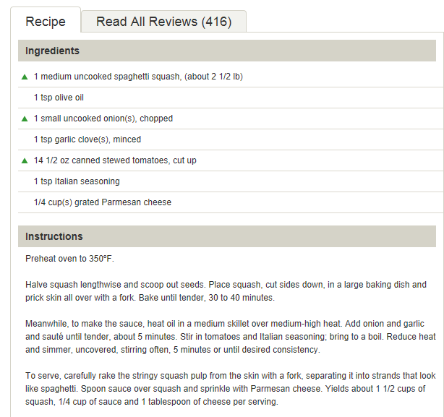

**Cornbread dressing** (<https://www.delish.com/cooking/recipe-ideas/a24570573/cornbread-dressing-recipe/>)

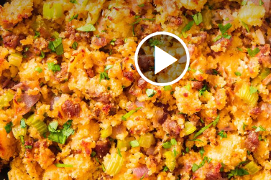

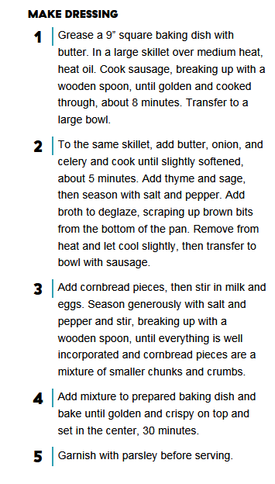

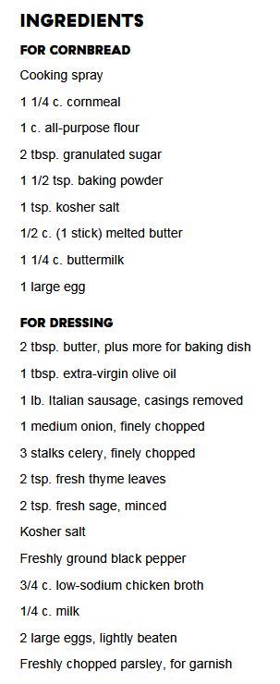

Grandma's Corn Bread Dressing

<https://www.allrecipes.com/recipe/19547/grandmas-corn-bread-dressing/>

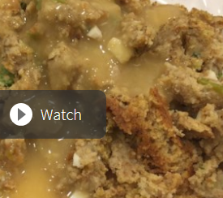

1 h 15 m servings 363 cals Prep: 45 m Cook: 30 m

**Ingredients**

+1 (16 ounce) package dry corn bread mix

+2 tablespoons butter

+1/2 cup chopped celery

+1 small onion

+2 eggs, beaten

+2 cups chicken stock

+2 tablespoons dried sage

+salt and pepper to taste

**Directions**

1. Prepare the dry corn bread mix according to package directions. Cool and crumble.
2. Preheat oven to 350 degrees F (175 degrees C). Grease one 9x13 inch baking dish.
3. In a large skillet over medium heat, melt the butter and saute the celery and onion until soft.
4. In a large bowl, combine the celery, onions, 3 cups crumbled corn bread, eggs, chicken stock, sage and salt and pepper to taste; mix well.
5. Place into prepared dish and bake at 350 degrees F (175 degrees C) for 30 minutes.

**Nutrition** **Facts**

Per Serving: 363 calories; 13 g fat; 52.8 g carbohydrates; 8.8 g protein; 76 mg cholesterol; 1582 mg sodium. Full nutrition

Southern Cornbread Dressing

<https://spicysouthernkitchen.com/southern-cornbread-dressing/>

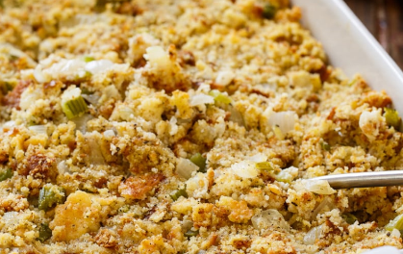

Prep Time: 30 mins Cook Time: 30 mins Total Time: 1 hr

Servings: [8](https://spicysouthernkitchen.com/southern-cornbread-dressing/) servings Calories: 314 kcal Author: Christin Mahrlig

**Ingredients**

Cornbread

* 1 cup self-rising cornmeal, I use Martha White
* 1/2 cup [self-rising flour,](http://amzn.to/2n7sXO2) I use White Lily
* 3/4 cup buttermilk
* 2 eggs
* 2 tablespoons Vegetable oil
* Or use packaged cornbread

Dressing

* 8 tablespoons butter (1 stick)
* 3 medium onion, chopped
* 4 stalks celery, chopped
* 1 1/2 teaspoons dried sage
* 1 teaspoon poultry seasoning
* 3/4 teaspoon salt
* 1/2 teaspoon pepper
* 3 pieces toast, crumbled
* 1/2 cup milk
* 3 eggs, lightly beaten
* 2 to 2 1/2 cups chicken stock or broth
* 2 tablespoons butter

**Instructions**

1. Preheat oven to 400 degrees.
2. In a medium bowl, stir together all ingredients for cornbread. Pour into a lightly greased 9-inch cast iron pan or a 9-inch baking pan. Bake for 20 to 25 minutes. Before using, crumble into small pieces.
3. Heat butter over medium heat in a large pan. Add celery and onion and cook until soft.
4. Add sage, poultry seasoning, salt, and pepper to onion mixture.
5. In a large bowl combine crumbled cornbread and toast.
6. Whisk together milk and eggs and add to bowl. Stir in 2 cups of chicken broth.
7. Stir in onion mixture. Mixture should be very moist. Add more broth if necessary.
8. Transfer to a greased baking dish. Cut butter into small slivers and scatter on top of dressing.
9. Bake at 350 degrees for 30 minutes, or until it turns light brown on top.

Note: The cornbread should be made a day or two in advance.

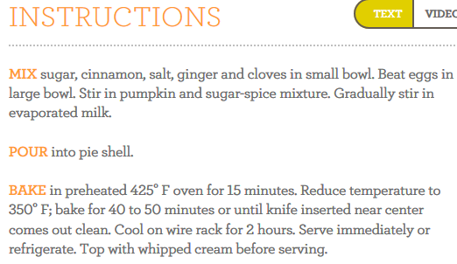Libby’s Pumpkin Pie

