Penalized for Faith: What Drives the Muslim Penalty?
  - Treatment-Effect Heterogeneity in European Conjoint Behavioral Games
Tristan Muno
Vera Okisheva
Raphael Klöckner
October 19, 2026
Abstract
Conjoint experiments across Europe consistently reveal a Muslim penalty: profiles displayed as Muslim receive systematically fewer resources than otherwise comparable profiles. We move beyond this average and ask what drives the penalty. Reanalyzing dictator and trust games embedded in a conjoint experiment across 25 European countries, we treat the Muslim attribute as a binary treatment and estimate conditional average treatment effects with Causal Forests. The penalty is negative in essentially every subgroup we examine. Other attributes of the displayed profile moderate it only weakly. In contrast, respondent characteristics matter more. Evaluations of the European Union form the strongest and most coherent gradient, yet even the most pro-European respondents retain a clear penalty. Anti-Muslim bias in Europe emerges as politically structured rather than idiosyncratic, attenuated but nowhere undone.

1 Introduction
Experimental research has documented a robust Muslim penalty across European societies (Helbling 2012). Individuals identified as Muslim receive less help in everyday encounters (Choi et al. 2023), are less welcome as labor migrants and refugees (Helbling et al. 2022), and elicit weaker opposition to their persecution abroad (Findor et al. 2025). Yet establishing the existence of this penalty, that is the systematic disadvantage incurred by individuals identified as Muslim, is only the starting point for a substantive understanding of the phenomenon. The more demanding questions concern who discriminates, against whom, and under which conditions.
Against this background, this paper revisits a large-scale conjoint survey experiment conducted across 25 European Union member states by Hahm et al. (2024). Using a combination of dictator and trust games alongside a conjoint design, they estimate the relative strength of multiple social divides. Their main finding is the dominance of the partisan divide, but religion emerges as the second strongest divide in their analysis. Whenever Muslim identity is experimentally signaled, respondents’ allocation decisions reveal a systematic penalty relative to otherwise comparable non-Muslim profiles (Table 1). What these averages do not reveal is whether and how the magnitude of the penalty varies with the other attributes attached to Muslim profiles, with the characteristics and political orientations of respondents, or with the interaction between the two.
This paper takes that heterogeneity as its central object of inquiry. Treating the Muslim penalty as the primary quantity of interest, it shifts from the average effects conventionally reported in conjoint analyses toward a conditional average treatment effect logic and distinguishes two sources of variation (Robinson and Duch 2024). The first concerns whether the remaining attributes of the displayed Muslim profile, such as class, nationality, or EU stance, moderate the magnitude of the penalty. The second, and substantively more consequential, concerns whether individual-level characteristics of respondents, in particular their populist predispositions and their orientations toward European integration, account for who discriminates more strongly. The literature gives strong reasons to expect that the penalty is conditional rather than uniform. Hostility toward Muslims is driven less by nominal religious affiliation than by perceived religiosity (Helbling and Traunmüller 2020; Helbling et al. 2022). Discriminatory behavior responds to signals about a Muslim target’s values and differs with the discriminator’s own gender and ideology (Choi et al. 2023). And anti-Muslim bias in policy attitudes appears only among respondents holding negative or neutral prior views of Muslims, varying more with individual attitudes than with country context (Findor et al. 2025). What is missing is a systematic account of this variation within a single behavioral design.
We reanalyze roughly 84,600 allocation decisions per game with Causal Forests (CF), treating the Muslim attribute as a binary treatment and recovering conditional effects across pre-specified profile-level and respondent-level moderators. A hierarchical Bayesian Causal Forest (BCF) serves as a robustness check. Three findings stand out. First, the penalty is negative in essentially every subgroup we examine. Second, the other profile attributes moderate it only weakly, with displayed partisanship the main exception. Third, respondent characteristics matter more, and evaluations of the European Union form the strongest and most coherent gradient. Respondents hostile to the Union penalize Muslim profiles substantially more, yet even the most pro-European retain a clear penalty.
These results promote a more nuanced understanding of anti-Muslim discrimination in Europe. The variation in penalties tracks the cosmopolitan–populist divide that defines contemporary European politics, suggesting a bias that is less an isolated individual disposition than a politically structured phenomenon. Understanding the conditions that amplify this bias is crucial for grasping the mechanisms that sustain it and the potential avenues for its mitigation.
Table 1: Mean tokens allocated to a profile by the Muslim label, by game. The outcome is the number of tokens the respondent allocates to the displayed profile. Profiles labelled Muslim are contrasted against all other religions pooled. The first two columns show group means with 95% confidence intervals in brackets. The SATE column reports the sample average treatment effect of the Muslim label, estimated by a per-game Welch two-sample difference-in-means t-test, with its 95% confidence interval alongside. The test is intentionally simple and descriptive. Respondent clustering is left to the heterogeneity models.
Game | Muslim | Non-Muslim | SATE | 95% CI
Dictator game | 2.80 [2.77, 2.84] | 3.37 [3.36, 3.39] | -0.57 | [-0.61, -0.53]
Trust game | 2.81 [2.78, 2.84] | 3.45 [3.43, 3.47] | -0.64 | [-0.68, -0.60]

Source: Additional Figures & Tables

2 Research Design

2.1 Data and Experiment
Our analysis reuses the conjoint survey experiment of Hahm et al. (2024), an online study fielded across 25 European Union member states around the 2019 European Parliament elections. The experiment embeds a randomized conjoint within two behavioral games. In each task a respondent is endowed with ten tokens and decides how many to transfer to a fictional co-player whose profile is randomly generated. The Dictator game records this transfer directly, whereas the Trust game adds announced reciprocity, as the experimenter triples the transferred amount and the co-player may return a share. Each respondent completes three rounds of each game, for six decisions in total, with a fresh profile drawn for every round.
The co-player profile varies seven attributes: age, gender, social class, nationality, partisan affiliation, EU identity, and religion. Both the order in which the attributes appear and the level shown for each are randomized by design. Because some attribute combinations are implausible, Hahm et al. (2024) restrict which attributes are displayed through four conditions that vary whether EU identity and partisan affiliation appear and whether the co-player is a co-national. For our analysis, we collapse partisan affiliation into a display-aware indicator of whether party was shown, not shown but the co-player was still a co-national, or not applicable because no co-national was displayed. This lets us recover the average effect of merely displaying a partisan affiliation on the Muslim penalty rather than the effect of any particular party. The religion attribute, with the four levels Muslim, Catholic, Protestant, and non-religious, is shown across all four conditions, so the full set of game decisions can be used to estimate the Muslim penalty.
The design contains no condition in which religion is absent, so there is no pure no-religion control. We do not adopt non-religious as the baseline, because being non-religious is not obviously a neutral reference and may be read differently across contexts, for instance in the post-communist states of eastern Europe. Rather than tying estimates to a single reference category (see Leeper et al. 2020), and to simplify the causal language, we collapse religion into a binary treatment $T$, equal to 1 when the co-player is displayed as Muslim and 0 otherwise. This coding follows from our interest in the drivers of the Muslim penalty rather than in the full multidimensional conjoint.
After standard quality filtering on attention checks and completed games, the analysis sample comprises roughly 28,200 respondents across the 25 countries, yielding about 84,600 decisions per game. These data are inherently hierarchical: decisions (rounds) are nested within respondents, who are in turn nested within countries. We include every covariate measured before the games and exclude those recorded afterward, to avoid post-treatment and collider bias (Blackwell et al. 2025). The retained set ranges from demographics to attitudinal batteries on national and European attachment, populist, democratic, and technocratic dispositions, and evaluations of the European Union. We make two exceptions for stable demographics drawn from the post-game block, age at which education stopped and residence type, which the experiment cannot plausibly have altered. Table 4 in the appendix gives the full set with exact question wordings and scales.

2.2 Causal Estimand
The conventional estimand in conjoint experiments is the Average Marginal Component Effect (AMCE, for definition see Hainmueller et al. 2014). Because the AMCE is by definition an average, it conceals how different respondents respond to the same treatment, which is exactly what we are interested in. Following Robinson and Duch (2024), we therefore adopt the idea of nested causal quantities (see also Goplerud et al. 2025).
With the religion attribute collapsed as described above, our treatment variable is binary: $T_{ric}∈\{0,1\}$, where $T_{ric}=1$ if the profile is displayed as Muslim and 0 otherwise. This recasts the marginal contrast in standard treatment-effect notation and shifts attention to its conditional counterparts. We observe only the realized outcome (Holland 1986), which in potential outcomes notation (Splawa-Neyman 1990; Rubin 1974) is:
$$Y_{ric}^{g,\text{obs}}=T_{ric}⋅Y_{ric}^{g}(1)+(1−T_{ric})⋅Y_{ric}^{g}(0) (1)$$
Since both games reflect different types of discrimination, we estimate separate models for each game $g∈\{D,TR\}$, where $D$ denotes the Dictator game and $TR$ the Trust game. The population Average Treatment Effect (ATE), $E[Y_{ric}^{g}(1)−Y_{ric}^{g}(0)]$, captures the average Muslim penalty, where $Y_{ric}^{g}(t)$ is the number of tokens allocated by respondent $i$ in country $c$ during round $r$ of game $g$ under treatment assignment $t$. Since the religion attribute is randomly assigned by design, $\{Y_{ric}^{g}(1), Y_{ric}^{g}(0)\}⟂T_{ric}$. However, as the sample was recruited to be representative of national populations only in terms of age and gender (Hahm et al. 2024, 73), our baseline estimand is the more conservative Sample ATE (SATE), which conditions on the observed sample rather than making broader claims about the target population:
SATEg=1Ni​Er​Yricg(1)−Yricg(0) (2)
As we are interested in factors that explain the heterogeneity in the Muslim penalty, we decompose the SATE into its conditional counterpart, the Conditional Average Treatment Effect (CATE):
$$τ^{g}(X_{ic}, A_{ric})=E​\left[Y_{ric}^{g}(1)−Y_{ric}^{g}(0) | X_{ic}, A_{ric}\right] (3)$$
where $X_{ic}$ denotes time-invariant respondent-level covariates (demographic questions, several EU-related items, democratic, populist, and technocratic items, see Table 4 in the appendix for the full list), and $A_{ric}$ denotes the remaining profile attributes displayed in round $r$, namely gender, age, social class, party affiliation and nationality. Importantly, we do not treat these profile attributes as separate treatments as in the AMCE approach, but as potential moderators of the Muslim penalty.
This single CATE function captures two different sources of heterogeneity. First, we are interested in causal moderation, namely whether the size of the Muslim penalty differs across respondent-level characteristics, which are not randomized, so these gradients describe who penalizes more, not the effect of changing a moderator (Bansak 2021). Disaggregating to the individual level by averaging over rounds, we define the respondent-level CATE:
$$τ_{ic}^{g}=E_{r}​\left[τ^{g}(X_{ic}, A_{ric})\right]=E​\left[Y_{ric}^{g}(1)−Y_{ric}^{g}(0) | X_{ic}\right] (4)$$
Second, we are interested in causal interaction: whether other profile attributes change the Muslim penalty. Disaggregating to the profile level by averaging over respondents, we define the profile-level CATE:
$$τ_{ric}^{g}=E_{i}​\left[τ^{g}(X_{ic}, A_{ric})\right]=E​\left[Y_{ric}^{g}(1)−Y_{ric}^{g}(0) | A_{ric}\right] (5)$$
These quantities are linked through the law of iterated expectations, which ensures internal consistency across levels of the hierarchy: ${\text{SATE}}^{g}=E_{i}​\left[E_{r}[τ^{g}(X_{ic},A_{ric})]\right]=E_{i}[τ_{ic}^{g}]$.

2.3 Estimation Strategy
Estimating how a treatment effect varies across units is a different problem from predicting an outcome, and a harder one. The variation in the effect is usually far weaker than the variation in the outcome itself, so a method tuned to prediction spends most of its capacity on the prognostic structure and little on the effect (Imai and Ratkovic 2013; Ratkovic and Tingley 2017). The modern tools for this task are tree ensembles (Breiman 2001; Dorie et al. 2019), which learn flexible response surfaces without a pre-specified functional form, adapted to treatment effects along two routes that differ mainly in where they place their corrections. The first disciplines the ensemble with a prior: Bayesian Additive Regression Trees (BART) model the outcome as a regularized sum of trees (Chipman et al. 2006; Chipman et al. 2010) and were carried into causal inference by differencing predicted potential outcomes (Hill 2011; Hill et al. 2020; Carnegie et al. 2019). The second corrects the data instead: the CF learns the partition on one part of the sample and estimates the effects on another, yielding honest confidence intervals that are asymptotically valid (Wager and Athey 2018; Athey and Wager 2019; Jawadekar et al. 2023) and that share their sample-splitting logic with double machine learning (Chernozhukov et al. 2018; Ratkovic 2023). Generalized random forests extend this orthogonalized, sample-split estimation to a broad class of estimands (Athey et al. 2019) and have become a workhorse for heterogeneous-effect analysis in political science (Davis and Heller 2017; Zheng and Yin 2023). Comparing the two families, Ratkovic (2021) raises two concerns about the Bayesian, full-sample approach: it does not model the treatment as a function of the covariates, and it uses the same data to fit the model and to test the effects. The first concern bites mainly when assignment is not randomized, and under the known propensities of our conjoint it loses its force. The second survives randomization, since using the same data to discover an effect surface and to test it can leave the resulting intervals undercovering regardless of how treatment was assigned. The BCF answers the first concern by giving the treatment surface its own prior and regularization, guarding against the regularization-induced confounding that arises when a single prior shrinks both surfaces (Hahn et al. 2020; Caron et al. 2022b, 2022a). They have no analogue for the second: standard BCF, including the hierarchical variants we draw on, fits the trees and forms the posterior intervals on the full sample (Hahn et al. 2020; Thal et al. 2024). The CF’s sample splitting is exactly that missing device, addressing the concern our randomized design does not dissolve.
Our design follows from this comparison and from the structure of our data. We observe each respondent over three conjoint rounds, and respondents are grouped within 25 countries, so the observations are clustered at two levels. Treating them as independent would understate our uncertainty. The CF accommodates this structure directly and scales to the full sample. We cluster the sample splitting and the variance estimation by respondent, which absorbs the within-respondent dependence across rounds, and we enter country as fixed effects in the covariate matrix, which absorbs between-country baseline variation, though residual within-country dependence is not reflected in the variance estimates (Athey et al. 2019). We therefore adopt the CF as our primary estimator, since it delivers the honest, cluster-robust intervals the comparison above favors. We keep the BCF as a robustness check, fit with country random intercepts only. Because the BCF does not model the within-respondent dependence directly, we recover that uncertainty after the fact with a respondent cluster bootstrap. The two fits therefore do not handle the clustered structure identically, a caveat we return to in Section 3.3. Throughout, we treat the country and respondent variation as a nuisance to absorb rather than a quantity to interpret, in keeping with our interest in heterogeneity within the sample rather than comparison across countries.
Before turning to heterogeneity, we confirm that the CF recovers the average effect. The CF estimates a SATE of $−0.56$ (95% CI $[−0.60,−0.53]$) in the Dictator game and $−0.64$ (95% CI $[−0.68,−0.60]$) in the Trust game. Both reproduce the difference in means reported above (Table 1), a first sign that the CF behaves as it should. We then gauge that heterogeneity with the targeting operator characteristic curve (Figure 6, appendix), whose area lies well above zero in both games. Because the curve ranks observations by the forest’s own out-of-bag predictions, we read it as descriptive support for targetable variation rather than a formal test, motivating the moderator-by-moderator analysis that follows.
We present the results in the visual grammar of Green and Kern (2012), plotting the estimated conditional effect as a function of each moderator (Woody et al. 2021). Each panel shows the $\hat{τ}$ on the token scale within a level or bin of one moderator, taken over the distribution of the remaining covariates, so it describes how the Muslim penalty varies with that moderator rather than a partial effect with all else held fixed. For categorical moderators we plot the point estimate and an honest 95% confidence interval at each level, drawn as a shape and a line segment. For continuous moderators and rating scales we estimate the point and interval at each value, binning age and years of education into a pre-specified number of bins, and connect them into a line with a ribbon, letting the CF reveal any non-linear trend. Throughout, we orient every rating scale so that moving right along the x-axis denotes more agreement, a more positive evaluation, or more attachment, with full wordings and original codings in Table 4. We overlay the two games within a single panel by color, so that any divergence between them reads directly as a game-specific difference in heterogeneity, and because the games share respondents we read interval comparisons as descriptive rather than as formal tests.

3 Empirical Analysis

3.1 Results
Figure 1 asks whether the remaining profile attributes interact with the Muslim signal, the source of heterogeneity we termed causal interaction, with the Dictator game in blue and the Trust game in orange. Across these attributes the penalty is strikingly stable, since every level carries a sizeable, clearly negative effect and no accompanying feature comes close to neutralizing it. The clearest moderation is partisanship. Among co-nationals, displaying a party affiliation reduces the penalty substantially relative to withholding it, the single largest shift in the figure, and the attenuation holds in both games. Nationality moderates the penalty as well. Profiles displayed as EU nationals draw the largest penalty and co-nationals an intermediate one, while non-EU nationals draw the smallest but on noticeably wider intervals. The penalty thus appears deepest not for the most distant, non-EU profile but for the fellow EU national, a contrast the imprecise non-EU estimates leave only suggestive. Social class moves the penalty only at its upper end, where lower- and middle-class profiles are penalized indistinguishably but upper-class profiles somewhat less. The remaining attributes leave the penalty essentially untouched. Whether a profile identifies as an EU citizen or rejects that identity makes no difference, though in the Dictator game both attract a marginally smaller penalty than the condition in which EU identity is not displayed, a gap within sampling error that does not recur in the Trust game. Profile age produces only a minor, non-systematic dip at thirty, with intervals overlapping across the age range, and male and female profiles are penalized alike. As a general pattern the Trust-game point estimates sit slightly below their Dictator-game counterparts, but the two games rarely diverge in a way the intervals can distinguish.
Figure 1: CF estimates of the profile-level CATE (${\hat{τ}}_{ric}$) of the Muslim profile across the levels of every conjoint-round moderator (x-axis), Dictator and Trust games overlaid and distinguished jointly by colour, shape, and linetype. The y-axis is ${\hat{τ}}_{ric}$ on the token-allocation scale. Each point is a per-level doubly-robust subset estimate with an honest cluster-robust 95% confidence interval, estimated separately on that subset and clustered by respondent. Grey bars along the bottom of each facet show the per-level row count (pooled over games). The y-axis is free per facet. In the Profile partisanship facet, partisanship not shown refers to within the co-national category only, since partisanship is displayed for co-national profiles only.
_{Source: GRF Post-Processing}
Figure 2 and Figure 3 turn to causal moderation, the respondent-level characteristics that govern who penalizes more, the source the introduction flagged as substantively more consequential. These characteristics display more heterogeneity than the profile attributes above. Among the categorical respondent characteristics, the sharpest contrast is by gender, as men penalize Muslim profiles more than women in both games, though only in the Dictator game do the intervals separate. Respondents’ own religion orders the penalty as well, with Catholics and Protestants exhibiting the strongest bias and the Orthodox the weakest by their point estimates. Place of residence matters at the margin, rural respondents penalizing somewhat more than those in large cities and smaller towns falling in between, a gradient that is firmer in the Trust game. Subjective class is largely flat, its main features the wide intervals and smallest penalty of respondents who decline to place themselves and a slightly lower penalty among the working class than lower-middle and middle class respondents in the Dictator game. The upper middle class is the interesting exception, drawing the smallest penalty of any class in the Dictator game but the largest in the Trust game, the clearest between-game divergence in the figure.
The attitudinal scales reveal more structure. The strongest single gradient is attachment to the European Union, which is associated with an almost linear reduction in the penalty. Attachment to one’s own country runs the other way and appears to deepen the penalty, though few respondents populate the unattached end, leaving that pattern uncertain. Attachment to Europe as a whole is weaker, consistent with a faintly declining penalty in the Dictator game and a flat one in the Trust game, while perceived ability to understand EU politics shows no moderation at all. A second cluster concerns populist and democratic dispositions. Agreement that officials merely talk rather than act, and agreement that compromise amounts to selling out, are each associated with a larger penalty, the latter a clear monotonic gradient. The view that politics is a struggle between good and evil follows the same direction from mid-scale upward before flattening near the top. Valuing compromise, its mirror image, is associated with a marginally smaller penalty, although agreement is high throughout and few respondents populate the item’s low end. Respondent age closes the figure and hints at a U-shaped relationship. Among the youngest respondents the intervals brush the zero line repeatedly and the point estimates briefly cross it, the only place in the analysis where the penalty appears to vanish. The penalty then deepens through middle age and lifts again past sixty-five, though that upturn coincides with the thinning sample at older ages and may be an artifact of the wider intervals there.
Figure 3 continues with the remaining attitudinal scales, where the moderation is dominated by evaluations of the European Union. Across this battery the pattern is consistent, as respondents who judge the Union negatively penalize Muslim profiles more and those who judge it favorably less. More negative assessments of the EU’s effect on the national economy, culture and identity, and political status each accompany a larger penalty, as does agreement that the Union would be better abolished and that it should heed the people. Satisfaction with the EU and support for its pursuing long-term goals run the other way toward a smaller penalty, the latter flattening at the scale’s top. The technocratic and remaining populist items move the penalty far less. Leaving decisions to experts and elevating leaders above ordinary citizens are associated with at most a slight increase in the penalty as agreement rises, more visible in the Trust game, and agreement that parties do more harm than good nudges it upward similarly. Valuing the views of other groups behaves like the compromise item, edging the penalty down over the scale’s upper half. The weakest moderators are the claim that ordinary people do not know what is good for them and the age respondents left education, both leaving the penalty essentially flat.
Taken together, the respondent-level results describe substantial heterogeneity across subgroups and pre-treatment attitudes, but almost entirely in the magnitude of the Muslim penalty rather than in its presence. Where the penalty comes closest to disappearing, only the upper bound of the interval grazes zero, and no single moderator credibly nullifies it, let alone reverses it. The strongest and most coherent moderation runs through evaluations of European integration, where respondents hostile to the Union or skeptical of its effects penalize Muslim profiles systematically more than those who regard it favorably. Yet even on the pro-European side of these scales a robust penalty remains, attenuated rather than abolished. The variable-importance ranking in the appendix (Figure 7) corroborates this reading, placing EU-evaluation items in four of the five top positions, though split-frequency importance mechanically favors scales with many values.

3.2 Robustness
The BCF reproduces the substantive findings of the primary analysis. For the profile-level moderators the two estimators agree closely (Figure 8). The Muslim penalty remains uniformly negative across attribute levels, partisanship among co-nationals attenuates it most.
The respondent-level picture replicates as well (Figure 9 and Figure 10). The penalty is robust throughout, a modest gender gap persists but narrows in the Trust game, evaluations of European integration remain the strongest source of heterogeneity, and the same populist items track its magnitude. The continuous moderators trace smoother gradients under the BCF than under the CF, yet their direction and shape are unchanged.
Two differences deserve comment, and both plausibly share one source. The BCF intervals are narrower than the CF’s, most visibly at sparsely populated moderator levels. A respondent cluster bootstrap shows that within-person dependence across the three rounds accounts for almost none of this narrowness, which we therefore attribute to the absence of sample splitting and the aggressive pooling of the Bayesian prior rather than to greater precision.
Figure 2: CF estimates of the respondent-level CATE (${\hat{τ}}_{i}$) of the Muslim profile across the levels of the first half of the discrete individual-level moderators (top panel) and across age (q_age, bottom panel), Dictator and Trust games overlaid and distinguished jointly by colour, shape, and linetype. The y-axis is ${\hat{τ}}_{i}$ on the token-allocation scale. All item scales are oriented so that higher x-axis values mean more agreement, a more positive evaluation, or more attachment, depending on the item (see Table 4). Every point and ribbon value is a doubly-robust subset estimate with an honest cluster-robust 95% interval, computed separately on that subset and clustered by respondent. Top: ordered numeric scales are drawn as a connecting line and interval ribbon per game, categorical moderators as dodged points and intervals. Grey bars show the per-level row count (pooled over games). Bottom: per-grid-cell estimate, interval ribbon, and connecting line per game over a grey histogram of the covariate, on 100 equal intervals across the full 18–75 years. The y-axis is free per facet. Discrete levels comprising less than 1% of a game’s sample are dropped because their estimate is too imprecise to compare.
_{Source: GRF Post-Processing}
Figure 3: CF estimates of the respondent-level CATE (${\hat{τ}}_{i}$) of the Muslim profile across the levels of the second half of the discrete individual-level moderators (top panel) and across age at which education stopped (q_edu_age_stop, bottom panel), Dictator and Trust games overlaid and distinguished jointly by colour, shape, and linetype. The y-axis is ${\hat{τ}}_{i}$ on the token-allocation scale. All item scales are oriented so that higher x-axis values mean more agreement, a more positive evaluation, or more attachment, depending on the item (see Table 4). Every ribbon value is a doubly-robust subset estimate with an honest cluster-robust 95% interval, computed separately on that subset and clustered by respondent. Top: ordered numeric scales are drawn as a connecting line and interval ribbon per game. Grey bars show the per-level row count (pooled over games). Bottom: per-year estimate, interval ribbon, and connecting line per game at each integer year of education-stopping age from 15 to 30, over a grey histogram of the covariate. The y-axis is free per facet.
_{Source: GRF Post-Processing}
The narrower intervals also make the BCF appear to separate the two games more cleanly than the CF does, a distinction we treat with the same caution. The one genuine disagreement concerns respondent age. The U-shaped pattern recovered by the CF, in which the penalty approaches zero among the youngest and oldest respondents, does not appear under the BCF, whose age gradient neither touches zero at the young end nor lifts at the old end.

3.3 Limitations
Several limitations qualify our conclusions. First, our binary treatment pools every non-Muslim religion into a single comparison and reduces partisanship to an indicator of whether a party was displayed. This averages over heterogeneous comparison groups by design and cannot isolate which facet of the Muslim signal drives the penalty. Second, our analysis treats the Muslim attribute as the primary signal respondents respond to. Whether it actually dominates perception in the experimental setting is a question our data cannot answer.
Third, to guard against post-treatment and collider bias we condition only on pre-treatment covariates, with the two exceptions noted above. Our interpretations therefore hold with respect to this covariate set, which excludes theoretically relevant measures such as general left-right placement, EU integration preferences, and nativist attitudes. Incorporating these in a principled way, for instance through designs that bound the trade-off between post-treatment and priming bias (Blackwell et al. 2025), is a natural extension. Fourth, we examine the moderating role of each covariate one at a time and do not characterize interactions among moderators. The CF accommodates high-dimensional, non-linear interactions internally, and a fuller treatment of these higher-order patterns is left to future work.
Fifth, our robustness check is not a fully independent confirmation. The full nested fit was computationally infeasible, so the BCF drops the respondent random effect and recovers the corresponding uncertainty through a cluster bootstrap, and it carries no sample-splitting step. The CF and the BCF therefore do not handle the clustered structure under identical assumptions, and their agreement is reassuring without being two independent verifications.
Sixth, the sample was recruited to be representative of national populations only in age and gender, which is why we report a sample rather than a population quantity. Our estimates describe the realized sample, and extrapolation to the wider European population should be made with that restriction in mind. The data are also a single cross-section fielded in 2019. Our estimates capture the penalty at that moment, and whether its size or its political gradient has shifted in the years since is a question the design cannot address. Finally, the conjoint is by construction an artificial setting. It isolates the causal effect of individual attributes cleanly, but how these effects translate to less structured real-world encounters, where group membership is inferred rather than labeled, remains a separate question.

4 Conclusion
A large experimental literature documents that Europeans penalize Muslims. This paper has asked who drives that penalty. Reanalyzing behavioral games from a conjoint experiment across 25 European countries, we moved from the average penalty to its variation across profiles and respondents.
The answer has two parts. In its reach, the penalty is general. It persists across every profile attribute and every respondent subgroup we examine, and no moderator comes close to undoing it. In its intensity, the penalty is political. The attributes of the displayed profile move it only at the margin, with displayed partisanship the main exception. Who the respondent is matters more, and the strongest and most coherent gradient runs through evaluations of European integration. Respondents hostile to the European Union penalize Muslim profiles substantially more than those who view it favorably, with populist dispositions tracing the same direction more weakly.
These results suggest that anti-Muslim discrimination in Europe is entangled with the cosmopolitan–populist divide rather than an isolated individual disposition. That the penalty attenuates but nowhere disappears is the sobering counterpart: even the most pro-European respondents allocate fewer tokens to Muslim profiles. A natural next step is to characterize how these moderators interact, a task the CF performs internally but our one-at-a-time presentation does not yet exploit.

5 References
Athey, Susan, Julie Tibshirani, and Stefan Wager. 2019. “Generalized Random Forests.” The Annals of Statistics 47 (2): 1148–78. https://doi.org/10.1214/18-AOS1709.
Athey, Susan, and Stefan Wager. 2019. “Estimating Treatment Effects with Causal Forests: An Application.” Observational Studies 5 (2): 37–51. https://doi.org/10.1353/obs.2019.0001.
Bansak, Kirk. 2021. “Estimating Causal Moderation Effects with Randomized Treatments and Non-Randomized Moderators.” Journal of the Royal Statistical Society Series A: Statistics in Society 184 (1): 65–86. https://doi.org/10.1111/rssa.12614.
Blackwell, Matthew, Jacob R. Brown, Sophie Hill, Kosuke Imai, and Teppei Yamamoto. 2025. “Priming Bias Versus Post-Treatment Bias in Experimental Designs.” Political Analysis 33 (4): 361–77. https://doi.org/10.1017/pan.2025.3.
Breiman, Leo. 2001. “Random Forests.” Machine Learning 45 (1): 5–32. https://doi.org/10.1023/A:1010933404324.
Carnegie, Nicole, Vincent Dorie, and Jennifer L. Hill. 2019. “Examining Treatment Effect Heterogeneity Using BART.” Observational Studies 5 (2): 52–70. https://doi.org/10.1353/obs.2019.0002.
Caron, Alberto, Gianluca Baio, and Ioanna Manolopoulou. 2022a. “Estimating Individual Treatment Effects Using Non-Parametric Regression Models: A Review.” Journal of the Royal Statistical Society Series A: Statistics in Society 185 (3): 1115–49. https://doi.org/10.1111/rssa.12824.
Caron, Alberto, Gianluca Baio, and Ioanna Manolopoulou. 2022b. “Shrinkage Bayesian Causal Forests for Heterogeneous Treatment Effects Estimation.” Journal of Computational and Graphical Statistics 31 (4): 1202–14. https://doi.org/10.1080/10618600.2022.2067549.
Chernozhukov, Victor, Denis Chetverikov, Mert Demirer, et al. 2018. “Double/Debiased Machine Learning for Treatment and Structural Parameters.” The Econometrics Journal 21 (1): C1–68. https://doi.org/10.1111/ectj.12097.
Chipman, Hugh A., Edward I. George, and Robert E. McCulloch. 2010. “BART: Bayesian Additive Regression Trees.” The Annals of Applied Statistics 4 (1): 266–98. https://doi.org/10.1214/09-AOAS285.
Chipman, Hugh, Edward George, and Robert McCulloch. 2006. “Bayesian Ensemble Learning.” Advances in Neural Information Processing Systems 19.
Choi, Donghyun Danny, Mathias Poertner, and Nicholas Sambanis. 2023. “The Hijab Penalty: Feminist Backlash to Muslim Immigrants.” American Journal of Political Science 67 (2): 291–306. https://doi.org/10.1111/ajps.12627.
Davis, Jonathan M. V., and Sara B. Heller. 2017. “Using Causal Forests to Predict Treatment Heterogeneity: An Application to Summer Jobs.” American Economic Review 107 (5): 546–50. https://doi.org/10.1257/aer.p20171000.
Dorie, Vincent, Jennifer Hill, Marc Scott, and Dan Cervone. 2019. “Automated Versus Do-It-Yourself Methods for Causal Inference: Lessons Learned from a Data Analysis Competition.” Statistical Science 34 (1): 43–68. https://doi.org/10.1214/18-STS667.
Findor, Andrej, Roman Hlatky, Matej Hruška, and Kristı́na Kironská. 2025. “Anti-Muslim Bias in Foreign Policy Attitudes: Experimental Evidence from Thirteen European Countries.” British Journal of Political Science 55: e41. https://doi.org/10.1017/S0007123425000134.
Goplerud, Max, Kosuke Imai, and Nicole E Pashley. 2025. “Estimating Heterogeneous Causal Effects of High-Dimensional Treatments: Application to Conjoint Analysis.” The Annals of Applied Statistics 19 (2): 866–88. https://doi.org/10.1214/24-AOAS1994.
Green, Donald P., and Holger L. Kern. 2012. “Modeling Heterogeneous Treatment Effects in Survey Experiments with Bayesian Additive Regression Trees.” Public Opinion Quarterly 76 (3): 491–511. https://doi.org/10.1093/poq/nfs036.
Hahm, Hyeonho, David Hilpert, and Thomas König. 2024. “Divided We Unite: The Nature of Partyism and the Role of Coalition Partnership in Europe.” American Political Science Review 118 (1): 69–87. https://doi.org/10.1017/S0003055423000266.
Hahn, P. Richard, Jared S. Murray, and Carlos M. Carvalho. 2020. “Bayesian Regression Tree Models for Causal Inference: Regularization, Confounding, and Heterogeneous Effects (with Discussion).” Bayesian Analysis 15 (3): 965–1056. https://doi.org/10.1214/19-BA1195.
Hainmueller, Jens, Daniel J. Hopkins, and Teppei Yamamoto. 2014. “Causal Inference in Conjoint Analysis: Understanding Multidimensional Choices via Stated Preference Experiments.” Political Analysis 22 (1): 1–30. https://doi.org/10.1093/pan/mpt024.
Helbling, Marc, ed. 2012. Islamophobia in the West: Measuring and Explaining Individual Attitudes. 1st ed. Routledge. https://doi.org/10.4324/9780203841730.
Helbling, Marc, Felix Jäger, and Richard Traunmüller. 2022. “Muslim Bias or Fear of Fundamentalism? A Survey Experiment in Five Western European Democracies.” Research & Politics 9 (1): 20531680221088491. https://doi.org/10.1177/20531680221088491.
Helbling, Marc, and Richard Traunmüller. 2020. “What Is Islamophobia? Disentangling Citizens’ Feelings Toward Ethnicity, Religion and Religiosity Using a Survey Experiment.” British Journal of Political Science 50 (3): 811–28. https://doi.org/10.1017/S0007123418000054.
Hill, Jennifer L. 2011. “Bayesian Nonparametric Modeling for Causal Inference.” Journal of Computational and Graphical Statistics 20 (1): 217–40. https://doi.org/10.1198/jcgs.2010.08162.
Hill, Jennifer, Antonio Linero, and Jared Murray. 2020. “Bayesian Additive Regression Trees: A Review and Look Forward.” Annual Review of Statistics and Its Application 7 (1): 251–78. https://doi.org/10.1146/annurev-statistics-031219-041110.
Holland, Paul W. 1986. “Statistics and Causal Inference.” Journal of the American Statistical Association 81 (396): 945–60. https://doi.org/10.1080/01621459.1986.10478354.
Imai, Kosuke, and Marc Ratkovic. 2013. “Estimating Treatment Effect Heterogeneity in Randomized Program Evaluation.” The Annals of Applied Statistics, 443–70. https://doi.org/10.1214/12-AOAS593.
Jawadekar, Neal, Katrina Kezios, Michelle C. Odden, et al. 2023. “Practical Guide to Honest Causal Forests for Identifying Heterogeneous Treatment Effects.” American Journal of Epidemiology 192 (7): 1155–65. https://doi.org/10.1093/aje/kwad043.
Leeper, Thomas J., Sara B. Hobolt, and James Tilley. 2020. “Measuring Subgroup Preferences in Conjoint Experiments.” Political Analysis 28 (2): 207–21. https://doi.org/10.1017/pan.2019.30.
McJames, Nathan, Ann O’Shea, Yong Chen Goh, and Andrew Parnell. 2025. “Bayesian Causal Forests for Multivariate Outcomes: Application to Irish Data from an International Large Scale Education Assessment.” Journal of the Royal Statistical Society Series A: Statistics in Society 188 (2): 428–50. https://doi.org/10.1093/jrsssa/qnae049.
Murray, Jared S. 2021. Multibart: A Collection of BART Models. https://osf.io/3zmqc/.
Prevot, Emma, Dieter A Häring, Thomas E Nichols, Chris C Holmes, and Habib Ganjgahi. 2025. “A Hierarchical Modelling Approach for Bayesian Causal Forests on Longitudinal Data: A Case Study in Multiple Sclerosis Clinical Trials.” arXiv Preprint arXiv:2508.08418, ahead of print. https://doi.org/10.48550/arXiv.2508.08418.
Ratkovic, Marc. 2021. “Subgroup Analysis: Pitfalls, Promise, and Honesty.” In Advances in Experimental Political Science, edited by James N. Druckman and Donald P. Green. Cambridge University Press Cambridge. https://doi.org/10.1017/9781108777919.020.
Ratkovic, Marc. 2023. “Relaxing Assumptions, Improving Inference: Integrating Machine Learning and the Linear Regression.” American Political Science Review 117 (3): 1053–69. https://doi.org/10.1017/S0003055422001022.
Ratkovic, Marc, and Dustin Tingley. 2017. “Sparse Estimation and Uncertainty with Application to Subgroup Analysis.” Political Analysis 25 (1): 1–40. https://doi.org/10.1017/pan.2016.14 .
Robinson, Thomas S., and Raymond M. Duch. 2024. “How to Detect Heterogeneity in Conjoint Experiments.” The Journal of Politics 86 (2): 412–27. https://doi.org/10.1086/727597.
Rubin, Donald B. 1974. “Estimating Causal Effects of Treatments in Randomized and Nonrandomized Studies.” Journal of Educational Psychology 66 (5): 688. https://doi.org/10.1037/h0037350.
Splawa-Neyman, Jerzy. 1990. “On the Application of Probability Theory to Agricultural Experiments. Essay on Principles. Section 9.” Statistical Science 5 (4): 465–72. https://doi.org/10.1214/ss/1177012031.
Thal, Dan RC, Lauren V Forrow, Erin R Lipman, Jennifer E Starling, and Mariel M Finucane. 2024. “Aggregate Bayesian Causal Forests: The ABCs of Flexible Causal Inference for Hierarchically Structured Data.” arXiv Preprint arXiv:2407.07067, ahead of print. https://doi.org/10.48550/arXiv.2407.07067.
Wager, Stefan, and Susan Athey. 2018. “Estimation and Inference of Heterogeneous Treatment Effects Using Random Forests.” Journal of the American Statistical Association 113 (523): 1228–42. https://doi.org/10.1080/01621459.2017.1319839.
Woody, Spencer, Carlos M. Carvalho, and Jared S. Murray. 2021. “Model Interpretation Through Lower-Dimensional Posterior Summarization.” Journal of Computational and Graphical Statistics 30 (1): 144–61. https://doi.org/10.1080/10618600.2020.1796684.
Yeager, David S, Christopher J Bryan, James J Gross, et al. 2022. “A Synergistic Mindsets Intervention Protects Adolescents from Stress.” Nature 607 (7919): 512–20. https://doi.org/10.1038/s41586-022-04907-7.
Yeager, David S, Paul Hanselman, Gregory M Walton, et al. 2019. “A National Experiment Reveals Where a Growth Mindset Improves Achievement.” Nature 573 (7774): 364–69. https://doi.org/10.1038/s41586-019-1466-y.
Zheng, Li, and Weiwen Yin. 2023. “Estimating and Evaluating Treatment Effect Heterogeneity: A Causal Forests Approach.” Research & Politics 10 (1): 20531680231153080. https://doi.org/10.1177/20531680231153080.

Appendix

Appendix A: Additional Sample Details

Example Profile From Conjoint Experiment
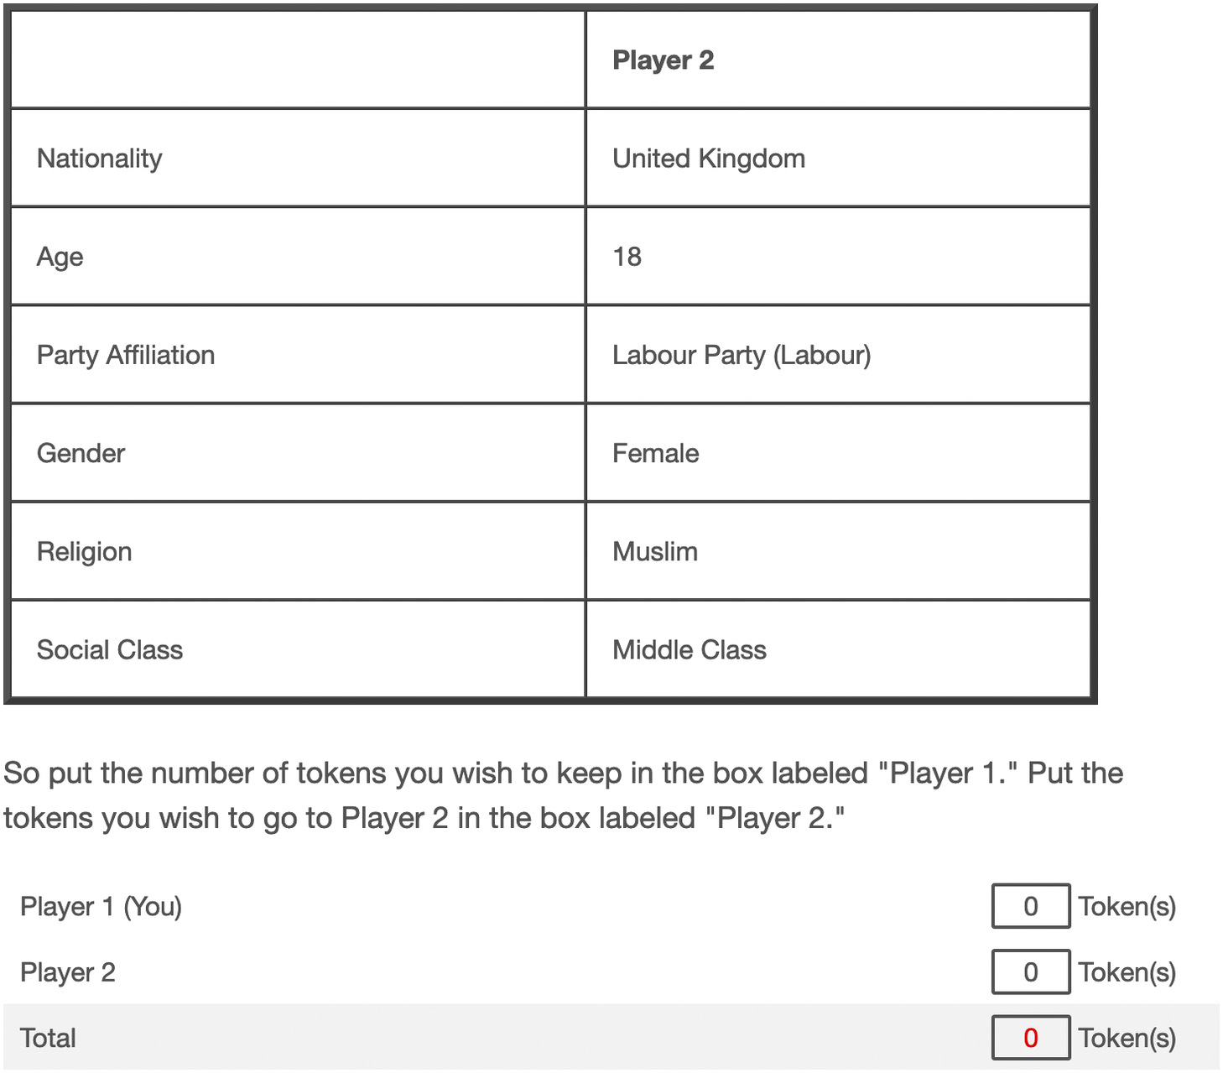
Figure 4: Player 2 Profile Example. Note: Figure embedded from Hahm et al. (2024), Figure 1.

Distribution of Outcome Variable
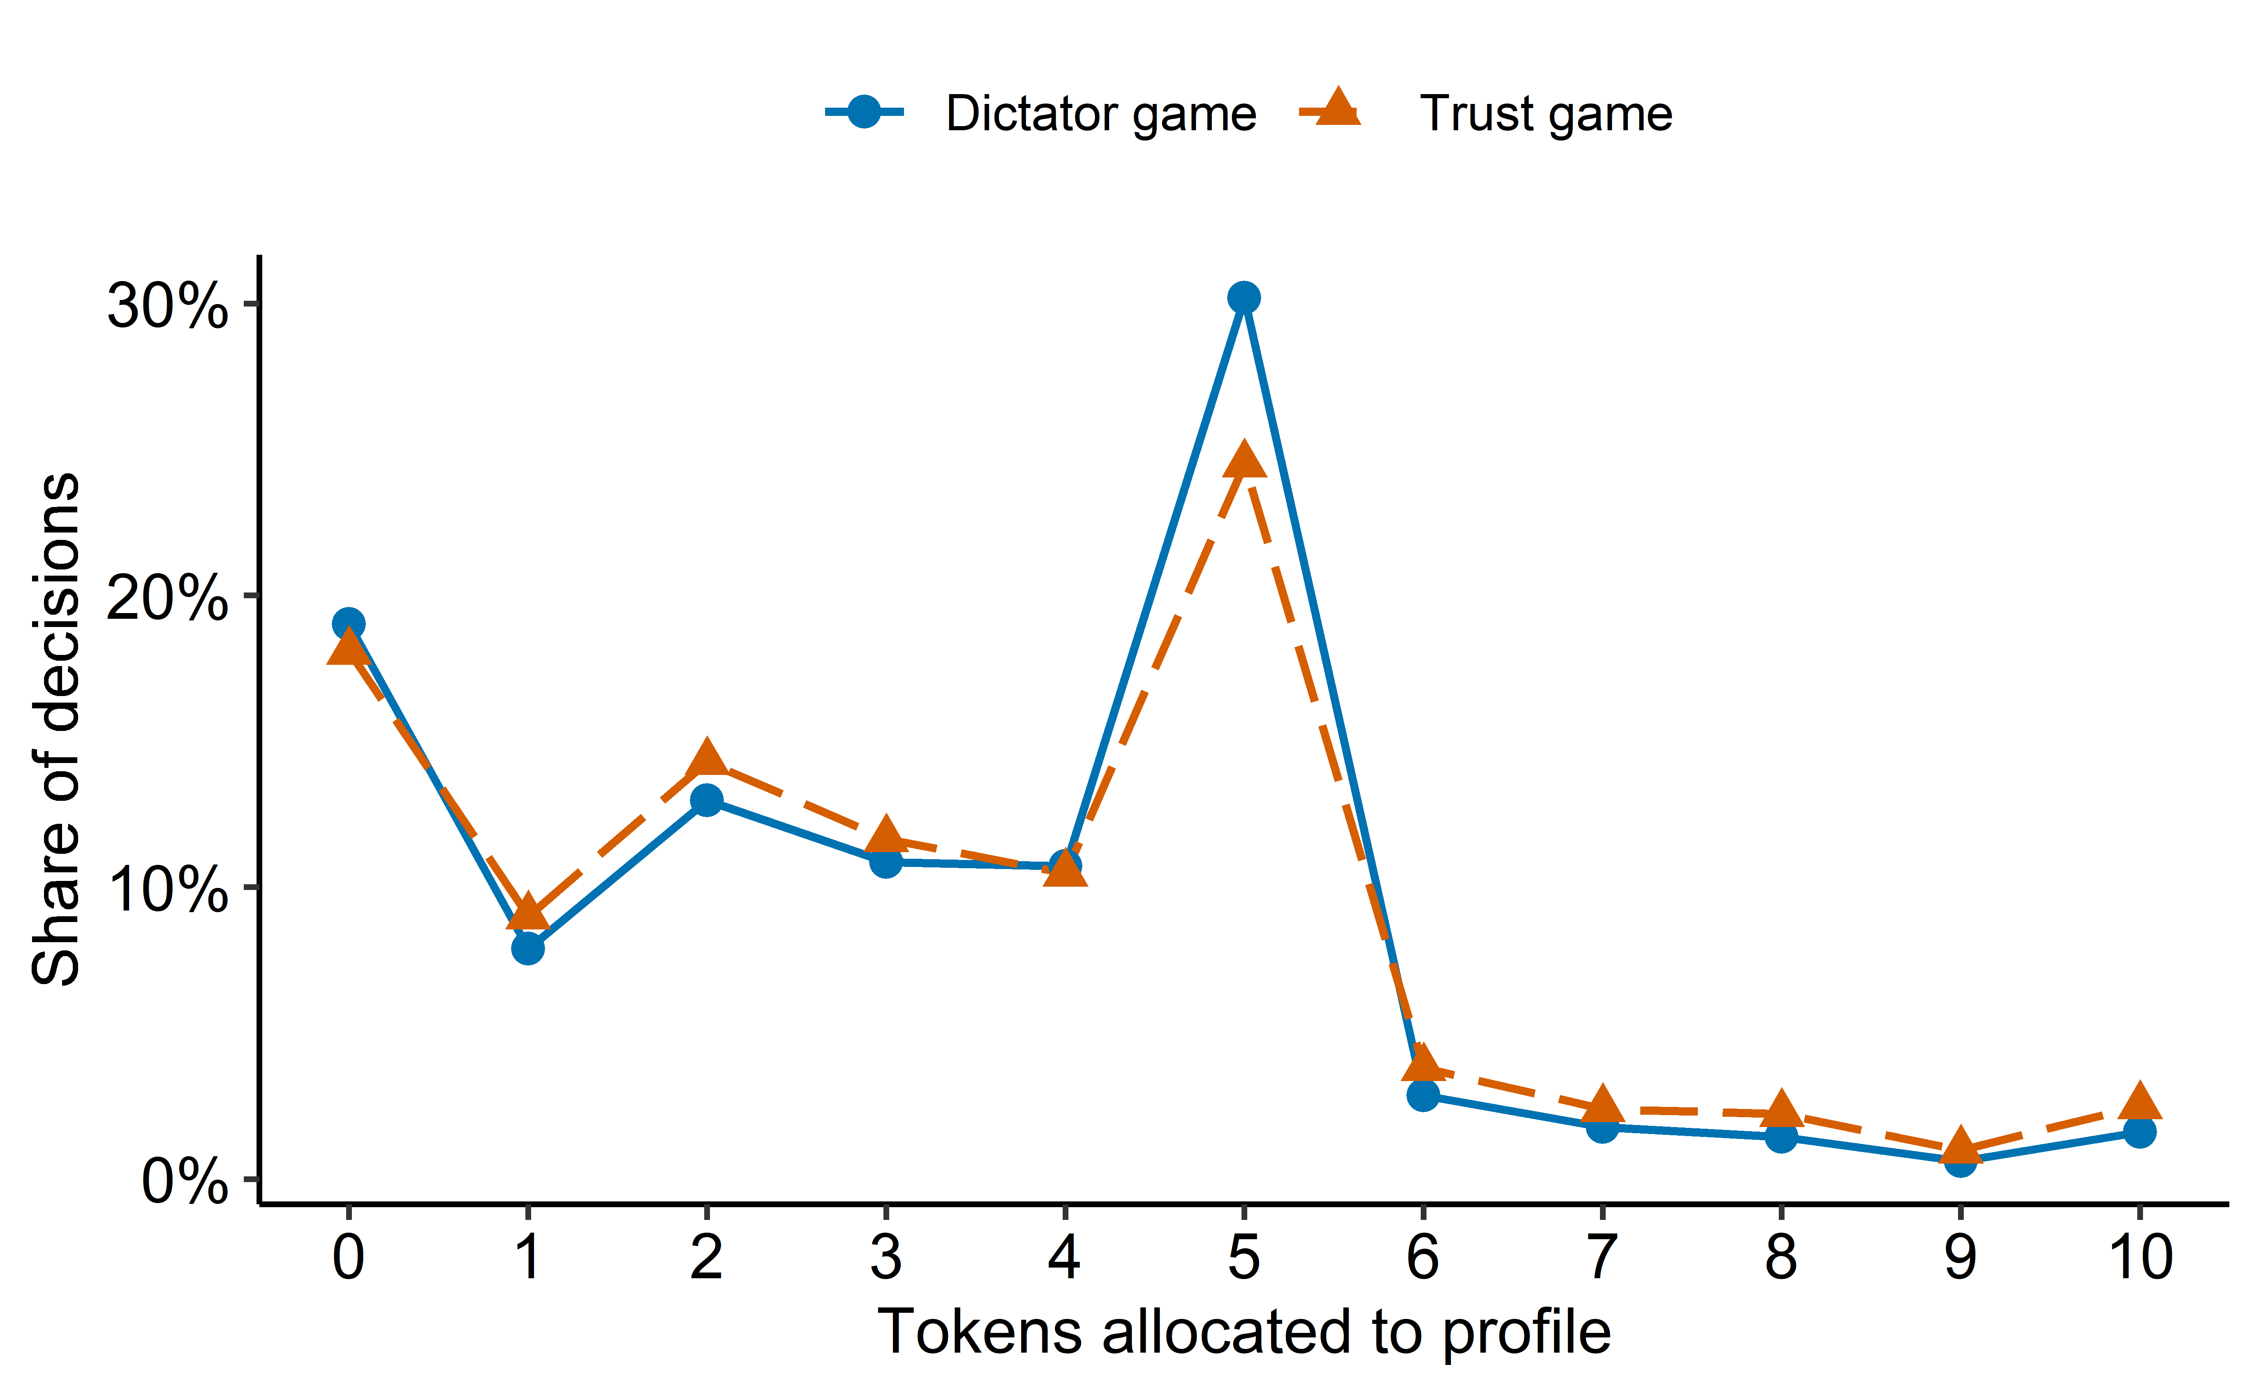
Figure 5: Distribution of outcomes (tokens allocated to the displayed profile) by game. Points are the within-game share of decisions at each integer token value, connected within game. $N=84.603$ in both games.
Source: Additional Figures & Tables

Distribution of Profile-level Covariates
Table 2: Profile level covariates distributions by treatment. Cells show raw counts with column percentages in parentheses for categorical variables, and the median with the first and third quartiles (Q1, Q3) in parentheses for numeric variables.
Variable | Non-Muslim N = 126,663 | Muslim N = 42,543
cj_nationality_shown
eu | 31,546 (25%) | 10,572 (25%)
non_eu | 8,660 (6.8%) | 2,988 (7.0%)
own_country | 86,457 (68%) | 28,983 (68%)
der_cj_eu_identity
eu_citizen | 34,470 (27%) | 11,558 (27%)
not_displayed | 57,469 (45%) | 19,544 (46%)
not_eu_citizen | 34,724 (27%) | 11,441 (27%)
der_cj_partisanship
not_applicable | 40,206 (32%) | 13,560 (32%)
not_shown | 17,130 (14%) | 5,874 (14%)
shown | 69,327 (55%) | 23,109 (54%)
cj_age
18 | 25,347 (20%) | 8,539 (20%)
30 | 25,348 (20%) | 8,373 (20%)
42 | 25,244 (20%) | 8,611 (20%)
53 | 25,521 (20%) | 8,622 (20%)
65 | 25,203 (20%) | 8,398 (20%)
cj_sex
female | 63,308 (50%) | 21,338 (50%)
male | 63,355 (50%) | 21,205 (50%)
cj_class
lower | 42,023 (33%) | 14,048 (33%)
middle | 42,393 (33%) | 14,294 (34%)
upper | 42,247 (33%) | 14,201 (33%)

Source: Additional Figures & Tables

Distribution of Respondent-level Covariates
Table 3: Individual level covariate distributions by treatment. Cells show raw counts with column percentages in parentheses for categorical variables, and the median with the first and third quartiles (Q1, Q3) in parentheses for numeric variables.
Variable | Non-Muslim N = 16,622 | Muslim N = 5,537
q_gender
female | 8,770 (53%) | 2,985 (54%)
male | 7,826 (47%) | 2,548 (46%)
other | 26 (0.2%) | 4 (<0.1%)
q_age | 46 (34, 57) | 46 (34, 58)
q_identity_country | 1 (1, 2) | 1 (1, 2)
q_identity_eu | 3 (2, 4) | 3 (2, 4)
q_identity_europe | 2 (2, 3) | 2 (2, 3)
q_religion
atheist | 1,996 (12%) | 634 (11%)
buddhist | 64 (0.4%) | 20 (0.4%)
catholic | 5,592 (34%) | 1,911 (35%)
dont_know | 687 (4.1%) | 209 (3.8%)
hindu | 22 (0.1%) | 2 (<0.1%)
jewish | 37 (0.2%) | 9 (0.2%)
muslim | 80 (0.5%) | 33 (0.6%)
nonbeliever_agnostic | 3,559 (21%) | 1,214 (22%)
orthodox | 1,823 (11%) | 570 (10%)
other | 589 (3.5%) | 177 (3.2%)
other_christian | 729 (4.4%) | 239 (4.3%)
protestant | 1,439 (8.7%) | 518 (9.4%)
sikh | 5 (<0.1%) | 1 (<0.1%)
q_class
dont_know | 540 (3.2%) | 210 (3.8%)
higher_class | 106 (0.6%) | 35 (0.6%)
lower_middle_class | 3,217 (19%) | 1,088 (20%)
middle_class | 7,848 (47%) | 2,537 (46%)
other | 7 (<0.1%) | 2 (<0.1%)
upper_middle_class | 1,541 (9.3%) | 551 (10.0%)
working_class | 3,363 (20%) | 1,114 (20%)
q_eu_efficacy_understand | 5 (4, 6) | 5 (4, 6)
q_pop_reps | 6 (5, 7) | 6 (5, 7)
q_pop_goodevil | 4 (3, 5) | 4 (3, 5)
q_pop_compromise | 5 (4, 6) | 5 (4, 6)
q_dem_compromise | 5 (5, 6) | 5 (5, 6)
q_dem_listen | 6 (5, 7) | 6 (5, 7)
q_tech_experts | 5 (4, 6) | 5 (4, 6)
q_tech_leaders | 6 (5, 7) | 6 (5, 7)
q_party_harm | 5 (4, 6) | 5 (4, 6)
q_people_incompetent | 4 (3, 5) | 4 (3, 6)
q_eu_longterm | 5 (4, 6) | 5 (4, 6)
q_eu_responsive | 6 (5, 7) | 6 (5, 7)
q_eu_imp_nat_econ | 3 (2, 3) | 3 (2, 3)
q_eu_imp_nat_cul | 3 (2, 4) | 3 (2, 4)
q_eu_imp_nat_pol | 3 (2, 4) | 3 (2, 4)
q_eu_abolish | 5 (3, 6) | 5 (3, 6)
q_eu_satisfaction | 4 (3, 5) | 4 (3, 5)
q_rural_urban
large_city | 6,320 (38%) | 2,123 (38%)
rural | 2,969 (18%) | 1,042 (19%)
small_med_town | 7,333 (44%) | 2,372 (43%)
q_edu_age_stop | 21.0 (18.0, 24.0) | 21.0 (18.0, 24.0)

Source: Additional Figures & Tables

Question Wordings and Scales
Table 4: Question wordings and scales of individual-level covariates used in the analysis.
Variable | Question wording | Scale coding
q_gender | Please indicate your gender. | Categorical
q_religion | Do you consider yourself to be…? | Categorical
q_class | Do you see yourself and your household belonging to…? | Categorical
q_rural_urban | Would you say you live in a…? | Categorical
q_identity_country | Please tell me how attached you feel to… - [SURVEY COUNTRY] | 1 (very attached) to 5 (not at all attached)
q_identity_eu | Please tell me how attached you feel to… - The European Union (EU) | 1 (very attached) to 5 (not at all attached)
q_identity_europe | Please tell me how attached you feel to… - Europe | 1 (very attached) to 5 (not at all attached)
q_eu_efficacy_understand | Please tell me to what extent you agree or disagree with each of the following statements. - I can understand and evaluate important political questions about the EU | 1 (strongly disagree) to 7 (strongly agree)
q_pop_reps | Please indicate how much you agree with each of the following statements. - Elected officials talk too much and take too little action. | 1 (strongly disagree) to 7 (strongly agree)
q_pop_goodevil | Please indicate how much you agree with each of the following statements. - Politics is ultimately a struggle between good and evil. | 1 (strongly disagree) to 7 (strongly agree)
q_pop_compromise | Please indicate how much you agree with each of the following statements. - What people call “compromise” in politics is really just selling out on one’s principles. | 1 (strongly disagree) to 7 (strongly agree)
q_dem_compromise | Please indicate how much you agree with each of the following statements. - In a democracy it is important to make compromises among differing viewpoints. | 1 (strongly disagree) to 7 (strongly agree)
q_age | How old are you? | Age in years
q_dem_listen | Please indicate how much you agree with each of the following statements. - It is important to listen to the opinion of other groups. | 1 (strongly disagree) to 7 (strongly agree)
q_tech_experts | Please indicate how much you agree with each of the following statements. - Our country would run better if political decisions were left up to experts instead of politicians and citizens. | 1 (strongly disagree) to 7 (strongly agree)
q_tech_leaders | Please indicate how much you agree with each of the following statements. - The leaders of our country should be more educated and skilled than ordinary citizens. | 1 (strongly disagree) to 7 (strongly agree)
q_party_harm | Please indicate how much you agree with each of the following statements. - Political parties do more harm than good to society | 1 (strongly disagree) to 7 (strongly agree)
q_people_incompetent | Please indicate how much you agree with each of the following statements. - Ordinary people don’t know what policies are good for them. | 1 (strongly disagree) to 7 (strongly agree)
q_eu_longterm | In thinking about the European Union (EU) and its decisions more generally, some people argue that it should act upon its long-term goals without pandering to the demand of the people. On the other hand, others argue that the EU should listen to the demand of people, rather than to act upon its long-term goals. When it comes to the question of whether the EU should act upon its long-term goals or it should listen to the demand of the people, what is your opinion? - The EU should act upon its long-term goals | 1 (strongly disagree) to 7 (strongly agree)
q_eu_responsive | In thinking about the European Union (EU) and its decisions more generally, some people argue that it should act upon its long-term goals without pandering to the demand of the people. On the other hand, others argue that the EU should listen to the demand of people, rather than to act upon its long-term goals. When it comes to the question of whether the EU should act upon its long-term goals or it should listen to the demand of the people, what is your opinion? - The EU should listen to the demand of the people | 1 (strongly disagree) to 7 (strongly agree)
q_eu_imp_nat_econ | Could you tell me whether you think that the EU has a rather positive or rather negative effect on each of the following domains? - UK economy | 1 (very positive) to 5 (very negative)
q_eu_imp_nat_cul | Could you tell me whether you think that the EU has a rather positive or rather negative effect on each of the following domains? - Our culture and identity | 1 (very positive) to 5 (very negative)
q_eu_imp_nat_pol | Could you tell me whether you think that the EU has a rather positive or rather negative effect on each of the following domains? - UK’s political status and influence | 1 (very positive) to 5 (very negative)
q_eu_abolish | Please tell me to what extent you agree or disagree with each of the following statements. - If the EU started making a lot of decisions that most people disagreed with, it might be better to do away with the EU altogether | 1 (strongly disagree) to 7 (strongly agree)
q_eu_satisfaction | Please tell me to what extent you agree or disagree with each of the following statements. - I am satisfied with the performance of the EU | 1 (strongly disagree) to 7 (strongly agree)
q_edu_age_stop | How old were you when you stopped full-time education? | Years

Source: Additional Figures & Tables

Appendix B: Additional CF Figures

TOC / AUTOC Curve
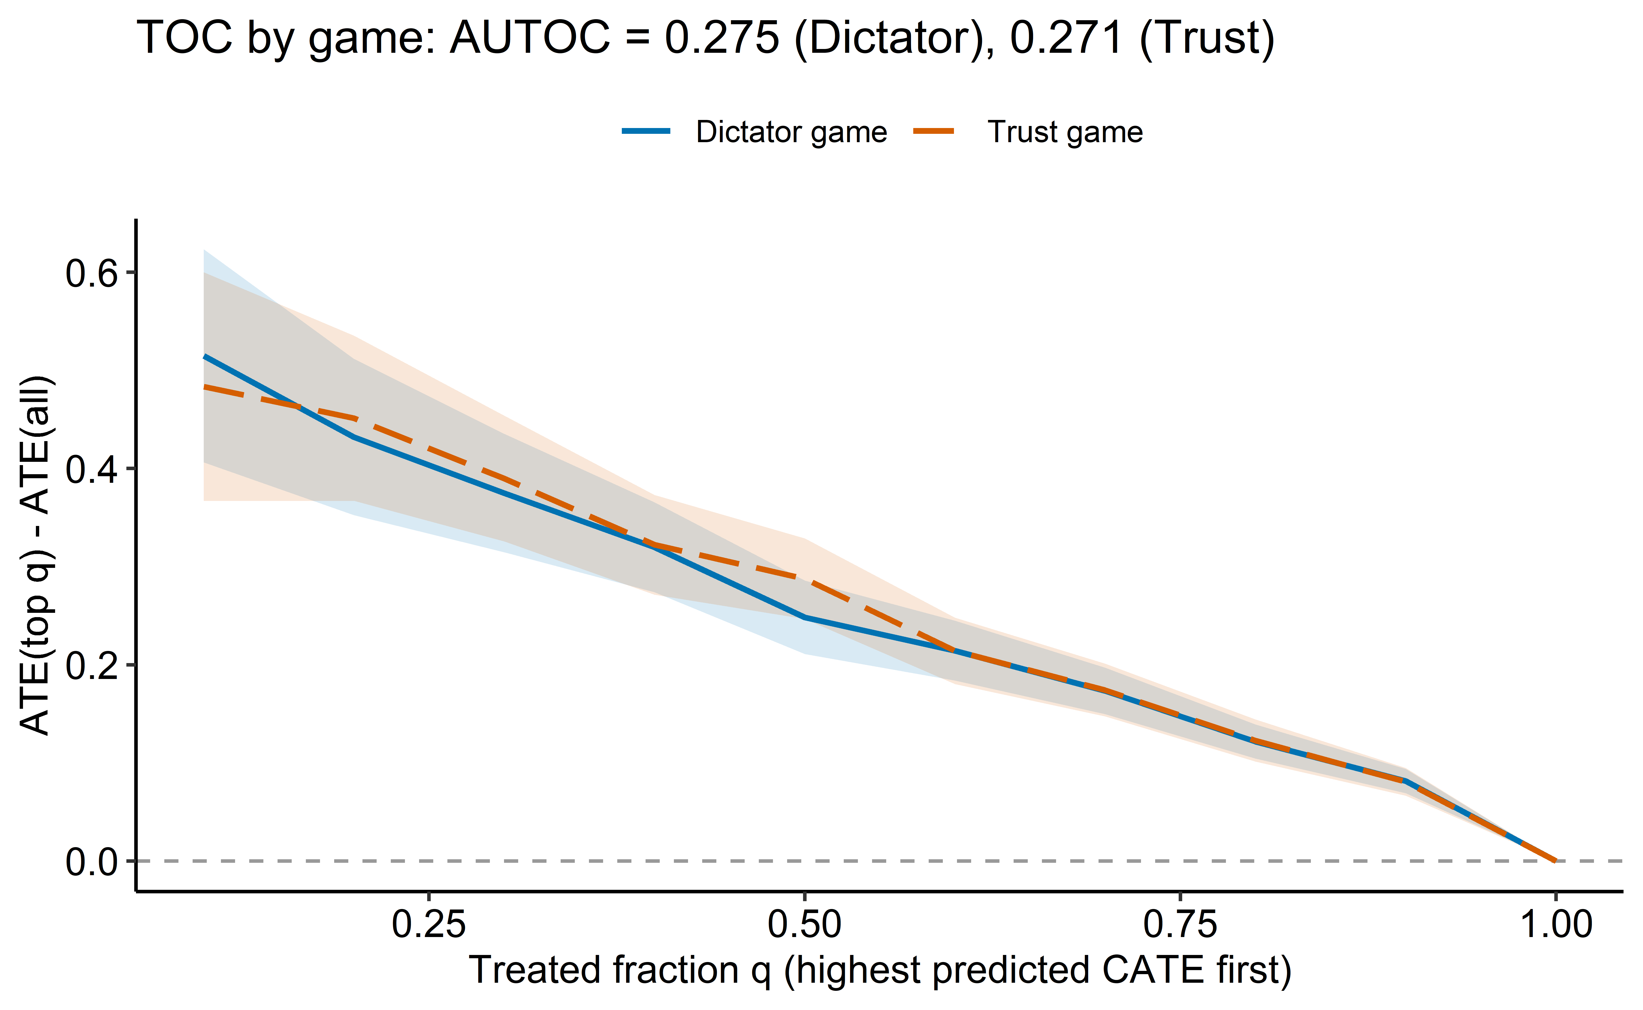
Figure 6: CF Targeting Operator Characteristic curve, both games overlaid: ATE among the top-q fraction by predicted CATE minus the overall ATE, with 95% CI ribbon. The area under each curve is the AUTOC, reported in the title.
_{Source: GRF Post-Processing}

Variable Importance
Figure 7: CF variable importance aggregated to the original moderators, both games overlaid (dodged bars by game). Profile-level and respondent-level moderators are separated into facets. Within each facet moderators are ordered by their mean importance across the two games. Country fixed-effect columns excluded.
_{Source: GRF Post-Processing}

Appendix C: Main Results from BCF Method

BCF Moderation by Profile-level Covariates
Figure 8: BCF posterior estimates of the profile-level CATE (${\hat{τ}}_{ric}$) of the Muslim profile across the levels of every conjoint-round moderator (x-axis), Dictator and Trust games overlaid and distinguished jointly by colour, shape, and linetype. The y-axis is ${\hat{τ}}_{ric}$ on the token-allocation scale. Each point is a per-level posterior median with a cluster-robust 95% interval, formed as the median plus or minus 1.96 times a combined standard error (a normal approximation) that adds the posterior SD of the within-level mean to a respondent cluster-bootstrap SD. Grey bars along the bottom of each facet show the per-level row count (pooled over games). The y-axis is free per facet. In the Profile partisanship facet, partisanship not shown refers to within the co-national category only, since partisanship is displayed for co-national profiles only.
_{Source: BCF Post-Processing}

BCF Moderation by Respondent-level Covariates
Figure 9: BCF posterior estimates of the respondent-level CATE (${\hat{τ}}_{i}$) of the Muslim profile across the levels of the first half of the discrete individual-level moderators (top panel) and across age (q_age, bottom panel), Dictator and Trust games overlaid and distinguished jointly by colour, shape, and linetype. The y-axis is ${\hat{τ}}_{i}$ on the token-allocation scale. All item scales are oriented so that higher x-axis values mean more agreement, a more positive evaluation, or more attachment, depending on the item (see Table 4). Every point and ribbon value is a posterior median with a cluster-robust 95% interval, formed as the median plus or minus 1.96 times a combined standard error (a normal approximation) that adds the posterior SD to a respondent cluster-bootstrap SD. Top: ordered numeric scales are drawn as a connecting line and interval ribbon per game, categorical moderators as dodged points and intervals. Grey bars show the per-level row count (pooled over games). Bottom: per-grid-cell estimate, interval ribbon, and connecting line per game over a grey histogram of the covariate, on 100 equal intervals across the full 18-75 years. The y-axis is free per facet. Discrete levels comprising less than 1% of a game’s sample are dropped because their CATE is too imprecise to compare.
_{Source: BCF Post-Processing}
Figure 10: BCF posterior estimates of the respondent-level CATE (${\hat{τ}}_{i}$) of the Muslim profile across the levels of the second half of the discrete individual-level moderators (top panel) and across age at which education stopped (q_edu_age_stop, bottom panel), Dictator and Trust games overlaid and distinguished jointly by colour, shape, and linetype. The y-axis is ${\hat{τ}}_{i}$ on the token-allocation scale. All item scales are oriented so that higher x-axis values mean more agreement, a more positive evaluation, or more attachment, depending on the item (see Table 4). Every ribbon value is a posterior median with a cluster-robust 95% interval, formed as the median plus or minus 1.96 times a combined standard error (a normal approximation) that adds the posterior SD to a respondent cluster-bootstrap SD. Top: ordered numeric scales are drawn as a connecting line and interval ribbon per game. Grey bars show the per-level row count (pooled over games). Bottom: per-year posterior median, interval ribbon, and connecting line per game at each integer year of education-stopping age from 15 to 30, over a grey histogram of the covariate. The y-axis is free per facet. Discrete levels comprising less than 1% of a game’s sample are dropped because their CATE is too imprecise to compare.
_{Source: BCF Post-Processing}

Figure 5 in the appendix shows the distribution of the allocated tokens by game.
Figure 4 in the appendix shows an example profile.
These randomly assigned conditions are: a co-national with both EU identity and partisan affiliation, a co-national with party but not EU identity, an EU national with EU identity but not party, and a co-player of some nationality with neither. Partisan affiliation is displayed only for co-nationals, since assigning a national party to a co-player ineligible to vote for it would be implausible.
This coding effectively averages the non-Muslim religion features against the Muslim one. As we are interested in the drivers of Muslim bias rather than in particular facets of that bias, we adopt this simpler approach.
Table 2 and Table 3 in the appendix report the profile-level attributes and respondent-level covariates by treatment status. Both sets are balanced across Muslim and non-Muslim profiles, consistent with random assignment of the religion attribute, which identifies the penalty jointly with the usual conjoint stability assumptions of no carryover and no profile-order effects (Hainmueller et al. 2014).
All quantities we report are sample quantities, and we return to the implications for external validity in Section 3.3.
The subscripts $r,i,c$ reflect the hierarchical structure of the outcome $Y_{ric}^{g}$ (round $r$, nested in respondent $i$, nested in country $c$), not the conditioning set in the expectation. The same convention applies to the covariates and the disaggregated CATEs: $X_{ic}$ carries the country index because $c$ is determined by $i$, and $τ_{ric}^{g}$ retains $i$ even though only $A_{ric}$ remains in the conditioning set after marginalizing over respondents, with $E_{r}$ taken over the randomized design distribution of the attributes and $E_{i}$ over the $N$ respondents of Equation 2.
The Bayesian branch absorbs the clustered structure through random intercepts and partial pooling, and an active literature extends BCF to such hierarchical and longitudinal settings (Thal et al. 2024; Prevot et al. 2025; McJames et al. 2025). A working implementation places a single random intercept on the prognostic surface for clustered, multisite trials (Yeager et al. 2019, 2022), built on the multibart package (Murray 2021), whose sampler accommodates an arbitrary random-effects design. We extended that implementation to the two nested levels our data require, respondent within country, and checked both estimators on synthetic data with the same two-level structure and a known, planted treatment surface, a smoke test of the machinery rather than a validation against realistic confounding. Each estimator recovered the planted effects within sampling error, but the nested BCF did so only at small scale. Its sampler solves a dense random-effects precision matrix at every Gibbs sweep, a cost that grows with the cube of the number of random-effect levels, and with tens of thousands of respondent intercepts the full nested fit proved computationally infeasible. The CF recovered the same quantities at a fraction of the cost, while restricting the BCF random effects to countries reduces its precision block to a trivial $25×25$ solve.
The BCF posterior means for the same quantity agree with these estimates.
The bootstrap quantifies only one of the two channels through which the respondent structure enters. It resamples respondents and recomputes each bin’s mean of the estimated effects, capturing the design and sampling variability of the displayed point estimates, and on the real fits this component is roughly an order of magnitude below the posterior standard deviation, so it adds at most one to three percent to the bands. It cannot, however, repair the second channel. The BCF likelihood treats the roughly 84,600 rows as conditionally independent given the trees and the country random intercept, so if there is residual within-respondent correlation beyond what the country intercept absorbs, the posterior over $τ(x)$ concentrates on too much information and the posterior standard deviation is internally deflated. An additive bootstrap term cannot detect or correct this. In the worst case of near-perfect within-respondent correlation the deflation could reach $\sqrt{3}≈1.7$, which is not negligible.

