SLEE Implementation Roadmap

M. Ranganathan

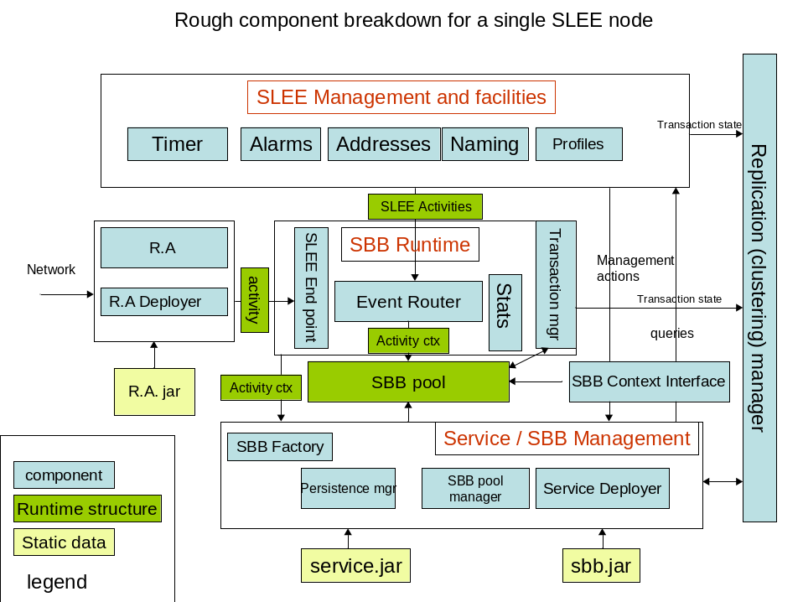

Phase 1 : Core Functionality

The goal for this phase of development is to build enough functionality that allows us to load and deploy simple SBB components as abstract classes. At the end of this phase we will have enough functionality to build and deploy simple components.

Here’s what we need to get done in this

1. Creating concrete SBBs from the SBB deployment descriptors and abstract SBB classes.
2. Creating service instances from the deployment descriptors under the appropriate conditions.
3. SBB lifecycle management.
4. Service Lifecycle management.

A little background on the above:

The fundamental event triggered building block of the SLEE is called an SBB. A developer builds a service by implementing some of the methods of this abstract class and deploying a collection of these into the SLEE.

Each SBB has a deployment descriptor. A service is a collection of SBBs. The spec refers to this as a SBB entity tree. SBBs can have container managed persistent (CMP) state. The persistent elements of the SBB are declared in its deployment descriptor. Because of the similarity of SBBs to entity beans, an in-memory copy of the persistent state of an SBB is referred to as an SBB entity.

The SBB entity is a tree derived from the service deployment. When an event comes into the container (from an SBB, the SLEE itself or from an external source), the event is delivered to SBBs in sequence as determined by delivery priority. The order in which events are delivered is laid out in Appendix B of the spec.

SBBs are written by the SBB developer as abstract classes (See Chapter 6). This is because the SBB developer does not know certain things at the time the service is written (for example, the service creator does not know about parent-child relationships and SBB priorites). The SLEE is supposed to provide implementations of methods that are defined in section 6.1.2.

The SLEE instantiates the service when the root SBB gets a trigger event. The trigger event is actually encapsulated in an activity context which the SLEE generates when an Activity is generated by a Resource Adapter. When the Root SBB of a service fires, the root SBB is attached to the activity context (which is the SLEE representation of the event). The activity context serves both as an event bus and an encapsulated representation of an event. This root SBB can in turn instantiate child SBBs (using the methods that are in its deployment descriptor). The SLEE fields these events and returns instances of SBB children. The child SBBs can in turn be attached to the Activity context and can fire events on it:

- When the SLEE is presented with the abstract SBB class during service loading time it generates a concrete SBB class from it. It makes the class concrete by supplying the missing abstract methods.

- When a matching event arrives that matches the service Start SBB then the SLEE can instantiate the service - i.e. it can instantiate an SBB Entity Tree corresponding to the service. Note that the SBB tree is dynamic as the SLEE allows for dynamic attachment of SBBs to activity contexts.

- Note that the SBB attachment to the activity context is under the control of the SBB itself. The SBB calls getChildSBB to get the child. This is an abstract method. The SLEE is responsible for providing the implementation of this method and for getting the instance of the object from persistent store and returning it to the caller. SBB deployment descriptors are defined in 3.1.7 of the spec.

The event router is the component that routes both SLEE generated and Resource Adapter generated events to the appropriate SBBs. The appendix B defines an algorithm for event delivery. This component is to implement the algorithm in appendix B. An event in SLEE can cause the instantiation of a service as described in the previous section.

The transaction manager is the component that enforces concurrency constraints and interfaces with the persistent store to implement SBB rollback. Transactions are defined in chapter 9 of the SLEE spec. JBoss Cache is a good choice to get transaction support implemented.

Here is an itemized list of things to do

Event routing and delivery

Implement the event router as defined in Appendix B of the SLEE spec. The event model is defined in chapter 8 of the spec (see 8.5, 8.6) The event router receives SLEE activities and RA activities Events must be fired within a resource adapter. (Ranga + Francesco)

Implement automatic event subscription for initial events (section 8.6) (Ranga, Francesco)

SBB Abstract Class

Provide support for interfaces between the SBB abstract class and the event router defined in section 8.4 of the spec. (Francesco)

Concrete class generation for a minimal subset of the Sbb that allows child creation, activity context attachment and detachment. (Jean Deruelle)

Integration with JBoss as a JBoss service

Package as a JBoss Sar. (Francesco)

Integrate with JBoss services support (transaction/logging) (Francesco , Ranga) (Note—Logging integration TBD by Ranga)

Integrate with JBoss Cache. (Ranga)

Service / Sbb Deployer

Parse the service and the SBB Deployment xml files. Several other components will need to access components of the deployment descriptor. Generate an in memory structure for use by other components. (Emil Ivov) Done

Load / verify SBB classes from the descriptors. Before this step can be done, SBB abstract classes need to be converted to SBB concrete classes. (Jean Deruelle) Done

Deploy from jar file. Emil Ivov and Ranga Done.

Deployment of Resource Adaptors ( Francesco )

Sbb Runtime management

Support for component keys. Sbb Identification and component mapping <name, vendor , version> to Component mapping. ( Francesco) Done

Instantiate sbbs from the deployment descriptors by looking up convergence name and manage object pool. We currently have only have support for EventType and Activity context. ( Francesco) Done

Support for selected sbb tags Done

Child relation (Francesco + Ranga) Done and tested

Activity Context Interface (Francesco + Ranga) Done and testing in progress

Sbb Local object (Francesco + Ranga) Done and testing in progress.

Support for dynamic deployment of sbbs from xml descriptor + class files. It would be nice to have hot deployment from a directory like jboss. Done but feature is disabled.Ranga

Minimal SLEE services (Francesco + Ranga)

Activity Context Naming ( Ranga) Done but Not tested

Null Activity Context (Ranga) Done andTested

Timer (Ranga) Spec Section 13.1 Timer Peristance Not done

Service Activity (Ranga) (Spec section 8.7.2) Done but not tested

Unit Testing Framework

Integration of minimal SIP test framework into the service container (Ranga) Done but deprecated.

Phase 2

Profile Support: Jean Deruelle
- Done not tested.

Persistance support: Jean Deruelle
- Investigate new JBoss Cache Persistance Support
- Design for Sbb CMP persistence done
- Define What persistence model we want to support for Sbbs done
- Profile CMP persistance. Done not tested

Resource Adapters : Francesco
- Resource Adapter Deployment sort of done
- Resource Adapter Entity Binding done
- Resource Adapter Mbean Done

Usage Parameters and Usage Mbean : Ranga
- Done. Not tested

Address Profiles : Jean
- Not yet done ( status?)

Env-entry Support : Tim Fox
- Done not tested

Connection support: Tim Fox
- Done and tested

Alarms : Tim Fox
- Done not tested

Ejb-ref : Tim Fox
- Done and tested

Start integrating TCK unit tests : All
- In progress

Sbb Usage support : Ranga
- Done and testing in progress

SLEE Deployment and Management Support

The SleeManagementMBean interface. Ranga
- Done but not tested.

The DeploymentMBean interface. Ranga
- Done and tested.

The ServiceManagementMBean interface. Ranga
- Done but not tested.

The ServiceUsageMBean interface. Ranga
- Done ( test in progress)

The ProfileProvisioningMBean interface and support. Jean
- Done but tests don’t pass

The AlarmMBean interface. Tim
- Done not tested

The TraceMBean interface. Ranga
- Done but not tested.

GUI/ Plugin for Service/SBB development and deployment ( Kilinc Alkan)
Nothing done yet.

Resource adapters for different signaling protocols TBD
Nothing done yet

