Jeffrey Levesque

jlevesqu@syr.edu | ist-718

IST-718: Lab #2

Professor Fox

**Introduction**

Property is often thought as one of the safer investment opportunities compared to various alternatives. This often brings to question: how does one analyze or predict investment property? Can linear regression, or time series analysis be implemented? To start, several Arkansas metro areas will be analyzed. Then, a national generalization will be made to gain a higher level understanding, before addressing whether specific zip codes can be identified as better investment opportunities. Using forecasting techniques, an ARIMA model will be used to predict mean and median estimates for successive months in 2017, through 2018.

**Analysis**

Data Preparation:

Multiple datasets were implemented, and version controlled with the codebase:

* <https://github.com/jeff1evesque/ist-718-lab/blob/master/data/>

Specifically, a main Zip_Zhvi_SingleFamilyResidence.csv was collected from Zillow, then used to estimate housing worth per city and state. This dataset covers a time series between 1996-01 through 2017-09. However, additional FBI crime data was aggregated based on state county:

* maryland.xls
* new-hampshire.xls
* virginia.xls
* district-of-columbia.xls

This allowed the former data to be filtered based on specific crime criteria. In the case of this study, the sum of all offense types divided by the county population (i.e. crime ratio). The ratio was not allowed to exceed 3%. Any county that exceed this value was omitted from the data aggregation. However, since there was only one row of data in the DC FBI dataset, its use was omitted, and possibly left as future exercise. Next labor force data was collected from the Department of Labor:

* laucnty17.xlsx

When joined with the latter combined data, the composition allowed further filtering based on unemployment rate. For this study, unemployment was not allowed to exceed 3.5%. Finally, the adjusted data was filtered on select locations to reduce the modeling:

* Maryland
* Virginia
* Washington D.C.
* Massachusetts
* New Hampshire

Furthermore, it is important to note that any NaN cell from the previous datasets were converted to zero. Then, the zipcodes package was used to introduce an additional zipcode column:

def get_zipcode(city, state):

result = zipcodes.filter_by(

zipcodes.list_all(),

active=True,

city=city,

state=state

)

if result and result[0] and result[0]['zip_code']:

return(result[0]['zip_code'])

else:

return(0)

df['zip_code'] = df[['City', 'State']].apply(

lambda x: get_zipcode(

x['City'].upper(),

x['State'].upper()

),

axis=1

)

**Results**

Time series models were generated for metro areas in Arkansas:

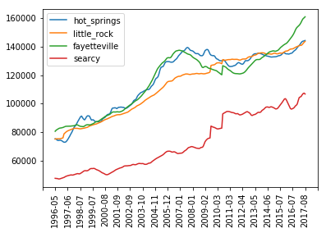

**Figure 1**. Time series plots for metro areas in Arkansas. The code used to generate the plot above can be reviewed in Appendix A below.

It appears that Fayetteville, Arkansas has the greatest increase of property value, followed by a visually difficult decision between Little Rock and Hot Springs Arkansas. Next, an ARIMA model was generated using a train dataset to determine whether a time series model could generalize housing data. This was done from 01/1997 to 01/2017:

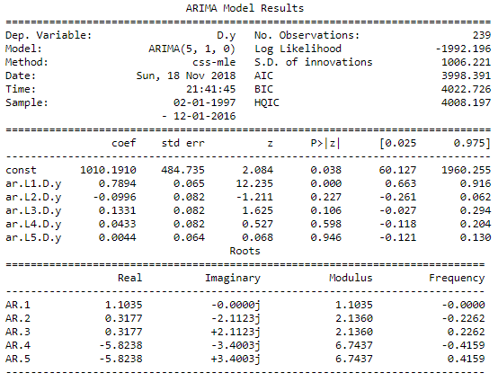

**Figure 2**. Descriptive statistics for an overall ARIMA model between 01/1997 and 01/2017 (train set). The code used to generate the plot above can be reviewed in Appendix B below.

An overall residual (Figure 3), and kernel density estimation (kde) plot (Figure 4) were generated using the same train dataset:

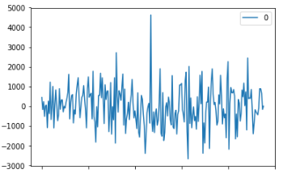

**Figure 3**. Residual plot for an overall ARIMA model. The code used to generate the plot above can be reviewed in Appendix C below.

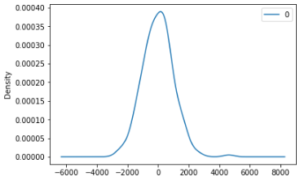

**Figure 4**. KDE plot for an overall ARIMA model. The code used to generate the plot above can be reviewed in Appendix C below.

Descriptive statistics for the overall ARIMA model:

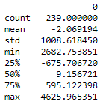

**Figure 5**. Descriptive statistics for the overall ARIMA model. The code used to generate the table above can be reviewed in Appendix C below.

The predicted values with error were computed for the remaining months in 2017, which were not in the train dataset (Figure 6), as well as for the 2018 months (Figure 7):

=======================================

date: 2017-2

---------------------------------------

predicted=388813.576701, expected=391050.000000

prediction difference: 0.005719

=======================================

predicted=388813.576701

=======================================

date: 2017-3

---------------------------------------

predicted=390443.689396, expected=392900.000000

prediction difference: 0.006252

=======================================

predicted=390443.689396

=======================================

date: 2017-4

---------------------------------------

predicted=392003.290988, expected=395800.000000

prediction difference: 0.009592

=======================================

predicted=392003.290988

=======================================

date: 2017-5

---------------------------------------

predicted=393503.316512, expected=398850.000000

prediction difference: 0.013405

=======================================

predicted=393503.316512

=======================================

date: 2017-6

---------------------------------------

predicted=394958.772728, expected=400850.000000

prediction difference: 0.014697

=======================================

predicted=394958.772728

=======================================

date: 2017-7

---------------------------------------

predicted=396374.708561, expected=402250.000000

prediction difference: 0.014606

=======================================

predicted=396374.708561

=======================================

date: 2017-8

---------------------------------------

predicted=397752.815045, expected=403400.000000

prediction difference: 0.013999

=======================================

Test MSE: 22164768.684165

**Figure 6**. ARIMA prediction and error rate, from the remaining 2017 months not in train. The code used to generate the plot above can be reviewed in Appendix D below.

=======================================

date: 2017-9

---------------------------------------

predicted=409223.452509

=======================================

date: 2017-10

---------------------------------------

predicted=413533.867822

=======================================

date: 2017-11

---------------------------------------

predicted=417515.922014

=======================================

date: 2017-12

---------------------------------------

predicted=421472.969033

=======================================

date: 2018-1

---------------------------------------

predicted=425233.650838

=======================================

date: 2018-2

---------------------------------------

predicted=428722.288873

=======================================

date: 2018-3

---------------------------------------

predicted=431986.176158

=======================================

date: 2018-4

---------------------------------------

predicted=435068.894530

=======================================

date: 2018-5

---------------------------------------

predicted=437986.877565

=======================================

date: 2018-6

---------------------------------------

predicted=440749.383756

=======================================

date: 2018-7

---------------------------------------

predicted=443369.575329

=======================================

date: 2018-8

---------------------------------------

predicted=445861.222357

=======================================

date: 2018-9

---------------------------------------

predicted=448234.798712

=======================================

date: 2018-10

---------------------------------------

predicted=450501.831974

=======================================

date: 2018-11

---------------------------------------

predicted=452672.004600

=======================================

date: 2018-12

---------------------------------------

predicted=454753.750478

**Figure 7**. ARIMA predictions for 2018 months. The code used to generate the plot above can be reviewed in Appendix D below.

To visualize the difference between the predicted and actual values:

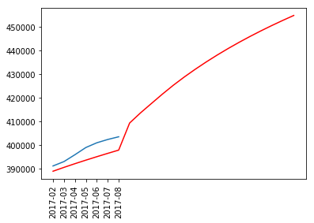

**Figure 8**. Comparison of the predicted (red) vs. actual mean (blue). The code used to generate the plot above can be reviewed in Appendix E below.

Upon reviewing the above train case, it is evident that none of the difference between the predicted with the actual test data exceed 1.5%. Therefore, the implementation of ARIMA(5,1,0) for the entire population, was extended for each individual zip code. However, since the internal statsmodels.tsa.arima_model does not allow d > 2[1], the differencing was indirectly applied, by adapting the actual dataset only when the base implementation would not succeed.

Each zipcode data was passed to a custom compute_arima function. However, a direct implementation could sometimes fail. Specifically, the statsmodels package could fail with LinAlgError: SVD did not converge[2] with unusual combination of data with arima arguments. This potential of this arising was reconciled by incrementing the difference factor until the error was eliminated.

A computed rolling prediction successfully generated n predictions after the train. Conveniently, earlier edge cases did not arise. Therefore, each computation succeeded with a standard non-iterative differencing strategy.

predictions: [441994.60672424873, 447533.39722298674, 452893.74103927833, 457767.27660728176, 462337.7806300529, 466176.1912943393, 468413.75085113844, 470550.8847704935, 473187.8653109091, 475525.0143412446, 478662.4989835472, 482899.99798691145, 487237.503724659, 491175.01066866284, 494912.5144486477, 499150.0146820069, 504687.51469225716, 511125.0146084265, 517462.5145216945, 523000.0144826223, 527837.5144814998, 532075.0144836435, 535212.5144869951]

**Figure 10**. Rolling prediction for a given zipcode in the aggregated list. Appendix F and Appendix G demonstrate the code to iterate all zipcode in the provided dataset.

An aggregated plot of the full original dataset duration indicates similar trends:

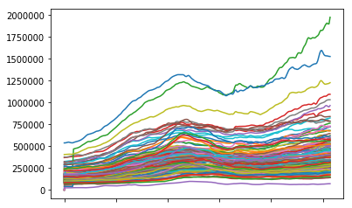

**Figure 11**. Zipcode trend for select zipcodes. The code used to generate the plot above can be reviewed in Appendix H below.

Based on the above plot, an iterative differencing would likely not provide large benefits. However, it is possible to further smooth the corresponding models. After models were generated from the train, 23 iterative months were predicted. The first seven months of this iterative process coincided with the test data and was used to validate the strength of the model. The successive 16 months were used for future forecasting.

The most accurate model was found to be Grottoes, VA (24441). The rolling prediction for successive months starting 2017-02:

1. $161,484.18/0.01
2. $163,610.26/0.006
3. $166,112.94/0.005
4. $167,715.31/0.007
5. $167,951.84/0.01
6. $168,296.66/0.01
7. $169,441.690.008
8. $170,185.82
9. $169,725.05
10. $168,858.37
11. $168,488.13
12. $168,717.51
13. $168,446.43
14. $168,174.83
15. $168,702.87
16. $168,930.72
17. $168,958.52
18. $169,086.27
19. $168,713.98
20. $167,941.67
21. $168,869.34
22. $171,397.01
23. $175,124.68

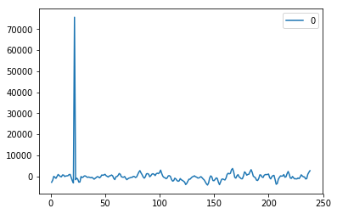

**Figure 11**. Residuals plot for most accurate model (24441). The code used to generate the plot above can be reviewed in Appendix I below.

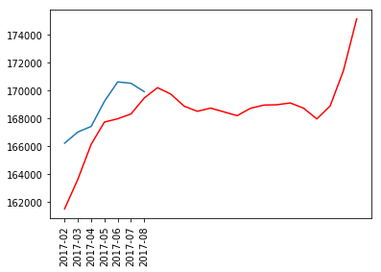

**Figure 12**. Most accurate model (red), against actual (blue) (01002). The code used to generate the plot above can be reviewed in Appendix I below.

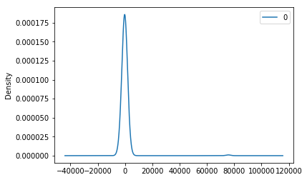

**Figure 13**. KDE plot for most accurate model (24441). The code used to generate the plot above can be reviewed in Appendix I below.

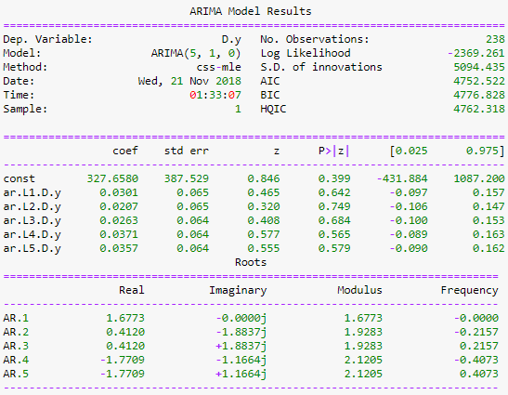

**Figure 14**. Model summary for most accurate model (24441). The code used to generate the plot above can be reviewed in Appendix I below.

The second most accurate model was found to be Dayton, VA (22821). The rolling prediction for successive months starting 2017-02:

1. $198,827.60/0.01
2. $198,677.87/0.0006
3. $199,964.44/0.002
4. $201476.82/0.007
5. $201,596.99/0.006
6. $202,217.43/0.01
7. $203,639.40/0.02
8. $205,962.23
9. $206,785.41
10. $204,108.72
11. $201,832.09
12. $204,355.50
13. $208978.92
14. $212,402.35
15. $215,625.79
16. $219,249.22
17. $221,972.66
18. $222,996.10
19. $224,019.54
20. $224,742.97
21. $224,466.41
22. $224,489.85
23. $225,413.29

**Note:** the first seven months (test) above, provide a prediction significance against the corresponding test value.

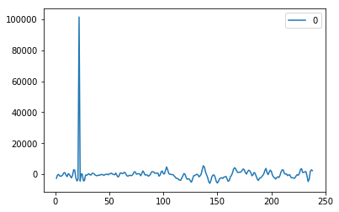

**Figure 15**. Residuals plot for most accurate model (22821). The code used to generate the plot above can be reviewed in Appendix I below.



**Figure 16**. Most accurate model (red), against actual (blue) (22821). The code used to generate the plot above can be reviewed in Appendix I below.

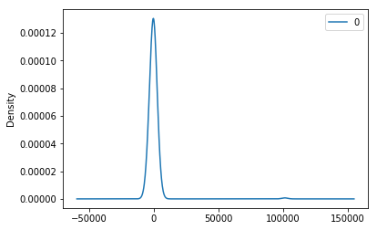

**Figure 17**. KDE plot for most accurate model (22821). The code used to generate the plot above can be reviewed in Appendix I below.

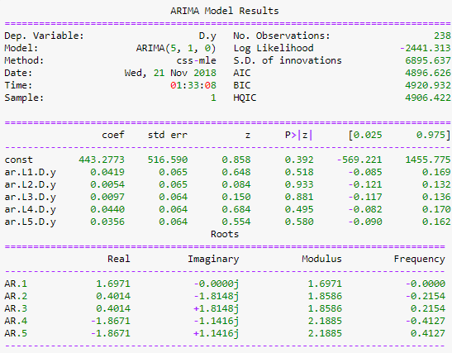

**Figure 18**. Model summary for most accurate model (22821). The code used to generate the plot above can be reviewed in Appendix I below.

The third most accurate model was found to be Elkton, VA (22827). The rolling prediction for successive months starting 2017-02:

1. $175,100.62/0.03
2. $174,356.88/0.01
3. $174,299.22/0.002
4. $175,067.27/0.008
5. $175,429.34/0.009
6. $175,691.15/0.003
7. $176,753.34/0.005
8. $177,813.93
9. $178,073.80
10. $177,533.66
11. $176,793.45
12. $177,853.19
13. $180,512.94
14. $183,972.70
15. $187,432.47
16. $190,192.23
17. $192,251.99
18. $195,111.76
19. $198,171.53
20. $199,131.29
21. $198,691.06
22. $198,450.82
23. $198,410.59

**Note:** the first seven months (test) above, provide a prediction significance against the corresponding test value.

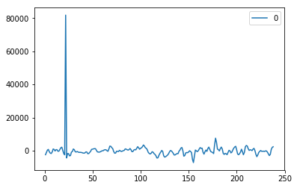

**Figure 19**. Residuals plot for most accurate model (22827). The code used to generate the plot above can be reviewed in Appendix I below.

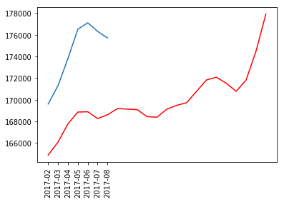

**Figure 20**. Most accurate model (red), against actual (blue) (22827). The code used to generate the plot above can be reviewed in Appendix I below.

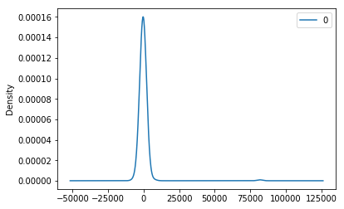

**Figure 21**. KDE plot for most accurate model (22827). The code used to generate the plot above can be reviewed in Appendix I below.

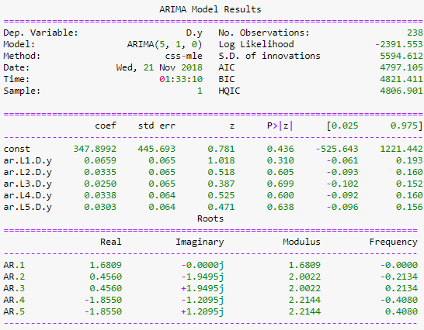

**Figure 22**. Model summary for most accurate model (22827). The code used to generate the plot above can be reviewed in Appendix I below.

The fourth most accurate model was found to be Ringe, NH (03461). The rolling prediction for successive months starting 2017-02:

1. $207,893.76/0.01
2. $207,011.27/0.008
3. $206,969.19/0.002
4. $207,273.43/0.01
5. $208,090.60/0.01
6. $209,303.86/0.01
7. $210,618.83/0.001
8. $212,134.11
9. $214,449.07
10. $216,363.91
11. $217,078.79
12. $217,393.64
13. $217,908.49
14. $218,723.33
15. $219,938.17
16. $221,153.02
17. $222,367.86
18. $224,982.70
19. $227,997.55
20. $229,712.39
21. $230,627.24
22. $230,142.08
23. $228,856.92

**Note:** the first seven months (test) above, provide a prediction significance against the corresponding test value.

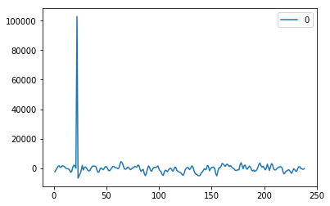

**Figure 23**. Residuals plot for most accurate model (03461). The code used to generate the plot above can be reviewed in Appendix I below.

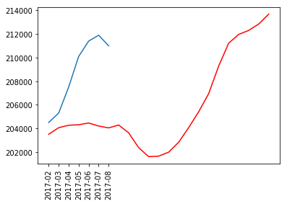

**Figure 24**. Most accurate model (red), against actual (blue) (03461). The code used to generate the plot above can be reviewed in Appendix I below.

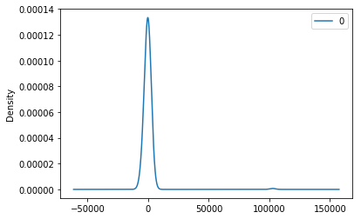**Figure 25**. KDE plot for most accurate model (03461). The code used to generate the plot above can be reviewed in Appendix I below.

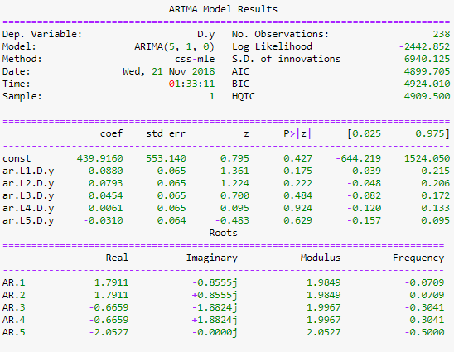

**Figure 26**. Model summary for most accurate model (03461). The code used to generate the plot above can be reviewed in Appendix I below.

When reviewing the top four performing models, it is evident that the first seven months for each model, never exceeded 3% difference between from the corresponding test value. Therefore, it is safe to assume the corresponding models are valid, and the successive 16 months are interesting.

An attempt was made to investigate other modeling packages for this study. Specifically, an alternative fbprophet[3] python package was briefly attempted. However, the package requires an additional Microsoft Visual C++ 14.0, and corresponding dependencies. Given its rich features, this approach should be further investigated for a similar study.

**Conclusions**

In this study, Figure 1 shows amongst four Arkansas metro area, each depicting a similar trend, while Fayetteville having much greater recent value. Next, an overall ARIMA rolling model showed (Figure 6) a highly accurate model. Specifically, at each interval-step, the predicted value contained less than a 1% error. Therefore, this approach was adopted when attempting to aggregate the dataset by zipcode, then predicting successive months of prediction.

When reviewing the above results, it was found that the top four zipcodes aggregated by crime, unemployment, and by location (MD, VA, D.C., MA, NH) were three in Virginia, and one New Hampshire. Though the results are highly accurate, and succeeds to model the defined constraints, it would have been more interesting to model the most profit returning zipcode. Adjusting the necessary code to make this determination is trivial. Specifically, measuring a series of prediction with the greatest positive rolling difference could be one way to capture this information.

Overall, this study succeeded at demonstrating concepts of timeseries forecasting using ARIMA. Figures 11 – 26 visually demonstrate this. Furthermore, understanding other approaches, and algorithms could complement similar studies, by improving either the performance or modeling accuracy. However, adding an additional data source with respect to school district performance, or accessibility to public transportation by zipcode could likely improve the model.

**Appendix A**

Arkansas Metro Area

# metro areas

hot_springs = df.loc[(df['Metro'] == 'hot springs') & (df['State'] == 'ar')]

little_rock = df.loc[(df['Metro'] == 'little rock') & (df['State'] == 'ar')]

fayetteville = df.loc[(df['Metro'] == 'fayetteville') & (df['State'] == 'ar')]

searcy = df.loc[(df['Metro'] == 'searcy') & (df['State'] == 'ar')]

# timeseries plot

fig, ax = plt.subplots()

ax.plot(hot_springs[date_columns].mean(), linestyle='solid')

ax.plot(little_rock[date_columns].mean(), linestyle='solid')

ax.plot(fayetteville[date_columns].mean(), linestyle='solid')

ax.plot(searcy[date_columns].mean(), linestyle='solid')

# decrease ticks

xmin, xmax = ax.get_xlim()

ax.set_xticks(np.round(np.linspace(xmin, xmax, 23), 2))

# rotate ticks + show legend

plt.xticks(rotation=90)

plt.gca().legend(('hot_springs', 'little_rock', 'fayetteville', 'searcy'))

# show overall plot

plt.show()

**Appendix B**

Overall ARIMA model descriptive statistics between 01/1997 through 01/2017:

# train: collapse column by median

train_start = df.columns.get_loc('1997-01')

train_stop = df.columns.get_loc('2017-01')

test_stop = df.columns.get_loc('2017-09')

train_columns = df.iloc[:, train_start:train_stop].columns.tolist()

test_columns = df.iloc[:, (train_stop + 1):test_stop].columns.tolist()

# transpose dataframe: left column data, right column value

df_train = df[train_columns].median().T

df_test = df[test_columns].median().T

# build arima model:

model = ARIMA(df_train, order=(5,1,0))

model_fit = model.fit()

print(model_fit.summary())

**Appendix C**

Residual plot for overall ARIMA model:

# plot residual errors

residuals = DataFrame(model_fit.resid)

residuals.plot()

plt.show()

**Appendix D**

Residual, KDE plot and descriptive for ARIMA model:

# plot residual errors

def residuals_plot(model_fit):

residuals = DataFrame(model_fit.resid)

residuals.plot()

plt.show()

# plot kernel density estimation

residuals.plot(kind='kde')

plt.show()

# descriptibe statistics

print(residuals.describe())

residuals_plot(model_fit)

**Appendix D**

Error rate for ARIMA model, with remaining 2017 months through 2018 predictions:

history = [x for x in df_train]

predictions = list()

iterations = (12-len(df_test)) + 18

for t in range(iterations):

model = ARIMA(history, order=(5,1,0))

model_fit = model.fit(disp=0)

output = model_fit.forecast()

yhat = output[0]

predictions.append(yhat)

if t > 10:

year = 2018

month = (t+2) % 12

if month == 0:

month = 12

else:

year = 2017

month = t+2

if month == 0:

month = 12

print('date: {}-{:01d}'.format(year, month))

try:

obs = df_test[t]

print('predicted={:03f}, expected={:03f}'.format(float(yhat), obs))

print('prediction difference: {:03f}'.format(abs(1-float(yhat)/obs)))

error = mean_squared_error(df_test, predictions)

print('Test MSE: {:03f}\n\n'.format(error))

except:

obs = yhat

print('predicted={:03f}'.format(float(yhat)))

history.append(obs)

**Appendix E**

Comparison between predicted vs actual mean value:

# plot rolling prediction

def rolling_plot(data, predictions):

plt.plot(data)

plt.plot(predictions, color='red')

plt.xticks(rotation=90)

plt.show()

rolling_plot(df_test, predictions)

**Appendix F**

Generic arima function using rolling prediction:

def compute_arima(

data=df_train,

p=5,

q=0,

d=0,

delta=(12-len(df_test)) + 18,

alpha=0.05,

residuals_plot=False,

summary=False

):

history = [x for x in data]

predictions = list()

model_fit = False

try:

model = ARIMA(difference(history, delta), order=(p,q,d))

model_fit = model.fit(disp=0)

print('standard fit used')

except Exception as e:

print('stationary differences will be used')

print('original error: {}'.format(e))

if not model_fit:

for delta in range(10):

stationary = difference(history, delta)

stationary.index = history[1:]

result = adfuller(stationary)

print('stationary fit: {}, p: {}'.format(delta, result[1]))

if (result[1] <= 0.05):

try:

model = ARIMA(stationary, order=(p,q,d))

model_fit = model.fit(disp=0)

break

except Exception as e:

print('bad condition {}: stationarity not adequate'.format(delta))

print('original error: {}'.format(e))

continue

if model_fit:

output = model_fit.forecast(steps=delta, alpha=alpha)[0]

if residuals_plot:

residuals_plot(model_fit)

if summary:

print(model_fit.summary())

for yhat in output:

inverted = inverse_difference(history, yhat, interval=delta)

history.append(inverted)

predictions.append(inverted)

print('predictions: {}'.format(predictions))

return(predictions)

**Appendix G**

Implementation of custom ARIMA rolling forecast model from Appendix F:

# iterate columns

results = []

for column in df_zipcode_clean:

predictions = compute_arima(df_zipcode_clean[column], q=1)

results.append({

'zip_code': df_zipcode_clean[column].name,

'predictions': predictions

})

Associated helper functions for Appendix G:

# stationarity test

def difference(dataset, interval):

diff = list()

for i in range(1, len(dataset)):

value = dataset[i] - dataset[i - interval]

diff.append(value)

return pd.Series(diff)

# invert differenced value

def inverse_difference(history, yhat, interval=1):

return yhat + history[-interval]

**Appendix G**

Zipcode trend for select zipcodes:

# iterate columns

results = []

for column in df_zipcode_clean:

predictions = compute_arima(df_zipcode_clean[column], p=5)

results.append({

'zip_code': df_zipcode_clean[column].name,

'predictions': predictions

})

**Appendix I**

Top four zipcodes:

# best 4 models

for model in sorted_results[:4]:

# get data

zipcode = model['zipcode']

data_zipcode = df_zipcode_clean[[zipcode]]

data_train = data_zipcode.T[train_columns].T

# compute_arima

predictions = compute_arima(

data_train.iloc[:,0],

q=1,

rplot=True,

summary=True

)

# plot predictions

rolling_plot(data_zipcode.T[test_columns].T, predictions)

1. <https://www.statsmodels.org/dev/_modules/statsmodels/tsa/arima_model.html>
2. <https://github.com/scipy/scipy/issues/4524>
3. <https://facebook.github.io/prophet/docs/quick_start.html>