Send mail using php 5
1. gmail account setting
Click on the Google Account button:
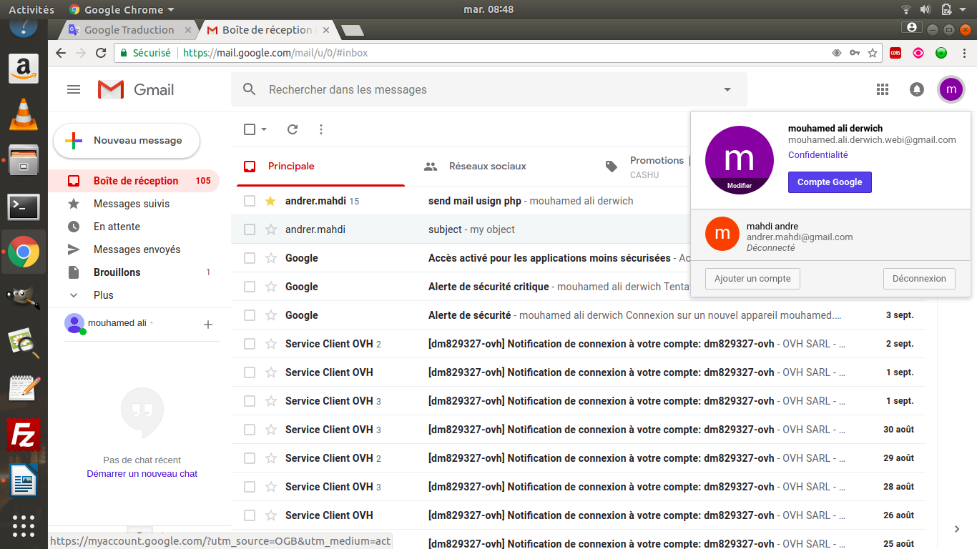

click on the connection and security :
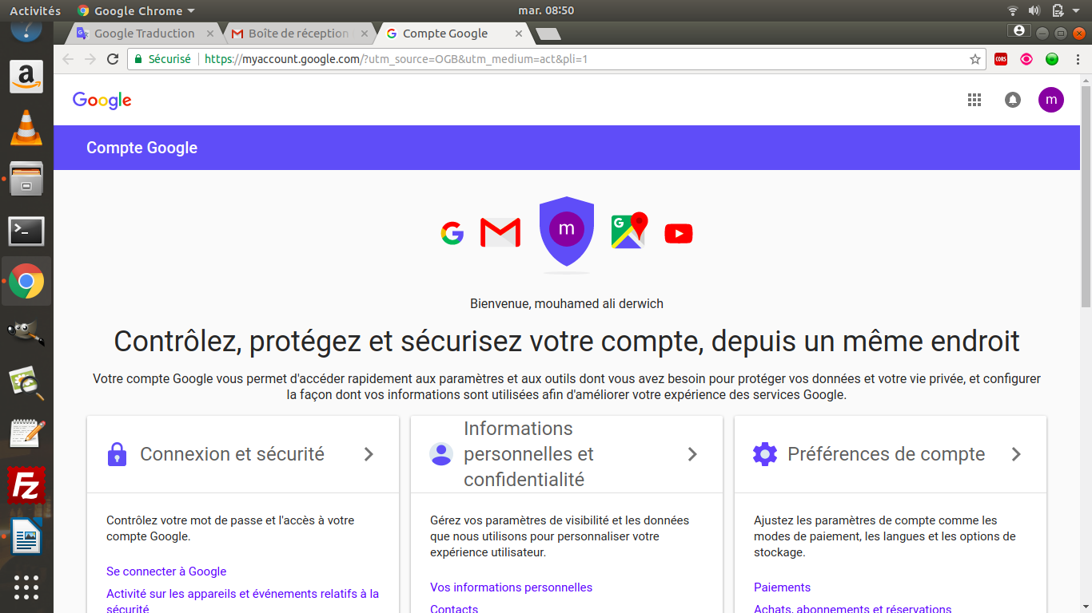

enable "Allow less secure apps" setting :
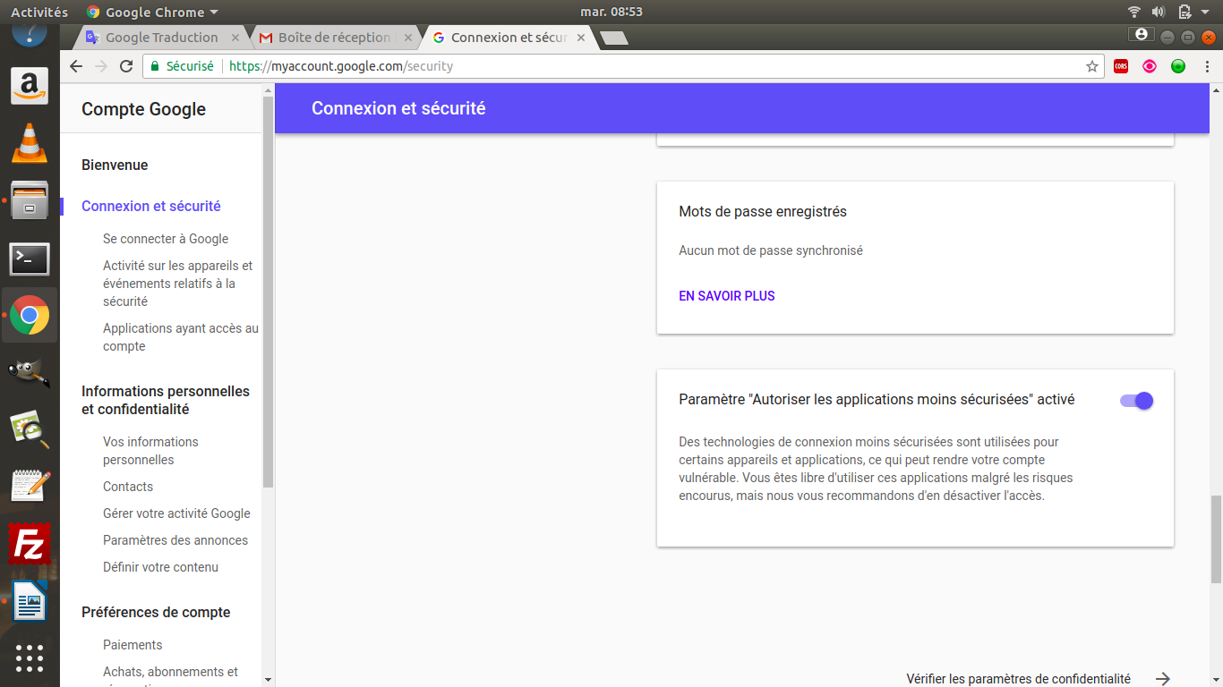
Set up the sendMail.php file :
to adapt the following parameters in the file sendMail.php you need:

//the mail server smtp address that you use
$mailer->Host = 'smtp.gmail.com';
$mailer->SMTPAuth = true;
//adress mail of your account
$mailer->Username = 'my_adress_mail@gmail.com';
//password of your mail account
$mailer->Password = 'my_mail_password';
$mailer->SMTPSecure = 'tls';
$mailer->Port = 587;
//your adress mail
$mailer→setFrom('andrer.mahdi@gmail.com');

