DIGOUT SERVER SIDE DEV

ENVIRONMENT

INSTALLATION GUIDE
Revision History
Ver | Change Description | Sections | Date | Authors | Reviewers | Approvals
1.0 | Initial description of how-to dev env setup |  | 14/01/2013 | Fevzi Anifieiev | Fevzi Anifieiev | Fevzi Anifieiev

REQUIRED SOFTWARE
- JDK 1.6.0.18 or greater version
- Subversion (latest version)
- Maven 3.0
- MySQL InnoDB 5.x
- Tomcat 6.x
- IDE (Eclipse or Intellij Idea)
IMPORTING AND RUNNING THE APPLICATION
- Checking out from SCM Repository
The source code is located in SVN repository. Use any SVN client to checkout the project. The source code can be checked out from http://192.168.0.60/svn/emotion/secondram/trunk
- Modules
digout-artifacts – this module contains data transfer contract.
The data transfer model is describer in XSD schema, and when the module is
built(using maven) JAXB classes are created.
So, just run: mvn clean install to create the classes from XSD schema.
digout-services – this module contains all source code and represents war
artefact.
Just run: mvn clean install to generate war artefact.
This module contains jetty plugin to run the application locally for dev
purposes, so you do not need Tomcat to run the application, so just run:
mvn clean install jetty:run -Dcom.digout.config=config file
-Dcom.digout.logs.dir=logs folder

digout-docs – this module contains any docs related to the project.

digout-infrastructure – this module contains configuration files, database scripts and all stuff required to setup the environment.
digout-integration-testing – this module contains integration tests which can be run after the application is up.
So just run: mvn clean test –Ddighost=ip -Ddigport=port
Substitute the ip and port by the values of the target server(tomcat).
- Importing the project into IDE
Run your favourite IDE and choose to import maven project:
Importing into Eclipse:
a) Run Eclipse
b) Install m2eclipse plugin to be able to import maven projects
(http://www.sonatype.org/m2eclipse/)
c) Select to import existing maven project
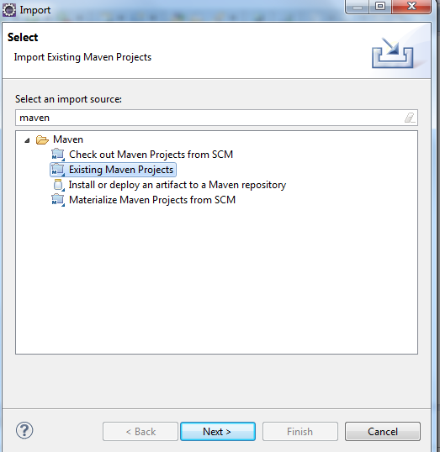
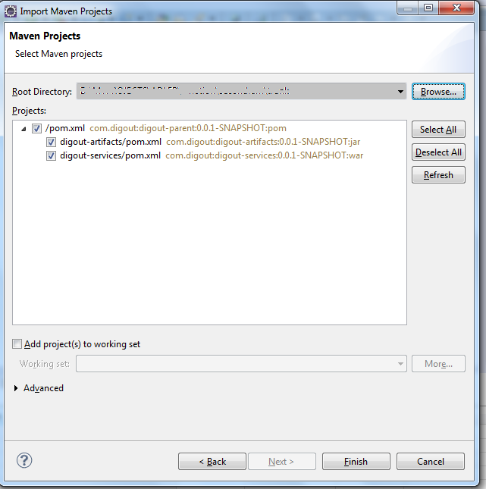
Click finish to finally import the modules.

d) Runnig the application from Eclipse
Make sure you have built the digout-artifacts module as digout-services depends on it.

Open Run Configurations in eclipse and fill in Name, Base Directory, Goals
as shown below:
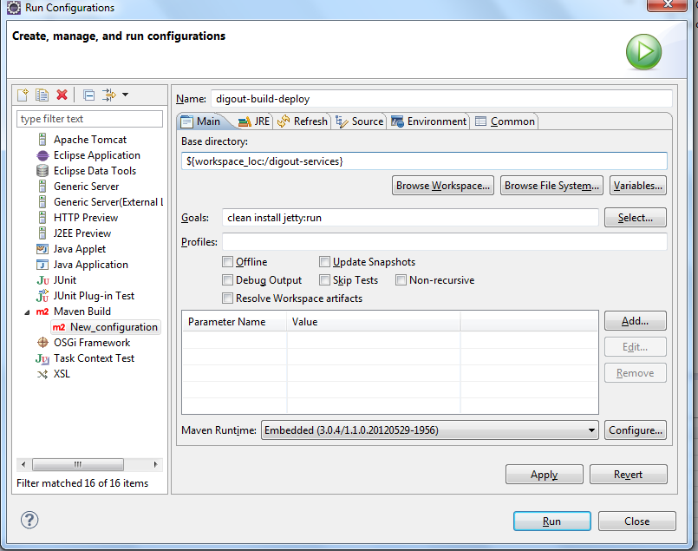
On the JRE tab fill in the VM section, by replacing the configuration file and logs dir paths by your own.
The configuration properties file is located:
digout-infrastructure/configuration/digout-config.properties
Just use the file as a template, by specifying your own config options inside the file.
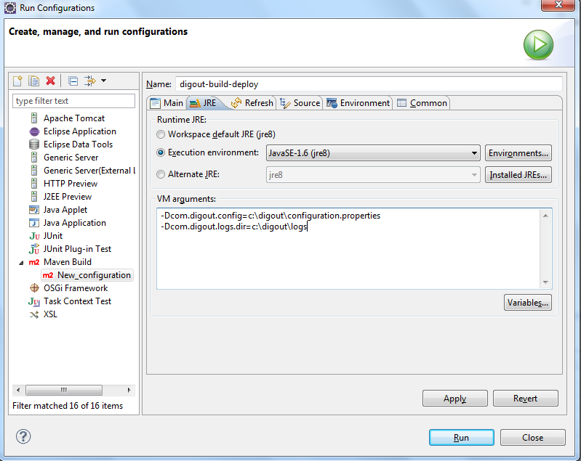
After you have done all previous steps, just run the digout-build-deploy as show below.
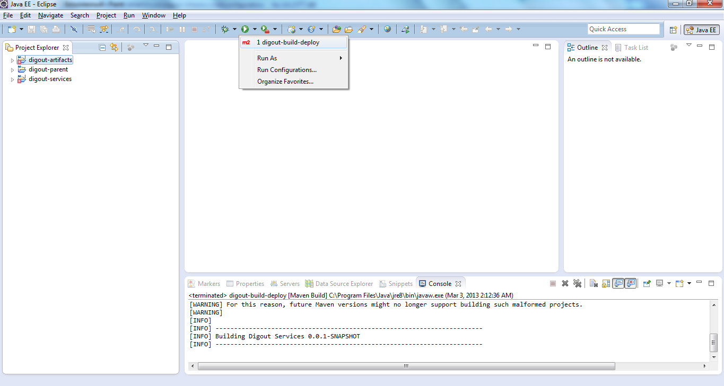
If you followed all above steps then you will see in console tab the following message at the end of log and no exceptions:
INFO: Initiating Jersey application, version 'Jersey: 1.9.1 09/14/2011 02:05 PM'
[INFO] Started Jetty Server
e) Running Integration tests
After the server application is up, you can run the integration tests that will simulate a real user which is registering, logging in, publish product and so on.
Go to digout-integration-testing module and run
mvn clean test –Ddighost=ip -Ddigport=port, by replacing ip and port with target server values.
For example: mvn clean test –Ddighost=localhost -Ddigport=8080
When the tests have finished running, you will see the following message at the end of console logs, if the tests run successfully:
[INFO] BUILD SUCCESS
f) Manual testing
You can also test the services manually using any REST client software.
Jusr navigate to http://host:port/digout/application.wadl to to see all services urls.

