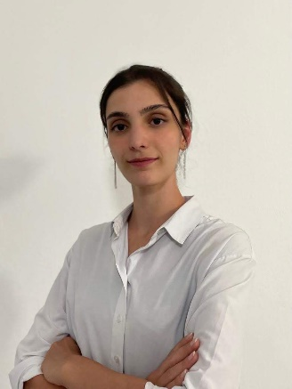 **Derya Kılıç**

Beykoz/ISTANBUL

 0545 457 6061

  [Deriak02@gmail.com](mailto:Deriak02@gmail.com)

 www.linkedin.com/in/derya-kilic-

**PROFILE**

I am an Industrial and Computer Engineering student. I am doing a double major. In addition of my university education, I like to improve myself in every way by doing frequent studies in Code Wars, BTK Akademi, Udemy etc. Also, I like to contribute to my teammates in project works, so I am successful in team works. I like to finish my works in the fastest, easiest and cheapest way. Briefly, I like to be efficient.

**PERSONAL INFORMATION**

**Birthplace/Date :** Caen, France / 2002

**Driving License :** Bclass

**EDUCATION**

**2020- 2024:** İstanbul Medipol University, Engineering Department, Industrial Engineering(4th year)

**2021- 2025:** İstanbul Medipol University, Engineering Department, Computer Engineering(3rd year)

**2016- 2020:** Özel Istanbul Fen Lisesi, Numeric, 91.76/100

* 2nd in class in the first year of Industrial Engineering
* 5th in class in the second year of Computer Engineering
* Varsity sport – In the kick boxing team of the university; won the 3rd place in the Inter-University Turkey Kick Boxing Championship
* Member in Google Student Developer and Operations Research Clubs

**SKILLS**

* Python
* Java
* C
* PostgreSQL
* Matlab

**EXPERIENCE**

Mertech Elektronik Arge Sanayi Ticaret A.Ş. Ümraniye / Istanbul

*ARGE Department*  July 2022- September 2022

* Learned important platforms in AWS Web Services
* Implemented tests in the software of a Project (Test&Validation Engineering in a Project)
* Improved the knowledge of Python by using in the codes of the project
* Made a presentation to the company about RabbitMQ which was searched and learned during the internship

*ARGE Department*  September 2023- October 2022

* Made researches about Machine Learning, Deep Learning models
* Analyzed the codes (Python) used for predicting failures of the machines
* Made a presentation to the company about data based Predictive Maintenance

Neo Auvra Üsküdar / Istanbul

*Software Department* August 2023- September 2023

* Examined the codes written by software developers working in the field of biotechnology to process biometric data such as EEG (Electroencephalography), GSR (Skin Electrical Conductivity), heart rate and many more.
* Made optimizations to make the codes faster and more effective
* Increased the understandability of the codes by adding documents (docstring) into the codes

Marubeni Distribution and Service Inc. Ataşehir / Istanbul  *IT Department March* 2024- May 2024

* Supporting business processes with SAP software and C4C application
* Ensuring follow-up of project processes by attending various meetings

**LANGUAGES**

* **French */*** *Upper-Intermediate*
* **English */*** *Advanced*
* **Turkish */*** *Mother language, proficient*

**VOLUNTEERING**

**Greenpeace (2020-) */****Supporting by sending letters, sharing and signing*.

**Humane Society International (2021-) */****Supporting by sending letters and signing.*

**TEMA */*** *Donating*

**CERTIFICATION**

Women In Engineering Carrer Summit February 2023

Complete Data Science Bootcamp 2024 February, 2024