MIS 313 Computer Networks and Security Final Project Assignment - Network Design and Subnetting
Derya Turan 2304109020
Faculty of Economics and Administrative Sciences
Izmir Democracy University
MIS 313 Computer Networks and Security
Asst. Prof. Dr. Can Saygıner

December 30, 2025

Network Topology and Physical Connections
In this project, I designed a network in Packet Tracer consisting of one router and four PCs. Each PC is directly connected to a separate FastEthernet interface on the router. This way, each PC has its own subnet, and we meet the project requirement that each subnet must have at least one router interface and one device.
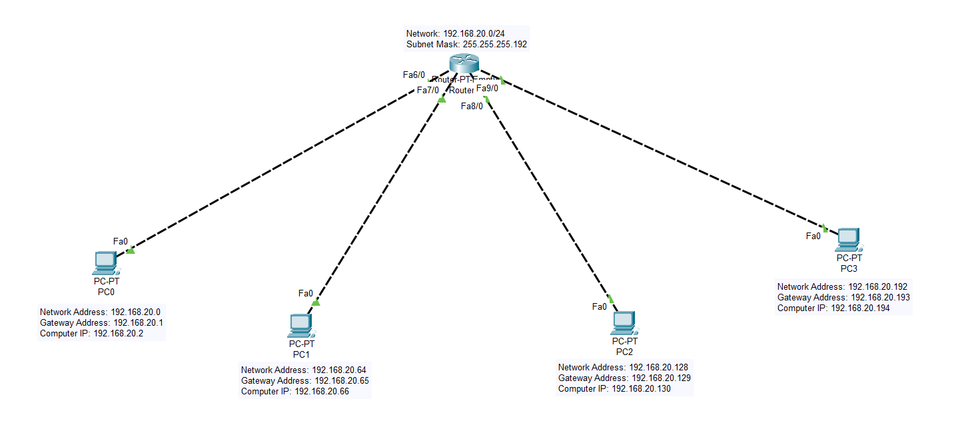
The router acts as the central device connecting all subnets. The connections between the PCs and the router were successfully established, and all interfaces shown in the topology are active. This setup allows all devices to communicate with each other.

IP Address Configuration of End Devices
In Cisco Packet Tracer, I set the IP addresses of each PC manually using the Desktop > IP Configuration screen. The IPs were assigned to each PC according to the subnet plan.
- For PC0, the IP was 192.168.20.2, subnet mask 255.255.255.192, and gateway 192.168.20.1.
- For PC1, the IP was 192.168.20.66, subnet mask 255.255.255.192, and gateway 192.168.20.65.
- For PC2, the IP was 192.168.20.130, subnet mask 255.255.255.192, and gateway 192.168.20.129.
- For PC3, the IP was 192.168.20.194, subnet mask 255.255.255.192, and gateway 192.168.20.193.
This way, each PC is set to use the router interface in its own subnet as the default gateway.

PC | IP Address | Subnet Mask | Default Gateway
PC0 | 192.168.20.2 | 255.255.255.192 | 192.168.20.1
PC1 | 192.168.20.66 | 255.255.255.192 | 192.168.20.65
PC2 | 192.168.20.130 | 255.255.255.192 | 192.168.20.129
PC3 | 192.168.20.194 | 255.255.255.192 | 192.168.20.193

Subnetting Design and Addressing Plan
The subnet table shows how I divided the 192.168.20.0/24 network into four equal /26 subnets. For each subnet, the network address, usable IP range, default gateway, and broadcast address are listed.
Each subnet has 62 usable IPs, which is enough for all devices. The first usable IP in each subnet is set as the gateway for the router interface in that subnet. The broadcast address just shows the last IP in the subnet for reference.
This subnet plan keeps the network logically separated, makes good use of IP addresses, and allows proper communication between subnets.
Subnet | Network | IP Range | Default Gateway | Broadcast | Subnet Mask
1 | 192.168.20.0 | 192.168.20.1 - 192.168.20.62 | 192.168.20.1 | 192.168.20.63 | 255.255.255.192
2 | 192.168.20.64 | 192.168.20.65 - 192.168.20.126 | 192.168.20.65 | 192.168.20.127 | 255.255.255.192
3 | 192.168.20.128 | 192.168.20.129 - 192.168.20.190 | 192.168.20.129 | 192.168.20.191 | 255.255.255.192
4 | 192.168.20.192 | 192.168.20.193 - 192.168.20.254 | 192.168.20.193 | 192.168.20.255 | 255.255.255.192

Router Configuration and Interface Setup
Based on the router CLI configuration shown in the screenshot, the router interfaces were configured according to the defined IP addressing and subnetting plan. Each FastEthernet interface was assigned an IP address corresponding to a different subnet, allowing the router to act as the default gateway for each network segment.
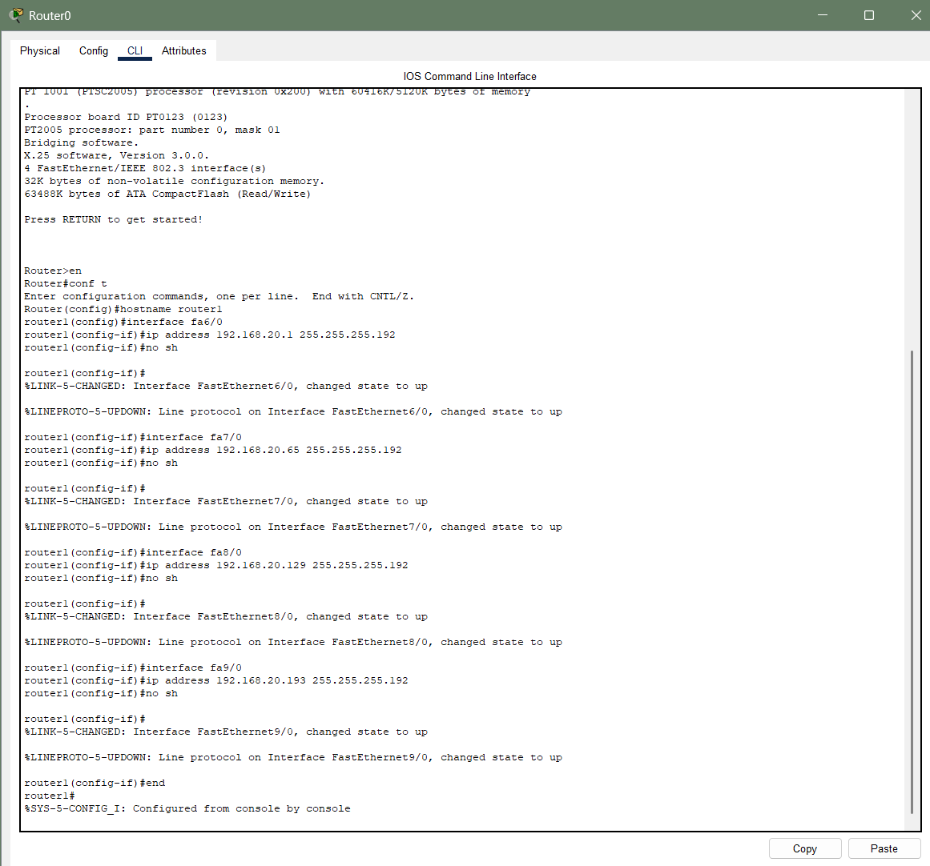

I enabled all router interfaces to ensure communication between the router and the four connected PCs. I assigned a different IP to each interface so that each PC could connect to the router through its own subnet. This way, the router can route traffic between subnets, and all PCs can communicate with each other.
I used the show ip interface brief command to check the status and IP assignments of the router interfaces. This command shows that each interface has the correct IP and is active.
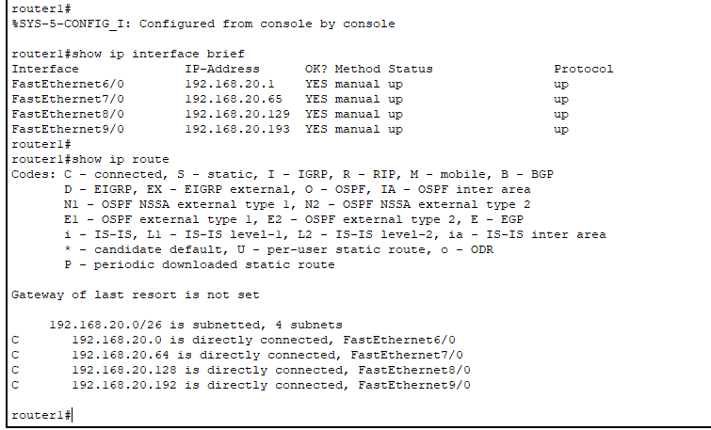
I ran the show ip route command to view the routing table. The output confirms that all subnets are in the table and that the router can route traffic between the PCs correctly without any additional configuration.

Network Connectivity Testing (Ping Tests)
Ping tests were performed between all PCs in the network to verify connectivity. Each computer was tested by sending ping requests to the other PCs, and the results were recorded using screenshots.
The successful ping results show that the IP addressing, subnetting, and router configurations were completed correctly. These tests confirm that all PCs can communicate with each other across different subnets through the router.

PC0> ping 192.168.20.66 (PC1)
PC0> ping 192.168.20.130 (PC2)
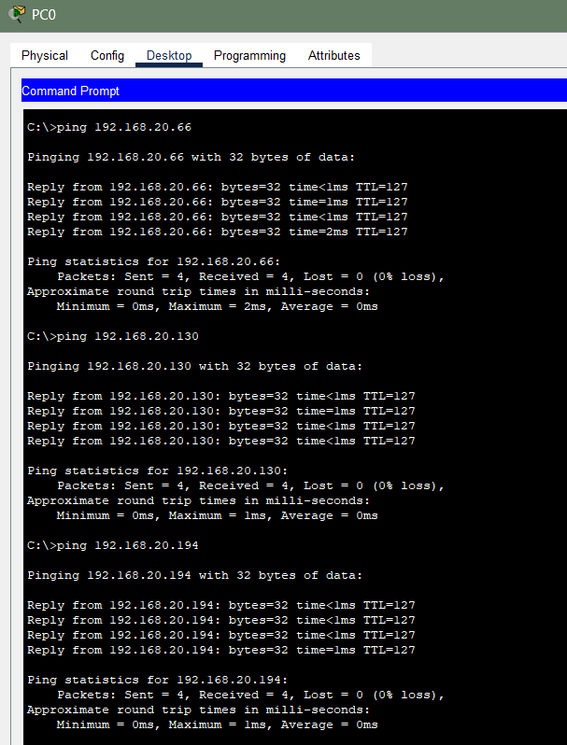
PC0> ping 192.168.20.194 (PC3)
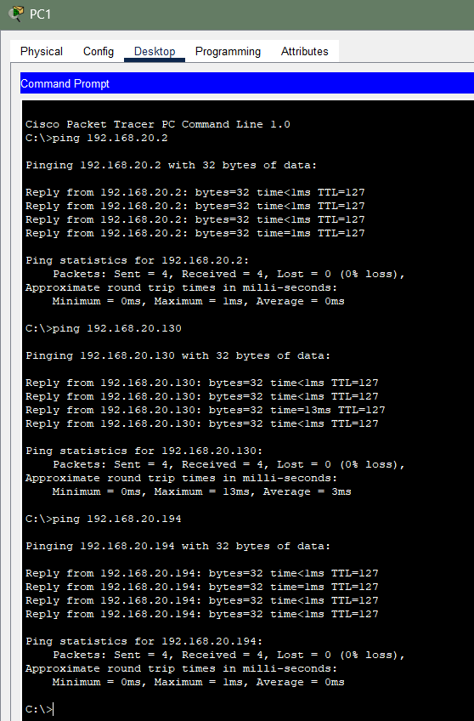

PC1> ping 192.168.20.2 (PC0)
PC1> ping 192.168.20.130 (PC2) PC1> ping 192.168.20.194 (PC3)

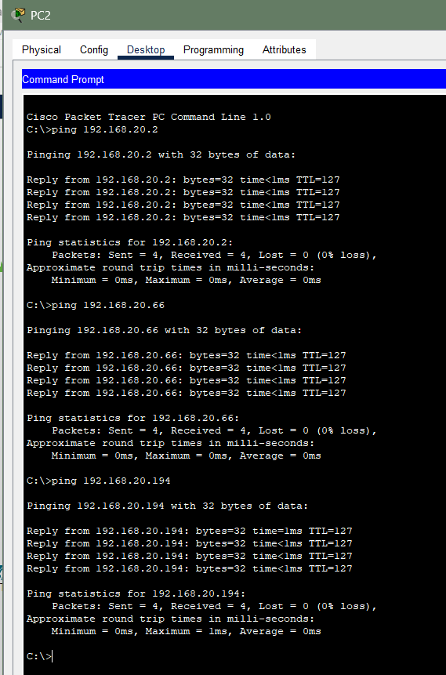

PC2> ping 192.168.20.2 (PC0)
PC2> ping 192.168.20.66 (PC1)
PC2> ping 192.168.20.194 (PC3)

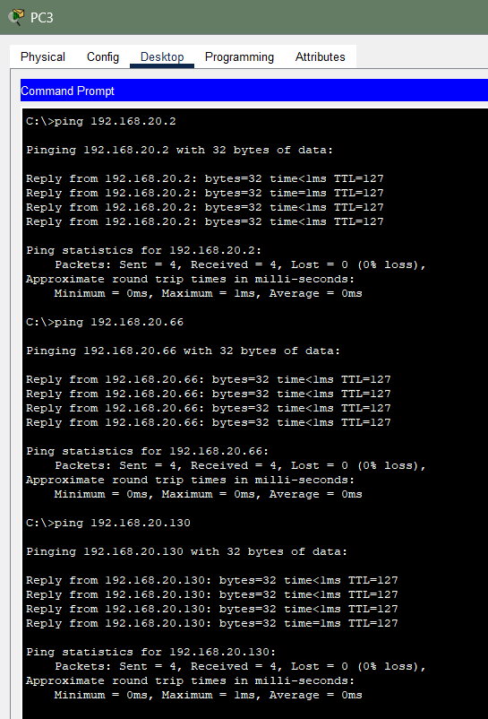

PC3> ping 192.168.20.2 (PC0)
PC3> ping 192.168.20.66 (PC1)
PC3> ping 192.168.20.130 (PC2)

From | To | Ping Result
PC0 | PC1 | Success
PC0 | PC2 | Success
PC0 | PC3 | Success
PC1 | PC0 | Success
PC1 | PC2 | Success
PC1 | PC3 | Success
PC2 | PC0 | Success
PC2 | PC1 | Success
PC2 | PC3 | Success
PC3 | PC0 | Success
PC3 | PC1 | Success
PC3 | PC2 | Success

- When I looked at the ping tests between the PCs, all of them were able to communicate successfully. This shows that each PC has the correct IP address, subnet mask, and gateway, and that the router interfaces are active and set with the right IPs. It also shows that all physical connections are working properly. The successful communication proves that the subnetting plan is logical and working, and that data is being sent correctly between devices.

Conclusion
In this project, I successfully divided the 192.168.20.0/24 network into four equal subnets. All PCs and router interfaces were configured according to the IP plan in Cisco Packet Tracer.
The ping tests confirmed that all PCs can communicate with each other through the router across the different subnets. Overall, the subnetting and network setup were done correctly and met all the project requirements.

