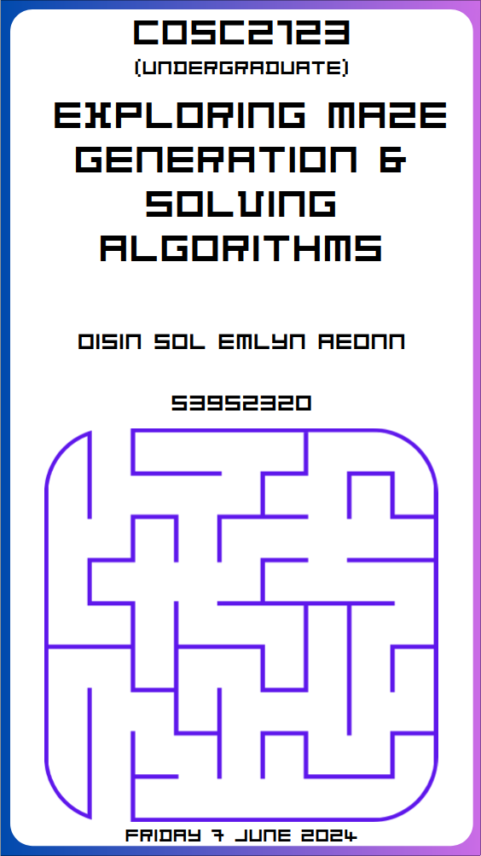

Table of Contents
Task C Report
Assumptions
Count refers to the number of unique cells explored, not including repeated visits due to looping or backtracking, as confirmed by Edward Small and Jeffrey Chan in the EdForum. This coincides with the given DFS Solver implementation.
Introduction
In Task C, we aim to find the shortest path between a set of entry-exit pairs in a perfect 3-D maze while minimising the total number of unique cells explored. Given this challenge we need to find, and optimise a solver s.t.
min(cells explored() + distance(entrance, exit))
One major constraint we have is that the locations of the exits are unknown, being only provided with the number of exits present in the maze. This represents a challenge, as heuristic path-finding algorithms such as A* or other greedy techniques rely on knowing where the destination or goals are to guide their searches efficiently.
My initial thoughts on how to minimise our optimisation function is that we are most likely best off with the first path we find unless we pass by another entrance. It is not beneficial to further explore the maze in search of another exit as this would just needlessly increase our exploration total. However, this does not necessarily mean that running our algorithm again if it is subject to randomness or using a different entrance won’t reduce our number of unique cells we traversed in the maze. There are also lots of factors that go into finding a solver that can solve a maze efficiently. For instance a Wall Following Algorithm may not work efficiently against some DFS mazes due to the long, and winding paths, but may work better against a Minimum Spanning Tree (MST) like Prim’s Algorithm. So, I will state here that my goal is to find a solver s.t. it minimises our optimisation function ∀ solvers. In terms of Algorithms that we know to be relatively efficient we have the given DFS as well as our implemented Wall Following and Pledge which will be useful for empirically analysing if our new solver is more efficient.
Approach
Thus, we must adopt more practical approaches given this constraint, such as Tremaux’s Algorithm or a Biased Random Walk. The rationale for adopting Tremaux’s Algorithm is its ability to mark already explored paths, allowing for a more direct approach compared to Wall Followers or Pledge methods, which often follow longer and indirect routes. This makes Tremaux’s Algorithm more suitable for efficiently navigating complex mazes.
On the other hand, none of the algorithms we have implemented or have access to yet take their position and previous positions into account (beyond not looping). Implementing a solver like a Biased Random Walk could be quite effective, as this type of solver is biased towards moving in a direction that has not yet been explored. I believe this approach may be more likely to find an exit in most cases.
To evaluate any approach it would be useful to implement a Shortest Path Algorithm such as Dijkstra or a Multi-Sourced Breadth-First Search (BFS). These will provide us with the actual shortest path between an entry-exit pair, so we can compare this to our solver.

Theoretical Analysis
Algorithm | Wall Following | Dijkstra | BFS | DFS | Tremaux | Biased Random Walk
E  (Unique Cells Explored) | Proportional to path length until exit. | Explores all cells. | Explores all cells level-by-level until an exit is found. | Typically less than BFS; explores deeply along branches until exit. | Similar to DFS. | Varies – worst case is if the exit is near an entrance.
D  (Distance between Entry and Exit) | Same as above. | Shortest path length. | Shortest path length. | Varies | Varies. | Varies.
Complexity Class
(Given V=L×R×C and E≈3V)
Hypothesis
from my Theoretical Analysis in Part C we can see the Explored Cells, and Distance from the first, and optimal set of entry and exits.
We can in combination with our generators theoretical analysis now hypothesise which combination of generators and solvers will be best to maximise our function.
Given the formula and the constraint of not knowing the exit locations, I hypothesise that a two-phase approach may yield promising results. In the first phase, we employ an exploration strategy to discover all the exits in the maze efficiently. Once all exits have been identified, we can transition to the second phase, where we will exploit to find the shortest path. By combining the results from both phases, we can determine the optimal entrance-exit pair that minimises the overall cost, which is the sum of the number of unique cells explored and the distance between the entrance and the exit.

I explored using Dijkstra, and a Multi-sourced BFS algorithm to confirm my findings. My initial thoughts were that it would be very expensive to try to find another solution to the maze regardless of the algorithm used thus we should always use the first path found as if you were to try again you would be starting having already explored, adding a constant to the cells explored. It was confirmed by Ed and Jeff that the cells explored was unique cells thus meaning backtracking cells or algorithms that explore mazes like pouring water in the maze should be quite effective.
Strategy
I will start with a base case of finding paths to multiple exits from a single entrance. This will involve exploring the maze using a Multi-Sourced BFS or an adapted version of Dijkstra's Algorithm until all exits are discovered. Upon finding an exit, the algorithm can either continue exploring to locate additional exits or transition to the second phase, where it finds the shortest path from that exit to each entrance using Dijkstra's Algorithm or A* (with the exit as the goal).
If the algorithm encounters another entrance while exploring or finding the shortest path to an exit, it can be assumed that there may be a shorter path if that entrance can connect to the current path. This observation can be used as a final optimisation step to further minimise the overall cost.
After exploring all possible paths, the algorithm will evaluate the cost (cells explored + distance from entrance to exit) for each entrance-exit pair and select the pair with the minimum cost as the optimal solution.

Pseudocode
Rationale / Reasoning
Variables
The main factors influencing the given formula outside of the solver are the maze dimensions (levels, columns, rows), number of entrances & exits as well as a small factor in the generating algorithm. When testing
Theoretical Analysis
Justify – talk about explore vs exploit. I hypothesis that the best strategy for this will be on in which the algorithm explores various parts of the maze, and upon finding an exit stops. Count number of unique cells explored, number of cells of the shortest path, and graph it. Mention bigO notation of algorithms chose.
Data Generation

Experiment Setup

Empirical Analysis
In terms of Algorithms that we already know to not take into account all cells in the maze we have our DFS, Wall Follower, and Pledge. These will be useful when benchmarking our new solver to see what generators, as well as what solvers are better at each type of maze. For instance to minimise a Wall Following Algorithm we should be better off with a MST Algorithm as opposed to a DFS generator.
I explored several algorithms; conducting an empirical analysis to confirm my hypothesis.

Results Discussion

Next Time
Given the constraints I felt quite limited in what I was allowed to implement. For instance, I really wanted to implement a Jump Point Search (JPS) Algorithm that jumps that checks all of the sides of each level to find an exit, from which we can then run a heuristic algorithm that is greedy that efficiently traverses the maze in the direction of the found exit. But, I deemed this to be illegal as this would mean not solving the maze in a way someone without being able to jump across the map was able to do. However, this to me seems like a very logical counter to not knowing where the exits are as you can focus on. I also considered a limited DFS Algorithm.

Task D Report
Objective
In Task D, we aim to design and implement a 3-D maze generator s.t. for the set of all Mazes M, we maximise the sum of unique cells explored E by our set of known solvers S and our unknown mystery solver u. Mathematically, this problem can be denoted as:

Constraints
Initially, I considered generating non-perfect mazes with isolated parts (islands), which could render the maze unsolvable for a Wall Following Algorithm due to potential loops. I had already explored this type of maze generation to test my Pledge Algorithm against scenarios where it might be more efficient or impossible to solve without this additional logic. However, this approach was deemed unsuitable as it would not achieve our goal of maximising the optimisation function for the number of unique cells explored by a solver as well as it was explicitly prohibited. Therefore, our maze generation algorithm must ensure that the maze is always perfect, meaning it should form a tree without loops or islands, although it may contain cul-de-sacs (dead-ends). During the maze generation process, we have prior knowledge of the solver type, as well as the entry, and exit locations. The challenge posed by the mystery solver with an unknown strategy adds a layer of complexity, requiring our maze generation strategy to balance accommodating known solving strategies and accounting for the unpredictability of an unknown solver.
Theoretical Analysis
I hypothesise that different combinations of maze generators and solvers will significantly vary in the total number of uniquely explored cells. As maze dimensions (levels, rows, columns) increase, the total number of these cells will also increase. Additionally, more entry and exit points should decrease the number of uniquely explored cells by providing more pathways to a valid solution.
Aspect | Prim’s Algorithm | DFS (Depth-First Search) | Wilson’s Algorithm
Maze Structure | Balanced, shallow, grid-like with shortest average paths | Long, winding paths, tree-like with longest average paths | Highly complex, unstructured (random) with moderate path lengths
Computational Complexity  (Given V=L×R×C and E≈3V) | Initialising a priority queue and processing each edge gives a worst-case complexity∈Θ(V_{log}V). | Initialising and marking cells, and traversing each vertex and edge gives a worst-case complexity∈Θ(V). | Initializing the grid and marking cells, and random walks potentially involving V steps per cell gives a worst-case complexity∈Θ(V²).
Distribution of Paths | Evenly distributed with many junctions. | Few junctions, long corridors | Random with intermediate junctions
Ease of Solving | Easier to solve for most solvers | Harder to solve, especially for non-exhaustive solvers like Wall Following or Pledge | Intermediate difficulty, exhaustive solvers like DFS will be able to solve easily
Approach
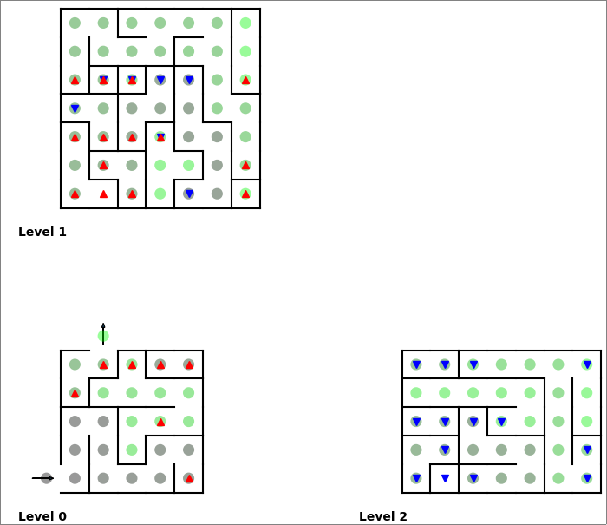Figure 1: Best Case Maze
I plan to conduct an empirical analysis to confirm my theoretical hypothesis about the inefficiencies of various maze generators when used against various solvers. We will first identify which generators are the least efficient for each solver. This analysis will ensure a thorough development of the Task D Generator, which will amalgamate different algorithms through conditional statements to match each solver to its least efficient generator, ensuring extensive traversal.
I also conducted extensive research into solving algorithms and alternative maze generation methods, such as Hunt-and-Kill and Kruskal's algorithm. However, the primary focus is on creating a DFS-inspired generator, which minimises dead-ends and emphasises long, winding paths. This approach will be particularly challenging for solving algorithms like the Wall Follower and Pledge. On the other hand by reducing the number of dead-ends, we can hopefully increase maze coverage by exhaustive algorithms like DFS. This will effectively challenge the mystery solver, ensuring it traverses as much of the maze as possible to reach the solution.
Additionally, I speculate that the potential mystery solver could be a direction-based DFS or a Breadth-First Search (BFS) algorithm, which will require optimising the generation technique against.
Empirical Analysis
Data Generation & Experiment Setup
To generate data for my empirical analysis, I wrote a Python Script (see Appendix X) designed to generate and test .json
configuration files for 4 variously sized mazes (with static entrances & exits), each doubling in the total number of cells (found by levels × columns × rows) present in the maze. I will also test 4 statically sized mazes with an increasing number of random entries and exits (placed at a minimum distance apart, and a preference for entrances being on the lower levels, and exits being at the top of the maze). This approach allows me to test a wide array of maze attributes to uncover the trends in the performance of each generator verses each solver while mitigating any bias. The maze attributes I tested are defined below:
          - Square Maze range: { levels × rows × columns∣3 ≤ l ≤ 6, 5 ≤ r ≤ 10, 5 ≤ c ≤ 10 }∈ ℤ
          - Entry and Exit Maze range: { 3 × 10 × 10∣2 ≤ entry / exits ≤ 5 }∈ ℤ
See Appendix X for all configuration files used for data generation.
To further mitigate bias and ensure quality data, I will employ the use of the random seed attribute. This will ensure that random numbers remain constant for generation and solving, affecting starting points and directions. Testing and averaging our tests multiple times is vital for consistent and comparable results as one generation may make it easy for one algorithm leading to biased results. Thus, I will test each combination three times (with seeds 42, 44, and 46), running additional tests if I detect outliers to ensure accurate averages. Furthermore, the minimum number of entrances in any maze will be 2, and we will test each maze for all entrances present in the maze.
Results Discussion
In my test results, I sought to measure two key metrics useful for evaluating each of our generator-solver combinations:
Scatterplot Graph for Average Number of Unique Cells Explored, and Histogram for Average Maze Coverage generator.
Final Generator
Now that we’ve got some results for how each generator goes at slowing down each solver we can create our final generator to further.
At this point in time it was also unveiled the Mystery Solver that it would be a random direction-based DFS Algorithm which I tried to implement to further maximise my generator against this one.
Pseudocode
Our final generator (
In the generator query the solver name used in the .json file, if found different generator is better at creating difficult mazes.
Conditional

Make a generator that creates lots of corridors. Could make a generator that moves away from the exit. Mention that non-perfect mazes are not laberinths (e.g. contain islands). This would make it not only difficult but impossible for the wall following solver.

I observed that often if one entrance performed well the other one on average would perform poorly, as well as if they performed around the estimated average the other one was likely to perform similarly. Percentage of solver coverage was interesting for evaluating.

Please look into the Appendices for further analysis and detailed insights.

References APA 7th Edition
Al Sweigart (2022) https://inventwithpython.com/recursion/chapter11.html accessed April 2024 | Professor Azadeh Alavi & Dr Pubudu Sanjeewani (2024) RMIT University COSC2673
Ayu Crystal (2022) https://stackoverflow.com/questions/70755207/how-create-an-adjacency-matrix-of-a-maze-graph accessed April 2024 | Professor Jeffrey Chan & Edward Small (PhD) (2024) RMIT University COSC2123
GroverIsOP (2022) https://www.reddit.com/r/javahelp/comments/yd9xju/random\_maze\_generator\_withh\_adjacent\_lists\_help/ accessed April 2024 | Professor Marc Demange & Dr David Ellison (2023) RMIT University MATH1150
Hybesis Hurna (2020) https://medium.com/swlh/handling-graphs-with-adjacency-lists-7e1befa93285 accessed April 2024 | Suzana Markovic (2019) https://unitech-selectedpapers.tugab.bg/images/papers/2019/s5/s5_p72.pdf accessed April 2024
Jamis Buck (2010) https://gist.github.com/jamis/761534 accessed April 2024 | Tikhon Jelvis (2024) https://jelv.is/blog/Generating-Mazes-with-Inductive-Graphs/ accessed April 2024
Jeff Ericson (2016) https://courses.engr.illinois.edu/cs374/fa2018/notes/05-graphs.pdf accessed April 2024 | Tim Oyebode (2022) https://medium.com/@teemarveel/procedural-maze-generation-using-binary-tree-algorithm-5f17cb52a221 accessed April 2024
Levitin Introduction to the Design and Analysis of Algorithms (3rd ed. 2011) accessed April 2024. https://raw.githubusercontent.com/oguzaktas/textbooks/master/Anany%20Levitin%20-%20Introduction%20to%20the%20Design%20and%20Analysis%20of%20Algorithms%20(3rd%20Edition)%20(2012)%20(Pearson).pdf | Whymarrh (2012) https://stackoverflow.com/questions/4551575/data-structure-to-represent-a-maze accessed April 2024
Lukasz Bienias et al. (2016) https://www.researchgate.net/figure/Mapping-the-maze-into-an-array_fig9_315969093 accessed April 2024

Appendix
For further analysis into my Parts A-D please see the following Appendices:
Appendix 1: theoreticalAnalysis.pdf | Appendix 6: EmpiricalData.xlsx
Appendix 2: edaNotebook.ipynb | Appendix 7: adjListGraph.py
Appendix 3: computerSpecs.png | Appendix 8: adjMatGraph.py
Appendix 4: configGenerator.py | Appendix 9: /dataGen/timedClasses/*
Appendix 5: dataGen/Configs/*

This Project was completed using GitHub (private repo); email for an invitation.

