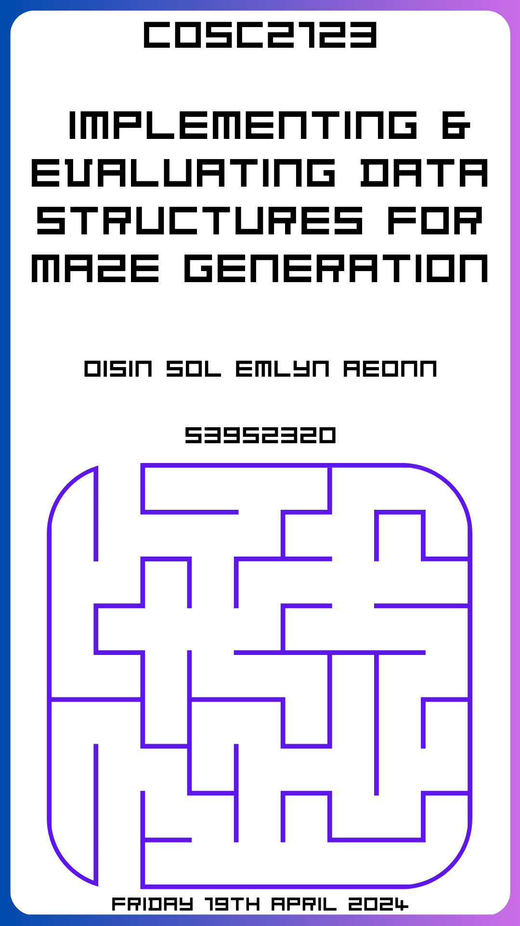

This Page was intentionally left blank.

Implementing & Evaluating Data Structures for Maze Generation

Published April 19, 2024

COSC2123 Algorithms & Analysis RMIT University Canvas

Oisin Sol Emlyn Aeonn

Student ID: 3952320
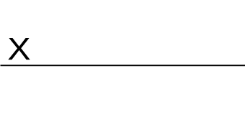
All Rights Reserved RMIT University

For Edward Small, Jeffrey Chan,
& RMIT University.

Table of Contents
Glossary 6
Symbols Used 6
Abstract 6
Research Methodology 6
This project utilies 6
Significance Statement 6
Introduction 7
Theoretical Analysis 7
table 7
Data Generation 7
Experiment Setup 7
Empirical Analysis 8
Charts / probably scatter plot with trendline? 8
Conclusion 8
References 8
Appendices 8

Glossary
Algorithm
Empirical
Theoretical
Analysis
ADT
Array
Adjacency Matrix
Adjacency List
Running-time

Symbols Used
∈denotes “is an element of”
O() denotes big O notation

Abstract
This project explores the theoretical, and empirical analysis of arrays, adjacency matrices, and lists in the context of maze generation. Specifically, implementing an adjacency matrix, and list from scratch and evaluate the expected verses practical running-time by gathering generating various size mazes, and recording the time.
The goal of this project is to learn about the different data structures, as well as theoretically and empirically analyse algorithms to solve problems more efficiently. By doing so we will complete Assessment 1 worth 20% in COSC2123 Algorithms & Analysis.

Research Methodology
This project will be implemented using Python 3.6.8, on the RMIT Teaching Servers to test the performance of the algorithms. The project will utilise LibreOffice Calc to record, and create charts for each data structure.
To evaluate the performance of the data structures (arrays, adjacency matrices, and lists) for maze generation, the built-in Python profiler and timing functions will be used to measure the running-time of the algorithms. This allows for the collection of empirical data to compare the expected theoretical running-time with the actual practical running-time.

Significance Statement
This project is significant as it fulfils the requirements for Assessment 1 in the COSC2123 Algorithms & Analysis course. The project also provides an opportunity to learn the importance of theoretically analysing algorithm complexity, gathering empirical data, and evaluating algorithms using both theoretical and practical approaches. These skills are crucial for designing efficient solutions to computational problems.

Introduction

Theoretical Analysis
Below we will theoretically hypothesis the best, average, and worst case complexities for an Array-Based, and Graph based: Adjacency Matrix, and List Maze Generation Algorithm. To do this we will be evaluating our code implementations in-depth.

Array-Based Maze
Operations | Worst Case | Average Case | Best Case
__init__() | O(n²) occurs if rowNum=colNum, meaning we need to initialise a (2n+2)*(2n+2) grid. Simplified: (2n+2)² ∈O(n²). | O(n) | O(1) occurs if rowNum&colNum=1 meaning we initialise a (2*1+2)² grid. Simplified 4*4 grid = 16 ∈O(1).
initCells() | O(n²) occurs if rowNum=colNum, as we are calling the allWalls() from our MASTER class which has O(n²) as it contains two nested loops, iterating from 0 to n-1. | O(n) | O(1) occurs if addWallFlag=false, meaning the function ends meaning it is∈O(1)
addWall() | O(1) occurs since addWall() performs checkCoordinates(), isAdjacent(), performs a calculation in the difference between the rows, and columns of each point, and finally checks if a wall already exists, and then otherwise sets the cell value to True. All of these operations are∈O(1) meaning that addWall() is the same for the worst, average, and best case.
removeWall() | Same as above, except it checks if a wall exists, and if it does removes it by setting the cell value to False. Similarly, all of these operations are∈O(1) meaning that removeWall() is the same for the worst, average, and best case.
hasWall() | Same as the last two, but it instead just returns True if there is a wall, or False if there is no wall. Again, all of these operations are∈O(1) meaning that hasWall() is the same for the worst, average, and best case.
neighbours() | Starting the same as the last 3, checkCoordinates() is performed first, it then creates an empty list, and then adds corresponding neighbouring cells to the list. Again, all of these operations are∈O(1) meaning that neighbours() is the same for the worst, average, and best case.
arrayMaze | O(n²) | O(n) | O(1) when rowNum&colNum=1
Figure 1.1: Time Complexity for Array-Based Maze Implementation

Adjacency List Graph Maze
Operations | Worst Case |  | Best Case
__init__() | O(1) since all we do to initialise the adjList implementation is create an empty dictionary which is an∈O(1).
addVertex() | O(1) addVertex() checks if the vertex ∈ adjList{}, if the vertex∉adjList{} it adds it as a key-value pair. Both of these operations∈O(1).
addVertices() | O(n) addVertices() loops across all vertices calling addVertex() n times, meaning addVertices()∈O(n). | O(1) if adjList{} is empty then no loop will be run.
addEdge() | O(1) addEdge() appends the adjacency list when
updateWall() | O(n) |  | O(n)
removeEdge() | O() |  | O()
hasVertex() | O() |  | O()
hasEdge() | O() |  | O()
getWallStatus() | O() |  | O()
neighbours() | O() |  | O()
adjListGraph | O() |  | O()
Figure 1.2: Time Complexity for Adjacency List Graph Maze
Adjacency Matrix Graph Maze
Operations | Worst Case | Best Case
__init__() | O(1) | O(1)
addVertex() | O(n^3) | O(n^3)
addVertices() | O(n^2) | O(n^2)
addEdge() | O(1) | O(1)
updateWall() | O(1) | O(1)
removeEdge() | O(1) | O(1)
hasVertex() | O(1) | O(1)
hasEdge() | O(1) | O(1)
getWallStatus() | O(1) | O(1)
neighbours() | O(n) | O(n)
adjMatGraph | O(n^2) | O(n^2)
Figure 1.3: Time Complexity for Adjacency Matrix Graph Maze

Data Generation
Second dot point on Page 8 refers to "data generation code", so I'm assuming they mean a script that generates a config file.
MENTION WHICH OPERATION WE ARE TESTING? IS IT JUST GENERATION AS A WHOLE OR INDIVIDUAL OPERATIONS.
Utilized a number of different .json configurations run by a bash script that would automate running them, and return the average result. I settled on taking the average of 10 runs for each data type as being satisfactory to mitgate any singular runtime bias.
I also settled on doing 10 variously sized data points consistently between each datatype to ensure we see the real empirical evidence for any trends, and predictions we can make on our algorithms.
In our experimental setup, we aimed to thoroughly evaluate the performance of various data structures in representing and navigating through mazes of different sizes and configurations. The key aspects of our data and experimental setup are as follows:
Maze Dimensions: We selected a range of maze sizes, starting from 3x3 and going up to 100x100. The decision to include this range was driven by the need to understand the scalability and performance characteristics of the data structures as the maze size increased. We included both square-based (e.g., 3x3, 9x9, 27x27) and non-square (e.g., 30x50, 60x40) maze sizes to explore the impact of aspect ratio on the data structures' performance.
The maximum maze size of 100x100 was chosen based on an initial test, where we found that creating a 100x100 maze took approximately 100 seconds. We felt that this time was too long to extend the experiments much further, especially considering the multiple data structures we were comparing.
Evaluation Parameters and Data Generation: To generate the test data, we utilized a script provided in the dataGen folder to create .json configuration files for each maze size. These configurations not only specified the maze dimensions but also included details about the number and positions of entry and exit points. This allowed us to explore the impact of the number and placement of entry/exit points on the data structures' performance.
Data Structures Evaluated: In our experiments, we implemented three different data structures to represent the mazes:
- Adjacency Matrix
- Adjacency List
- Array (as a baseline)
The choice of these data structures was driven by their varying trade-offs in terms of space complexity, time complexity for common operations (e.g., finding neighbors, path finding), and their suitability for representing maze-like structures.
Timing Measurements: To measure the performance of the data structures, we focused on the time taken to perform various maze-related operations, such as finding all neighbors of a given cell, computing the shortest path between two cells, and traversing the maze. We recorded the timing results for each data structure and maze size, allowing us to compare their relative performance and identify any trends or patterns.
In summary, our experimental setup aimed to provide a comprehensive evaluation of the selected data structures by considering a range of maze sizes, both square-based and non-square, as well as the impact of the number and positioning of entry/exit points. The resulting data and timing measurements would allow us to draw insights into the strengths and weaknesses of the different data structures in the context of maze representation and navigation.

Experiment Setup
Setting up the experiment did not involve much, I did however use the built-in <TIME FUNCTION IN PYTHON TO TIME / GATHER DATA FOR GENERATION / SPECIFIC METHODS>
I then formulated these into a table, and used them to create charts to analyse / predict the empirical analyse for each datatype algorithm.
There is a method that measures the entire time it takes to generate a maze. However, your empirical testing requires you to time very specific functions (e.g. updateWall). How will you time this? Will you take an average of a certain number of runs for each maze size? Etc.
- There is no specific number - you need to use enough variation in the parameters to justifiably show that the different implementations have different behaviours, and that your empirical analysis matches your analytical analysis. If you want to be VERY precise about this, you should have a read about uncertainty quantification and monte carlo methods (but this is additional reading, and is well beyond the scope of this course - it just might be interesting and informative).

TABLES OF VALUES ARE PROVIDED IN THE APPENDIX, BUT I THOUGHT IT WOULD BE BETTER USE OF SPACE TO PUT JUST CHARTS.

Empirical Analysis

Charts / probably scatter plot with trendline?

Conclusion
Summarise analysis
Provide recommendation for the data structure you would use based on different range of maze dimensions, and other problem requirements
Justify using previous findings why.

References

Appendices
Code NEEDS COMMENTS
table with raw data 2 significant digits only max.

