# MÉTODO GENERICO

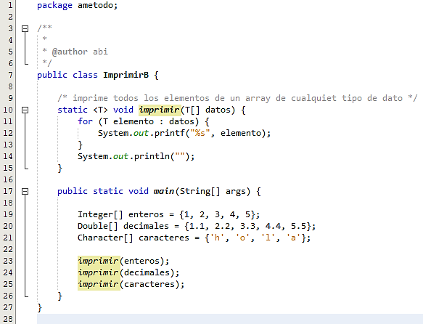

# CLASE GENERICA

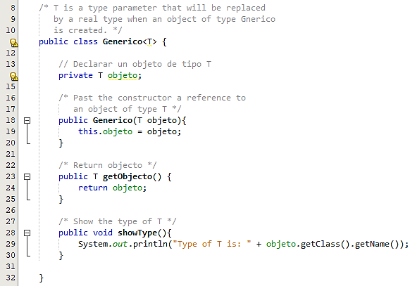

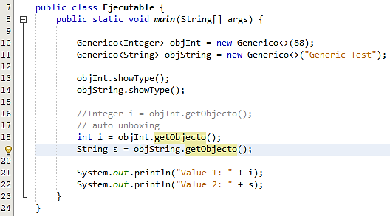

**Type of T is: java.lang.Integer**

**Type of T is: java.lang.String**

**Value 1: 88**

**Value 2: Generic Test**

# CLASE GENERICA: DOS TIPOS

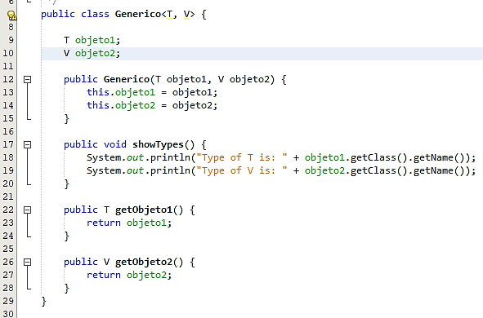

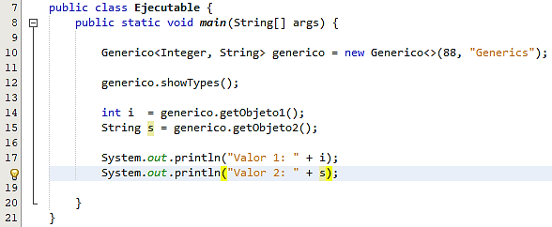

**Type of T is: java.lang.Integer**

**Type of V is: java.lang.String**

**Valor 1: 88**

**Valor 2: Generics**

# BOUNDED TYPES

|  |  |  |
| --- | --- | --- |
|  |  | |
|  | | run:  Promedio enteros: 15.0  Promedio decimales: 16.5 |

# WILDCARD

|  |
| --- |
|  |
|  |
|  |

|  |
| --- |
|  |

# GENERIC CONSTRUCTORS

# GENERIC INTERFACES