Wildlife Tracker – Application Design Document

Ver: 1.0
03-10-2017

 |  |  | Initials | Sign & Date
 |  | Prepared by | Pradeep | 03/10/17

Revision History

Rev. No | Approved Date | Affected Sections/ Pages | Description
1.0 | 03/10/17 | All | Initial release

Contents
1. Revision History 2
2. Contents 3
3. Introduction 4
4. Scope 4
5. Definitions and Acronyms 4
6. Software architecture 5
7. Hardware and software specifications 9
7.1 List of software specifications: 9
7.2 Wildlife Details Screen 12
8. Class Diagram 13
9. Installation and perquisite packages 14
10. API 14

Introduction
The purpose of this document is to describes the overview of software architecture, design to develop Wildlife tracker Application for Multichoice.
The Wildlife tracker application is used to keep an account and track of entire wildlife sanctuary and their movement. Keeping track involves storing GPS coordinates for various wildlife, as and when it is received as well as keeping/updating a count/tally for wildlife.
The application also provide reports with total number of wildlife per categories/type over the input duration.
This document includes use cases, sequence diagrams, class diagram and other supporting requirement information.

Scope
Wildlife tracker application will be part of Multichoice System.
Features of Wildlife tracker Application:
- Dashboard to show list of wildlife details, includes different menu like Tracking, Mapping and Reports.
- Tracking will display the map plot contains GPS co-ordinates for wildlife.
- Reports includes totals of a wildlife per category/type over an input duration. (Tally over time, wildlife per category must be color coded, eg: type1 = red, type2 = blue etc...)
- GPS map to search and track wildlife category animals.

Definitions and Acronyms

S. No | Term | Definition
1 | GPS | Global Positioning System
2 | API | Application Programming Interface
3 | UI | User Interface

Software architecture
System architecture for Wildlife tracking system application.

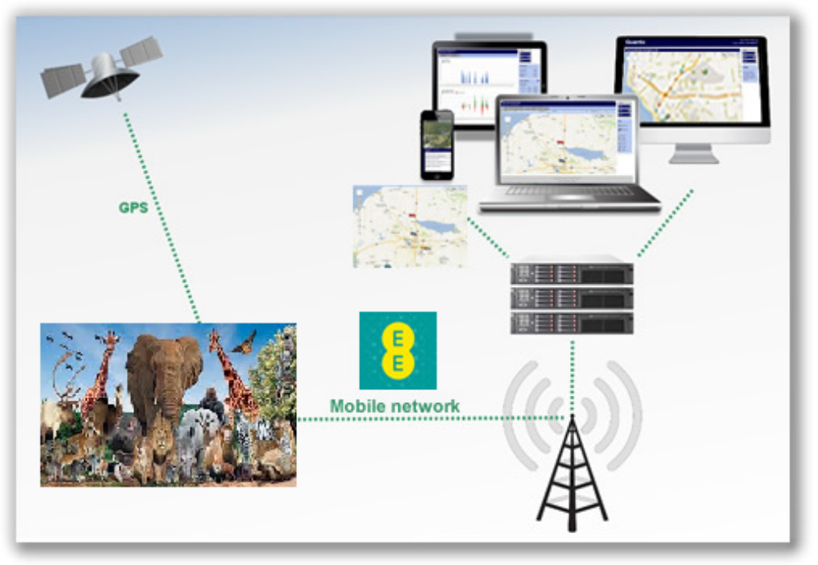
The Wildlife tracking system consists of below major components:
- Operating system
- C# libraries
- MySQL database
- GPS tracker component
- User Interface
The Operating System provides the machine level interface on which the application and MySQL environments can run.
C# libraries provides different interface to communicate between application and different modules like database connection, device communication etc. These libraries used to stores and processes all incoming and outgoing information. The server communicates with GPS hardware device and stores data into database and generate reports depending on the information gathered.
MySQL database provides the persistent storage for the Device, EventData, and other database records.
GPS tracker component is device communication service module which receives data from electronic tracking hardware device installed in every wildlife animal uses GPS satellite constellation and determines its latitude, longitude and time of triangulation. The hardware uses the GPRS to connect to internet and transmit the data gathered by GPS with time stamp to predefined back-end server.
User Interface component is used has Dashboard to display detailed grid view of wildlife animal list. User Interface also has Wildlife GPS map tracker to search and locate the wildlife animal. The reports are generated depending on total number of wildlife category/type over the input time.

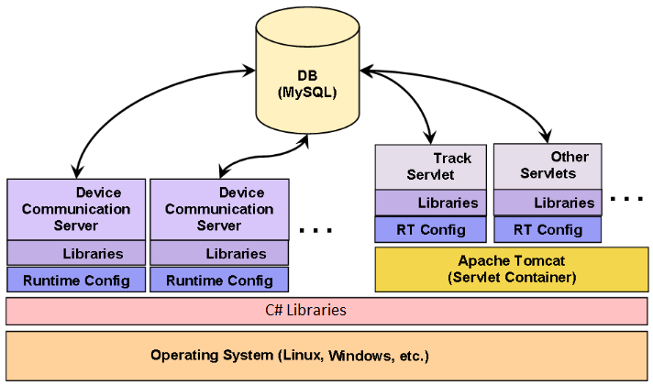
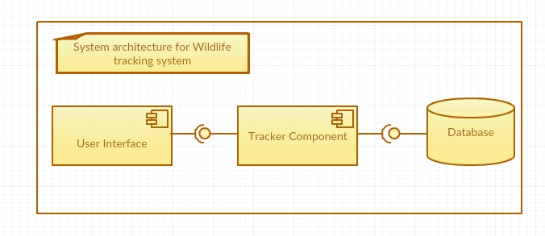
SubSystems:
The Wildlife tracker application is uses MVC(Model View Controller) design pattern, The application display the list of animals, maps and Reports User Interface into view. Controller interacts with both view(UI) and database for display and interaction with user requests.
- User Interface component: User Interface is a subsystem used by different users to access the different UI components like Dashboard, Reports and Tracking.
- Tracker component: The tracker components has four subsystems.
  - GPSInterface: GPSInterface subsystem represents the interface to external system used by the tracker system, This subsystem is used by the tracker user interface to get the details of the movement and current positions on the map. It also provides the coordinates of the wildlife to UI subsystem.
  - TrackingInterface: Tracking subsystem performs the job of wildlife tracking. This subsystem communicates with subsystem GPS Interface, as well as wildlife DB and incident DB.
  - User Management: UserManagement subsystem implements all the user related functions like login, managing users and creating reports.
  - AddInterface: AddInterface subsystem allows user to add user details.
- Database component: Provides the persistent storage for the Device, EventData, and other database records.
The Database component has four subsystems.
  - Wildlife DB
  - Tracker DB
  - Incident DB
  - User DB

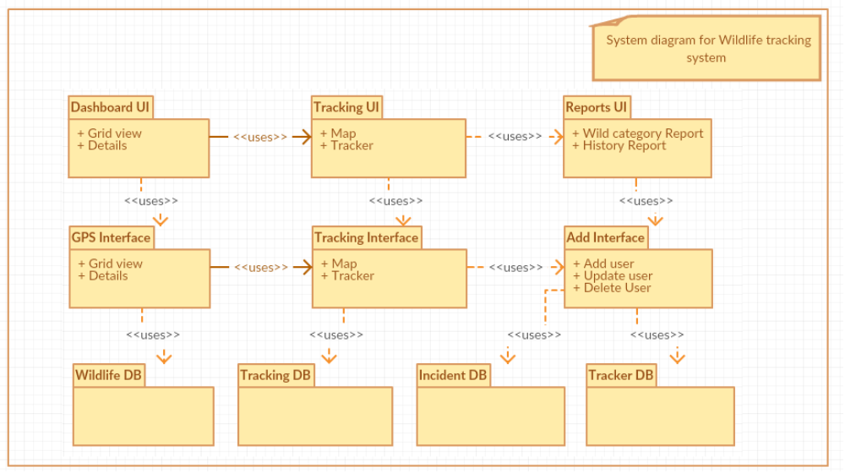

Hardware and software specifications

List of software specifications:

UI application:
C#.NET Windows Forms.
Database Server:
MySQL

GPS device:
Tractive/Whistle GPS tracker device

Web data Services API:
RESTFul service API, XML and JSON

Third party tools:

OpenDMTP(Open Device Monitoring and Tracking Protocol) protocol is open source and is used for bi-directional data communications between servers and devices (clients) over the Internet and similar networks. OpenDMTP gets Location-based information (LBS) such as GPS and other data collected in remote-monitoring devices.
The client includes a kit for designing an application-rich remote-controlled device.
The server is a back-end system where the collected information from the client can be stored. The information can be stored in a comma separated file (CSV file format) as well as in a MySQL database.
On server side, device/protocol communication server required to communicate with remote device and store the data in SQL database.
The Wildlife Tracker application is build using c#.NET framework and require MYSQL database server. The various device communication server runs separately on windows.

Direct Flow – View of wildlife_home

User open “Wildlife” icon to open the application.

Application Homescreen will be opened.

HomeScreen contains panels items Dashboard, Tracking, Reports, Settings and Accounts.

Dashboard Application retrieves the list of wildlife from the database server and display items in gridview.

If application retrieves wildlife list from server, display wildlife details.

If application does not retrieve wildlife from server, display message as “No wildlife found.”

Tracking Application retrieves the latitude and longitude details from server and display the wildlife in map.

Report application gives option to list category based report of wildlife.

Navigate dashboard

User Clicks on Dashboard panel

If category items are available, application displays category items with details.

User can do following operation on Gridview:

Sort, Select, Filter, Export to CSV/XLS.

Navigate Tracking

User clicks on the Navigate panel item

Application retrieves wildlife tracker in map.

Application retrieves category specific items.

Click Settings panel

User clicks on “Settings”

User clicks on “Language” in Settings popup.

If “Language” button is ON, application displays filtered category items.

User clicks on “OK” button of Settings

User selects a Language, application displays category items related to that language.

User clicks on “Cancel” button in Settings

Click Reports panel

User clicks Reports panel item

Reports panel display Group dropdown, date range and Format selections

User clicks on Group dropdown and select All Wildlife

User select the date range

User select the Format (Ex: HTML, CSV, XML and Email)

User click on Generate Report button.

User can see the Report generated

If there is no data the below message will be displayed:
“This report contains no data”

Wildlife Details Screen

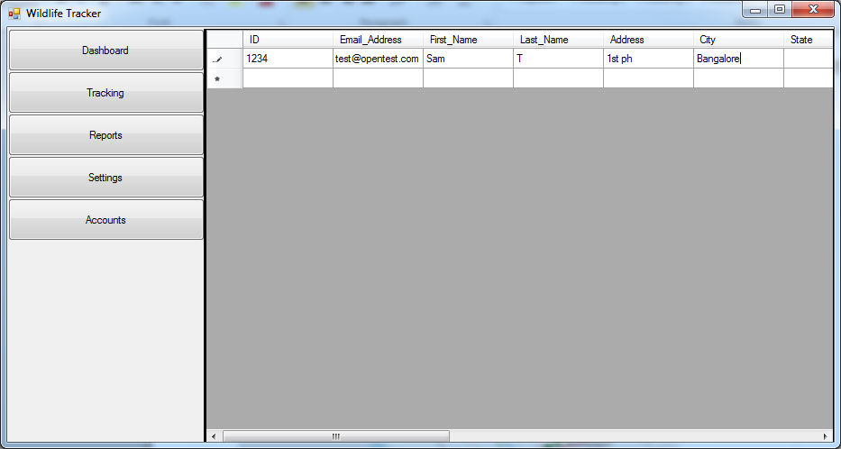
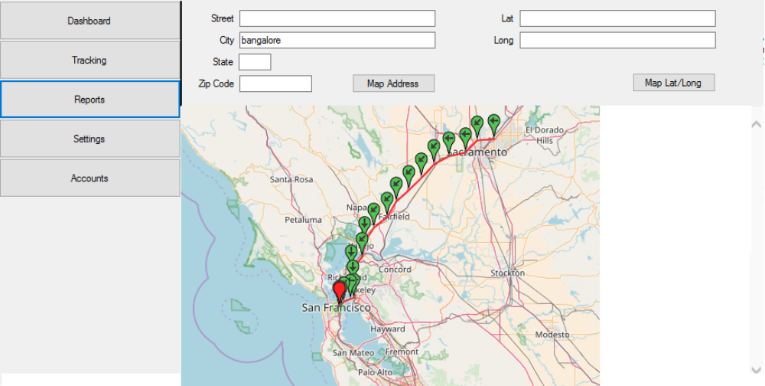

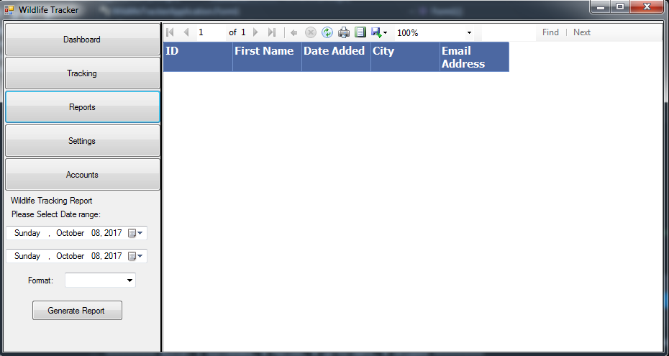

Class Diagram

Packages

Installation and perquisite packages
WildlifeTracker application requires that the following packages or applications be installed, configured, and running on the local system:
- Visual studio 2015.NET
- Java compiler(Java SE SDK 8)
Set the JAVA_HOME environment variable using below command:
setx JAVA_HOME "C:\Program Files (x86)\Java\jdk1.8.0_111"
- Apache Tomcat(Apache Tomcat v7.x servlet container)
The CATALINA_HOME environment variable should then be set to the following:
setx CATALINA_HOME "C:\Program Files (x86)\Apache Software Foundation\apache2.2"
- MySQL Database(MySQL v5.X.X)
- Apache "Ant" Build Tool(Ant v1.9.4+)

Initialization and installation:

- Initializing the SQL Database
- Use below script to create database:
$ bin/dbAdmin.pl -createdb -user=root
Creating database ...
Enter MySQL 'root' password (needed to create the database):
Database created: gts
- Use below command to create tables:
bin/dbAdmin.pl -tables -user=root

API
API name | Purpose

