# Web Server

1. **All web files all created must be in the directory: home/public_html, sub directories can be used.**
2. **Web Access Permissons**

* All directories must have permission 701

i.e. chmod 701 . (home directory)

chmod 701 public_html

chmod 701 <sub directory>

* All files must have permissions 644

i.e chmod 644 <filename>

3. **Here we give an example.**

* + Use putty to log into the unix.

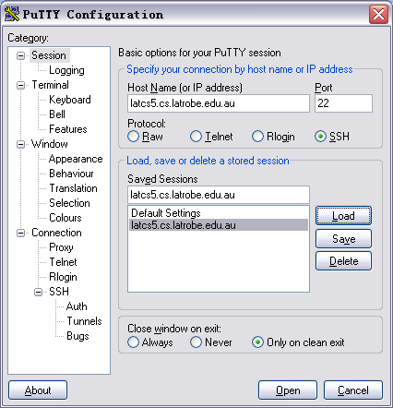

Log into unix:

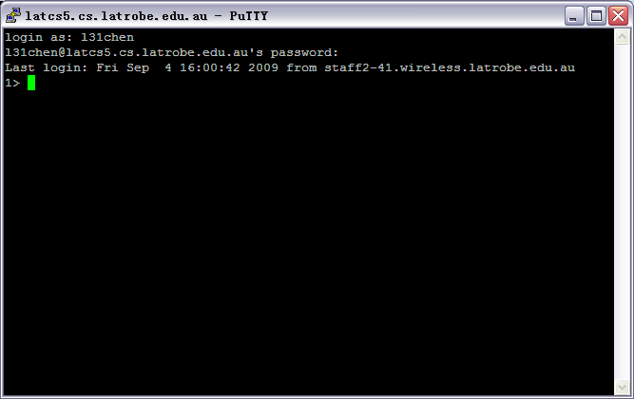

* + In the home directory, create a directory name that must be “public_html” by typing:

mkdir public_html

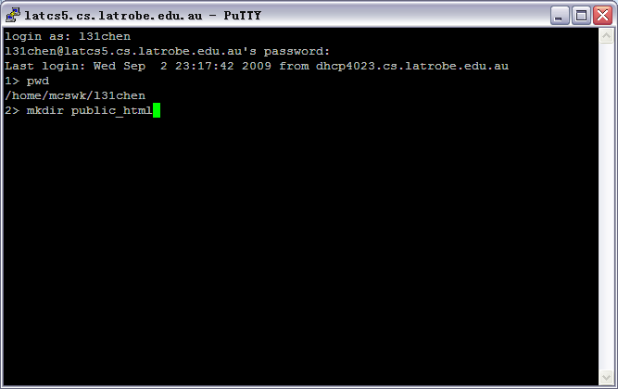

* + Change the web access(home directory) by typing: chmod 701 **.**

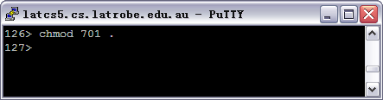

* + Change the public_html directory web access by typing: chmod 701 public_html
  + If you want to have a subdirectory, you can create a sub directory called ADBAssginment by typing:

cd public_html

mkdir ADBAssignment

chmod 701 ADBAssignment

cd ADBAssignment

* + Now assume you want to create a php file, the name is test.php, type:

vi test.php

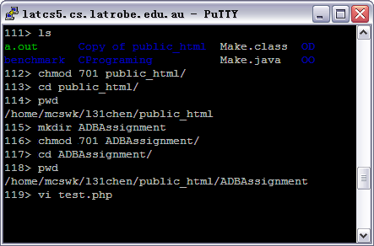

* + Save and quite from test.php file after you edit the php file

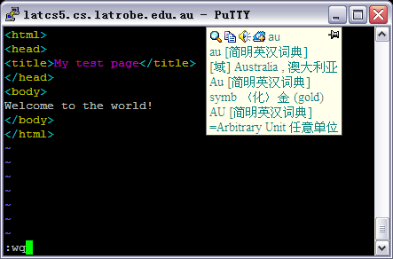

* + Then change the file’s web access by typing:

chmod 644 test.php

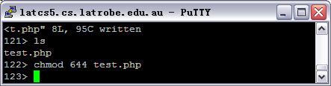

Now if you go to the website, my user name is l31chen, so the website address is:

http://homepage.cs.latrobe.edu.au/l31chen/ADBAssignment/test.php

