AI-BASED LOAN APPROVAL PREDICTION
& RISK ANALYTICS
Data Analytics with AI — Internship Project
AICTE Internship Submission

1. Abstract
This project demonstrates an end-to-end Data Analytics and Artificial Intelligence workflow for loan application analysis. The system converts structured applicant data into KPIs, visual trends, risk-oriented insights and a machine-learning prediction interface. A Random Forest classifier is used to predict the historical-style loan status in the educational dataset.

2. Problem Statement
Loan application datasets contain financial, credit and applicant attributes. The project aims to analyze these attributes, identify patterns associated with approval outcomes, and build a machine-learning model that can provide a prediction for a new application.

3. Objectives
- Perform data inspection and preparation.
- Create meaningful KPIs and visualizations.
- Analyze approval trends and potential risk drivers.
- Train and evaluate a classification model.
- Create an interactive prediction dashboard.
- Translate analytical findings into business-oriented actions.

4. Dataset
The project uses a synthetic educational dataset containing 5,000 loan applications and 13 columns. The target column is loan_status with Approved and Rejected outcomes. The dataset was generated specifically for this educational project and is included with the project files.

5. Technologies Used
Python, Pandas, NumPy, Matplotlib, Scikit-learn and Streamlit.

6. Data Analytics and Business Intelligence Approach
The project follows the internship session's business-intelligence mindset: represent KPIs, understand trends, identify drivers, consider risks and opportunities, and translate findings into actions.

7. Exploratory Analysis
The dataset contains 3,092 approved and 1,908 rejected applications. The overall approval rate in this generated dataset is 61.8%.
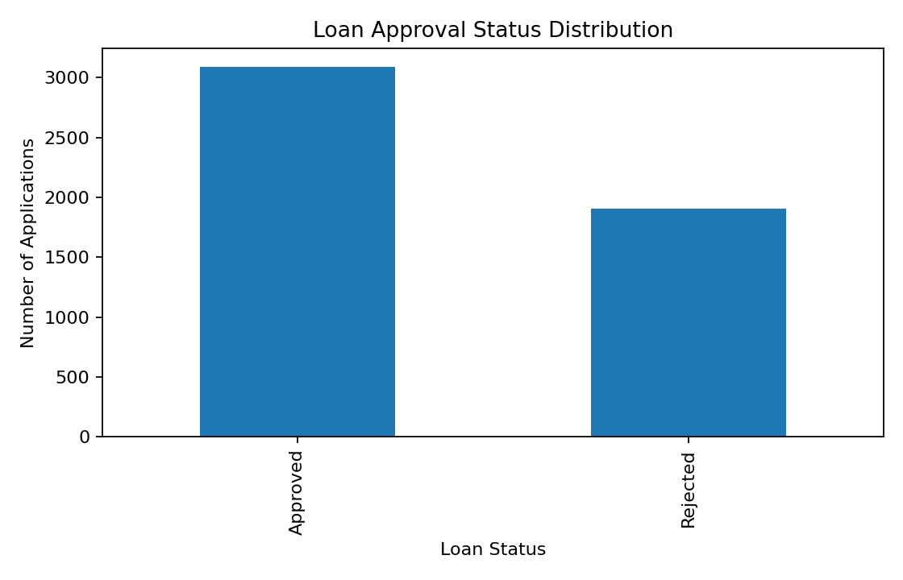
Figure 1. Loan approval status distribution
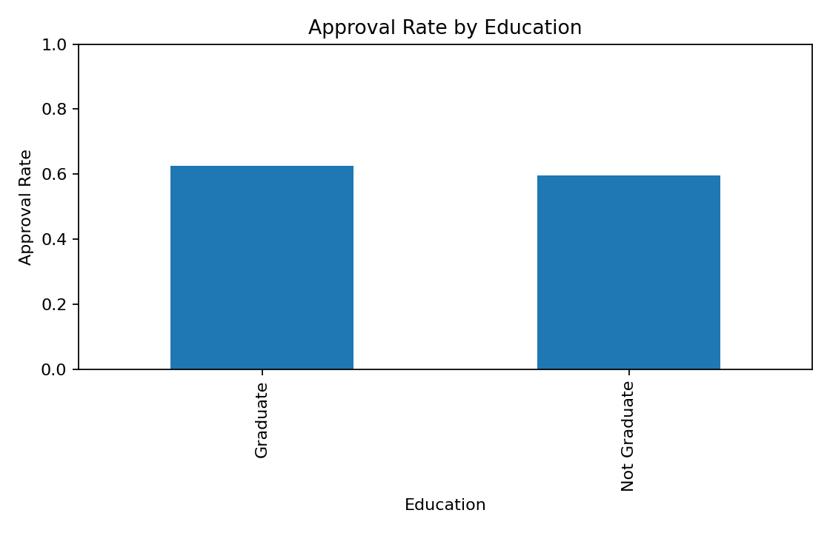
Figure 2. Approval rate by education
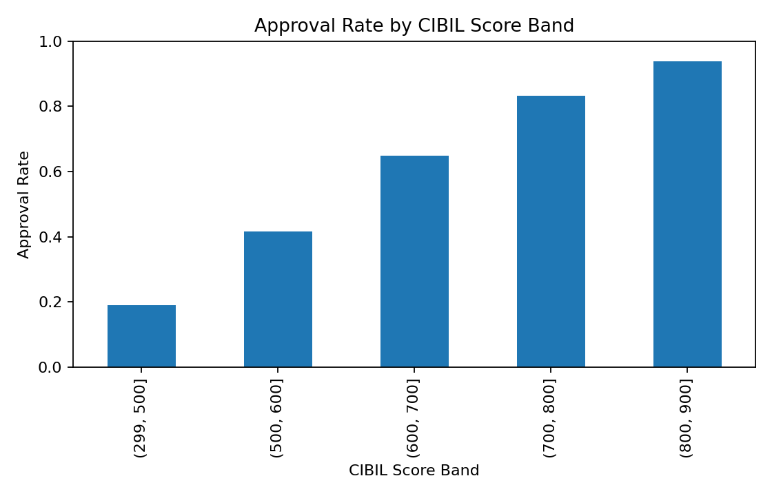
Figure 3. Approval rate by CIBIL score band

8. Machine Learning Methodology
Categorical variables are one-hot encoded and numeric variables are passed through the preprocessing pipeline. The dataset is divided into 80% training and 20% testing data using stratification. A Random Forest Classifier with 300 trees is trained on the training set.

9. Model Evaluation
Metric | Value
Accuracy | 70.50%
Precision | 75.04%
Recall | 78.32%
F1 Score | 76.64%
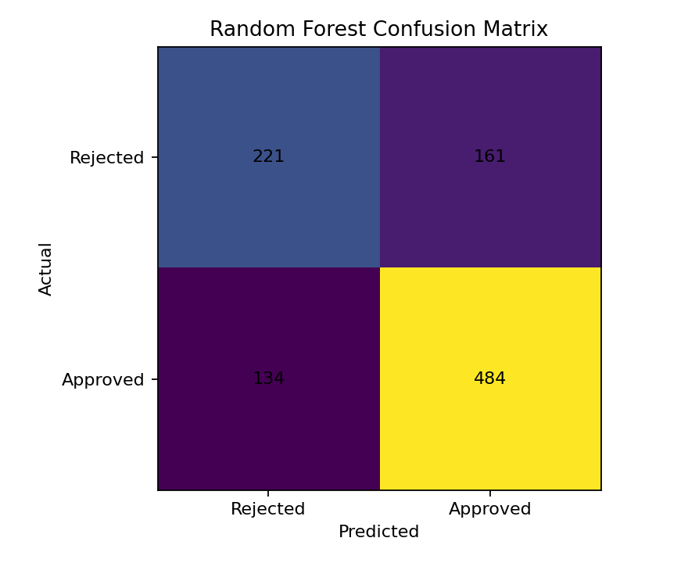
Figure 4. Confusion matrix on the held-out test set

10. Key Insights and Business Actions
- Credit score is treated as a major analytical signal because it is directly represented in the applicant data and is useful for segmenting approval patterns.
- Approval rates can be compared across education and credit-score bands to identify segments that require deeper investigation.
- Loan amount should be interpreted together with applicant income rather than in isolation.
- Risk-oriented analysis should be used to prioritize manual review and further investigation, not to automate consequential lending decisions without appropriate governance.
- The dashboard provides an executive overview first and a prediction interface separately so users can find information quickly.

11. Conclusion
The project demonstrates how raw structured data can be transformed into a decision-support workflow using analytics, visualization and machine learning. It combines descriptive analysis with predictive modeling and presents the results through an interactive Streamlit interface.

12. Future Scope
- Add model explainability using SHAP or permutation importance.
- Add model calibration and threshold analysis.
- Add a role-based dashboard for analysts and managers.
- Use a verified real-world dataset with appropriate governance and fairness checks.
- Deploy the application to a cloud platform.

13. Reproducibility
Install the dependencies using requirements.txt and run: streamlit run loan_approval_project.py

