Output File

Note: Due to issues with colab I completed my work in spyder. The code is uploaed and this is its corresponding output.

Logistic Regression

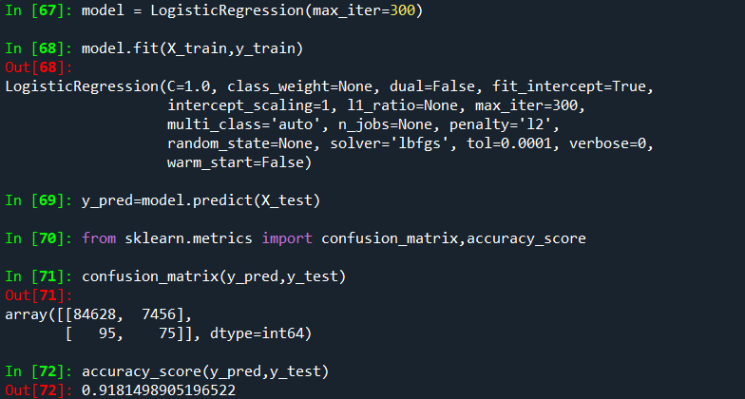

Random Forest

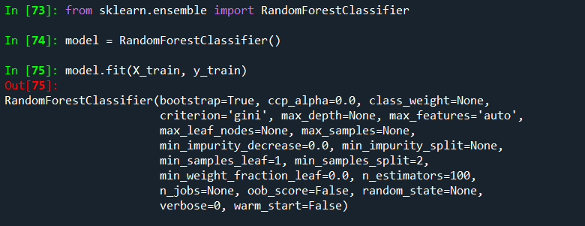

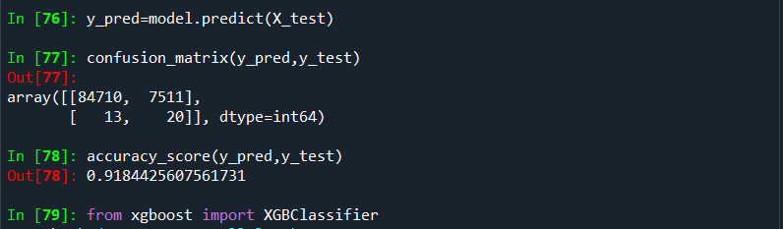

Xgboost

